Ministry of Higher Education and Scientific Research Al-Mustaqbal University College

Department of Chemical Engineering and petroleum Industrials
Pollution

2nd Stage

Lecturer: Dr. Duaa Alwarid

2020-2021

Greenhouse Effect
The solar energy coming from the sun passes through the atmosphere gases to reach the Earth's surface. Roughly one-third of this radiation is reflected directly back to the space. The remaining two-thirds are absorbed by the earth’s surface and warm it. A long wave infrared (IR) radiation (heat) emitted from the Earth's surface. Some of IR radiation passes through the atmosphere into the space and some of it is absorbed by certain gases in the atmosphere, called greenhouse gases and re-emitted in all direction. The effect of this is to warm the Earth's surface and the lower atmosphere. This phenomenon is called the greenhouse effect.
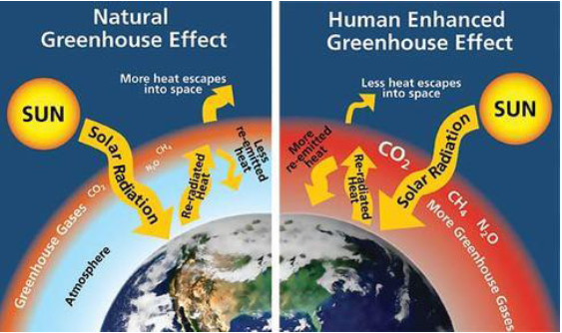
Important of greenhouse effect: The important of greenhouse effect is:
1. To maintain the average temperature of world. The average temperature should remain constant and governs all life process.
2. To maintain the sea level.
3. The polar ice caps remain intact.
Global warming
Global warming is increase in global average temperature near the Earth's surface as a result of increasing in concentration of greenhouse gases in the atmosphere from human activities. If more greenhouse gases are added to the atmosphere from human activities, they will absorb more of infrared radiation reflected by the Earth's surface. The surface and the lower atmosphere will warm further. This extra warming is called the enhanced greenhouse effect. Enhanced greenhouse effect causes global warming.
Effects of global warming
The following effects will results from the global warming (rising temperature):
1- Thermal expansion of the water and melting of polar ice caps would cause sea level to rise.
2- Changes in regional wind systems which would influence global rainfall distribution and lead to redistribution and frequently of flood, drought, and forest fires.
3- Growth in insect population: Climate change would create favorable conditions for growth in insect population, which this have bad effect on agriculture and human health.
4- Disrupts the Water supply and droughts would be more common.
Controlling global warming
1- Reduce deforestation and develop way to sustainable agriculture.
2- Use of technologies to absorb CO2f rom emission.
3- Increased absorption of CO2 by planting more trees.
4- Sequester CO2 in deep ocean.
5- Increased dependence on renewable energy source.

