*Giardiasis*

*Giardia* is an important cause of diarrhea worldwide. Most symptomatic patients recover with treatment although disease is more prolonged and can be difficult to treat in certain groups of immunocompromised patients. The greatest impact of giardiasis is likely on children of marginal nutritional status where the malabsorption associated with infection can cause growth stunting. As our watersheds become increasingly contaminated with human waste, it is likely that the incidence of the disease will increase.

*Giardia* is the

most common cause of waterborne diarrheal disease. Risk factors for *Giardia* infection via waterborne transmission include drinking tap water, swallowing water while swimming, contact with recreational fresh water

**Giardia lamblia**

Also called *Giardia intestinalis* and *G.duodenale*

***Geographical Distribution:-*** Cosmopolitan distribution in warm climate and is more prevalent in children than in adults. It is the most commonly diagnosed flagellate of the human intestinal tract. High prevalence occurs in young, malnourished children in large families, orphan asylums, and elementary schools.

***Habitat:*** Upper parts of the small intestine mainly in the duodenum and jejunum.

***Morphology:***

***Trophozoite****:-*Size: 10-21 by 5-15μm

**Shape**: pyriform (pear-shaped), i.e. rounded anteriorly and pointed posteriorly.

**Motility**: Progressive, rapid, tumbling and spinning often linked to a “falling leaf” type of motility in fresh liquid stools.

Bilaterally symmetrical

Covex dorsal surface and a flattened ventral side

**Contents**: - Anteriorly there are two sucking discs each contains a nucleus, 4 pairs (8) flagella, Parabasal body and axonemes

***Cyst :-*** Size: 8-12μm, oval shape with thick cyst wall.

Finely granular cytoplasm clearly separated from cyst wall.

2-4 oval nuclei at one pole, each with small, central karyosome.

**Cytoplasm**: clear when unstained; yellowish green or bluish in iodine solution.

Fibril: thread-like remains of flagella; axonemes and parabasal bodies folded as S-shaped placed length wise in the center of the cyst.



***Life cycle***

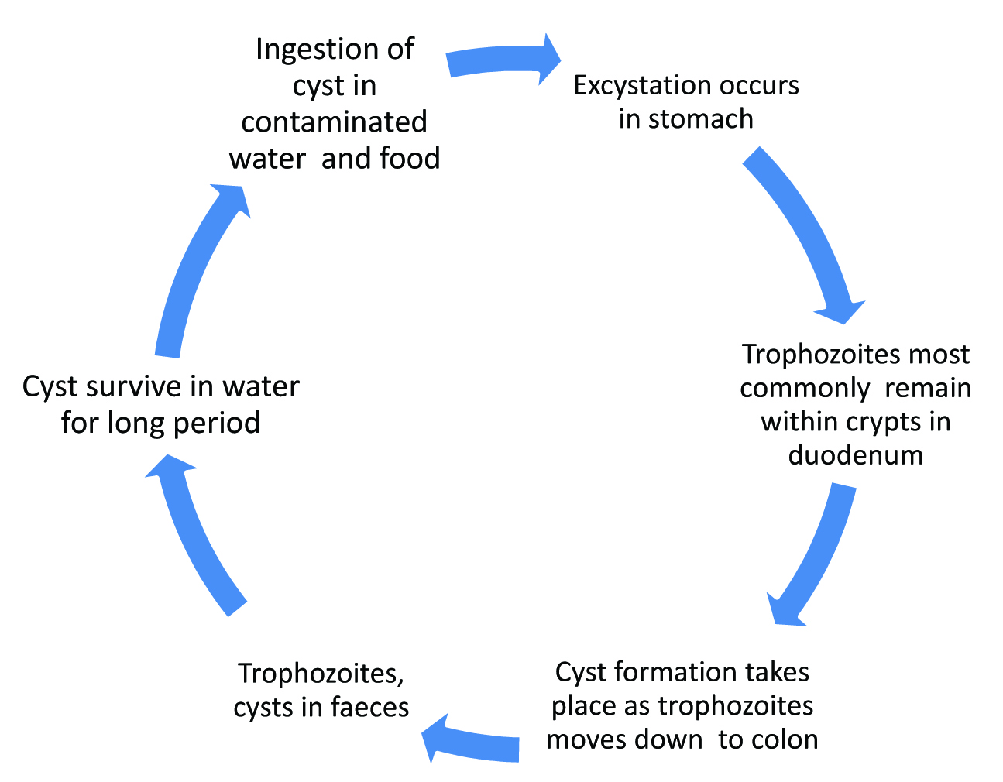

***Clinical Feature and Pathology****:-*

Major symptoms includes duodenitis, excess secretion of mucus or malabsorption of fat (steatorrhoea), sugar and vitamins, dehydration, diarrhoea, weight loss, poor appetite, vomiting, lethargy bile passage obstruction

Symptoms usually begin 7 to 14 days aft er cyst ingestion but can begin as late

as 4 weeks later. The onset is usually acute with diarrhea accompanied by diff use

abdominal cramping and discomfort, bloating, flatulence and fatigue. Nausea can

be present but vomiting is rare. Fever, when present, is low-grade and seen early

in the course of infection.

the cause of diarrhea and malabsorption in Giardia infection is likely to be multifactorial, involving the host immune response to the pathogen as well as, yet to be identifi ed, cytopathic substances that the parasite may secrete.

Additionally, it has been suggested that *Giardia* may cause pathology by alteration

of the bile content or endogenous fl ora of the small intestine which in turn could

aff ect the absorptive function of gut. Th ese hypotheses must now be formally tested before a more complete picture emerges.`

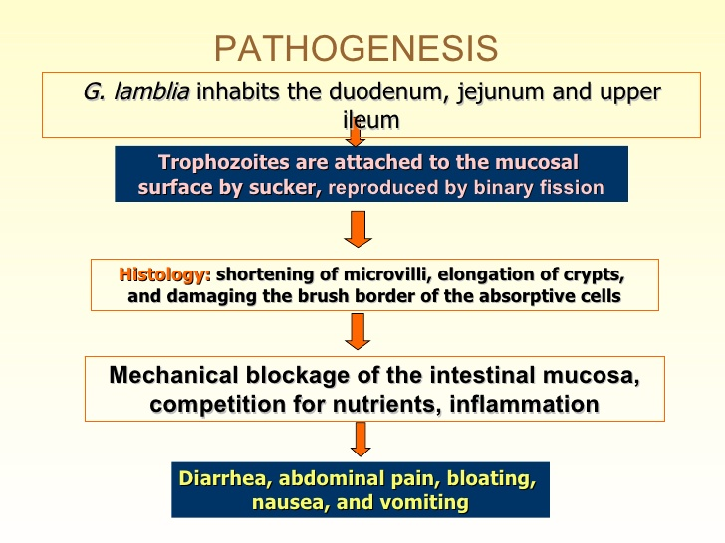

**Prevention and Control:**

1. Improving personal, family and group sanitation and hygiene.

2. Avoid contamination of food, drink and hands with the faeces.

3. Safe water supply and latrine construction.

5. Treatment of infected individuals and health education.

***Laboratory Diagnosis*:-**

Finding the trophozoite and cyst stages in stool specimen. The stool is usually offensive, bulky, pale, mucoid (fatty), diarrheic (watery) but there is no blood in the stool. Several specimens collected at different time need to be examined because trophozoites and cysts are excreted irregularly.

Intestinal and non-pathogenic flagellate that require differentiation from

*G.lamblia* include: *C.mesnili* and *Pentatrichomonas hominis (*formerly

*T.hominis).*

Trophozoites of the above mentioned flagellates can be easily differentiated from *G.lamblia* by their shape and movement (in fresh sample) and bcause they have only one nucleus (and fewer flagella).

The only other trophozote that has two nuclei is *D.fragilis* but this organism

has no flagella or median bodies and look likes a small amoeba.

Cyst of intestinal flagellates can be easily differentiated from those of G.lamblia because they are smaller and do not have the same characterstic appearance of G. lamblia (do not contain remains of flagella). *C.mensili* cysts are lemon shape and *D. fagilis* does not has cyst stage.

