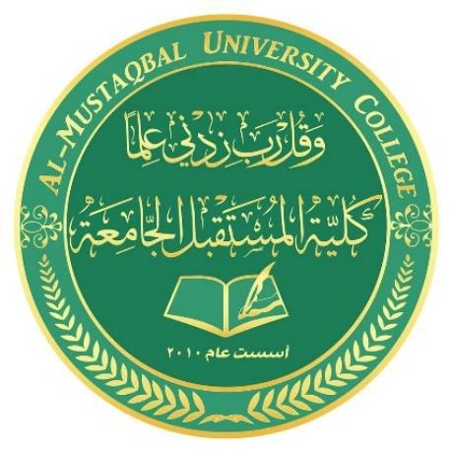

Ministry of Higher Education and Scientific Research Al-Mustaqbal University College

Department of Chemical Engineering and petroleum Industrials
Properties of crude oil

2nd Stage

Lecturer: Dr. Duaa Alwarid

2020-2021

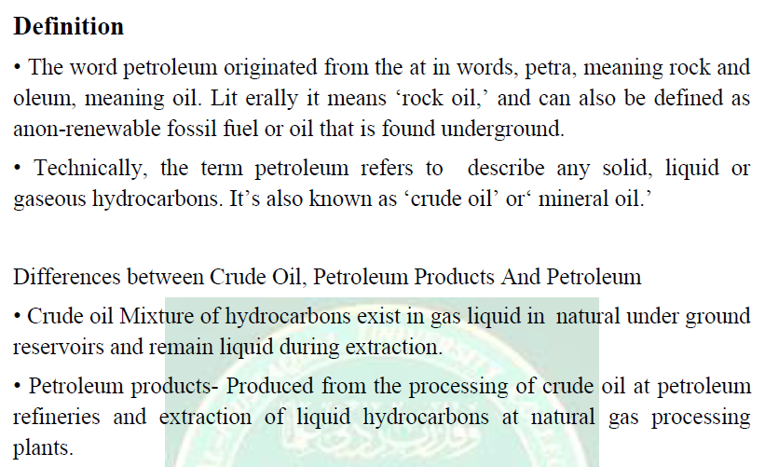
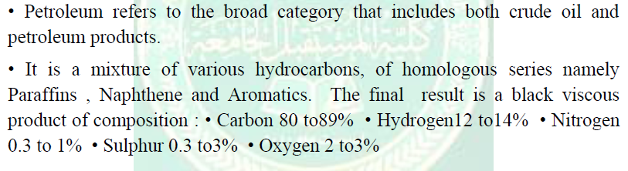
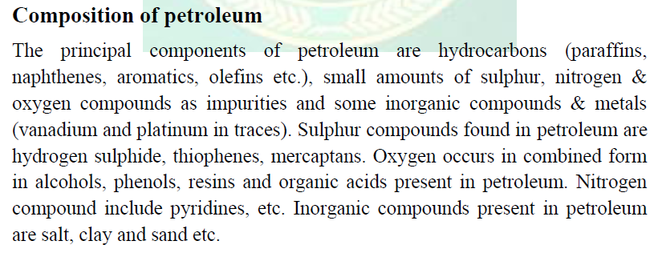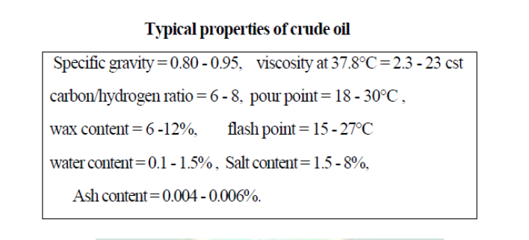
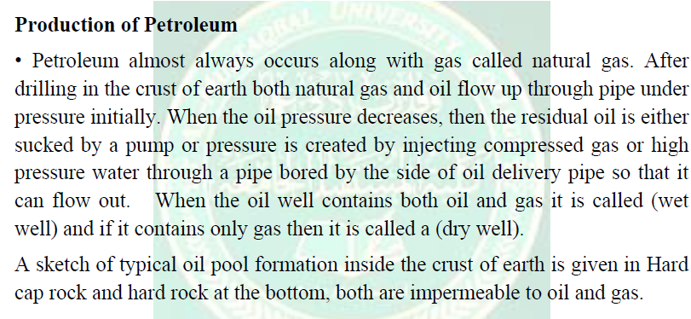

Typical oil pool
