**Class: Zoomastigophorea Mastigophora: Flagellates**

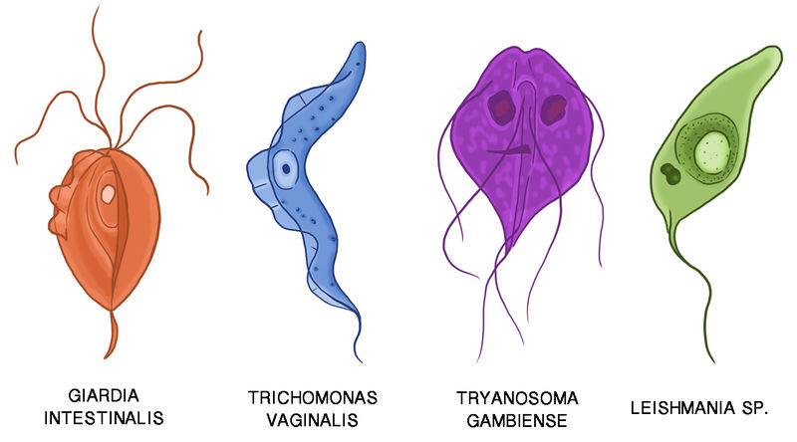

**Flagellates infecting human are divided into two groups.**

**1. The oro-intestinal and urogenital flagellates**

**2. The Hemo-somatic flagellates.**

**The oro-intestinal and urogenital flagellates** are found in the intestine, oral cavity and genital tract. Many of them are not pathogenic. They are classified in to 2 orders, namely; Protomonadida and Diplonadida, The former is characterized by one nucleus and flagella at the anterior end; where as the latter has a pair of nuclei and flagella, which are symmetrically distributed at the interior end.

**The hemoflagellates** are present in the blood and invade various tissues of the body; remain either in the intercellular fluid, bathing the cells; as in trypanosoma, or are engulfed by the Red cells and leucocytes as in Leshmania. Of the six genera the parasite athogenic to man belong to two genera under the family Trypansomatidae, these are Trypanosoma and Leishmania.

**The Oro-intestinal and Urogenital Flagellates**

General Characteristics

1. Uses flagellum as locomotory organelle

2. Reproduce by simple binary fission

3. Complete their life cycles in **a single host** and a second host whom they infect is necessary for the continuation of the species.

4. Most are commensal forms except G.lamblia, T.vaginalis and D.fragilis

5. The infective stage may be either the trophozoite or the cyst stage

6. Except the species of Trichomonas and Dienatamoeba fragilis, all have both cyst and trophozoite stages.

**Chilomastix mesnili**

Geographical Distribution: cosmopolitan but mostly prevalent in warm climates.

Habitat: Trophozoite and cyst live in the colon and caecum of the large intestine.

Morphology Trophozoite:- Size: 6-20 by 3-10μm

Shape: Triangular and tapered at one end

Motility: spiral in one definite direction.

Cytoplasm: - Spiral groove that makes asymmetrical flagellate - cytostome (mouth-like cleft) at the rounded end.

Nucleus: one nucleus, easily visible in unstained preparation

Flagella: Six flagella. Three anterior free flagella, one delicate flagellum lying in the cytostome and two flagella on the lateral margin of the cytostome

Cyst:- Size: 6-8 by 4-6μm Shape: pear or lemon shaped Cystostome and remains of locomotory organelles can be seen. Nucleus: single; Thick nuclear membrane with small central karyosome.

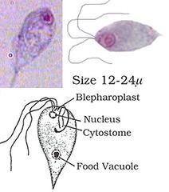

Life Cycle Cyst→Excystation→Trophozoite→Binary fission→encystation→Cyst

in the faeces Trophozoite stage reproduces by binary fission. The infective stage is the cyst from contaminated food or drink. Excystation occurs in the large intestine and trophozoite multiplies by binary fission.

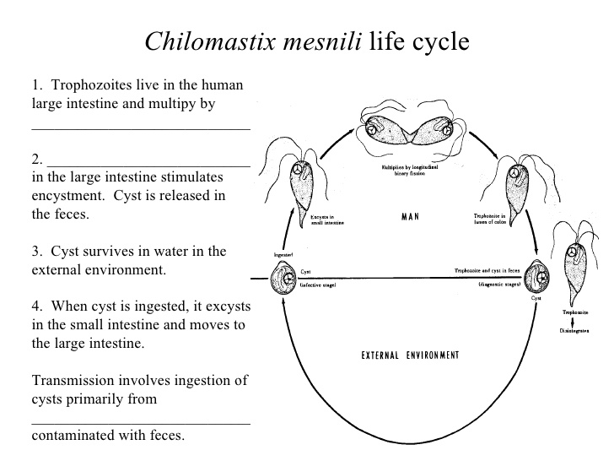

Pathology: It is commensal

Laboratory Diagnosis:-

Finding the trophozoite and cyst stages in stool specimen. The trophozoite stage is very similar to Giardia lamblia and Trichomonas hominis; and needs careful identification.

**Giardia lamblia**

Also called Giardia intestinalis and G.duodenale

Geographical Distribution:-Cosmopolitan distribution in warm climate and is more prevalent in children than in adults. It is the most commonly diagnosed flagellate of the human intestinal tract. High prevalence occurs in young, malnourished children in large families, orphan asylums, and elementary schools.

Habitat: Upper parts of the small intestine mainly in the duodenum and jejunum.

Morphology:

Trophozoite:-Size: 10-21 by 5-15μm Shape: pyriform (pear-shaped), i.e. rounded anteriorly and pointed posteriorly. Motility: Progressive, rapid, tumbling and spinning often linked to a “falling leaf” type of motility in fresh liquid stools. Bilaterally symmetrical Covex dorsal surface and a flattened ventral side Contents: - Anteriorly there are two sucking discs each contains a nucleus, 4 pairs (8) flagella, Parabasal body and axonemes

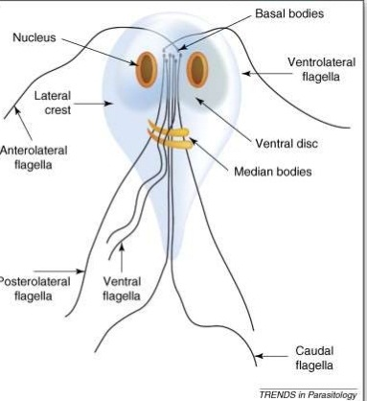

Cyst :- Size: 8-12μm, oval shape with thick cyst wall. Finely granular cytoplasm clearly separated from cyst wall. 2-4 oval nuclei at one pole, each with small, central karyosome.

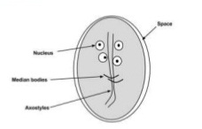

Cytoplasm: clear when unstained; yellowish green or bluish in iodine solution.

Fibril: thread-like remains of flagella; axonemes and parabasal bodies folded as S-shaped placed length wise in the center of the cyst.



Life Cycle Requires a single host to complete its cycle and reproduces by a simple longitudinal binary fission

Cyst ingested→excystation→Trophozoite→binary fission→Encystation→cyst in faeces

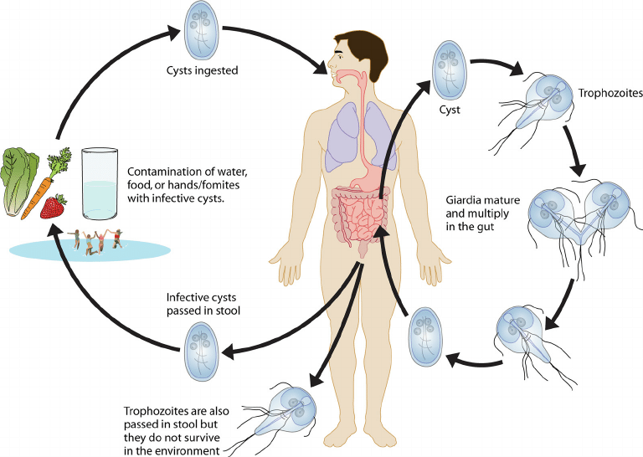

Infection occurs by ingestion of mature tetranucleated cyst with contaminated food, drink, finger, etc. Following ingestion, the cyst excyst in the upper part of the small intestin to form flagellates. They become attached to the intestinal wall by a sucking disc and absorb nourishment through their body surface. They multiply by longitudinal binar fission and some of them are carried down the intestinal tract to undergo encystation. The trophozoites and infective cysts are excreted in the faeces.

**Interaction of *Giardia* and the host.**

(A) Parasites release proteins, like secreted proteins and proteins contained in macrovesicles and microvesicles, such as **ADI, OCT**, and several proteases.

(B) These secreted factors can degrade tight junction proteins and villin in the epithelial cells, degrade mucins and cytokines secreted by cells, and metabolize arginine resulting in immune evasion and immunomodulation. **ADI, arginine deiminase; OCT, ornithine carbamoyltransferase.**

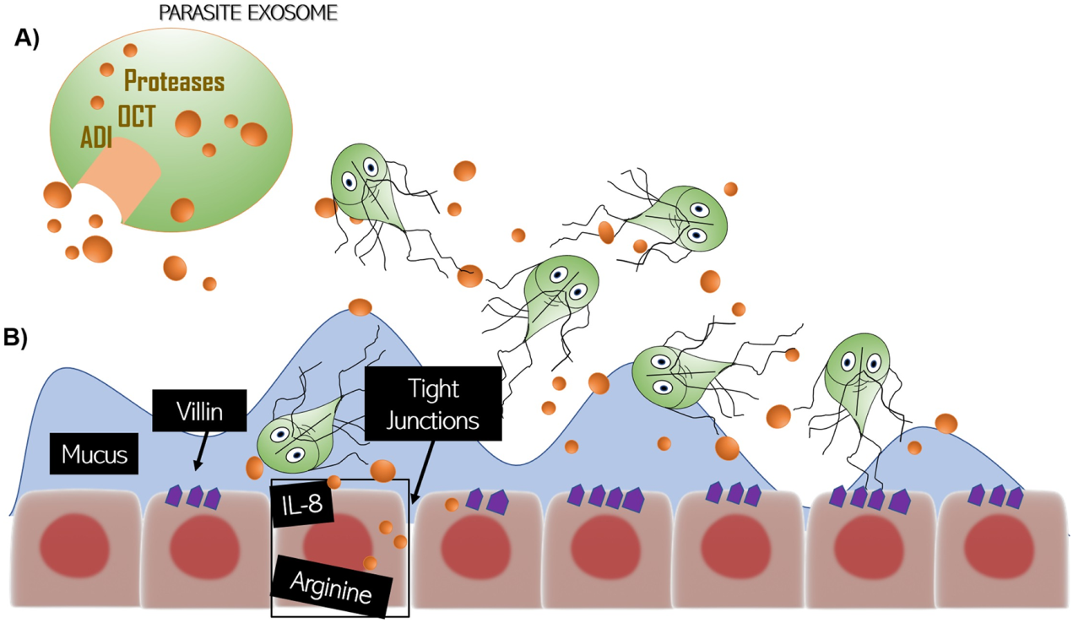

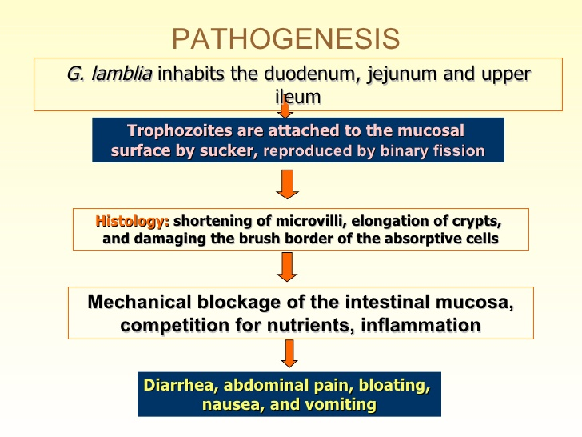

Clinical Feature and Pathology:-Major symptoms includes duodenitis, excess secretion of mucus or malabsorption of fat (steatorrhoea), sugar and vitamins, dehydration, diarrhoea, weight loss, poor appetite, vomiting, lethargy bile passage obstruction

Prevention and Control:

1. Improving personal, family and group sanitation and hygiene.

2. Avoid contamination of food, drink and hands with the faeces.

3. Safe water supply and latrine construction.

5. Treatment of infected individuals and health education.

