Chronic bronchitis and pulmonary embolism

Chronic bronchitis is one type of COPD (chronic obstructive pulmonary disease). The inflamed bronchial tubes produce a lot of mucus. This leads to coughing and difficulty breathing, is a common condition defined clinically as persistent cough on most days for at least three months of the year for two or more years The cough is caused by over secretion of mucus. The condition is more common in middle-aged males than females; approximately 20% of adult men and 5% of adult women have chronic bronchitis
ETIOPATHOGENESIS
1. Smoking The most commonly factor of chronic bronchiti . Heavy cigarette smokers have 4 to 10 times higher proneness to develop chronic bronchitis.
2. Atmospheric pollution The incidence of chronic bronchitis is higher in industrialized urban areas where air polluted.
3. Occupation Workers engaged in certain occupation such as in cotton mills, plastic factories etc.
4. Familial and genetic factors There appears to be a poorly defined familial tendency and genetic predisposition to develop chronic bronchitis. However, it is more likely that nonsmoker family members who remain in the air-pollution home are significantly exposed to smoke (passive smoking) and have increased blood levels of carbon monoxide.

Chronic Bronchitis of Lung
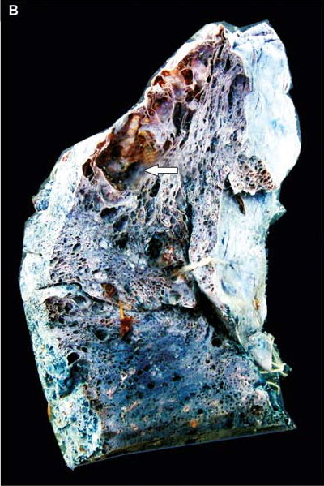
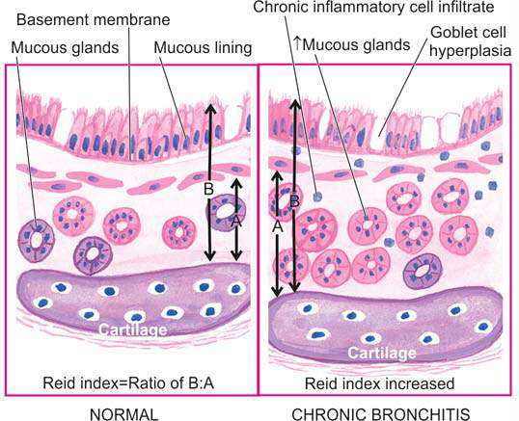
MORPHOLOGY

The mucosal lining of the larger airways usually is hyperemic (is the increase of blood flow to different tissues in the body) and swollen by edema fluid. It often is covered by a layer of mucinous secretions. The smaller bronchi and bronchioles also may be filled with similar secretions.
On histologic examination, the diagnostic feature of chronic bronchitis in the trachea and larger bronchi is enlargement of the mucus- secreting glands .
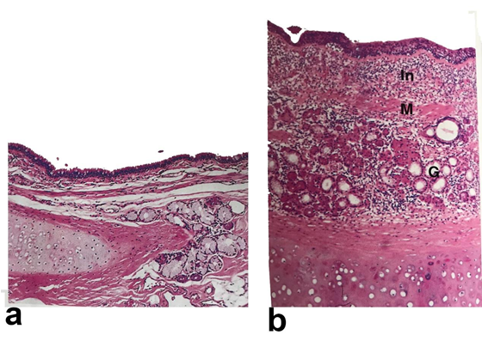
Normal bronchial wall Bronchial wall in chronic brochities
Three factors contribute to the increased thickness of the bronchial wall

1- Infiltration of the submucosa by chronic inflammatory cells (In).

2- Marked hypertrophy of mucosal smooth muscle (M).
3- Marked hyperplasia of the mucous glands (M). with production mucus.

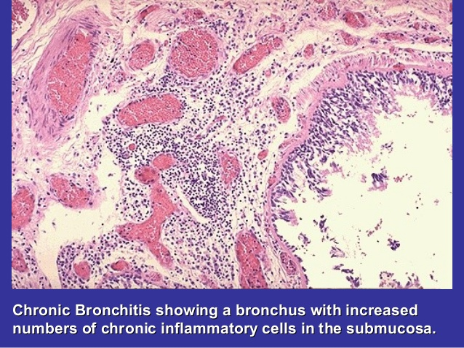

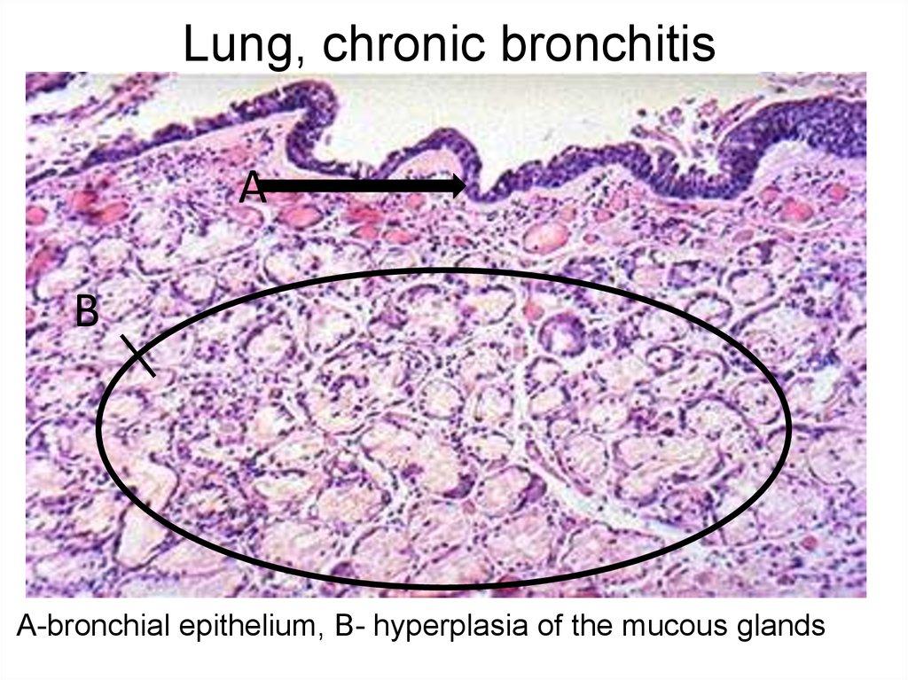
Pulmonary embolism (PE): is a blockage of an artery in the lungs by a substance that has traveled from elsewhere in the body through the bloodstream (embolism). Pathophysiological effects of the lung depend on the size of the embolus.

Symptoms: shortness of breath, chest pain particularly upon breathing in and coughing up blood.

Signs : low blood oxygen levels, rapid breathing, rapid heart rate, and sometimes a mild fever.
PE usually results from a blood clot in the leg that travels to the lung and the risk of blood clots is increased by cancer, prolonged bed rest, smoking, stroke, certain genetic conditions, pregnancy, obesity, and after some types of surgery.

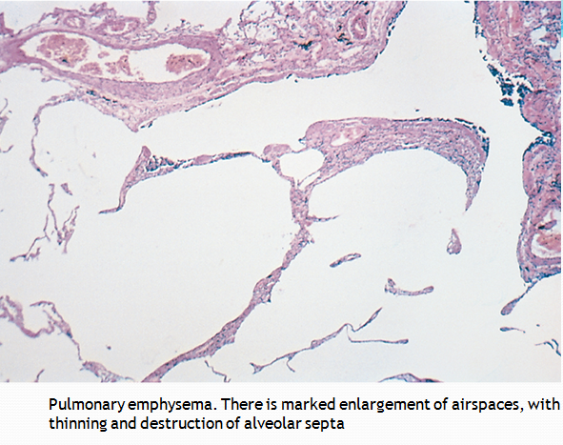

م.م سرمد جاسم محمد

