IgA nephropathy (IgAN), also known as Berger's disease or synpharyngitic glomerulonephritis, is a disease of the kidney (or nephropathy) and the immune system; specifically, it is a form of glomerulonephritis or an inflammation of the glomeruli of the kidney. Aggressive Berger's disease (a rarer form of the disease) can attack other major organs, such as the liver, skin and heart.

IgA nephropathy is the most common glomerulonephritis worldwide; however, aggressive Berger's disease is on the NORD list of rare diseases.[1] Primary IgA nephropathy is characterized by deposition of the IgA antibody in the glomerulus. There are other diseases associated with glomerular IgA deposits, the most common being IgA vasculitis (formerly known as Henoch–Schönlein purpura [HSP]), which is considered by many to be a systemic form of IgA nephropathy.[2] IgA vasculitis presents with a characteristic purpuric skin rash, arthritis, and abdominal pain, and occurs more commonly in young adults (16–35 years old). HSP is associated with a more benign prognosis than IgA nephropathy. In non-aggressive IgA nephropathy there is traditionally a slow progression to chronic kidney failure in 25–30% of cases during a period of 20 years.

Signs and symptoms
The classic presentation for the non-aggressive form (in 40–50% of the cases) is episodic hematuria, which usually starts within a day or two of a non-specific upper respiratory tract infection (hence synpharyngitic), as opposed to post-streptococcal glomerulonephritis, which occurs some time (weeks) after initial infection. With both aggressive and non-aggressive Berger's disease loin pain can also occur. The gross hematuria may resolve after a few days, though microscopic hematuria will persist, it is however more common with aggressive Berger's disease for gross hematuria to persist rather than microscopic hematuria. Renal function usually remains normal with non-aggressive Berger's disease, though rarely acute kidney failure may occur (see below). This presentation is more common in younger adults.

The following is a basic list of symptoms taken primarily from Mayo clinic
-Severe flank/abdominal pain
-High blood pressure
-Hematuria (gross, frank, microscopic)
-Compromised immune system
-Edema in hands and feet
-Cola- or tea-colored urine

Pathophysiology
The disease derives its name from deposits of immunoglobulin A (IgA) in a granular pattern in the mesangium (by immunofluorescence), a region of the renal glomerulus. The mesangium by light microscopy may be hypercellular and show increased deposition of extracellular matrix proteins. In terms of the renal manifestation of Henoch–Schönlein purpura, it has been found that although it shares the same histological spectrum as IgA nephropathy, a greater frequency of severe lesions such as glomerular necrosis and crescents were observed. Correspondingly, HSP nephritis has a higher frequency of glomerular staining for fibrin compared with IgAN, but with an otherwise similar immunofluorescence profile.

There is no clear known explanation for the accumulation of the IgA. Exogenous antigens for IgA have not been identified in the kidney, but it is possible that this antigen has been cleared before the disease manifests itself. It has also been proposed that IgA itself may be the antigen.

A recently advanced theory focuses on abnormalities of the IgA1 molecule. IgA1 is one of the two immunoglobulin subclasses (the other is IgD) that is O-glycosylated on a number of serine and threonine residues in a special proline-rich hinge region. Aberrant glycosylation of IgA appears to lead to polymerisation of the IgA molecules in tissues, especially the glomerular mesangium.[4] A similar mechanism has been claimed to underlie Henoch–Schönlein purpura, a vasculitis that mainly affects children and can feature renal involvement that is almost indistinguishable from IgA nephritis. However, human studies have found that degalactosylation of IgA1 occurs in patients with IgA nephropathy in response only to gut antigen exposures (not systemic), and occurs in healthy people to a lesser extent.[5] This strongly suggests degalactosylation of IgA1 is a result of an underlying phenomenon (abnormal mucosal antigen handling) and not the ultimate cause of IgA nephropathy. Prevailing evidence suggests that both galactose-deficient o-glycans in the hinge region of IgA1 and synthesis and binding of antibodies against IgA1 are required for immunoglobulin complexes to form and accumulate in glomeruli.[6]

From the fact that IgAN can recur after renal transplant, it can be postulated that the disease is caused by a problem in the immune system rather than the kidney itself. Remarkably, the IgA1 that accumulates in the kidney does not appear to originate from the mucosa-associated lymphoid tissue (MALT), which is the site of most upper respiratory tract infections, but from the bone marrow. This, too, suggests an immune pathology rather than direct interference by outside agents.

Diagnosis
For an adult patient with isolated hematuria, tests such as ultrasound of the kidney and cystoscopy are usually done first to pinpoint the source of the bleeding. These tests would rule out kidney stones and bladder cancer, two other common urological causes of hematuria. In children and younger adults, the history and association with respiratory infection can raise the suspicion of IgA nephropathy. A kidney biopsy is necessary to confirm the diagnosis. The biopsy specimen shows proliferation of the mesangium, with IgA deposits on immunofluorescence and electron microscopy. However, patients with isolated microscopic hematuria (i.e. without associated proteinuria and with normal kidney function) are not usually biopsied since this is associated with an excellent prognosis. A urinalysis will show red blood cells, usually as red cell urinary casts. Proteinuria, usually less than 2 grams per day, also may be present. Other renal causes of isolated hematuria include thin basement membrane disease and Alport syndrome, the latter being a hereditary disease associated with hearing impairment and eye problems.

Other blood tests done to aid in the diagnosis include CRP or ESR, complement levels, ANA, and LDH. Protein electrophoresis and immunoglobulin levels can show increased IgA in 50% of all patients.

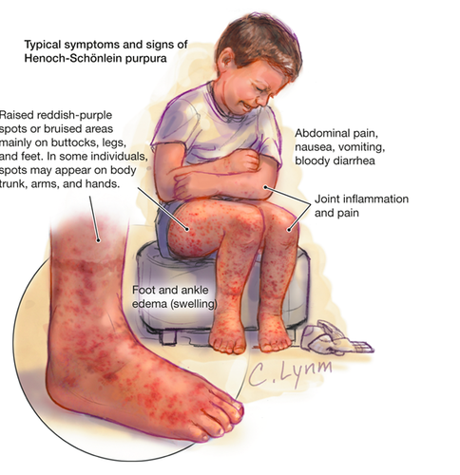

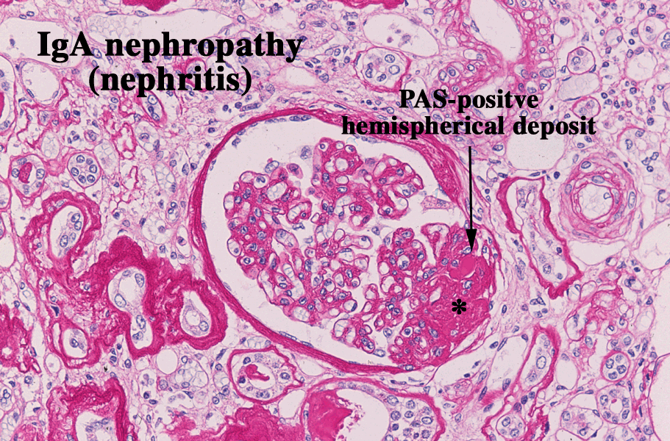

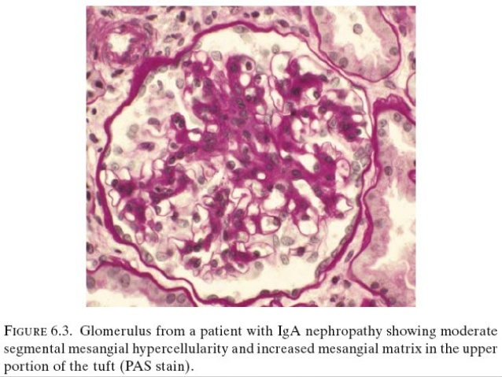
Kidney carcinoma
Renal cell carcinoma (RCC) is a kidney cancer that originates in the lining of the proximal convoluted tubule, a part of the very small tubes in the kidney that transport primary urine. RCC is the most common type of kidney cancer in adults, responsible for approximately 90–95% of cases , Hereditary factors have a minor impact on individual susceptibility cases
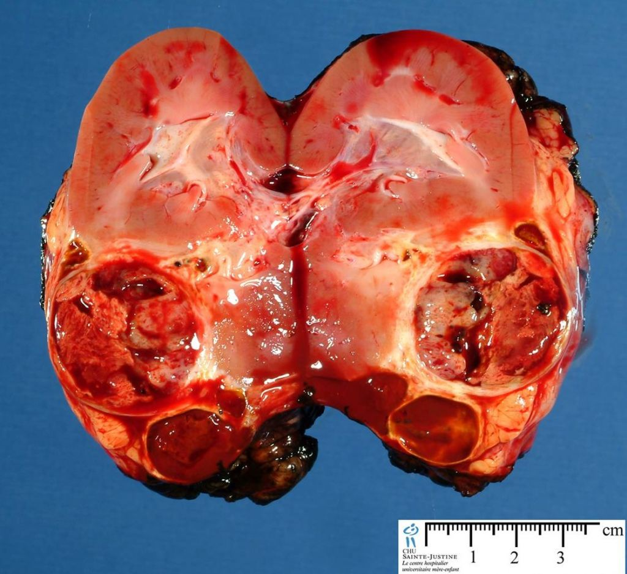
Grossly : there is enlargement in the size of kidney with yellowish nodules and area of hemorrhagic
Diagnosis : kidney carcinoma

There are some risk factors for the disease, including:
-family history of RCC
-dialysis treatment
-hypertension
-obesity
-smoking cigarettes
-polycystic kidney disease (an inherited disorder that causes cysts to form in the kidneys)
-the genetic condition Von Hippel-Lindau disease (characterized by cysts and tumors in various organs)
chronic abuse of certain prescribed and over-the-counter medications such as nonsteroidal anti-inflammatory drugs used to treat arthritis, and medications for fever and pain relief such as acetaminophen
Symptoms of renal cell carcinoma
When RCC is in its early stages, patients may be symptom-free. As the disease progresses, symptoms may include:
-a lump in the abdomen
-blood in the urine
-unexplained weight loss
-loss of appetite
-fatigue
-vision problems
-persistent pain in the side
-excessive hair growth (in women)
Renal cell cancers are classified on the basis of morphology and growth patterns.
-Clear Cell Carcinomas
Clear cell carcinomas are the most common type, accounting for 65% of renal cell cancers. Histologically, they are composed of cells with clear cytoplasm.

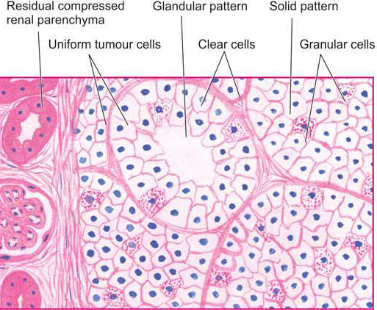

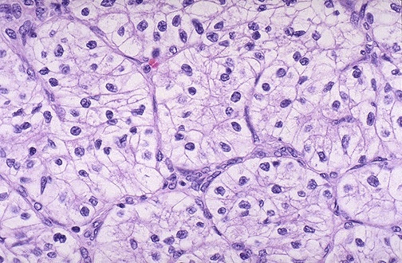
This is the classic clear cell histologic appearance of a renal cell carcinoma: the neoplastic cells have clear cytoplasm and are arranged in nests with intervening blood vessels. This microscopic appearance is why they are often called "clear cell carcinomas". Mutation of the VHL gene may be found.

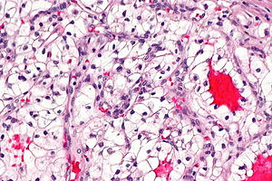
solid or trabecular pattern, polygonal cells usually with clear cytoplasm (may be eosinophilic - esp. in high grade tumours), central nucleus, delicate branching vasculature (chicken wire-like), +/-hyaline bodies

-Papillary Renal Cell Carcinomas
Papillary renal cell carcinomas account for 10% to 15% of all renal cancers. As the name indicates, they show a papillary growth pattern. These tumors are frequently multifocal and bilateral and appear as early-stage tumors. Like clear cell carcinomas, they occur in familial and sporadic forms, but unlike these tumors, papillary renal cancers are not associated with abnormalities of chromosome 3
Papillary renal cell carcinoma (PRCC) is a malignant, heterogeneous tumor originating from renal tubular epithelial cells of the kidney, which comprises approximately 10-15% of all kidney neoplasms.[1] Based on its morphological features, PRCC can be classified into two main subtypes, which are type 1 (basophilic) and type 2 (eosinophilic)
Histology:
-Characterized by papillae with central fibrovascular core (true papillae) containing foamy histiocytes lined by single layer of cells (image B).
-Tumor cells have either basophilic cytoplasm (type 1) (image C) or abundant eosinophilic (type 2) cytoplasm (image D).
-Nuclei are round, small, with low-grade appearance.
-~1/2 of tumors may have solid (non-papillary) growth consisting of tubules and "glomeruloid" growth.

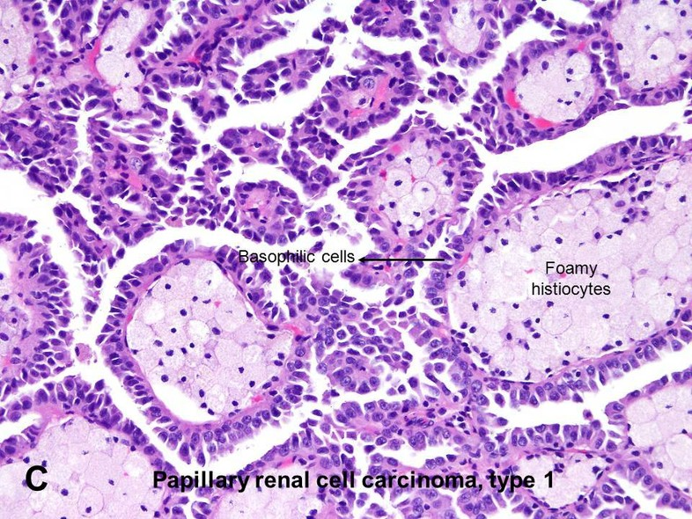
Histopathology of papillary renal cell carcinoma type 1, characterised by tubulopapillary architecture with admixed foamy histiocytes in the papillary cores .
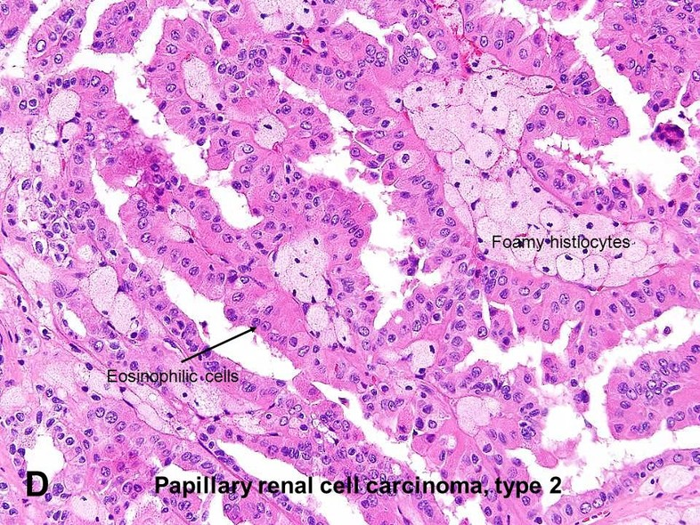

-Chromophobe Renal Carcinomas
Chromophobe renal carcinomas are the least common, representing 5% of all renal cell carcinomas. They arise from intercalated cells of collecting ducts. Their name derives from the observation that the tumor cells stain more darkly (i.e., they are less clear) than cells in clear cell carcinomas.
Microscopic (histologic) description
Large tumor cells with fine eosinophilic granularity, peripheral accentuation of cytoplasm, perinuclear halo, wrinkled raisinoid nuclei, frequent binucleation and coarse chromatin (resembles koilocytes); still some classic chromophobe cells
Often focal areas resembling oncocytoma
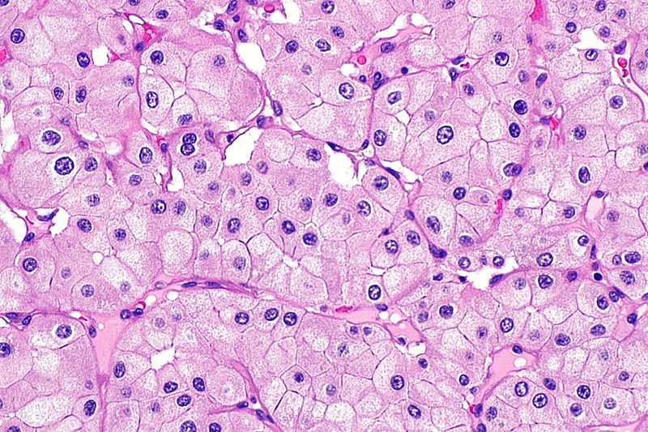
Microscopically : The tumour shows solid masses and acini of uniform-appearing tumors cells the tumors cells are plump with abundant,nely granular, acidophilic cytoplasm and round nuclei. the cysts are lined by tubular epithelium while the stroma between the cysts contains mesenchymal tissue with some immature blastemal or abortive tubules
diagnosis : kidney carcinoma
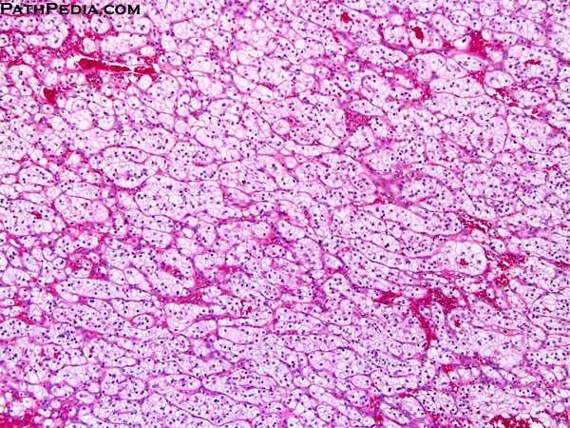
Microscopically : The tumour shows solid masses and acini of uniform-appearing tumour cells , the tumour cells are plump with abundant,nely granular, acidophilic cytoplasm and round nuclei. the cysts are lined by tubular epithe lium while the stroma between the cysts contains mesenchymal tissue with some immature blastemal or abortive tubules
diagnosis : kidney carcinoma
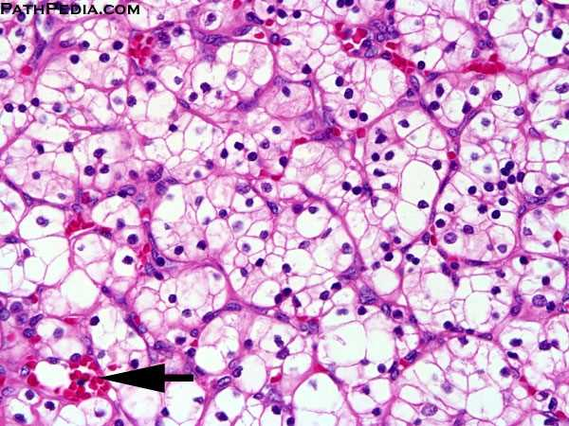
Microscopically : The tumour shows solid masses and acini of uniform-appearing tumour cells , the tumour cells are plump with abundant,nely granular, acidophilic cytoplasm and round nuclei. the cysts are lined by tubular epithe lium while the stroma between the cysts contains mesenchymal tissue with some immature blastemal or abortive tubules
diagnosis : kidney carcinoma

