**Clinical immunity**

**Objectives:**

1. **Definition of Clinical immunity**
2. **Types of clinical immunity**
3. **Diseases and disorder with syndrome related to C.I.**
4. **Take a wide window about the pathology and diagnosis of disease.**

**Introduction:**

Clinical immunity is the study of diseases caused by **disorders of the immune system** (Mistake or failure in the action), and malignant growth of the cellular elements of the system).

The diseases in clinical immunology classified into two types:

1. **Immunodeficiency;** Defect in **ability** of immune system to fight infectious disease and cancer cells (ex. HIV infection).
2. [**Autoimmunity**](https://en.wikipedia.org/wiki/Autoimmunity); is an immune response against a **self-antigen** or antigens. It is tissue damage or disturbed physiological function due to an autoimmune response. It may occur by other mechanisms (such as infection).

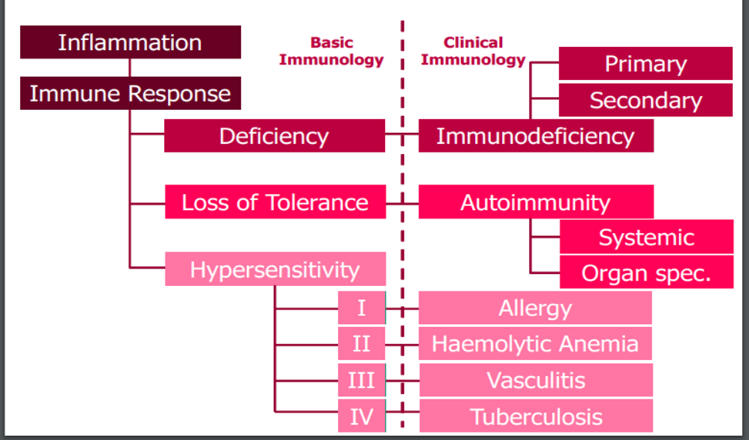



Autoimmune diseases can affect any organ in the body and classified to:

1. **Organ-specific autoimmune disorders** usually affect a single organ and the autoimmune response directed against multiple antigens within that organ. (like of endocrine system).
2. **Non-organ-specific disorders** affect multiple organs and are usually associated with autoimmune responses against self-molecules that are widely distributed through the body (examples include [systemic lupus erythematosus](https://en.wikipedia.org/wiki/Systemic_lupus_erythematosus), [rheumatoid arthritis](https://en.wikipedia.org/wiki/Rheumatoid_arthritis), & others).

**Who gets this disease**: There are striking gender differences in the risk of an autoimmune disease. Almost all are more common in women, autoimmune diseases also show evidence of clustering within families.

Autoimmune responses are very similar to immune responses to non-self-antigens. Both are driven **by antigen**, involve the same adaptive immune cell types and produce tissue damage by the same effector mechanisms – both T cells and B cells. The development of autoimmunity is due to failure of the **normal regulatory mechanisms**.

Suppression of unwanted immune responses mostly **by regulatory populations of T cells (Treg cell)** formed in the thymus and are generally defined by the **markers CD4, CD25** and exert their regulatory effects either through secretion of immunosuppressive cytokines such **as IL-10 and TGF-β** or through cell contact mechanisms, such as **CTLA-4 expression**

**How dose T.Cell Recognize Ag**

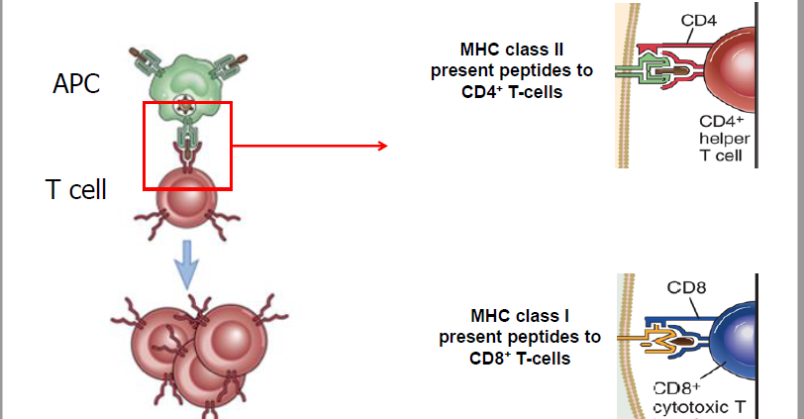

**Tolerance**

**Central Tolerance:** mechanism by which immature T cells that recognize self-antigens are deleted during development in the thymus, sometimes referred to as “thymic education”

**Peripheral Tolerance:** mechanism by which mature T cells that recognise self antigens in peripheral tissues are rendered incapable of subsequently responding to those antigens



**What triggers autoimmunity?**

Interactions between genetic and environmental factors are critically important in the autoimmune disease,.

* Genetic factors( MHC genes are the most important ex.HLA DR4 in RA)
* Environmental factors ( Hormones, Infection, drugs, Molecular mimicry, physical agents like sun light (ultra violet)

**Tissue damage** in autoimmune disease is mediated by antibody (auto-antibody) or by CD4+ T-cell activation of macrophages or CD8+ T cells .

**The treatment of many autoimmune** **diseases**: is currently unsatisfactory. The two principal strategies are either to suppress the immune response or to replace the function of the damaged organ. In many autoimmune diseases, such as Systemic lupus, rheumatoid arthritis and autoimmune kidney disease, immunosuppression or immunomodulation is the only means of preventing severe disability or death.

**Rheumatologic Diseases:**

**Rheumatism** is a conditions causing chronic pain affecting the joints ,connective tissue.

**Arthralgia:** Joint pain (there may not be any inflammation)

**Arthritis:** Inflammation of the Joint

**What are the Factors that Predispose to Rheumatologic Diseases:-**

**I. Genetics or the Susceptibility Genes :-**

A. MHC class I (i.e., HLA-B27 in Ankylosing spondylitis)

B. MHC class II (i.e. HLA-DR4 in **Rheumatoid Arthritis**)

C. **Complement deficiency** states (i.e., C2 or C4 deficiency in SLE)

**II. Environmental Factors :-**

A. Viral infections (hepatitis B, hepatitis C, others).

B. Bacterial infections (Shigella, Salmonella, group A strep)

C. Drugs (Procainamide, others).

D. Toxins and UV-light ( in SLE)

**III. Status of the Immune System :-**

**IV. Status of Target Organ/Tissue :-**

**What is the Chronic Arthritis?** gradual onset (days to weeks ) disease, the Symptoms are more moderate, Muscle stiffness , Mediated by the adaptive immune response, especially  **T cells (Th1 in RA)** and macrophages.

**Rheumatoid arthritis (RA):**

**Definition:**  It is a common chronic autoimmune, inflammatory arthritis m**ost** common in age between (25-55) years and in women **3:1** for men. RA affects **lining of joints** cause painful swelling result in bone erosion and join deformity.

**The etiology of RA and factors increase risk factor of RA:**

**Family history , age , sex** ( **hormonal factors), obesity.**

**environmenal** factors (smoking and **exposure to silica asbestos)**

**Genetic factor : (HLA class II-DR4)** gene.

The allel**e HLA-DRB1- 0101 ,0401, 0404**

**What are the Universal Criteria of RA?**

1. Morning stiffness in or around joints,, > 1 hour.
2. Arthritis (swelling of 3 or more joint area)
3. Symmetric arthritis
4. Arthritis of Hands joints( wrist, MCP metacarpo -phalangeal )
5. Rheumatoid nodules
6. Rheumatoid factor in serum (70% positive)
7. Radiographic changes like erosions

**What are the main immune characterization of RA?**

* T and B lymphocytes are highly represented. It forms lymphoid aggregates
* **pro-inflammatory cytokines** produced by macrophage such as tumor necrosis factor (TNF) and interleukin-1, 6 ,17 (IL-1) (IL-6) IL17, and metalloproteinases (including collagenase ,elastase, gelatinase) produced **from fibroblast** causing tissue damage.
* The presence of immune complexes and autoantibodies .
* The autoantibody : rheumatoid factor (RF sensitive), and anti-cyclic citrullinated peptide antibodies (Anti CCP,**specific** autoantibody).

**Difinition of RF** (Rheumatoid factor) :an auto-antibody mostly (IgM) with specificity for the **Fc portion** of IgG, which have been used in diagnosis of RA (70%) and other disease as sensitive test.

**What are the Signs and symptoms of RA in different organs?**

**Skin :**[Cutaneous](http://en.wikipedia.org/wiki/Cutaneous" \o "Cutaneous) [*rheumatoid nodule*](http://en.wikipedia.org/wiki/Rheumatoid_nodule) ("[necrotizing](http://en.wikipedia.org/wiki/Necrotizing) [granuloma](http://en.wikipedia.org/wiki/Granuloma)"). Nodules are associated with a positive RF ([rheumatoid factor](http://en.wikipedia.org/wiki/Rheumatoid_factor)) [titer](http://en.wikipedia.org/wiki/Titer) and severe erosive arthritis..

**Lungs** [Fibrosis](http://en.wikipedia.org/wiki/Fibrosis) of the [lungs](http://en.wikipedia.org/wiki/Lungs) ( [Kaplan's syndrome](http://en.wikipedia.org/wiki/Caplan%27s_syndrome" \o "Caplan's syndrome))  **and**  [Pleural effusions](http://en.wikipedia.org/wiki/Pleural_effusion)

**Kidneys** RA may affect the kidney [glomerulus](http://en.wikipedia.org/wiki/Glomerulus) directly through a [vasculopathy](http://en.wikipedia.org/wiki/Vasculopathy) or a [mesangial](http://en.wikipedia.org/wiki/Mesangium) [infiltrate](http://en.wikipedia.org/wiki/Infiltration_(medical)) lead to immune complex-mediated hypersensitivities

**Heart and blood vessels** : RA are more prone to [atherosclerosis](http://en.wikipedia.org/wiki/Atherosclerosis), and [myocardial infarction](http://en.wikipedia.org/wiki/Myocardial_infarction) (heart attack) .

**Other like Eyes** [episcleritis](http://en.wikipedia.org/wiki/Episcleritis). [scleromalacia](http://en.wikipedia.org/w/index.php?title=Scleromalacia&action=edit&redlink=1). **And** [keratoconjunctivitis sicca](http://en.wikipedia.org/wiki/Keratoconjunctivitis_sicca)

**Liver** .Increased production of [acute-phase proteins](http://en.wikipedia.org/wiki/Acute-phase_protein), such as [**C-reactive protein**](http://en.wikipedia.org/wiki/C-reactive_protein)**.**

**&** Increased release of [enzymes](http://en.wikipedia.org/wiki/Enzyme) such as [**alkaline phosphatase**](http://en.wikipedia.org/wiki/Alkaline_phosphatase)

[**Anemia**](http://en.wikipedia.org/wiki/Anemia)**:** RA may also cause a [warm autoimmune hemolytic anemia](http://en.wikipedia.org/wiki/Warm_autoimmune_hemolytic_anemia).

**Neurologica** [Peripheral neuropathy](http://en.wikipedia.org/wiki/Peripheral_neuropathy) and [mononeuritis multiplex](http://en.wikipedia.org/wiki/Mononeuritis_multiplex) may occur.

**Bones :** Local [osteoporosis](http://en.wikipedia.org/wiki/Osteoporosis) occurs in RA around inflamed joints.

**Morning stiffness:** persists for **at least one hour** due to accumulation of edema fluid within joints during sleep. The joints most commonly involved first are **small joints** of the hands and feet, Larger joints generally infected **after** small joints.

**What are the most common clinical signs of RA?**

1. association of pain (chronic)
2. swelling in small joints
3. stiffness of the metacarpo -phalangeal and wrist joints,
4. pain in the sole of the foot, indicating metatarso-phalangeal involvement.

**The earliest pathologic changes** :

**1-** increase the permeability of the endothelium of the microvasculature

**2-** development of edema and edematous subsynovial space.

**3-** presence of polymorphonuclear leukocytes.

**In the chronic stage:**

**1-** Hyperplasia of the synovial lining cells the synovial lining cells increases .

**2-** The synovial membrane takes a villous appearance.

**3-** Formation of **pannus**, it is a Massive infiltration by lymphocytes, plasmablasts, and granulation tissue.This thick pannus after months and years continues to grow, protruding into the joint. The synovial space filled by exudative fluid, and causes pain and limits motion.

**Diagnosis of Rheumatoid Arthritis:**

RA can be difficult to diagnose in its early stages because the **early signs and symptoms mimic those of many other diseases.**

**By Imaging**[X-rays](http://en.wikipedia.org/wiki/X-ray) of the hands and feet are generally performed .

**What are the laboratory test for Diagnosis of RA?**

1. **ESR.** Elevated erythrocyte sedimentation rate **.**
2. **C-reactive protein (CRP)** levels are an even better indication than ESR of the amount of inflammation present.
3. **Rheumatoid factors (RF)** are a variety of antibodies that are present in about 70% of people with (RA).  RF can be found in people without RA or with other autoimmune disorders.
4. (anti-CCP) ) is more specific new test for RA that measures levels of antibodies that bind citrulline modified proteins (anti-CCP ). Also Anti mutated citrullinated vimentin Anti-MCV**.**
5. For HLA typing in RA have involved amplification by the polymerase chain reaction (PCR) of the HLA-DR4, HLA-DRB1 gene.
6. ANA anti-Nuclear antibody.

**Treatments**

1-NSAIDs : Nonsteroidal anti-inflammatory drugs (NSAIDs) can relieve pain and reduce inflammation. Include aspirin ,diclofenac (voltaren ) ,ibuprofen.

2- Corticosteroid medications, such as prednisone, reduce inflammation,pain and slow joint damage .used in acute stage

3-DMARDs : Disease-modifying antirheumatic drugs These drugs can slow the progression of RA and save the joints and other tissues from permanent damage. Common DMARDs include methotrexate hydroxychloroquine and sulfasalazine.

4- Biologic agents : modified newer class of DMARDs includes AntiTNF infliximab,

5-Surgery :-, Hip and knee replacements are most common .

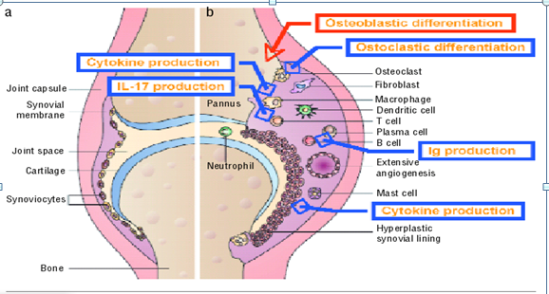

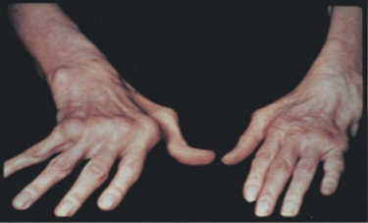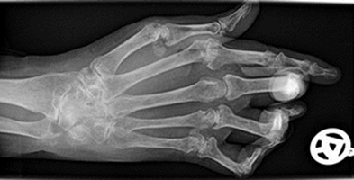  
 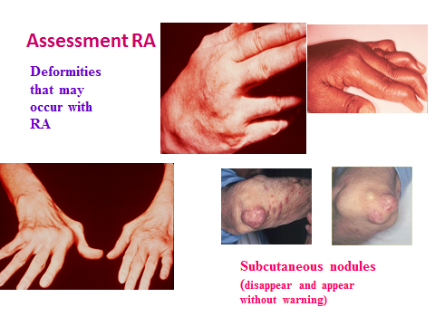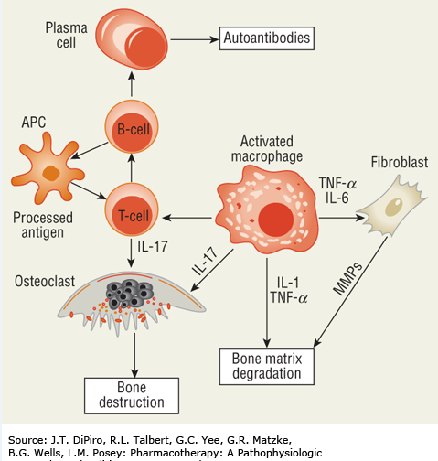

**Multiple Cell Types and Cytokine Involved in Chronic Inflammatory Arthritis**