Swallowing
Swallowing, or deglutition, is divided into three separate phases: voluntary, pharyngeal, and esophageal.

1- The voluntary phase, a bolus of food is formed in the mouth and pushed by the tongue against the hard palate, forcing the bolus toward the posterior part of the mouth and into the oropharynx.

2-The pharyngeal phase this phase of swallowing begins with the elevation of the soft palate, which closes the passage between the nasopharynx and oropharynx. The pharynx elevates to receive the bolus of food from the mouth and moves the bolus down the pharynx into the esophagus. The superior, middle, and inferior pharyngeal constrictor muscles contract in succession, forcing the food through the pharynx. At the same time, the upper esophageal sphincter relaxes, the elevated pharynx opens the esophagus, and food is pushed into the esophagus. This phase of swallowing is unconscious and is controlled automatically, even though the muscles involved are skeletal. The pharyngeal phase of swallowing lasts about 1–2 seconds. During the pharyngeal phase, the vestibular folds are moved medially, the epiglottis is tipped posteriorly so that the epiglottic cartilage covers the opening into the larynx, and the larynx is elevated. These movements of the larynx prevent food from passing through the opening into the larynx.

3-The esophageal phase of swallowing takes about 5–8 seconds and is responsible for moving food from the pharynx to the stomach. Muscular contractions in the wall of the esophagus occur in peristaltic waves. The peristaltic waves associated with swallowing cause relaxation of the lower esophageal sphincter in the esophagus as the peristaltic waves, and bolus of food, approach the stomach. This sphincter is not anatomically distinct from the rest of the esophagus, but it can be identified physiologically because it remains tonically constricted to prevent the reflux of stomach contents into the lower part of the esophagus. The presence of food in the esophagus stimulates the enteric plexus, which controls the peristaltic waves. The presence of food in the esophagus also stimulates tactile receptors, which send afferent impulses to the medulla oblongata through the vagus nerves.Motor impulses, in turn, pass along the vagal efferent fibers to the striated and smooth muscles within the esophagus, thereby stimulating their contractions and reinforcing the peristaltic contractions.

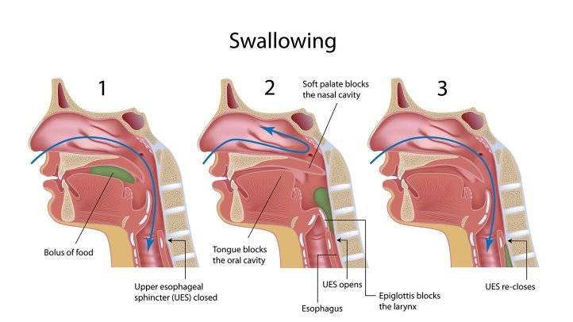

Stomach
The stomach is an enlarged segment of the digestive tract in the left superior part of the abdomen. Its shape and size vary from person to person; even within the same individual its size and shape change from time to time, depending on its food content and the posture of the body.
The opening from the esophagus into the stomach is the gastroesophageal, or cardiac opening, and the region of the stomach around the cardiac opening is the cardiac region. The lower esophageal sphincter, also called the cardiac sphincter, surrounds the cardiac opening. A part of the stomach to the left of the cardiac region, the fundus, is actually superior to the cardiac opening. The largest part of the stomach is the body, which turns to the right, thus creating a greater curvature and a lesser curvature. The body narrows to form the pyloric region, which joins the small intestine. The opening between the stomach and the small intestine is the pyloric opening, which is surrounded by a relatively thick ring of smooth muscle called the pyloric sphincter.

Ingested food and stomach secretions, mixed together, form a semifluid material called chyme. The stomach functions primarily as storage and mixing chamber for the chyme. Although some digestion and absorption occur in the stomach, they are not its major functions. Stomach secretions include mucus, hydrochloric acid, gastrin, histamine, intrinsic factor, and pepsinogen. Pepsinogen is the inactive form of the protein-digesting enzyme pepsin. The surface mucous cells and mucous neck cells secrete a viscous and alkaline mucus that covers the surface of the epithelial cells and forms a layer 1–1.5 mm thick. The thick layer of mucus lubricates and protects the epithelial cells of the stomach wall from the damaging effect of the acidic chyme and pepsin. Irritation of the stomach mucosa results in stimulation of the secretion of a greater volume of mucus.
Hydrochloric acid produces the low pH of the stomach, which is normally between 1 and 3. Although the hydrochloric acid secreted into the stomach has a minor digestive effect on ingested food, one of its main functions is to kill bacteria that are ingested with essentially everything humans put into their mouths. Some pathogenic bacteria may avoid digestion in the stomach, however, because they have an outer coat that resists stomach acids. The low pH of the stomach also stops carbohydrate digestion by inactivating salivary amylase.

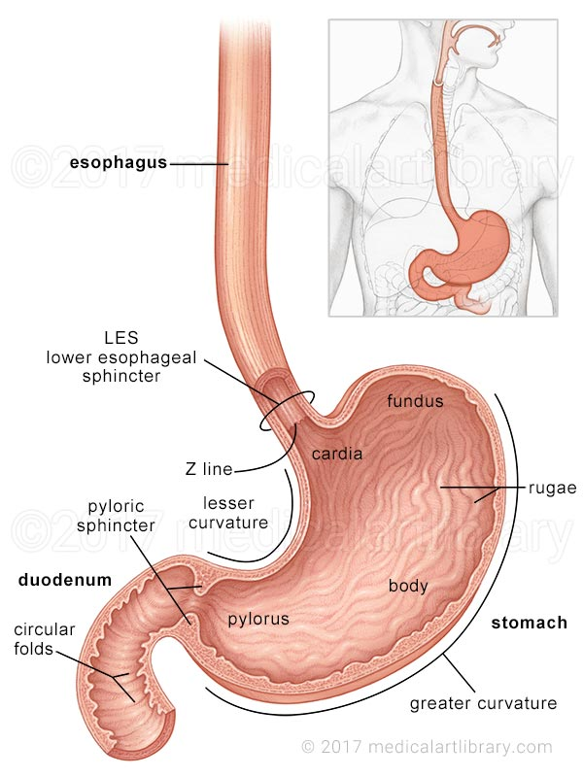

Regulation of Stomach Secretion
Approximately 2–3 L of gastric secretions (gastric juice) is produced each day. The amount and type of food entering the stomach dramatically affects the secretion amount, but up to 700 mL is secreted as a result of a typical meal. Both nervous and hormonal mechanisms regulate gastric secretions. Regulation of stomach secretion is divided into three phases: cephalic, gastric, and intestinal.

1. Cephalic phase. In the cephalic phase of gastric regulation, the sensations of the taste and smell of food, stimulation of tactile receptors during the process of chewing and swallowing, and pleasant thoughts of food stimulate centers within the medulla oblongata that influence gastric secretions. Action potentials are sent from the medulla along parasympathetic neurons within the vagus (X) nerves to the stomach. Within the stomach wall, the preganglionic neurons stimulate postganglionic neurons in the enteric plexus. The postganglionic neurons, which are primarily cholinergic, stimulate secretory activity in the cells of the stomach mucosa.
Parasympathetic stimulation of the stomach mucosa results in the secretion of gastrin and histamine from endocrine cells.

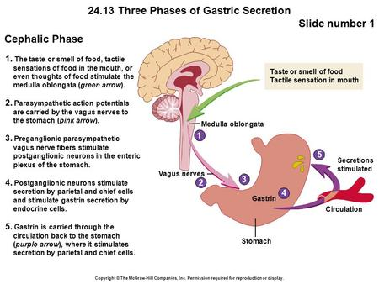

2. Gastric phase. The greatest volume of gastric secretions is produced during the gastric phase of gastric regulation. The presence of food in the stomach initiates the gastric phase. The primary stimuli are distention of the stomach and the presence of amino acids and peptides in the stomach. Distention of the stomach wall, especially in the body or fundus, results in the stimulation of mechanoreceptors.
Action potentials generated by these receptors initiate reflexes that involve both the CNS and enteric reflexes, resulting in secretion of mucus, hydrochloric acid, pepsinogen, intrinsic factor, and gastrin. The presence of partially digested proteins or moderate amounts of alcohol or caffeine in the stomach also stimulates gastrin secretion. When the pH of the stomach contents falls below 2, increased gastric secretion produced by distention of the stomach is blocked. The mechanism by which this response is mediated is not clearly understood.

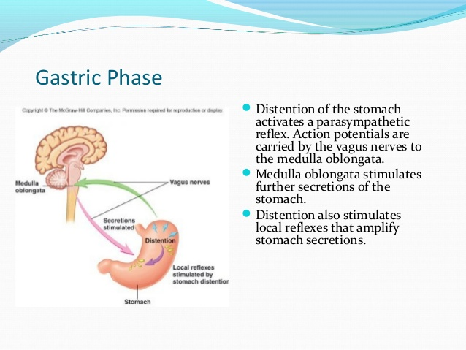

3. Intestinal phase. The entrance of acidic stomach contents into the duodenum of the small intestine controls the intestinal phase of gastric regulation. The presence of chyme in the duodenum activates both neural and hormonal mechanisms. When the pH of the chyme entering the duodenum drops to 2 or below, or if the chyme contains fat digestion products, gastric secretions are inhibited.
Acidic solutions in the duodenum cause the release of the hormone secretin into the circulatory system. Secretin inhibits gastric secretion by inhibiting both parietal and chief cells. Acidic solutions also initiate a local enteric reflex, which inhibits gastric secretions. Fatty acids and certain other lipids in the duodenum and the proximal jejunum initiate the release of two hormones: gastric inhibitory polypeptide and cholecystokinin. Gastric inhibitory polypeptide strongly inhibits gastric secretion, and cholecystokinin inhibits gastric secretions to a lesser degree.

