كلية المستقبل الجامعة
قسم ادارة الاعمال

commercial Correspondence

المراسلات التجارية
المحاضرةالثالثة

What is the management report?

the management report is :-"One of the means of communication used between the various units of activity".

Steps of writing a management report
There are three steps of writing a management report as following:-

1- Collecting and organizing information .
2- Identify the main ideas .
3- Proofreading .

Types of management reports
Management reports have several types according to the position that the individual occupies and as following :-

1- Short reports
2- Scientific reports
3- Engineering reports
4- Research reports

Parts of Businsess letter
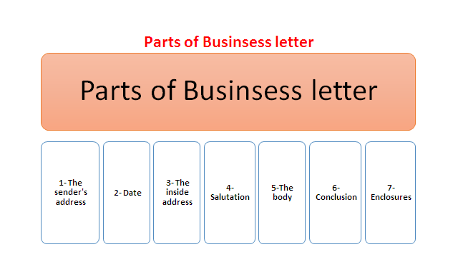

1-Heading
2-Date
3- Inside address
4-Salutation
5- Body
------------------------------------------------------------------------------------------------

6-name
7-Signature

نموذج (مثال) لكتابة رسالة
Enquiries and Replies
An equiryvfor constructional Materials
Karrada Sharkia
Baghdad –Iraq
7-9-2010
Our Ref :3/A16
The ceramiche Artistich Piemme
4/053 Maranells,Modena
Italy
Dear Mr.Joun,
We should be grateful to know whether you supply ceramic tiles suitable for floor and wall coverage .
If so, will you please send us particulars concerning designs ,shados,and sizes available .we also appreciate sending us your latest catalogue and price –list based on cuf Baghdad,we may place considerable orders with you if your goods and prices meet with our approval.
Your faithfully,

Ahmed Mohammed
Commercial Director

Review questions

1-Put true or false
1-Engineering reports: One of the means of communication used between the various units of activity.

2-Identify the main ideas is one of Steps of writing a management report

2- Choose the right answer

One of Types of management reports is

Research reports
Salutation reports
Body reports

