- THE FIRST LAW OF THERMODYNAMICS
The first law of thermodynamics is simply a statement of the conservation of energy principle, and it asserts that total energy is a thermodynamic property. The first law of thermodynamics, also known as the conservation of energy principle, provides a sound basis for studying the relationships among the various forms of energy and energy interactions. Based on experimental observations, the first law of thermodynamics states that energy can be neither created nor destroyed; it can only change forms. Therefore, every bit of energy should be accounted for during a process. We all know that rock at some elevation possesses some potential energy, and part of this potential energy is converted to kinetic energy as the rock falls. Experimental data show that the decrease in potential energy exactly equals the increase in kinetic energy when the air resistance is negligible, thus confirming the conservation of energy principle.
Energy Balance
The conservation of energy principle can be expressed as follows: The net change (increase or decrease) in the total energy of the system during a process is equal to the difference between the total energy entering and the total energy leaving the system during that process. That is, during a process,
$$\left(\begin{aligned}Total energy \\ entering the system\end{aligned}\right)-\left(\begin{aligned}Total energy \\ leaving the system\end{aligned}\right)=\left(\begin{aligned}Change in the total \\ energy of the system \end{aligned}\right)$$
Or
$$∆E_{system}=E_{in }-E_{out } (1)$$
Energy Change of a System, ($∆E_{system}$)
The determination of the energy change of a system during a process involves the evaluation of the energy of the system at the beginning and the end of the process and taking their difference. That is,
$$\left(Energy change\right)-\left(Energy at final state\right)=\left(Energy at initial state\right)$$
Or
$$∆E_{system}=E_{final }-E_{initial }=E_{2 }-E_{1 } (2)$$
Note that energy is a property, and the value of a property does not change unless the state of the system changes. Therefore, the energy change of a system is zero if the state of the system does not change during the process. Also, energy can exist in numerous forms such as internal (sensible, latent, chemical, and nuclear), kinetic, potential, electric, and magnetic, and their sum constitutes the total energy (E) of a system. In the absence of electric, magnetic, and surface tension effects (i.e., for simple compressible systems), the change in the total energy of a system during a process is the sum of the changes in its internal, kinetic, and potential energies and can be expressed as
$$∆E=∆U+∆KE+∆PE (3)$$
Where
$$∆U=m\left(u_{2 }-u_{1}\right) (4)$$
$$∆KE=\frac{1}{2}m\left(v_{2}^{2}-v_{1}^{2}\right) (5)$$
$$∆PE=mg\left(z_{2 }-z_{1}\right) (6)$$
When the initial and final states are specified, the values of the specific internal energies (u₁) and (u₂) can be determined directly from the property tables or thermodynamic property relations.
Most systems encountered in practice are stationary, that is, they do not involve any changes in their velocity or elevation during a process. Thus, for stationary systems, the changes in kinetic and potential energies are zero ($∆KE=∆PE=0$), and the total energy change relation in Eq. (3) reduces to $\left(∆E=∆U\right)$for such systems. Also, the energy of a system during a process will change even if only one form of its energy changes while the other forms of energy remain unchanged.
For stationary systems $(∆KE=∆PE=0)$
Thus
$∆E=∆U (7)$

- MECHANISMS OF ENERGY TRANSFER ${(E}_{in }$ and $E_{out })$
Energy can be transferred to or from a system in three forms: heat, work, and mass flow. The only two forms of energy interactions associated with a fixed mass or closed system are heat transfer and work.
Noting that energy can be transferred in the forms of heat, work, and mass and that the net transfer of a quantity is equal to the difference between the amounts transferred in and out, the energy balance for closed system can be written more explicitly as
$$∆E_{system }=E_{in }-E_{out }=\left(Q_{in }-Q_{out }\right)+\left(W_{in }-W_{out }\right) (8)$$
where the subscripts “in’’ and “out’’ denote quantities that enter and leave the system, respectively.
NOTE:
- The heat transfer (Q) is zero for adiabatic systems (isolated).
- The work transfer (W) is zero for systems that involve no work interactions.
2.1 Energy of an Isolated System
An isolated system is one in which there is no interaction of the system with the surroundings. For an isolated system
$$∆Q = 0 and ∆W = 0.$$
So the first law gives:
$$∆E = 0 or E_{in}= E_{out}$$
Thus the energy of an isolated system is always constant. This conclusion is very important since the universe is considered an isolated system, then energy is conserved in the universe which leads to the principle of conservation of energy. The principle of conservation of energy states that energy can neither be created nor destroyed rather, it transforms from one form to another.

2.2 Energy Balance for Closed Systems
Noting that a closed system does not involve any mass flow across its boundaries, the energy balance for a cycle can be expressed in terms of heat and work interactions as
$$Q_{net, in}-W_{net, out}=∆E_{system } (9)$$
$$Q-W=∆E (10)$$
$$\dot{Q}-\dot{W}=∆\dot{E} (11)$$
where $Q=Q_{net, in}=Q_{in}-Q_{out}$ is the net heat input
$W=W_{net, out}=W_{out}-W_{in}$ is the network output.
For constant rates, the total quantities during a time interval (∆t) are related to the quantities per unit time as
$$Q=\dot{Q}∆t \left(12\right)$$
$$W=\dot{W}∆t \left(13\right)$$
$$E=\dot{E}∆t (14)$$
Neglecting kinetic and potential energies, and considering internal energy only $(E = U)$, we have:
$$Q-W=∆U (15)$$
For a unit mass, we get:
$$q-w=∆u (16)$$

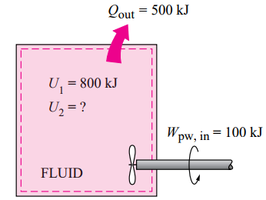
Example (1): A rigid tank contains a hot fluid that is cooled while being stirred by a paddle wheel. Initially, the internal energy of the fluid is (800 kJ). During the cooling process, the fluid loses (500 kJ) of heat, and the paddlewheel does (100 kJ) of work on the fluid. Determine the final internal energy of the fluid. Neglect the energy stored in the paddlewheel.
Solution:
The tank is stationary and thus the kinetic and potential energy changes are zero, ($∆KE = ∆PE = 0$). Therefore, ($∆E = ∆U$) and
$$Q-W=∆U=U_{2}-U_{1}$$
Since heat is lost, then it will have a negative sign. Also work input will have a negative sign. Hence:
$$-500-\left(-100\right)=U_{2}-800$$
$$U_{2}=400 kJ$$
3. SPECIFIC HEAT OF GASES
3.1 Specific Heat at Constant Volume (C_{v})
From the first law of thermodynamic for a closed system at constant volume:
$$Q-W=∆U$$
Since the volume is constant:
$$W=\int_{1}^{2}{PdV}=0$$
Then $Q=∆U$
$$Q=mC_{v}∆T$$
so, $∆U=mC_{v}∆T$
$$U=mC_{v}T$$
For a unit mass:
$$u=C_{v}T$$
3.2 Specific Heat at Constant Pressure (Cp)
From the first law of thermodynamic for a closed system at constant pressure:
$$Q-W=∆U$$
Since the pressure is constant:
$$W=\int{PdV}=P\left(V_{2}-V_{1}\right)$$
$$Q=mC_{p}∆T$$
So, $mC_{p}∆T-P\left(V_{2}-V_{1}\right)=∆U=U_{2}-U_{1}$
then, $\left(U_{2}+PV_{2}\right)-\left(U_{1}+PV_{1}\right)=mC_{p}∆T$
since $H=U+PV$
$$∆H=mC_{p}∆T$$
then $H=mC_{p}T$
For a unit mass:
$$h=C_{p}T$$
4. RELATIONSHIP BETWEEN (C_{V}) AND (C_{P})
We know that the enthalpy may be given as:
$$H = U + PV (1)$$
Since $$H=mC_{p}T (2)$$
$U=mC_{v}T (3)$
and $PV = mRT (4)$
sub. Eqs. (2, 3 and 4) in Eq. (1)
then: $mC_{p}T=mC_{v}T+mRT$ Dividing by 𝑚𝑇,
$$C_{p}=C_{v}+R$$
$R=C_{p}-C_{v} (17)$
$γ = C_{p}C_{v} (18)$ where 𝛾 is the adiabatic index.
Example (2): In an internal combustion engine, during the compression stroke the heat rejected to the cooling water is (50 kJ/kg) and the work input is (100 kJ/kg). Calculate the change in internal energy of the working fluid stating whether it is a gain or loss.
Solution:
$$q-w=∆u$$
Since heat is rejected, then it will have a negative sign. Also work input will have a negative sign. Hence:
$$-50-(-100)=∆u$$
$$∆u=50 KJ/kg$$

Example (3): (0.3 kg) of nitrogen gas at (40 °C) is contained in a cylinder. The piston is moved to compress nitrogen until the temperature becomes (160 °C). The work done during the process is (30 kJ). Calculate the heat transferred from the nitrogen to the surroundings. Take (C_{v} for nitrogen = 0.75 kJ/kg.K).
Solution:
The absolute temperatures: $T_{1}= 40 + 273 = 313 K$
$T_{2}=160 + 273 = 433 K$
Applying the first law of thermodynamics:
$$Q-W=∆U$$
$$∆U=mC_{v}∆T= mC_{v}(T_{2}-T_{1})$$
$$Q-W=mC_{v}(T_{2}-T_{1})$$
$$Q-\left(-30\right)=0.3*0.75\left(433-313\right)$$
$$Q=-3 KJ$$

Example (4): An insulated rigid tank initially contains (1.5 lbm) of helium at (80 °F) and (50 psia). A paddlewheel with a work of (25.45 Btu). Determine (a) the final temperature and (b) the final pressure of the helium gas. Take (C_{v} = 0.753 Btu/lbm · °F)
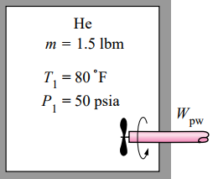
Solution:
$$Q-W=∆U$$
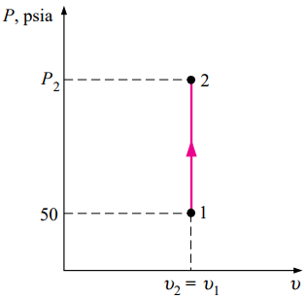
For insulated $Q=0$
$$W=∆U=m\left(u_{2}-u_{1}\right)=mC_{v}\left(T_{2}-T_{1}\right)$$
$$25.45=1.5*0.753(T_{2}-80)$$
$$T_{2}=102.5 °F$$
$$\frac{P_{1}V_{1}}{T_{1}}=\frac{P_{2}V_{2}}{T_{2}}$$
$$for rigid tank V_{1}=V_{2}$$
$$\frac{50}{(80+460)}=\frac{P_{2}}{(102.5+460)}$$
$$P_{2}=52.1 psai$$
5. THE FIRST LAW OF THERMODYNAMICS FOR NON-FLOW PROCESSES
The energy equation for non-flow processes is written as:
$$Q-W=∆U$$
$$q-w=∆u (per unit mass)$$
$$since U=mC_{v}T$$
$$Q-W=mC_{v}∆T$$
$$q-w=C_{v}∆T (per unit mass)$$
5.1 Constant Volume (Isochoric) Process: consider a completely closed vessel filled with a perfect gas as shown in the figure below. Let 𝑄 units of heat be supplied to the system. This increases the pressure and temperature of the system at constant volume as presented by process 1-2 on the (P-V) diagram shown below. Since there is no change in volume, therefore:
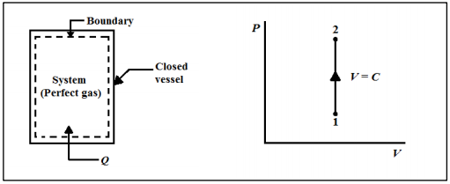
Applying the first law of thermodynamics:
$$Q - W = ∆U=mC_{v}(T_{2} - T_{1})$$
For a constant volume process, no work is done on the system. Hence:
$$W = ∫ PdV = 0$$
Then: $Q=mC_{v}\left(T_{2} - T_{1}\right)$
For a unit mass, we get:
$$q=C_{v}\left(T_{2} - T_{1}\right)$$
Example (5): (1 kg) of air enclosed in a rigid container, is initially at (4.8 bar) and (150 °C). The container is heated until the temperature becomes (200 °C). Calculate the final pressure of the air and the heat supplied during the process. Take ($C_{v}=0.718 KJ/kg.K$)
Solution:
The absolute temperatures: $T_{1}=150 + 273 = 423 K$
$$T_{2}= 200 + 273 = 473 K$$
Since we have a rigid container, then the volume is constant. (𝑊 = 0).
For a constant volume process:
$$\frac{P_{1}}{T_{1}}=\frac{P_{2}}{T_{2}}→\frac{4.8}{423}=\frac{P_{2}}{473}$$
$$P_{2}=5.37 bar$$
$$Q=mC_{v}\left(T_{2} - T_{1}\right)=1*0.718*\left(473-423\right)$$
$$Q=35.9 KJ$$
5.2 Constant Pressure (Isobaric) Process: consider a cylinder with a piston carrying perfect gases as shown in the figure below. When heat (𝑄) is supplied to the system, its temperature will rise and it will expand, forcing the piston to move upward. Thus a displacement work is done by the system against a constant force. The (P-V) diagram of the process is shown in the figure below.
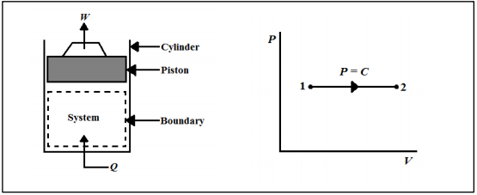
Work done by the system:
$$W=\int{PdV}=P(V_{2}-V_{1})$$
Applying the first law of thermodynamics:
$$Q-W=∆U$$
then, $\left(U_{2}+PV_{2}\right)-\left(U_{1}+PV_{1}\right)=Q$
since $H=U+PV$
then: $Q = H_{2} - H_{1}$
$$Q=mC_{p}\left(T_{2} - T_{1}\right)$$
For a unit mass, we get:
$$q=C_{p}\left(T_{2} - T_{1}\right)$$
It can be seen that during an isobaric process, the heat transfer is equal to the change in enthalpy.
Example (6): When a stationary mass of gas was compressed without friction at constant pressure, its initial state of (0.4 m³) and (0.105 MPa) was found to change to a final state of (0.2 m³) and (0.105 MPa). There was a transfer of (42.5 kJ) of heat from the gas during the process. How much did the internal energy of the gas change?
Solution:
Since we have a constant pressure process, then work done by the gas is:
$$W=P\left(V_{2}-V_{1}\right)=0.105×{10}^{6}\left(0.2-0.4\right)=-21 KJ$$
$$Q-W=∆U$$
$$-42.5-\left(-21\right)=∆U$$
$$∆U=-21.5 KJ$$
5.3 Constant Temperature (Isothermal) Process: an isothermal process is shown in the figure below. It consists of a constant temperature reservoir at temperature (𝑇₁) surrounding a piston-cylinder arrangement. Assume that a perfect gas is at any instant, at the temperature of the system (𝑇₁), is contained inside the cylinder. At the thermal equilibrium state, the temperature of the system and the surroundings are the same. Hence, there is no transfer of heat across the boundary. If the piston now moves slightly downward, expansion of the gas takes place increasing its volume by (dV) and consequently the pressure and temperature of the system drop by an amount of (dP) and (dT) respectively. Therefore, heat will flow from the surroundings until the system reaches the original temperature (𝑇₁). The isothermal process will be possible only when the process is quasi-static. The (P-V) diagram of the isothermal expansion process is shown in the figure below.
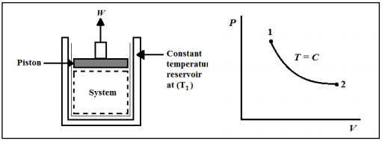
Applying the first law of thermodynamics:
$$Q - W = ∆U=mC_{v}\left(T_{2} - T_{1}\right)$$
Since $\left(T_{2}= T_{1}\right)$for an isothermal process
then:
$$Q=W=\int_{1}^{2}{PdV} (19)$$
For an isothermal process, from Boyles’s law, we have:
$$PV = C → P = C/V (20)$$
Substituting equation (20) in (19), we get
$$Q=W=C\int_{1}^{2}{dV/V}=C\ln\left(\frac{V_{2}}{V_{1}}\right)$$Since $P_{1}V_{1}=P_{2}V_{2}= mRT = C$
then:
$$Q = W=P_{1}V_{1}\ln\left(\frac{V_{2}}{V_{1}}\right) (21)$$
or
$$Q = W=mRT\ln\left(\frac{V_{2}}{V_{1}}\right) (22)$$

Example (7): Air enters a compressor at (10⁵ Pa) and (25 °C) having a volume of (1.8 m³ /kg), is compressed to (5 × 10⁵ Pa) isothermally. Determine:
1) Work done. 2) Change in internal energy. 3) Heat transferred.
Solution:
1) The work done by an isothermal process is:
$$w=P_{1}v_{1}\ln\left(\frac{V_{2}}{V_{1}}\right)$$
Since for an isothermal process
$$\frac{V_{2}}{V_{1}}=\frac{P_{1}}{P_{2}}$$then$$w=P_{1}v_{1}\ln\left(\frac{P_{1}}{P_{2}}\right)={10}^{5}*1.8\ln{(\frac{{10}^{5}}{5*{10}^{5}})}$$
$$w=-289. 7 kJ/kg$$
2) The change in internal energy for an isothermal process is:
$$∆u = 0$$
3) For an isothermal process:
$$q = w = -289. 7 kJ/kg$$

5.4 Adiabatic Process: an adiabatic process is one in which the system undergoes no heat transfer with the surroundings, but the boundary of the system moves giving displacement work. The arrangement for the adiabatic process is shown in the figure below. It consists of a piston-cylinder arrangement where the cylinder is insulated from all sides to prevent heat transfer. Since (∆𝑄 = 0), therefore (∆𝑊) is only due to (∆𝑈). The (P-V) diagram for an adiabatic process is shown in the figure below.
Applying the first law of thermodynamics:
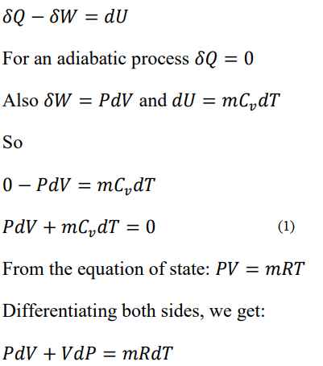
From the equation of state: $PV = mRT$
Differentiating both sides, we get:
$$PdV + VdP = mRdT$$
Substituting Eq. (2) in Eq. (1), we get:
Example (8): Air at (1.02 bar) and (22 °C), initially occupying a cylinder volume of (0.015 m³), is compressed reversibly and adiabatically by a piston to a pressure of (6.8 bar). Calculate: 1) The final temperature. 2) The final volume. 3) The work done. 4) The heat transferred to or from the cylinder walls.
Solution:
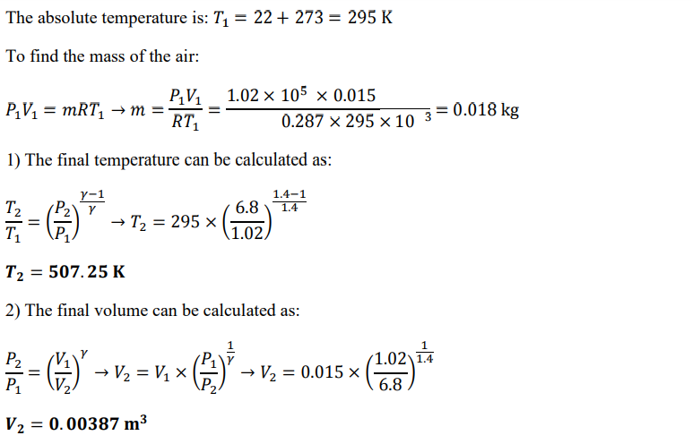
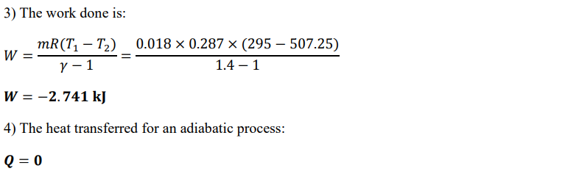
5.5 Polytropic Process: During actual expansion and compression processes of gases, pressure and volume are often related by ($PV^{n}=C$), where n and C are constants. A process of this kind is called a polytropic process. The (P-V) diagram for such a process is shown below. As mentioned, the general equation for polytropic processes is expressed as: $PV^{n}=C$
From the above equation, we can derive the following equations in the same method as in adiabatic processes:
From Eq. (1), the work done is derived in the same method earlier and expressed as:
The heat transfer for polytropic processes does not equal zero and can be calculated from the following equation:
Example (9): (1 kg) of air at (1.02 bar) and (17 °C) is compressed reversibly according to a law (𝑷𝑽 ^{𝟏.𝟑} = 𝑪), to a pressure of (5.5 bar). Calculate the work done on the air and the heat flow to or from the cylinder walls during the compression.
Solution:
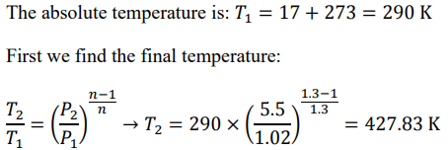
The work done is calculated as:
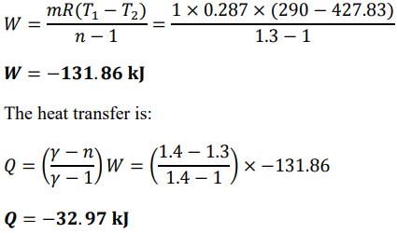
SIGNIFICANCE OF THE FIRST LAW
The first law of thermodynamics leads directly to the non-flow energy equation and embodies four important concepts, as follows:
- Heat and work are mutually convertible one into the other as they are both modes of energy transfer.
- The existence of a type of energy (internal energy) that depends on the thermodynamic state of a system.
- The possibility of measuring a difference in internal energy between thermodynamic states by making measurements of heat transfer and work.
- The fact that energy is conserved whenever the thermodynamic state of a closed system changes.
SUMMARY
The non-flow process is the one in which there is no mass interaction across the system boundaries during the occurrence of the process such as heating and cooling of a fluid inside a closed container, compression and expansion of a fluid in a piston-cylinder arrangement, etc. For non-flow processes the first law can be written as:
For non-flow processes the kinetic and potential energies are very small and can be neglected, so the energy equation becomes:
where: state (1) refers to the initial state and state (2) refers to the final state. For reversible processes:
• For adiabatic processes (no heat transfer) 𝑄 = 0
• For constant volume processes 𝑊 = 0
•For constant temperature processes 𝛥𝑈 = 0
The following table contains the governing equations, displacement work equation and heat interaction equation for different non-flow thermodynamic processes:

Process | Governing equations | Work  ($W=\int_{1}^{2}{PdV})$ | Heat interaction | Figure
Constant volume (Isochoric) | 𝑉 = 𝐶𝑜𝑛𝑠𝑡𝑎𝑛  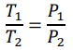 | $$W=0$$ | 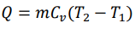 | 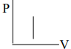
Constant pressure (Isobaric) | 𝑃 = 𝐶𝑜𝑛𝑠𝑡𝑎𝑛  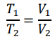 |  |  | 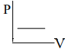
Constant temperature (Isothermal) | 𝑇 = 𝐶𝑜𝑛𝑠𝑡𝑎𝑛  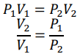 | 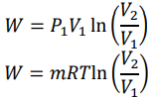 | 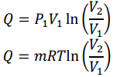 | 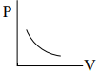
Adiabatic | 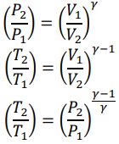 | 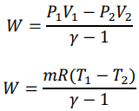 | $$Q=0$$ | 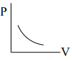
Polytropic | 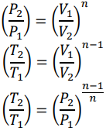 | 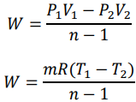 | 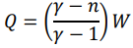

NOTE:
• The heat transferred to the system is positive (+).
• The heat transferred from the system is negative (-).
• The work transferred from the system is positive (+).
• The work transferred to the system is negative (-).

HOMEWORK (2)
- In an air motor cylinder the compressed air has an internal energy of (450 kJ/kg) at the beginning of the expansion and internal energy of (220 kJ/kg) after expansion. If the work done by the air during the expansion is (120 kJ/kg), calculate the heat flow to or from the cylinder.
Ans. (-110 kJ/kg)

- (2 kg) of gas, occupying (0.7 m³) has an initial temperature of (15 °C). It was then heated at constant volume until its temperature became (135 °C). How much heat was transferred to the gas and what is its final pressure? Take (C_{v} = 0.72 kJ/kg.K) and (R = 0.29 kJ/kg.K).
Ans. (158.4 kJ, 338.1 kPa)

- A mass of air whose pressure, volume and temperature are (275 kPa), (0.09 m³) and (185 °C), respectively has its state changed at constant pressure until its temperature becomes (15 °C). How much heat is transferred from the gas and how much work is done on the gas during the process?
Ans. (-32.5 kJ, -9.1 kJ)

- A quantity of air occupies a volume of 0.3 m3 at a pressure of (100 kPa) and a temperature of (20 °C). The air is compressed isothermally to a pressure of (500 kPa). Draw the (P-V) diagram of the process and determine:
1) The heat received or rejected (stating which) during the compression process.
2) The mass of the air.
3) The final volume of the air.
Ans. (-48.3 kJ, 0.36 kg, 0.06 m³)

- (0.05 kg) of carbon dioxide (molecular weight 44), occupying a volume of (0.03 m³) at (1.025 bar), is compressed in a perfectly thermally insulated cylinder, until the pressure is (6.15 bar). Calculate the final temperature, the work done on the gas and the heat flow to or from the cylinder walls. Assume carbon dioxide to be a perfect gas and take γ = 1.3.
Ans. (492 K, -5.25 kJ, 0 kJ)

- A cylinder contains (0.07 kg) of fluid having a pressure of (1 bar), a volume of (0.06 m³) and specific internal energy of (200 kJ/kg). After a polytropic compression process, the pressure and volume of the gas become (9 bar) and (0.0111 m³) respectively and the internal energy becomes 370 kJ/kg. Draw the (P-V) diagram of the process and determine:
1) The amount of work required for compression.
2) The quantity and direction of heat transferred during the compression process.
Ans. (-13.3 kJ, -1.4 kJ)

- Air at a pressure of (1.06 bar) and a temperature of (15 °C), is compressed isothermally to (14 bar) and is then expanded adiabatically to the original pressure. Draw the (P-V) diagram of the processes then calculate:
1) The final temperature and specific volume of the gas.
2) The net work done.
3) The heat transferred to or from the surroundings.
Ans. (137.8 K, 0.37 m³ /kg, -105.5 kJ/kg, -213.3 kJ/kg)
- From the first law of thermodynamic for a closed system drive an expression the relation of Specific heat at constant volume.
- From the first law of thermodynamic for a closed system drive an expression the relation of Specific heat at constant pressure.

