Lec17- Mycology

**Introduction**

Mycology is the study of fungi and their multiple functions in nature. Fungi are microorganisms in the domain eucarya. They show less differentiation than plants, but a higher degree of organization than the prokaryotes bacteria (Table 1). The kingdom of the fungi (Mycota) comprises over 50 000 different species, only about 200 of which have been identified as human pathogens (human mycoses). Many mycotic infections are relatively harmless, for instance the dermatomycoses. In recent years, however, the increasing numbers of patients with various kinds of immune defects have resulted in more life-threatening mycoses.

Table 1 Some Differences between Fungi and Bacteria.

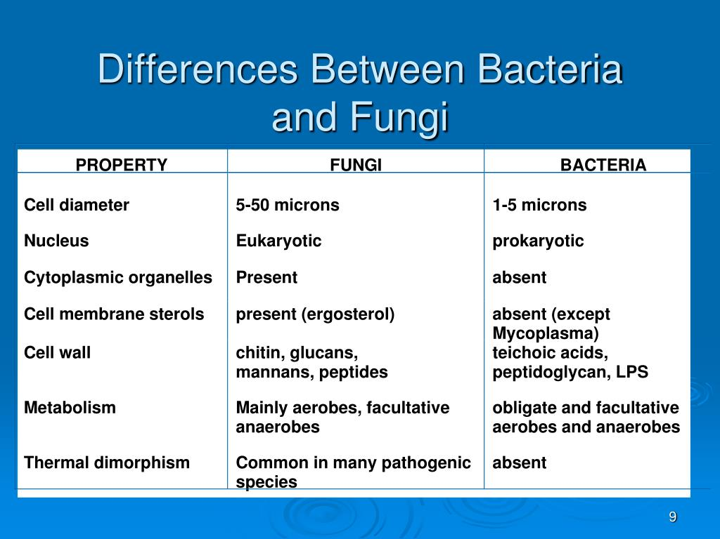

**IMPORTANCE OF FUNGI**

**A : Beneficial Effects of Fungi :**

1. Decomposition process of nutrients and carbon recycling .
2. Biosynthetic factories , the fermentation property is used for the industrial production of alcohols , fats , citric acid , oxalic acid and gluconic acid.
3. Sources of antibiotics , such as Penicillin , cephalosporin , griseofulvin .
4. Model organisms for biochemical and genetic studies.
5. Some fungi are edible such as **mushroom** .
6. Yeasts provide nutritional supplements such as vitamins .
7. ***Penicillium*** fungus is used to flavour Roquefort and Camembert cheeses.
8. Ergot produced by ***Claviceps purpurea*** contains medically important alkaloids that help in inducing uterine contractions , controlling bleeding and treating migraine.
9. Fungi (***Leptolegnia caudate*** and ***Aphanomyces laevis***) are used to trap mosquito larvae in paddy fields and thus help in malaria control.

B : Harmful Effects of Fungi

Some of fungi damage and destruction of food, lumber, paper, cloth, magnetic tapes, disks, glass lenses , marble statues.

1. Fungal spores which are dispersal and transmission of the fungus , are important as human allergenic agents.
2. Some fungi can cause human and animal diseases .
3. Mushroom poisoning (also known as mycetism) by ingestion of toxic substances present in a mushroom such as : *Amanita phalloides* (alfa-amanitin ) and *Amanita muscaria* (muscarin).
4. Mycotoxicosis , refers to all of those diseases caused by the effects of toxins produced by moulds, such as *Aspergillus flavus* ( produce aflatoxin) , *Aspergillus ochraceus* (produce ochratoxin) , *Penicillium rubrum* (produce rubratoxin ).
5. Plant diseases .
6. Spoilage of agriculture products such as vegetables and cereals .

**General properties of fungi :**

1. They are eukaryotic organisms , cells contain membrane bound cell organelles including nuclei, mitochondria, golgi apparatus, endoplasmic reticulum, lysosomes (conversely the bacteria) .
2. Have ergosterols in their cytoplasmic membranes.
3. Have a rigid cell wall made of chitin therefore non-motile.
4. Chemoheterotrophs (require organic compounds) .
5. Fungi lack chlorophyll (nonphotosynthetic), therefore not autotrophic, they obtain their nutrients by absorption. Fungi obtain nutrients as saprophytes by living on decaying matter, or as parasites by living on (human / animals / plant) tissues
6. They obtain their nutrients by absorption.
7. All fungi require water and oxygen.
8. Reproduce asexually and/or sexually by producing spores.
9. They grow either reproductively by budding or non-reproductively by hyphal tip elongation. .
10. Food storage is generally in form of lipids and glycogen.

# Classification of fungi:

### Classification Based on Sexual reproduction:

* + 1. Zygomycetes 2. Ascomycetes

3. Basidiomycetes 4.Deuteromycetes

### Classification Based on modes of fungal growth (Morphology) :

* + 1. Moulds 2. Yeasts 3. Dimorphic fungi

# Moulds

Also called filamentous fungi. Moulds are multicellular. The vegegative body (thallus) of mould is made of **hyphae** (singular hypha), a mass of hyphae is known as **mycelium**, which grows by branching. Hyphae are cylindrical tube that elongates by growth at tips (apex). The hypha is responsible for the filamentous nature of mould . The hyphae may be branched or unbranched , they may be septate or aseptate (coenocytic) . Septate hyphae usually have cross walls that divide them into numerous cells, these cross walls, called **septa,** septa have small pores through which cytoplasm is continuous throughout the hyphae. aseptate hyphae are considered to be more primitive because if a hyphal strand is damaged the entire strand dies , while when septate hyphal strand is damaged, the pores between adjacent compartments can be plugged, thus preventing death of the whole hyphal strand..

### Yeasts

Yeasts are unicellular spherical to ellipsoid cells. They reproduce by budding, such as:

*Cryptococcus neoformans* and *Saccharomyces cerviciae*

Some yeast such as *Cryptococcus neoformans* and *Blastomyces dermatatidis* produce polysaccharide capsule. Capsules can be demonstrated by negative staining methods using India ink or Nigrosin. Some yeasts such as *Cryptococcus neoformans* and *Histoplasma capsulatum* possess polysaccharide capsules that help them to evade phagocytosis.

**Dimorphic Fungi**

Some fungal species, especially those that cause systemic mycoses, are dimorphic, fungi existing in two different morphological forms at two different environmental

conditions.

They exist as yeasts in tissue (in vivo) at

(37oC)

and as moulds in their

*natural habitat (in vitro) at room temperature. Conditions that can affect on modes of fungal growth (morphology) include:* ***1.****temperature* ***2.****Carbon dioxide level eg: Histoplasm*a *capsulatum and Blastomyces dermatiditis*

Fungi Structure

● fungal cells are eukaryotic cells containing cell wall , cell Membrane m mitochondria m vacuoles , reticular endothelium , ribosomes .. etc like other eukaryotic cells .

● cells division - sexual / asexual

●cells wall – made of chitin , glucans , mannans and complex polysaccharides .

● cell membrane contains ergosterol incontrast to mammalian cell which contain cholesterol .

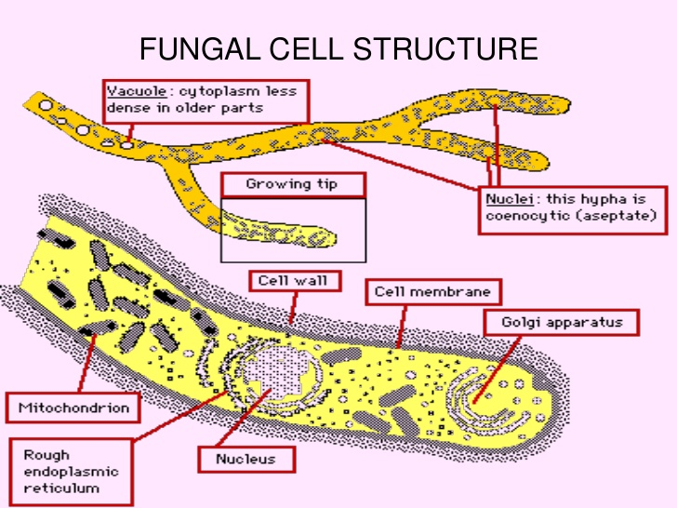

Fungal cell wall

Consists of chitin not peptidoglycan like bacteria . ●

●Thus fungi are insensitive to antibiotics as pencillins

Chitin is a polysaccharide composed of long chain of N- acetyle ●

glucasamine

● Also the fungal cell wall contain other polysaccharide , B- glucan , which is the site of action of some antifungal drugs .

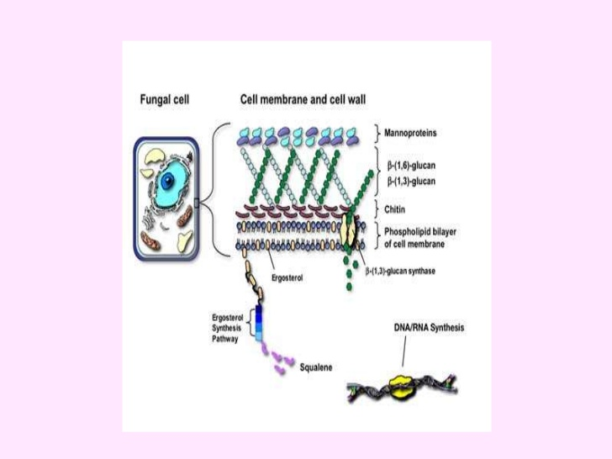

Fungal cell membrane

● consist of ergosterol rather than cholesterol like bacterial cell membrane .

● Ergosterol is the site of action of antifungal drugs , amphotericin B and azole group .

