Small Intestine

The small intestine consists of three parts: the duodenum, the jejunum, and the ileum. The entire small intestine is about 6 m long. The duodenum is about 25 cm long. The jejunum constituting about two-fifths of the total length of the small intestine, is about 2.5 m long; and the ileum, constituting three-fifths of the small intestine, is about 3.5 m long. Two major accessory glands, the liver and the pancreas, are associated with the duodenum. The small intestine is the site at which the greatest amount of digestion and absorption occur. Each day, about 9 L of water enters the digestive system. It comes from water that is ingested and from fluid secretions produced by glands along the length of the digestive tract.

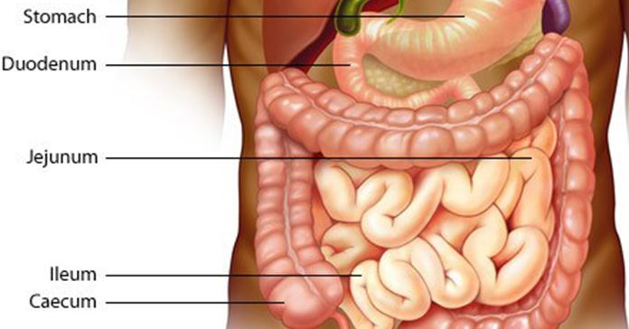

Anatomy of the Small Intestine

Duodenum
The duodenum nearly completes a 180-degree arc as it curves within the abdominal cavity, and the head of the pancreas lies within this arc. The duodenum begins with a short superior part, which is where it exits the pylorus of the stomach, and ends in a sharp bend, which is where it joins the jejunum.

Two small mounds are within the duodenum about two thirds of the way down the descending part:

1-The major duodenal papilla
2-The lesser duodenal papilla

At the major papilla, the common bile duct and pancreatic duct join to form the hepatopancreatic ampulla, which empties into the duodenum. A smooth muscle sphincter, the hepatopancreatic ampullar sphincter regulates the opening of the ampulla. An accessory pancreatic duct, present in most people, opens at the tip of the lesser duodenal papilla.
The surface of the duodenum has several modifications that increase its surface area about 600-fold to allow for more efficient digestion and absorption of food.Tiny fingerlike projections of the mucosa form numerous villi which are 0.5–1.5 mm in length. Most of the cells that make up the surface of the villi have numerous cytoplasmic extensions (about 1 $μ$m long) called microvilli, which further increase the surface area. The combined microvilli on the entire epithelial surface form the brush border. These various modifications greatly increase the surface area of the small intestine and, as a result, greatly enhance absorption.

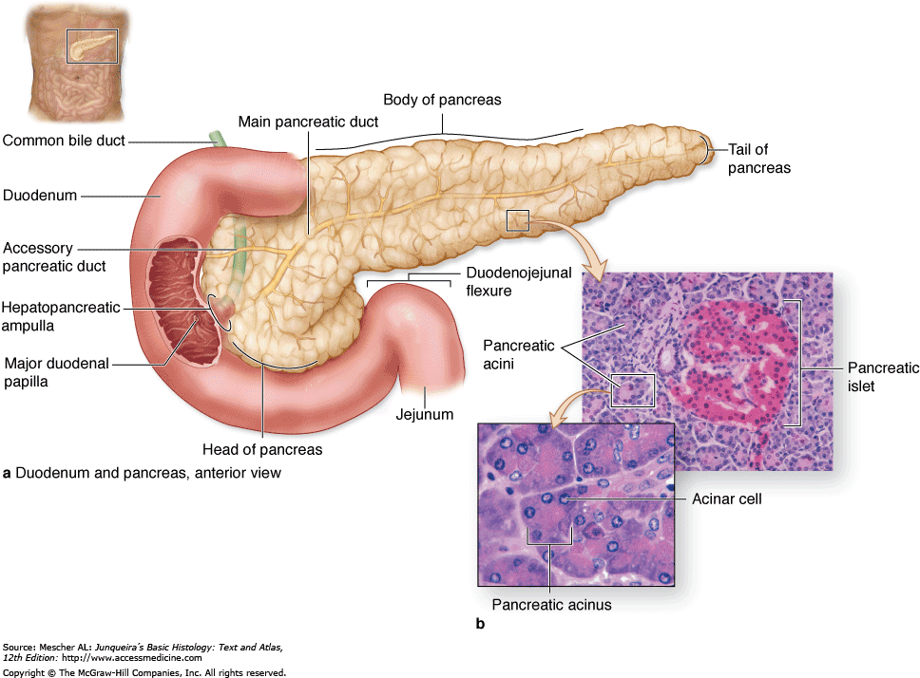

Jejunum and Ileum
The jejunum and ileum are similar in structure to the duodenum, except that a gradual decrease occurs in the diameter of the small intestine, the thickness of the intestinal wall, the number of circular folds, and the number of villi as one progresses through the small intestine. The duodenum and jejunum are the major sites of nutrient absorption, although some absorption occurs in the ileum. Lymph nodules called Peyer’s patches are numerous in the mucosa and submucosa of the ileum. The junction between the ileum and the large intestine is the ileocecal junction. It has a ring of smooth muscle, the ileocecal sphincter, and a one-way ileocecal valve.

Secretions of the Small Intestine
The mucosa of the small intestine produces secretions that primarily contain mucus, electrolytes, and water. Intestinal secretions lubricate and protect the intestinal wall from the acidic chyme and the action of digestive enzymes. They also keep the chyme in the small intestine in a liquid form to facilitate the digestive process. The intestinal mucosa produces most of the secretions that enter the small intestine, but the secretions of the liver and the pancreas also enter the small intestine and play essential roles in the process of digestion .Most of the digestive enzymes entering the small intestine are secreted by the pancreas. The intestinal mucosa also produces enzymes, but these remain associated with the intestinal epithelial surface.
The duodenal glands, intestinal glands, and goblet cells secrete large amounts of mucus. This mucus provides the wall of the intestine with protection against the irritating effects of acidic chyme and against the digestive enzymes that enter the duodenum from the pancreas. Secretin and cholecystokinin are released from the intestinal mucosa and stimulate hepatic and pancreatic secretions.

Liver
The liver is the largest internal organ of the body, weighing about 1.36 kg (3 pounds), and it is in the right-upper quadrant of the abdomen, tucked against the inferior surface of the diaphragm .The liver consists of two major lobes, left and right, and two minor lobes, caudate and quadrate.
A porta is on the inferior surface of the liver, where the various vessels, ducts, and nerves enter and exit the liver. The hepatic portal vein, the hepatic artery, and a small hepatic nerve plexus enter the liver through the porta. Lymphatic vessels and two hepatic ducts, one each from the right and left lobes, exit the liver at the porta. The hepatic ducts transport bile out of the liver. The right and left hepatic ducts unite to form a single common hepatic duct. The cystic duct from the gallbladder joins the common hepatic duct to form the common bile duct, which joins the pancreatic duct at the hepatopancreatic ampulla, an enlargement where the hepatic and pancreatic ducts come together. The hepatopancreatic ampulla empties into the duodenum at the major duodenal papilla. A smooth muscle sphincter surrounds the common bile duct where it enters the hepatopancreatic ampulla. The gallbladder is a small sac on the inferior surface of the liver that stores bile. Bile can flow from the gallbladder through the cystic duct into the common bile duct, or it can flow back up the cystic duct into the gallbladder.

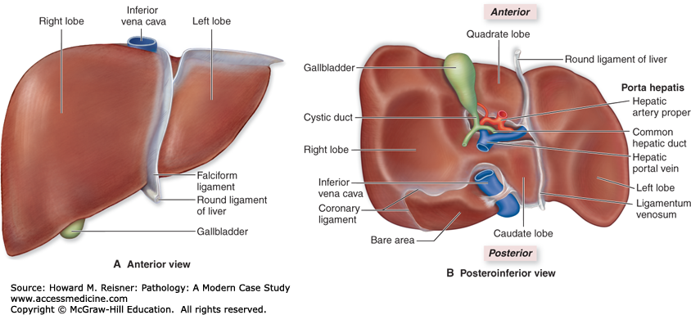

Functions of the Liver
The liver performs important digestive and excretory functions stores and processes nutrients, synthesizes new molecules, and detoxifies harmful chemicals.

Bile Production
The liver produces and secretes about 600–1000 mL of bile each day .Bile contains no digestive enzymes, but it plays a role in digestion because it neutralizes and dilutes stomach acid and emulsifies fats. The pH of chyme as it leaves the stomach is too low for the normal function of pancreatic enzymes. Bile helps to neutralize the acidic chyme and to bring the pH up to a level at which pancreatic enzymes can function. Bile also contains excretory products like bile pigments. Bilirubin is a bile pigment that results from the breakdown of hemoglobin. Bile also contains cholesterol, fats, fat-soluble hormones, and lecithin. Secretin stimulates bile secretion, primarily by increasing the water and bicarbonate ion content of bile.

Detoxification
Many ingested substances are harmful to the cells of the body. In addition, the body itself produces many by-products of metabolism that, if accumulated, are toxic. The liver forms a major line of defense against many of these harmful substances. It detoxifies many substances by altering their structure to make them less toxic or make their elimination easier. Ammonia, for example, a by-product of amino acid metabolism, is toxic and is not readily removed from the circulation by the kidneys. Hepatocytes remove ammonia from the circulation and convert it to urea, which is less toxic than ammonia and is secreted into the circulation and then eliminated by the kidneys in the urine. Other substances are removed from the circulation and excreted by the hepatocytes into the bile.

Phagocytosis
Hepatic phagocytic cells (Kupffer cells), which lie along the sinusoid walls of the liver, phagocytize “worn-out” and dying red and white blood cells, some bacteria, and other debris that enters the liver through the circulation.

Synthesis
The liver can also produce its own unique new compounds. It produces many blood proteins, such as albumins, fibrinogen, globulins, heparin, and clotting factors, which are released into the circulation.

Gallbladder

The gallbladder is a sac like structure on the inferior surface of the liver that is about 8 cm long and 4 cm wide.
The cystic duct connects the gallbladder to the common bile duct. Bile is continually secreted by the liver and flows to the gallbladder, where 40–70 mL of bile can be stored. While the bile is in the gallbladder, water and electrolytes are absorbed, and bile salts and pigments become as much as 5–10 times more concentrated than they were when secreted by the liver. Shortly after a meal, the gallbladder contracts in response to stimulation by cholecystokinin and, to a lesser degree, in response to vagal stimulation, thereby dumping large amounts of concentrated bile into the small intestine.

Pancreas

Anatomy of the Pancreas
The pancreas is a complex organ composed of both endocrine and exocrine tissues that perform several functions. The pancreas consists of a head, located within the curvature of the duodenum a body, and a tail, which extends to the spleen. The endocrine part of the pancreas consists of pancreatic islets. The islet cells produce insulin and glucagon ,which are very important in controlling blood levels of nutrients, such as glucose and amino acids, and somatostatin, which regulates insulin and glucagon secretion and may inhibit growth hormone secretion. The exocrine part of the pancreas is a compound acinar gland. The acini produce digestive enzymes.

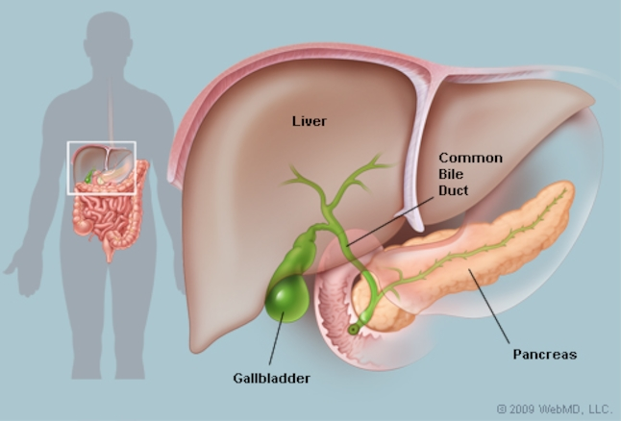

Large Intestine

The large intestine is the portion of the digestive tract extending from the ileocecal junction to the anus. It consists of the cecum, colon, rectum, and anal canal. Normally 18–24 hours are required for material to pass through the large intestine. Thus, the movements of the colon are more sluggish than those of the small intestine. While in the colon, chyme is converted to feces. Absorption of water and salts, the secretion of mucus, and extensive action of microorganisms are involved in the formation of feces, which the colon stores until the feces are eliminated by the process of defecation .About 1500 mL of chyme enters the cecum each day, but more than 90% of the volume is reabsorbed so that only 80–150 mL of feces is normally eliminated by defecation.

Anatomy of the Large Intestine

Cecum
The cecum is the proximal end of the large intestine. It’s where the large and small intestines meet at the ileocecal junction. The cecum extends inferiorly about 6 cm past the ileocecal junction in the form of a blind sac. Attached to the cecum is a small blind tube about 9 cm long called the vermiform appendix. The walls of the appendix contain many lymphatic nodules.

Colon
The colon is about 1.5–1.8 m long and consists of four parts: the ascending colon, transverse colon, descending colon, and sigmoid colon. The ascending colon extends superiorly from the cecum and ends at the right colic flexure (hepatic flexure) near the right inferior margin of the liver. The transverse colon extends from the right colic flexure to the left colic flexure (splenic flexure), and the descending colon extends from the left colic flexure to the superior opening of the true pelvis, where it becomes the sigmoid colon. The sigmoid colon forms an S-shaped tube that extends into the pelvis and ends at the rectum. The circular muscle layer of the colon is complete, but the longitudinal muscle layer is incomplete. The longitudinal layer doesn’t completely envelop the intestinal wall but forms three bands that run the length of the colon.

Rectum
The rectum is a straight, muscular tube that begins at the termination of the sigmoid colon and ends at the anal canal. The mucosal lining of the rectum is simple columnar epithelium, and the muscular tunic is relatively thick compared to the rest of the digestive tract.

Anal Canal
The last 2–3 cm of the digestive tract is the anal canal. It begins at the inferior end of the rectum and ends at the anus (external GI tract opening). The smooth muscle layer of the anal canal is even thicker than that of the rectum and forms the internal anal sphincter at the superior end of the anal canal. Skeletal muscle forms the external anal sphincter at the inferior end of the canal. The epithelium of the superior part of the anal canal is simple columnar and that of the inferior part is stratified squamous.

