Lecture 2 Dr. SHAKER S. BAHAR2024 EQUIPMENTS DESIGN
GAS-SOLIDS SEPARATIONS (GAS CLEANING)

The primary need for gas-solid separation processes is for gas cleaning: the removal
of dispersed finely divided solids (dust) and liquid mists from gas streams. Process gas streams must often be cleaned up to prevent contamination of catalysts or products, and to avoid damage to equipment, such as compressors.

Gas-cleaning equipment can be classified according to the mechanism employed to
separate the particles: gravity settling, impingement, centrifugal force, filtering, washing and electrostatic precipitation.

- Gravity settlers (settling chambers)
Settling chambers are the simplest form of industrial gas-cleaning equipment, but have only a limited use; they are suitable for coarse dusts, particles larger than 50 µm. They are essentially long, horizontal, rectangular chambers; through which the gas flows. The solids settle under gravity and are removed from the bottom of the chamber. Horizontal plates or vertical baffles are used in some designs to improve the separation. Settling chambers offer little resistance to the gas flow, and can be designed for operation at high temperature and high pressure, and for use in corrosive atmospheres.

- Impingement separators
Impingement separators employ baffles to achieve the separation. The gas stream flows easily round the baffles, whereas the solid particles, due to their higher momentum, tend to continue in their line of flight, strike the baffles and are collected. A variety of baffle designs is used in commercial equipment; a typical example is shown in Figure 10.42. Impingement separators cause a higher pressure drop than settling chambers, but are capable of separating smaller particle sizes, 10- 20 µm.

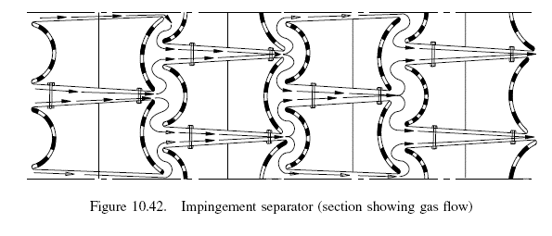

- Centrifugal separators (cyclones)
Cyclones are the principal type of gas-solids separator employing centrifugal force, and are widely used. They are basically simple constructions; can be made from a wide range of materials; and can be designed for high temperature and pressure operation. Cyclones are suitable for separating particles above about 5 µm diameter; smaller
particles, down to about 0.5 µm, can be separated where agglomeration occurs. The most commonly used design is the reverse-flow cyclone, Figure 10.43; other configurations are used for special purposes. In a reverse-flow cyclone the gas enters the top chamber tangentially and spirals down to the apex of the conical section; it then moves upward in a second, smaller diameter, spiral, and exits at the top through a central vertical pipe.

