**Ovens**

The oven is a device used in a laboratory for drying and sterilizing glass and metal containers or materials used for examinations or tests performed in the laboratory. The ovens operate between **room temperature** and **350 °C**. They are also known as **hot air oven.**

**1. Operation Principle**

**Heat** is generated through sets of **electrical resistors** transferring this **thermal energy** to the chamber. These resistors are located in the **lower part** of the oven and heat is transferred and **distributed** by natural or forced convection (in oven with internal ventilators). As shown in figure 1.

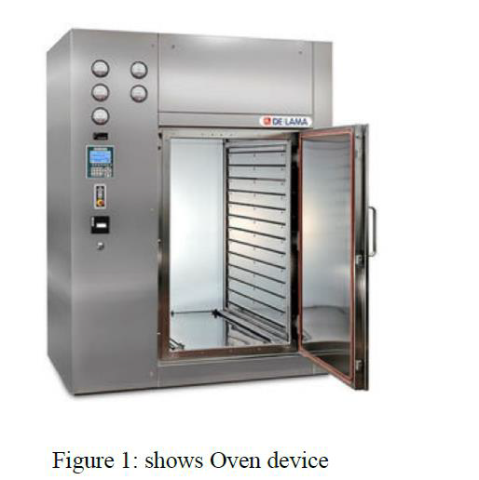

**2. Parts of Oven**

Oven is consist of two parts, they are:

**1. Mechanical part**.

**2. Electrical part.**

Lecturer A.D. Amir Mohammed Khalaf



**1. The coat**: The coat is made of aluminum or stainless steel because it’s resisting the mechanical shocks, resisting the oxidation and rectangle solid shape to be easily placed anywhere. The coat consists of several surfaces of an isolator material to prevent heat from getting outside.

**2. Fiber glass**: There are two type of it:-

a) **Brown fiber glass**: it is cheap, but dangerous substance because it causes inflammation in the chest that should be wary of dealing with.

b) **Yellow fiber glass**: it is available by many and also a serious but less dangerous than brown, because of the sensitivity and be careful by wearing gloves.

**The advantage of fiber glass is that:-**

a) 1-It is a good insulator of heat and use it in the oven due to lack of access of heat from inside the device to the outside.

b) 2- Maintain the internal temperature.

c) 3-Very bad conduction heat so it is suitable for heat insulation purpose.

**3. The container**: It’s a material that must be made of a very low conductive to heat such as stainless steel and to be resistance to mechanical shock and the volume of the container must be available to contain certain amount of the tools to be serialized or cleaned.

**4. The shelves (mesh)**: The mesh is made of aluminum or steel it contains of group of holes to increase thermal conductivity.

Lecturer A.D. Amir Mohammed Khalaf

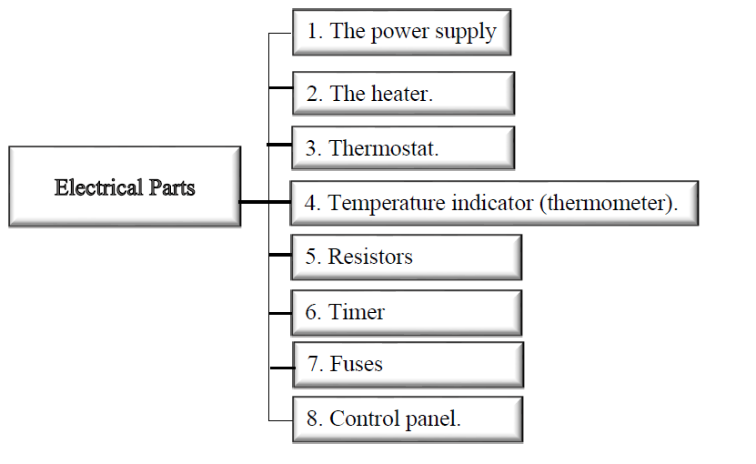

**1. Power supply**: The used supply in water bath is 220v — 50Hz the step down transformer and rectifying circuit (AC to DC convert) to run the control panel if the parameters, numeric or other departments in the modern fashion.

**2. The heater**: The electric heating system is the system in which **heating produce** by rising of temperature by the passing electric current through a conductor having a high resistor to current flow; it is only placed in base of the instrument. The heater element has the following characteristics:

**1**- High resistance

**2**- Electrical insulation.

**3**- Thermal conductivity.

**3. Thermostat**: Is a sensor of heat connecting directly with heater, separate the heater in certain degrees and used to protect the device.

**4. Temperature indicator**: Two ways are used in temperature indicator there are **thermometer** (used to measure temperature of material) and **thermocouple** that identified the internal temperature.

**There are several types of thermometer**:-

a) **Mechanical thermometer**: the principle of it is depending on the expanding factor of different material like mercury where it is used more than alcohol because its wide thermal range for mercury from (-70 -350).

b) **Electrical thermometer**: - the principle of it is depend on electrical conductive property for the material.

**5. Resistors:** Heating elements transforming

**6. Timer**: There are **two type of timer** electrical and mechanical at range 5-60 min. given period of time required for sterilization.

**7. Fuse**: To protect the circuit from high current, high loads, short circuits.

**8. Control panel**: Contains several elements:-

a) The most important is indicator power lamp usually **green**,

b) Indicator heater lamp usually **red**, contain

c) Switch on/off

d) Timer

e) Selected temperature

Lecturer A.D. Amir Mohammed Khalaf

**36**

**3. Types of Oven**

There several **types of oven** according to the operation by:-

**1**-natural convection (gravity convection)

**2**-forced convection

**4. Application of Oven:-**

1-Drying

2- Sterilizing glass, metal containers, materials used for examinations or tests.

**Notification:** - Avoid using flammable or explosive materials in the oven, spills of acid solutions or corrosive vapors inside the oven to prevent corrosion of the surfaces and interior shelves and use personal protection elements (insulated gloves,

Safety glasses and tongs for placing or removing substances or materials inside the drying oven).

Lecturer A.D. Amir Mohammed Khalaf

**37**

**References:** 1. 1st Edition , Sterilization of Medical Devices , *By: Anne Booth* Copyright Year 1999