Auto clave
Autoclaves provide a physical method for disinfection and sterilization. They work with a combination of steam, pressure and time. Autoclaves operate at high temperature and pressure in order to kill microorganisms and spores
Purpose
Sterilization refers to the complete killing of all living organisms, including spores. Common sterilization techniques include the application of wet heat, dry heat, chemicals, and radiation. The type of material, the container, and quantity of items to be sterilized determines which method to use. Despite built-in safeguards, an autoclave presents the possibility of serious injury to personnel from hot surfaces and from the release of steam. It is important, therefore, that laboratory personnel understand the proper operation, limitations, and safeguards for sterilization by autoclaving
History of Autoclave
The modern era of microbiology. An early pioneer in sterilization was Lazzaro Spallanzani (1729-1799) an Italian biologist.
Later, Pasteur showed that once a medium is sterilized, it will remain sterile until contaminated by microorganisms (i.e., they do not appear by spontaneous generation.).
The current design of the autoclave was largely finalized in the 1880s by Charles Chamberland, a colleague of Pasteur, building up on Denis Papin’s marmite.
Denis Papin (French), When in Germany, he invented the pressure cooker and his famous steam engine. He constructed a steam boat, but the boatmen, fearing unemployment, broke his machine. He died in utter poverty in London.
Why is it called an autoclave? Because it describes a device that automatically locks shut when the pressure rises (to avoid steam spraying out if you open it by accident). The word is French, and comes from the Greek "auto" for automatic and the Latin "clvis," for key (as in lock and key).
Theory of operation
The basics. Why is an autoclave such an effective sterilizer? An autoclave is a large pressure cooker; it operates by using steam under pressure as the sterilizing agent. High pressures enable steam to reach high temperatures, thus increasing its heat content and killing power. Most of theheating power of steam comes from its latent heat of vaporization.
How does the autoclave itself work?
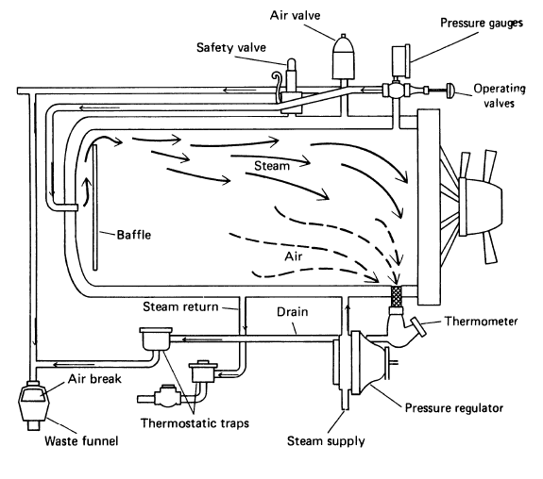
The diagram of an autoclave depicts the
simplicity of its operation.
Basically, steam enters the
chamber jacket, passes
through an operating valve and
enters the rear of the chamber
behind a baffle plate. It flows
forward and down through the
chamber and the load, exiting
at the front bottom.
Lecturer A.D. Amir Mohammed Khalaf
A pressure regulator maintains at a minimum of 15 psi, the pressure required for steam to
reach 121¼C (250¼F). Overpressure protection is provided by a safety valve.
The conditions inside are thermostatically controlled so that heat (more steam) is
applied until 121C is achieved, at which time the timer starts, and the temperature is maintained for the selected time.
Are all autoclaves the same? No! There are two general types of steam sterilizers: gravity
displacement, in which the displaced air flows out the drain through a steam-activated exhaust valve; and pre-vacuum, in which a
vacuum is pulled to remove
the air before steam is introduced
into the chamber. With both types,
as the air is replaced with pressurized
steam, the temperature in the chamber
increases. However, the latter is
more efficient. Both approaches
should result in temperature increases
within the load that, under most
conditions, are sufficient to treat the
materials to be sterilized .{1}
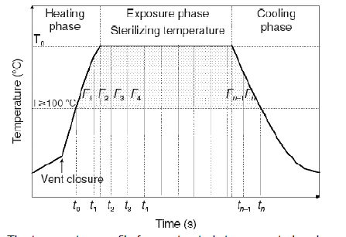
Just to be safe, when running the autoclave make sure that it reaches the desired pressure and temperature. Also, before using the autoclave, check the drain screen at the bottom of the chamber and clean if blocked. If the sieve is blocked with debris, a layer of air may form at the bottom of the autoclave, preventing efficient operation.
Microbial load. Contaminated items take longer to sterilize than clean items. Consequently, water sterilizes faster than yeast-extract containing media (which contains lots of microbes), or media left at room temperature for a while before autoclaving (which allows the concentration of microbes to increase).
A finite probability of surviving organisms, independent from the magnitude of the
delivered sterilizing agent can be expressed as:
Nt=Noe-kt
in which Nt is the number of surviving organisms after time t, N0 is the number of microorganisms at time zero (i.e., the bioburden), t is the exposure time, and k is the microbial inactivation rate constant. K will vary with the organisms being killed.
Be cautious of packages wrapped too tightly. Air and steam do not mix readily. Air, being heavier than steam, normally is displaced to the bottom of the sterilizer and is then forced out through the drain. If your dry items are wrapped too tightly, however, air is trapped and cannot escape.
If you have a large bag of dry items to sterilize, consider adding some water to the bag. This will create additional steam which will displace the dry air from the bag, increasing the rate of heat penetration. Can things be autoclaved too long? Yes. Nutrients in media, for example, often break down in the presence of heat. Consequently, a load of media filled containers
Lecturer A.D. Amir Mohammed Khalaf

should be of similar size, shape, content and volume, because exposure time is based on these characteristics. Otherwise some items might cook too long, and others too short.
Packing the autoclave. As much attention must be applied to loading the autoclave as was given
to packaging. Again, the determining factor is ensuring heat/steam penetration. Therefore care must be given to avoid overloading the chamber or placing bags in the chamber which are too large. You should also leave room between bags, bottles, etc. for steam circulation.
Some general guidelines. Here are some recommended times for autoclaving liquids of the
following volume per container:
75Ð200 ml 20 minutes
200Ð500 ml 25 minutes
500Ð1000 ml 30 minutes
1000Ð1500 ml 35 minutes
1500Ð2000 ml 40 minutes {2}
Associated Risks
Autoclaves are sterilizers using high pressure and high temperature steam. The potential
safety risks for the operators are:
• Heat burns -from hot materials and autoclave chamber walls and door
• Steam burns -from residual steam coming out from autoclave and materials on completion of cycle
• Hot fluid scalds from boiling liquids and spillage in autoclave.
• Hand and arm injuries when closing the autoclave door.
• Body injury if there is an explosion
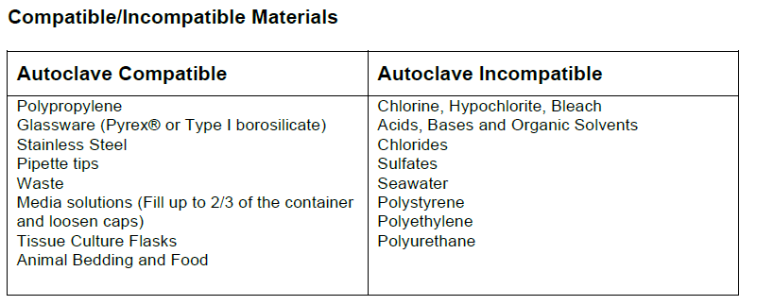
Safety Precautions
• Wear insulated thermal gloves when removing glassware from autoclaves. The OSHA fact sheet publication on Autoclaves and Sterilizers describes the DO’s and DON’Ts while working with autoclaves and Sterilizers.
• Assure that employees using the autoclave have been informed how to use autoclaves safely.
• All operators must receive training on the safe operation of the autoclave prior to using the equipment. Training may be delegated to a qualified individual, but it remains the responsibility of the supervisor to ensure their personnel are adequately trained.
Lecturer A.D. Amir Mohammed Khalaf
• All glassware should be inspected prior to autoclaving. Older glassware can be less stable and may break during the process.
• Always wear suitable personal protective equipment. Closed toed shoes, lab coats and insulated gloves must be worn when handling autoclaved materials. When a splash hazard exists, face shields and aprons must be worn.
• When sterilizing liquids, use liquid cycle only and do not agitate containers of heated liquids, place containers in an autoclavable tray.
• Jarring containers can cause hot-bottle explosions. Allow materials to cool before transporting. Place containers on carts or trolleys lined with paper to avoid shattering of glass.
• Ensure all lids have loose, vented closures to prevent pressurization/vacuum.
• Sterilizers, racks, and materials will be very hot after processing. Stand back from the sterilizer when opening the door, and allow materials to cool before unloading.
• Immediately clean any spilled material or condensate from the floor to prevent slips or falls.
• Keeps hands and arms out of the door opening when closing the sterilizer.
• Report any problems with the equipment, including unexpected noises, vibration, or smells to the person responsible for arraigning service.
• Place any sharps to be autoclaved in a designated sharps container.
• Do not attempt to open the door when a cycle is in process, or in the event of an alarm.
Never autoclave:
• Flammable, reactive, corrosive, toxic or radioactive materials
• Liquids in sealed containers.
• Material contained in such a manner that it touches the interior surfaces of the autoclave.
• Paraffin-embedded tissue sections.
Autoclave Cycles
To be effective, the autoclave must reach and maintain a temperature of 121° C for at least 30 minutes by using saturated steam under at least 15 psi of pressure. Increased cycle time may be necessary depending upon the make-up and volume of the load.
The rate of exhaust will depend upon the nature of the load. Dry material can be treated in a fast exhaust cycle, while liquids and biological waste require slow exhaust to prevent boiling over of super-
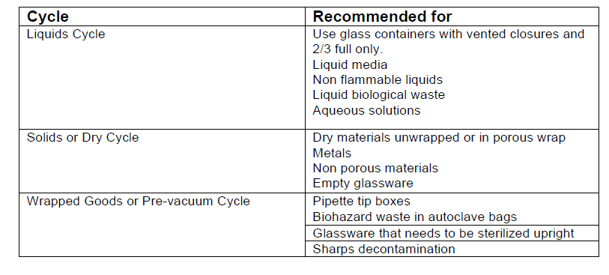
Autoclave Procedure
Wear personal protective equipment:
Lab coat
Eye/face protection
Closed-toe shoes
Heat-resistant gloves to remove items, especially hot glassware.{3}
Lecturer A.D. Amir Mohammed Khalaf
References: 1. 1st Edition , Sterilization of Medical Devices , By : Anne Booth 2. Operation of the Autoclaves, Howard Judelson on 6/28/04
3. Autoclave Use , The George Washington university, Washington DC. Revised on :01/15/2017

