Biothermal physics

Seventh lecture
Ultrasound Therapy

M.Sc. Ayed Fadhil M.Sc. Bashaer Albdulhamza

Third Stage
Department of medical physics
Al-Mustaqbal University
2023- 2024

Introduction
- Ultrasound (US) is a form of mechanical energy, Mechanical vibration is known as Sound Energy. The normal human sound range is from 20 Hz to 20,000 Hz. Beyond this upper limit, the mechanical vibration is known as ultrasound. The frequencies used in therapy are typically between 1.0 and 3.0 MHz (1 MHz = 1 million cycles per second).
- Sound waves are longitudinal waves consisting of areas of compression and rarefaction.
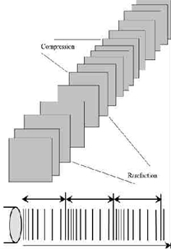
- Particles of a material, when exposed to a sound wave will oscillate about a fixed point as the energy within the sound wave is passed to the material, it will cause oscillation of the particles of that material.
- Clearly any increase in the molecular vibration in the tissue can result in heat generation,
- ultrasound can be used to produce thermal changes in the tissues, though current usage in therapy does not focus on this phenomenon.
- As the ultrasound wave passes through the tissues, the energy levels within the wave will decrease as energy is transferred to the material.

Ultrasound therapy devise
- Ultrasonic therapy (Ultrasonic diathermy) Equipment are used in Physiotherapy equipment produce high-frequency sound waves that travel deep into tissue and create therapeutic heat.

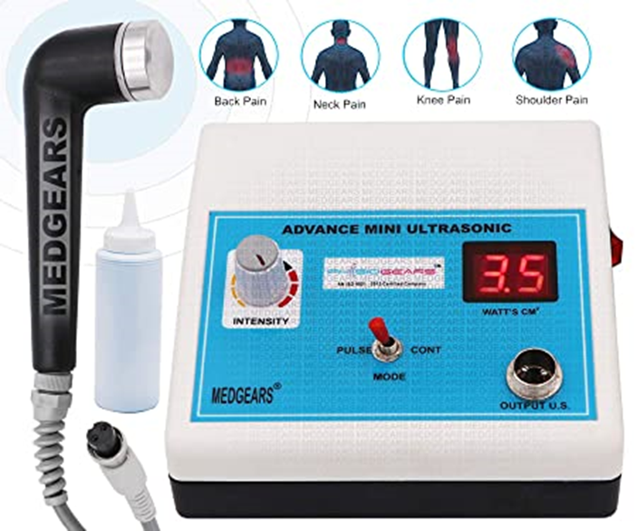
- Ultrasonic diathermy is intended to generate deep heat within body tissues for the treatment of selected medical conditions such as Muscles pain, muscle spasms and joint contractures, but not for the treatment of malignancies.
- The ultrasound waves are transmitted through a round-headed wand that the therapist applies to the skin with circular movements.
- A gel aids in the transmission of the ultrasonic energy and prevents overheating at the surface of the applicator.
- Treatments usually last between five and 10 minutes.

The production of Ultrasound
- For 1 MHz machine a vibrating source with a frequency of once million cycles per second is needed.
- This is achieved using either a quartz or a barium titanate crystal.
- These crystals deform when subjects to a varying potential difference a piezoelectric effect.
The components of Ultrasonic apparatus:
- There is a source of high frequency current, which is conveyed by a coaxial cable to a transducer circuit.
- Inside the transducer circuit, the high frequency current is applied to the crystal via a linked electrode.
- The crystal being fused to the metal front plate of the treatment head.

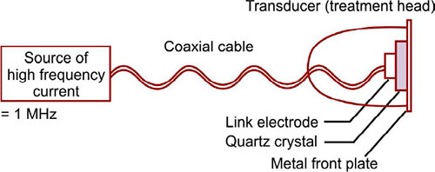
The components of Ultrasonic apparatus
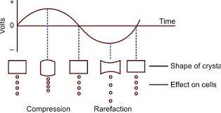
- Any change in the shape of the crystal = effect of the ultrasound is different.

Ultrasound treatment parameters:
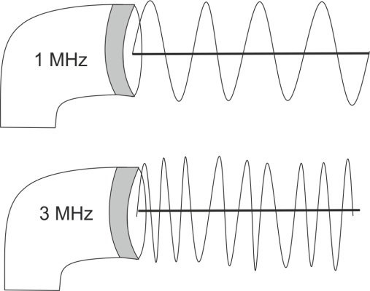Frequency of Ultrasonic therapy machine
1. Frequency:
- Mostly used 1 MHz & 3 MHz
- 1 MHz = heats tissue from 2 to 5 cm
- 3 MHz = heats superficial tissue
2. Mode:
- Continuous = treatment head continuously produces ultrasonic energy.
- Pulsed = the period of ultrasound is separated by periods of silence.
3. Intensity:
- Unit of intensity = watt.
- Space averaged intensity = it is used in continuous mode [ watt per square centimeter].
- Time averaged intensity = it is used in pulse mode and give to per second intensity [ watt per square centimeter].
Coupling media for ultrasound:
- Ultrasonic waves are not transmitted by air, thus some coupling media which does transmit them must be interposed between head and patient’s skin
- Air transmission is zero so it is reflecting the ultrasonic beam back into the treatment head & damage to crystal.
- Efficiency of transmission of ultrasound by various coupling media:
coupling media | % Transmission
Aqua sonic gel | 72.6
Glycerol | 67
Distilled water | 59
Liquid paraffin | 19
Petroleum jelly | 0
Air | 0
Testing of ultrasound machine:
- The simplest way of finding out whether ultrasound is in fact being produced is to use a water bath and to reflect an ultrasonic beam up to the surface where it should produce ripples.
- The apparatus is turned on and off the treatment head below the water.
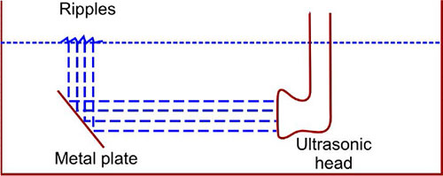
Testing of ultrasound machine

Techniques of application of ultrasound:
1. Direct contact 2. water bath 3. water bag

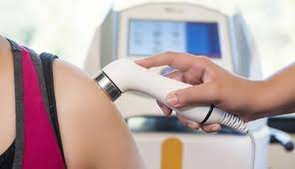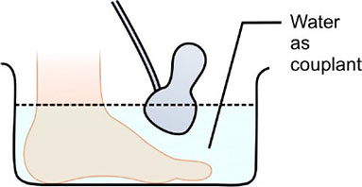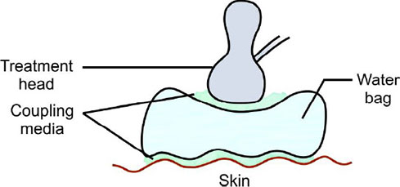

Physiological effect of Ultrasonic Therapy Machine
- Increased blood flow.
- Reduction in muscle spasm.
- Increased extensibility of collagen fibers.

Thermal effect of Ultrasonic Therapy Machine:
- Ultrasound is absorbed by the tissues and converted to heat at the point.
- The amount of heat is depending upon:
1. Absorption characteristics of the tissue.
2. Times of treatment.
3. Efficiency of the circulation through the insonated tissue.
4. Continuous ultrasound = intensity and duration of insonation.
5. Pulsed = less effect than continuous.

Indications of Ultrasonic therapy machine:
Carpal tunnel syndrome, Shoulder pain, including frozen shoulder, Tendinitis, joint Arthritis, Tennis elbow, Golfer elbow, Ganglion cyst, Recent injuries and inflammation, Scar tissue, Chronic indurated edema, Swelling, Ligament injuries, Wound healing.

Thermal ablation
- Thermal ablation is a type of procedure that uses heat, cold, microwave and electrical currents to vaporize (ablate) cancer cells and tumors.
- Thermal ablation procedures come in many forms, including:
- Cryoablation (Cryosurgery or cryotherapy).
- Radiofrequency ablation.
- Cytoablation (PVP laser surgery).
- During an ablation procedure, a catheter (thin, flexible tube) or a needle is inserted into the body and carefully guided to the specific area where cancer is located.
- Doctors most often use CT scanning or ultrasound imaging to guide these tools.
- Once there, the tips of these tools use either radiofrequency energy, liquid nitrogen, electric currents, or heat to destroy (ablate) the cancer cells within the tumor.
- Thermal ablation, the most clinically advanced bio-effect of focused ultrasound, produces cell death in a targeted area with minimal damage to the surrounding tissue.
- Tissue damage can be accurately controlled using a range of focused ultrasound transducers with different sonication sizes.
- Magnetic resonance imaging and ultrasound imaging allows for the monitoring of temperature rise in real time, allowing quantification of the therapeutic dose.
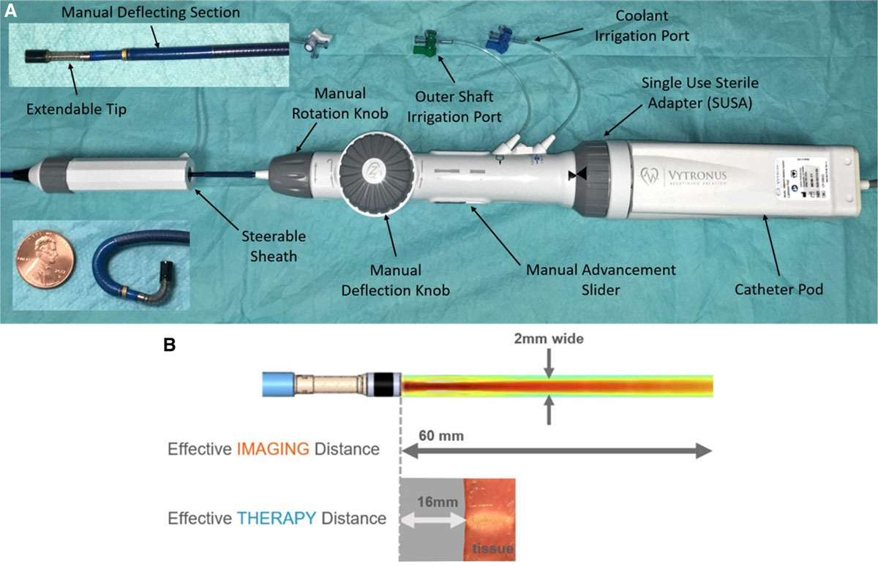
Low-intensity collimated ultrasound (LICU) ablation system.
- (A) the ablation catheter is a 12.8F deflectable, robotic tip open-irrigated ablation catheter that contains the proprietary LICU driven at ≈10 MHz.
- (B) the LICU beam is directional, controlled robotically, and can image tissue within 60 mm and ablate tissue effectively within 16 mm.

