***Biothermal physics***

***Third lecture***

***Methods of heat transfer***

***M.Sc. Ayed Fadhil M.Sc. Bashaer Albdulhamza***

***Third Stage***

***Department of medical physics***

***Al-Mustaqbal University***

***2023- 2024***

***Mechanism of heat exchange***

* Heat is the form of energy that can be transferred from one system to another due to a temperature difference or gradient
* The science which deals with the rates of such energy transfer is known as “heat transfer”.
* The means by which therapeutic heat is delivered to the target tissues is attributed to the following physical mechanisms:

1. Conduction 2. Convection 3. Radiation 4. Conversion 5. Evaporation

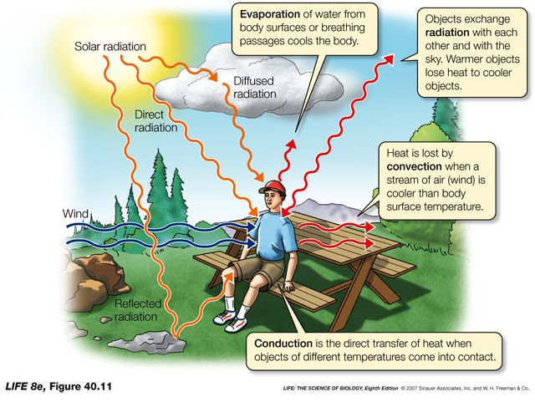

***1. Conduction***

* Heat is transferred through a material by being passed from one particle to the next.
* Particles at the warm end move faster and this then causes next particles to move faster and so on
* In this way heat in an object travels from hot end to cold end
* Heat gain or loss through direct contact between materials with different temperature is called ***conduction.***
* For example, ***heat is absorbed by the body tissues when using a*** ***heating pad.***

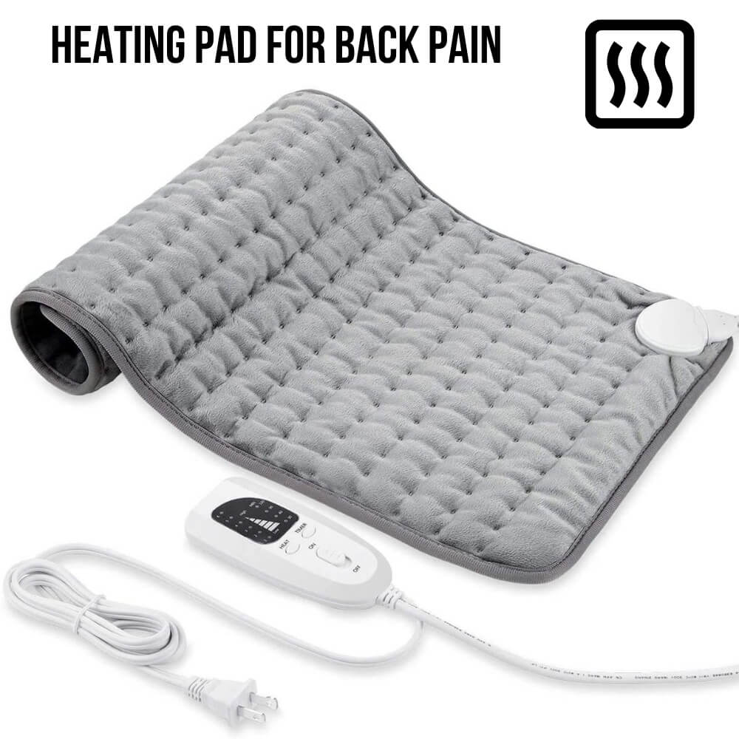 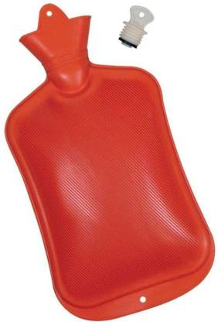

* Physically: ***Thermal conduction is the transfer of thermal energy from the high energetic to the low energetic particles of a stationary medium (solids, liquids or gas) due to interactions between the particles.***
* In solids, conduction may be attributed ***to atomic activity in the form of lattice vibrations and energy transport by the free electrons***.
* In fluids, conduction occurs due to the ***collisions and diffusion of the molecules during their random motion.***



* The basic equation for thermal conduction is the ***Fourier’s law.***
* It states that ***the heat flux (Heat Transfer rate per unit area) is directly proportional to the temperature gradient.***



* Where, k is thermal conductivity (W/ m K)

dT/dx is temperature gradient

q is heat flux (W/m2)



***Thermal Conductivity(k)***

* ***It is the measure of the ability of a material to conduct heat.***
* It is one of the ***transport properties*** of a material.
* Its unit is W/m οC or W/m K.
* For Solids and Liquids, k f(T). For gases/vapor, k f(p, T)

***2. Convection***

* it is defined as the ***transference of heat to a body by the movement of air, matter or liquid around the body***.
* The heat is carried by the particles themselves moving ***convection currents.***
* For example: warm or cool whirlpool in which movement of the water around a body part results in a temperature change.
* Hot liquids and gases expand and rise while the cooler liquid or gas falls.

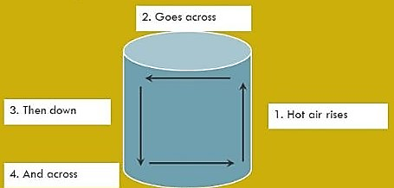

* The sun can cause large convection currents (winds) during daytime the land warms up more than the sea.
* The warm air rises over the land and cool air falls over the sea. So we feel a sea breeze.
* Convection refer to the thermal energy transfer between a solid surface and a moving fluid when they are at different temperature levels.
* Thermal energy transfer by convection is classified as:

**1.** Forced convection

**2.** Natural convection

* ***Forced convection*** is the transfer of thermal energy when the flow is caused by external means such as a fan a pump or atmospheric winds.
* ***Natural convection*** is induced by buoyancy forces due to density variations as a result of temperature differences.
* There is thermal energy convection by ***latent heat exchange***. This latent heat is due to change of phase from liquid to vapor or vice versa.
* ***Boiling*** and ***condensation*** are examples for such processes.





***Bimetallic strip thermometers***

***3. Radiation***

* Transfer of heat directly from the source to the object by a wave, travelling as rays.
* Heat radiation is also known as infrared radiation.
* All objects that are hotter than their surroundings give out heat as infra-red radiation, e. g. ***infra-red radiation lamp*** (I. R. R).

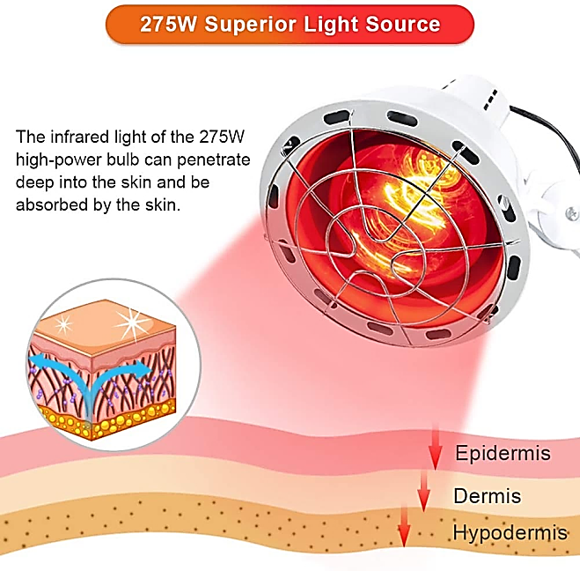

* Thermal energy transfer by radiation is caused by electromagnetic waves (or photons).
* Thermal radiation is emitted by all surfaces which are kept at a finite temperature level.
* This happens from solids, liquids and gases.
* Rate of emission increases with temp. level.
* Radiant energy does not require a material medium for its transport.
* Moreover, radiation transfer will occur effectively in vacuum.
* The mechanism of heat flow by radiation consists three distinct phases:

1. Conversion of thermal energy of the hot source into electromagnetic waves.

* Photons are propagated through the space as rays.

2. Passage of wave motion through intervening space.

* Photons travel with unchanged frequency in straight paths with speed equal to that of light.

3. Transformation of waves into heat.

* Reconversion of wave motion into energy occurs in the receiving surface which may partly absorbed, reflected or transmitted through.
* The basic rate equation for radiation is the ***Stefan-Boltzmann*** law:





***4. Conversion***

* It refers to the temperature change that results when energy is transformed from one form to another.
* such as the conversion from mechanical or electrical to thermal energy.
* E.g. ultrasound therapy (U. S. T.)

***5. Evaporation***

* It is defined as the transformation from a liquid state to a gas state.
* Heat is given off when liquids transform to gases.
* E.g. sweating results from heat production within the body.
* Cooling occurs as the perspiration evaporates from the surface of the skin.