Lecture 4
Fourth stage
Medical Physical Department

Medical Image Analysis

Technical Properties of Medical Images, Displays and Workstations, Compression of Medical Images

By

Asst. Prof. Dr. Mehdi Ebady Manaa

- Technical Properties of Medical Images
Medical images differ from ordinary images taken by a camera in several aspects because they are visualized measurement values. This has consequences on the technical properties of these images. With technical properties we mean attributes that result from the image acquisition technique and that are independent of the image’s semantics. Medical images may come with two, three, or four dimensions. 2D images may be slices of the human body such as an ultrasound image or a single CT slice. They may also be projections of a 3D scene such as an x-ray image or a scintigram. 3D images are volumes of the human body such as a 3D sequence from computed tomography, or time sequences of 2D images. 4D images are 3D volumes acquired over time. The DICOM file format in which images are stored often treats 2D images as an information unit even if they are part of a 3D or 4D sequence. A 3D data set is then treated as a sequence and a 4D data set is treated as a study of several sequences. Images may be differentiated into projection and slice images. In projection images, image attributes are integrated along rays and projected on a single pixel. The type of projection is important, if measurements in such images shall be made. For a cone beam projection such as in x-ray radiography an unambiguous relationship between distance in the image and distance in imaged space cannot be established See figure below :-
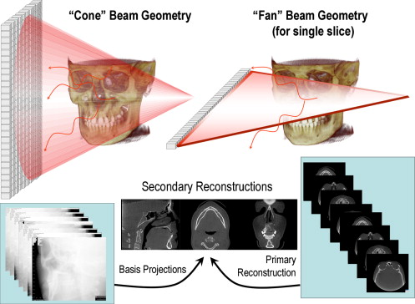
Fig. 1 X-ray beam projection scheme comparing acquisition geometry of conventional or “fan” beam ( right ) and “cone” beam ( left ) imaging geometry and resultant image production

Images may be acquired at several signal bands (e.g., in MRI imaging,). If done so, these bands are stored separately. Two different bands may even be stored as separate studies. Interpretation is only possible if the image file information about the semantic of each image with respect to the signal can be retrieved.
Image sizes given in the DICOM tags relate to the number of pixels per column or row. The true physical size of a pixel or voxel (in mm or cm) are mandatory data elements that can be found if the tag identification is known (either from the data dictionary or hard-coded in the image reading program). Pixel values of medical images are quantized. The quantization often differs from digital photos. The range may exceed 256 values when the information acquired by the imaging device justifies a bigger quantization range. Pixel values are stored as integers. The storage reserved for a single pixel is one or two bytes depending on the quantization range. For 2-byte-per-pixel images often only 12 bits are used. Sometimes negative values are stored (e.g., to represent Hounsfield units which begin at −1000). The user should be aware that there is no guarantee that different vendors represent values in the same fashion. This is especially true if the file format for data exchange is nonstandard. Hounsfield units, e.g., may be represented on a scale from −1000 to 3000 or—shifted—as unsigned integers on a scale from 0 to 4000. Transferring digital image files between systems may involve changing between big-endian and little-endian notation of the two bytes. This refers to whether the first or the last byte is the most significant byte in a 2-byte-word. It should be no problem if communication is standardized, but needs to be considered otherwise. It is easily recognized when looking at the images (see Fig. 4.1). Endianity may also be different for the bit-order in a byte.

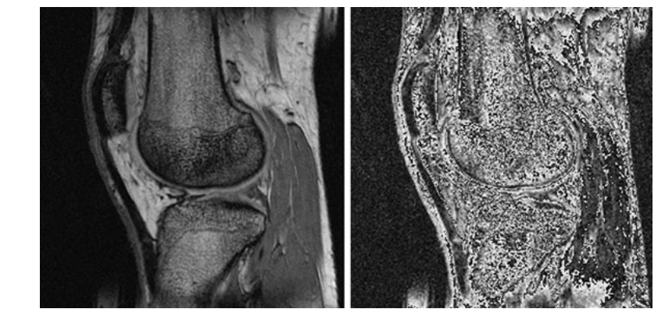
Fig. 4.1 MR image with correct endianity (scaled from its original range 0. . . 4000 to 0. . . 255) and the same image with endianity reversed

Sometimes, pixels or voxels of images presented for postprocessing are reduced to single bytes. This is the case when images are transferred via formats that do not support a wider range. The mapping from 2 to 1 byte may have been created expertly and intentionally to highlight specific details in an image. It may support human capabilities of recognizing important aspects in an image, but computer based methods operate on very different assumptions than human vision. The reduction, while being supportive for human perception, may be counterproductive to computer-based image interpretation.
- Displays and Workstations
Traditionally, many medical images—x-ray images, computer tomograms, MR images—are viewed as hard copies. Hard copies are readily transportable and readily readable. No specific equipment is needed to perceive a hard copy radiograph although a light box system is required for professional reading. For reading an image by a radiologist, the film is placed in front of a light box (see Fig. 4.2). Reporting or other evaluation tasks are carried out there. Film has a number of advantages. Backlit light boxes allow for a good control of perceived contrast. This is further supported by the fact that most light boxes are large and are at a fixed position where lighting conditions can be controlled. A modern light box system can easily carry several hundreds of films. On such a system, films are mounted beforehand. Several of the films may be presented simultaneously. They can be selected at the push of a button from the set of films mounted. Replacing analogue data transfer and display by a PACS has advantages. Most notably, digital data can be easily copied and transferred to any location reachable on the network. Transfer may also be extended to long distances in a short time (teleradiology). Replacing the analogue archive by a digital archive also makes localizing images easier. It has been reported that accessibility increased from 70% to 98% after switching from analogue to digital archives. Another advantage is that image enhancement techniques such as magnification or contrast enhancement may support image interpretation. Replacing film viewing by displaying images on a screen should preserve most of the advantages of a film-based reporting. The first problem to be solved relates to image transfer. The capacity of the “muscle net” (i.e., carrying films around) can be surprisingly high and may compare favorably to digital transfer capacities if the network infrastructure is poor. Although this is becoming a problem of the past with improvement of the network infrastructure, perceived transfer capacity may still be unsatisfactory. Conventionally transported radiographs are “invisibly” transferred to places, i.e., the user does not perceive transport time as waiting time (although he or she may get upset about pictures not or not yet delivered). Once pictures are present, all of them are immediately at his or her disposal
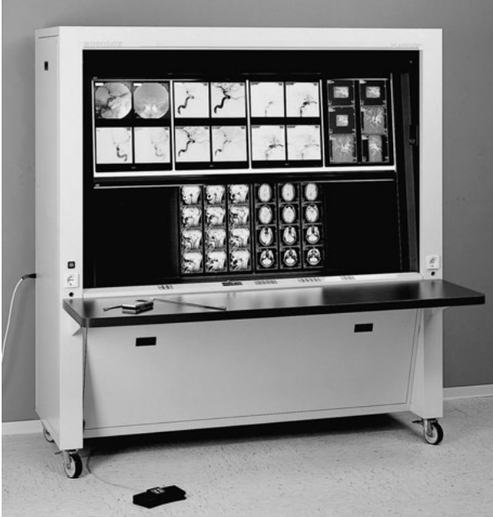
Fig 4.2 Light box in a traditional reading room: The system can be loaded with several hundreds of films. Films to be read are loaded immediately using a handheld or a foot control

In a digital environment, the user initiates the image transfer. The time span between the request and completion of an image transfer is perceived as waiting time. Although an 80% decrease in preparation time has been reported after switching to digital reporting, this includes time spent by technicians and archive support staff. The radiologist may still feel that the waiting time increased with the introduction of a digital system. With increased data sizes—a CT study from a modern multislice CT scanner may contain more than 1000 slices—the situation may worsen, as even a fast network may need several minutes to transfer the data. Faster networks and intelligent solutions similar to those preparing a conventional reading session can help to reduce this problem.
Another problem is the limited spatial and contrast resolution of a monitor. The contrast range of today’s ( Thin-Film Transistor ) TFT monitors is quite satisfactory, but monitor placement and the influence from external lighting can reduce perceived image contrast. A professional reading system will allow to control such influence (see Fig. 4.3 for an example). The spatial resolution of a conventional monitor is about 2 megapixels, whereas a digital radiograph may contain up to 4096×4096 pixels (=16 megapixels). There are few monitors that are able to display such a resolution. Hence, a professional reading station is much more expensive than a conventional TFT monitor. Furthermore, a reading room usually contains several light boxes that are able to display several images at the same time. Using several monitors instead is only a partial replacement since there will never be enough monitor space to display as many images as can be displayed on a big light box (see Fig. 4.3 for an example and compare it to Fig. 4.2). A suitable user interface for switching between views has to make up for this deficiency.
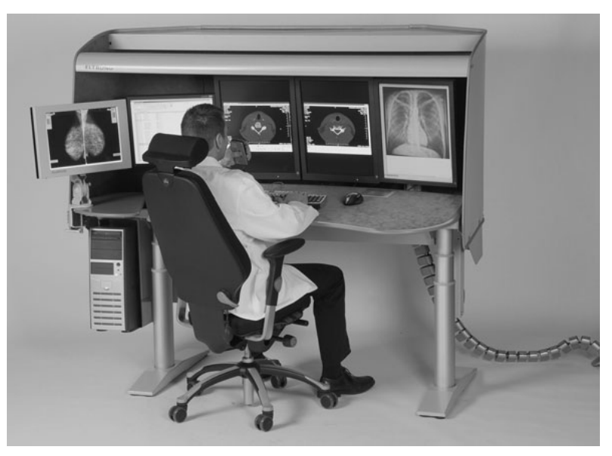
Fig. 4.3 A reading room as part of a PACS displays images on monitors instead of light boxes. Active and passive components of the depicted system control the lighting situation

There are no legal standards for the display of digital radiography, but the American College of Radiology (ACR) has developed some recommendations. The ACR distinguishes between the images used for diagnosis (interpretation) and those used for other purposes (clinical review, teaching, etc.). According to ACR, the image quality should be sufficient to satisfy the needs of the clinical circumstances if images are meant for display use only. Their recommendations for display and display software are as follows
- The luminance of the gray-scale monitor should be greater or equal than 50 foot lamberts.
- Controlled lighting should enable eliminating reflections in the monitor.
- The ambient light level should be as low as feasible.
- A capability for the selection of image sequences should be provided.
- The software should be capable of associating the patient with the study and demographic characterizations with the images. The rendering software for images should
- be capable of window and level adjustment,
- be capable of pan and zoom (magnification) functions,
- be capable of rotating or flipping the images, provided correct labeling of patient orientation is preserved,
- be capable of calculating and displaying accurate linear measurements and pixel values,
- be capable of displaying prior image compression ratio, processing, or cropping,
- have available the matrix size, the bit depth, and the total number of images acquired in the study. Requirements for display consoles that are not used for interpretation are less stringent. This relates, for instance, to workstations that are used for computer assisted procedures. There are two places where such work can take place:
- workstations as part of the image acquisition system,
- independent workstations in the hospital network. Most vendors sell workstations and workstation software for postprocessing image data.
These workstations are a part of the imaging system and as such may communicate with image acquisition devices in some nonstandard fashion. Standardized communication is not really necessary unless such a workstation is meant to be connected to the network. Methods for image processing are predefined by the vendor of the imaging device (a typical user interface for such a workstation software is depicted in Fig. 4.4). They are generally not open (i.e., they are neither adaptable nor extendable). Software being delivered with such a workstation falls in six different groups.
- Image display: Retrieval and display of images, setting window and level of the mapping between image values and rendered intensities, printing of images.
- Image enhancement: Magnification, contrast enhancement, noise filtering.
- Image annotation.
- Image analysis: Measurements of distances and angles, volume estimation or volume measurements, simple segmentation techniques.
- 3D imaging: Slice view in cine mode, maximum intensity projection, surface and volume rendering.
- Specialized interpretation or support to a specific planning task (e.g., surgical, radiotherapeutical).

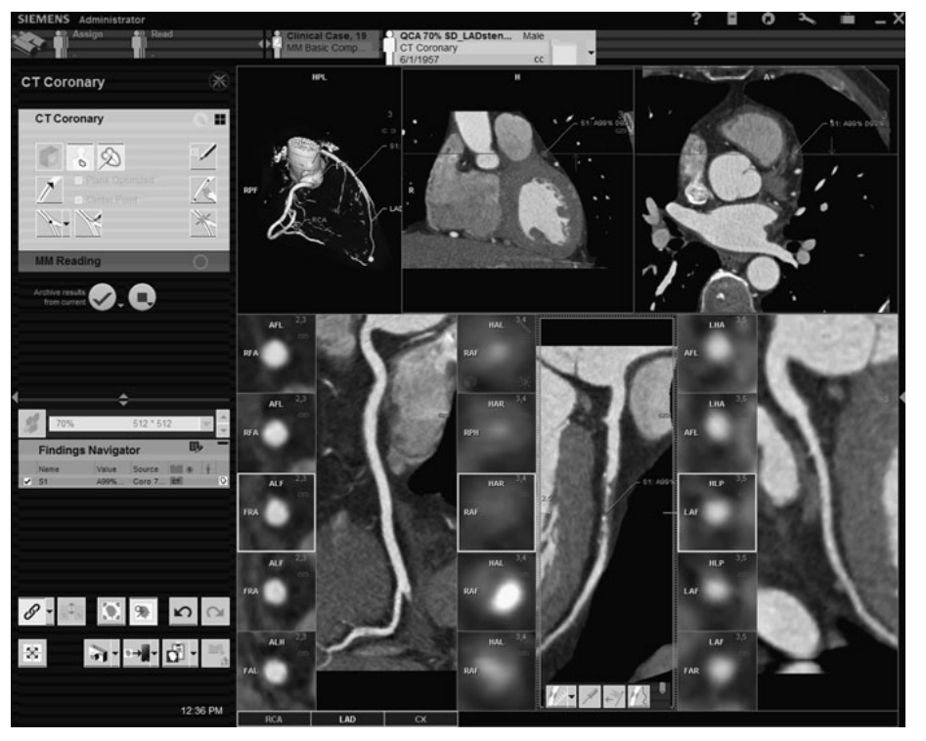
Fig. 4.4 Example of a user interface of a DICOM viewer software. The software is able to interpret the information in the DICOM header and organizes images accordingly. Viewing software includes display and simple tools such as setting window and level or annotating the image

- Compression of Medical Images DICOM supports data compression. Images may be compressed lossless or lossy. Lossless compression such as entropy encoding or run-length encoding typically result in compression rates of 1:2 to 1:3. Lossy compression in the range 1:10 to 1:30. Anybody who ever created a JPEG image knows that most images contain much psychovisual redundancy since data reduction does not automatically reduce the perceived image quality. Regarding medical images, lossy compression is a difficult issue. Laws in most countries require that medical images are to be saved for a given time. The intention of these laws is that decisions that have been based on these images can be reviewed based on the original data. If data have been compressed for saving storage space, their original content must be retrievable, which prohibits lossy compression. However, there are other reasons for image compression. If images are transferred in a teleradiology network, their purpose is to provide the person at the receiving end with additional information. This person may be a senior radiologist at home who has to decide whether attendance in the hospital is required. It may also be a transferring radiologist at a small clinic who receives images from one of his patients taken and interpreted in a medical center. In such cases, image compression may be lossy if the partners in the data exchange have agreed that this loss does not constitute a loss of information for the kind of purpose. There are no general rules as to the quality of such images since image interpretation is to be carried out or confirmed by reading the original images. A recommendation of the American College of Radiology states, however, that, clinically, diagnostic image quality must not be reduced. While this does not rule out lossy compression it is not clear whether it can be established statistically by means of readability studies or whether it requires expert decisions for every individual image. Compression is part of the DICOM standard. Among others, the JPEG and JPEG2000 standards have been adopted by the DICOM standardization committee. The DICOM committee does not make a decision about the type of compression, whether lossless or lossy. Not all DICOM viewers, however, can read compressed DICOM images. It may also be an obstacle to a self-written DICOM image interpreter when the data have first to be uncompressed before they can be interpreted.

