***AL- Mustaqbal University***

**Optometry Department**

**Lec.13**

Optical Instruments

assistant teacher

MCS

**Ali Hadi Al-Husseini**

*2023-2024*

***Corneal topography***

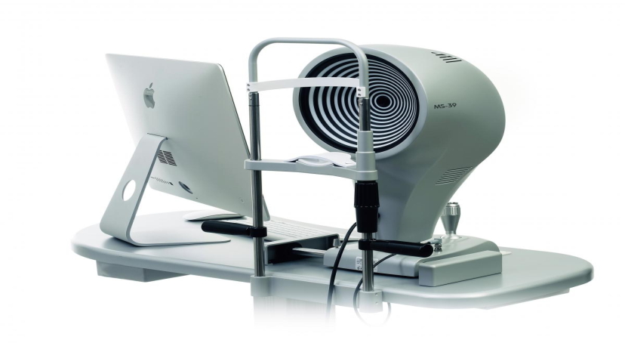

also known as photokeratoscopy or videokeratography, is a three‐dimensional (3D) non‐contact medical imaging technique for mapping the anterior curvature of the cornea, the outer structure of the eye, that helps find distortions and abnormalities in the curvature of the cornea, which is normally smooth. It also helps in monitor in eye diseases and planning for surgery. Cornea, is a transparent dome‐like structural cover that located at the frontal portion of the eyeball in front of the iris and centered the white of the eye (sclera), the circular outline border of the cornea or its junction with the sclera is termed as the limbus. Cornea is the most powerful refractive element of the eye contributing 43‐44D which is 3/4 of refractive power of eye. Since the shape of corneal surface determines its refractive power, even a minor modification of its surface can lead to significant alteration of image formed on retina.



***Normal adult cornea should be:***

* Prolate shape, the cornea is horizontally oval, and sharper centrally than in the periphery.
* Anterior surface is oval, posterior surface is circular.
* Horizontal diameter of both surfaces is same (11.7 mm).
* While vertical diameter of posterior surface (11.7 mm) is about 1 mm less than anterior surface (10.6 mm).
* Radius of curvature of anterior surface is 7.8 mm & of posterior surface is 6.5 mm.
* The vertical meridian of cornea is 0.05 D steeper than the horizontal meridian.
* Thickness of cornea:
* 0.52mm at center.
* 0.8mm at periphery.
* 1mm at limbus.
* Anterior radius of curvature, 7.8mm.
* The cornea divided into zones:
* Central zone.
* Paracentral zone, (surrounding the central zone)
* Nearby to the paracentral zone is the peripheral zone or transitional zone.
* Finally, there is the limbus (limbal zone), where the cornea steepens prior to joining the sclera at the limbal sulcus.
* The cornea has six layers:
* Epithelium layer.
* Bowman’s layer (anterior limiting membrane).
* Corneal stroma (substantia propria).
* Descemet’s layer (posterior limiting membrane).
* Corneal endothelium.
* Dua’s layer. The anterior surface of the cornea acts like a convex mirror, reflecting parts of the incident light. Several instruments were developed to estimate the anterior surface of the cornea by measuring the reflected light.





Corneal topographic system (CTS) implies computerized, videos assisted techniques which provides a detailed information about the shape of the corneal surface, allowing both qualitative and quantitative measurements of the cornea. Most corneal topographers evaluate 6000– 10000 specific points across the corneal surface and offers an excellent accuracy. The basic unit of CTS consists of projection device, video camera, digital computer attached to a slit lamp chin rest.



***Indications of using Corneal Topography:***

* Scarring, trauma (injury) or infections can scar the cornea. This changes the shape of the cornea. A topography scan measures the distortion and its effect on vision.
* Growths, the size of pterygia or other growths can be monitored with topography.
* Astigmatism and keratoconus. Topography can help find astigmatism and early cases of keratoconus and track their progression.
* Incision, placement and intrastromal ring placement in keratoconus.
* Perfection Contact lens fitting. Topography scans help find what type of contact lens can be worn to improve vision. If the scan shows a lot of distortion, sometimes a special hard contact lens (RGP) can help correct vision.
* Cataract and refractive surgery assessment.

***Most common principles or technologies that topography based on are:***

* Placido disc reflection.
* Scanning slit topography.
* Scheimpflug photography.

***Placido Disc Reflection:***

The primary optical aim of the cornea is refraction and focusing of the light rays as it acts as a convex lens. However, all non‐ideal refracting surfaces reflect some light off them. This is the principle used for Purkinje imaging as well in Placido discs.

***Placido disc*** is a device made of concentric rings drawn on a device of a different color (generally white rings on a black background).



After projecting a concentric annular light source onto the corneal surface, Placido disc reflection systems capture the reflected light so their software can measure curvature, irregularities, foreign bodies, tear film.

***Corneal topographers with this technology are based on:***

* The application of the principles of convex mirrors’ geometrical optics.
* Using Placido discs with known size and spacing that reflected on the anterior surface of the cornea.

The first refracting surface of the cornea (the tear film –air interface) acts as a convex mirror and reflects back light in a pattern dependent of the corneal pattern, the image is initially captured by a digital a CCD/CMOS camera, which is located behind the central hole of the plate, and then processed by a computer. From identifying the edges of the rings, each topographer uses an algorithm reconstruction of the corneal curvature, with an accuracy depends on how the programming architecture is defined.





By analyzing the virtual image reflected by the cornea, the curvature at different positions of the cornea can be obtained. If the patient’s cornea is normal, a series circular concentric rings can be observed on the image. If the cornea is abnormal, a series of irregular bends will appear in the concentric ring. The shorter the distance between concentric rings, the higher the corneal power, and inversely. Therefore, the clarity of the image is very important. In order to eliminate aberration and obtain a high‐quality image, the shape of Placido disk needs to be designed. The Placido disk systems use cones, hemispheres, cylindrical or ellipsoidal surfaces as targets.

***How Does Corneal Topography Help with Surgery?***

* Refractive surgery: During refractive surgery like LASIK, the shape of the cornea is changed to correct refractive errors like myopia (nearsightedness). A topography scan helps the surgeon understand how to precisely reshape the cornea.
* Cataracts: When cataracts make the eye’s natural lens cloudy, it is replaced with an intraocular lens (IOL) during cataract surgery. Corneal topography helps surgeons select the right IOL in some cases.
* Corneal transplants: After a corneal transplant, a surgeon may use corneal topography to help a patient heal correctly. The images help assess which stitches should be removed and when based on the shape of the cornea.
* Corneal cross‐linking: Corneal cross‐linking surgery helps strengthen a cornea with keratoconus. A topography scan may be done to see if this surgery is needed. After surgery, scans are done to monitor the eye.
* The patient will be seated facing a large bowl with lighted circles inside it.
* The chin and forehead fixated on the chin rest and forehead rest.
* keep the head secure to get the clearest images.
* The patient is asked to stare at a fixed target in the bowl while the pictures are taken.
* The scan only takes a few seconds, but it may need to be repeated a few times.
* Getting a corneal topography is painless, as nothing touches your eye during the scan.

***Types of topographic maps:***

* Axial display map: This is the most traditional way of viewing a topography image, as it is known for its overview of the corneal power. However, since it collects the averages of the data to produce a smooth map, it is considered less accurate than the other maps.
* Tangential display map: This type of map provides an accurate measurement of the cornea’s power and curvature, and is therefore helpful in fitting contact lenses, especially ortho‐k lenses. it can also be used to evaluate the power of a contact lens while the lens is on the eye. This is helpful when the patient is being fitted for a multifocal contact lens and the optical powers must be correctly positioned on the eye. The tangential map is ideal for detecting changes in the corneal curvature that may occur as a result of corneal distortion from wearing contact lenses
* Elevation display map: This map is used to determine the true shape of the cornea and is crucial for selecting the best contact lens design for an irregular cornea. This map display is especially important when deciding between a scleral gas permeable (GP) lens or a corneal contact lens.
* Corneal thickness display map: This map display is used to stage ocular diseases, such as keratoconus, but is primarily used to monitor changes in corneal thickness during contact lens wear.
* Tear break‐up display: This map displays the quality of the natural tear film and also shows how the tear quality has been impacted by contact lens wear. A corneal topography test will measure the tear film before the patient begins to wear contact lenses and then be compared to the measurement taken after the patient has been wearing contact lenses.

***How do interpret corneal topography?***

* Cool colors correspond to flat curves and elevation values below the reference sphere (blue or violet colors).
* Mild colors correspond to medium curvature and elevation values equal to the reference sphere (green or yellow colors).
* Warm colors correspond to high curvature and elevation values above the reference sphere.

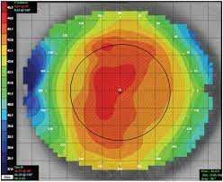

THANK YOU