Department of Electrical Engineering techniques
DC Electric Circuits Lab. 1
Assist. Lect. Ali imad

Introduction
  - Objective:

Experiment No.4 Delta – Star connection

To verib' the equivalence between star connection and delta connection for the resistors networks.

Components:
    - DC power supply.
    - Electrical and electronic system trainer.
    - Connecting wire.
    - Multimeter.

Theory
Circuit configurations are often encountered in which the resistors do not appear to be in series or parallel .1Jnder these conditions, it may be necessary to convert the circuit from one form to another. Two circuit configurations that often account for these difficulties are the vye (Y) interconnection because the interconnection can be shaped to look like the letter Y. The (Y) configuration also is referred to as tee (T) structure without disturbing the electrical equivalence of the two structures and delta (Δ)in which the interconnection looks like the Greek letter (Δ) . It also is referred to as pi (Π) interconnection without disturbing the electrical equivalence of the two configuration depicted in Figures 1 and 2.

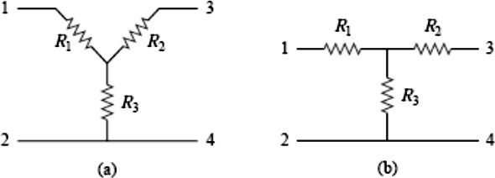
Figure 1 Two forms of the same network: (a) Y, (b) T.

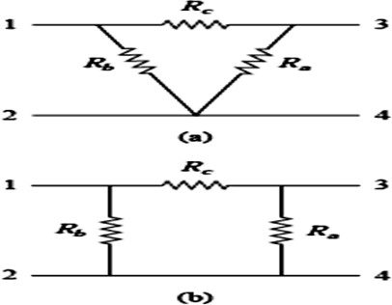

Figure 2 Two forms of the same network: (a) Δ, (b) π.

Delta to Wye Conversion

Suppose it is more convenient to work with a wye network in a place where the circuit contains a delta configuration. We superimpose a wye network on the existing delta network and find the equivalent resistances in the wye network. For terminals 1 and 2 in Figs. 1 and 2

𝐑
𝟏
=
𝐑𝐛 𝐑𝐜
𝐑𝐚 + 𝐑𝐛 + 𝐑𝐜
𝐑
𝟐
=
𝐑𝐜 𝐑𝐚
𝐑𝐚 + 𝐑𝐛 + 𝐑𝐜
𝐑
𝟑
=
𝐑𝐚 𝐑𝐛
𝐑𝐚 + 𝐑𝐛 + 𝐑𝐜

Wye to Delta Conversion
Reversing the Δ-to-Y transformation also is possible. That is, we can start with the Y structure and replace it with an equivalent Δ structure. The expressions for the three Δ- connected resistors as functions of the three Y-connected resistors are

𝐑𝐚 = 𝐑𝟏𝐑𝟐 + 𝐑𝟐𝐑𝟑 + 𝐑𝟑𝐑𝟏
𝐑𝟏
𝐑𝟏𝐑𝟐 + 𝐑𝟐𝐑𝟑 + 𝐑𝟑𝐑𝟏

𝐑𝐛 =
𝐑𝟐

𝐑𝐜 = 𝐑𝟏𝐑𝟐 + 𝐑𝟐𝐑𝟑 + 𝐑𝟑𝐑𝟏
𝐑𝟑

Experiment procedure:
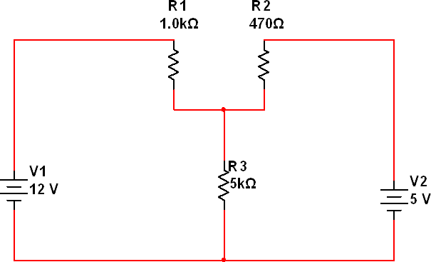
- Using the DC circuit trainer, connect the circuit shown in Fig. 3.
Fig. 3: Y circuit.

- Use the multimeter to measure the currents in each branch.
- Convert the Y circuit in Fig. 3 to delta connection theoretically.
- Using the DC circuit trainer, connect the circuit shown in Fig. 4.
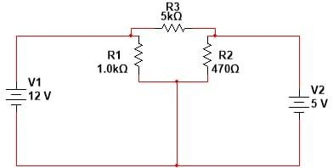
Fig. 4: Delta circuit.

- Repeat. step 2 and convert it to the equivalent Y circuit.

Discussion
  - Why do we convert Wye to Delta or Delta to Wye?
  - What is the difference between delta and star-delta?And, Which current is higher Star or Delta?
  - Did the power delivers from (DC power supply) is changed after using the conversion from A to Y. Prove that?
  - Find RT for the circuit below in Fig. 5.
  - Find IT for the circuit below in Fig. 6.

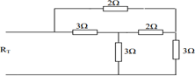

Fig. 5

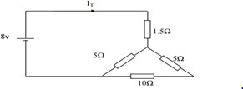

Fig. 6

