**Unit 7**

**Simple past , Modal verbs, Auxiliary verbs**

**7.1 . Match answers with the questions**

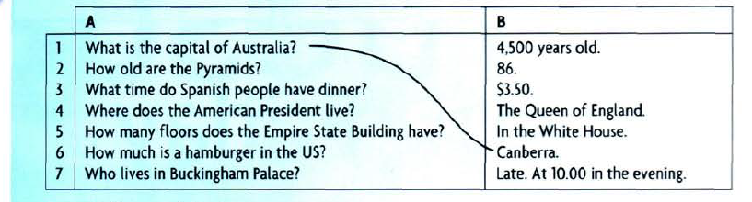

**7.2. Grammar Spot / Spots**

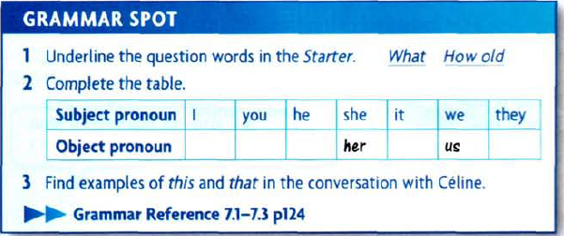

**7.3. Vocabulary**

- Adjective

Hot , cold, horrible, expensive , cheap, lovely , small, old, new , big

Match the words and pictures :

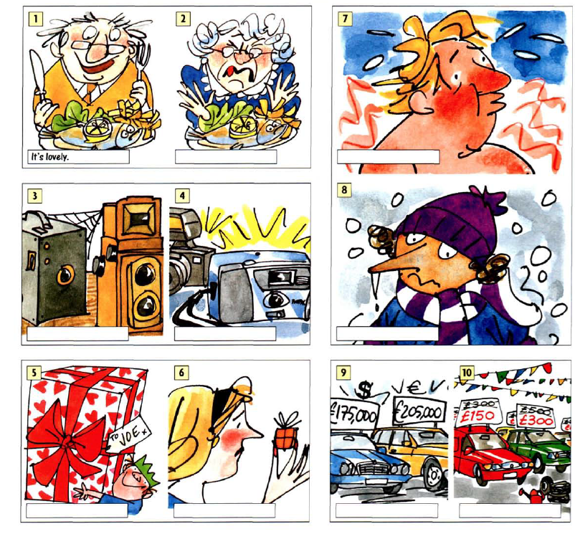

**7.4. Reading and writing**

**7.4.1. A post card from Dublin**

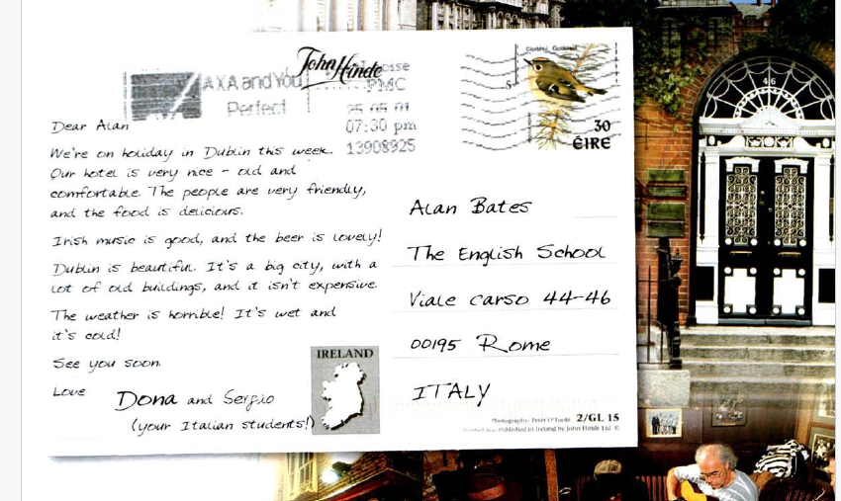

**7.4.2. Look at the postcard , read and answer the questions bellow :**

1. Who is the postcard from ?

2. Where are they

3. Why are they in Dublin ?

4. 4. Is their holiday good?

5. What isn’t good?

**7.5. Every day English**

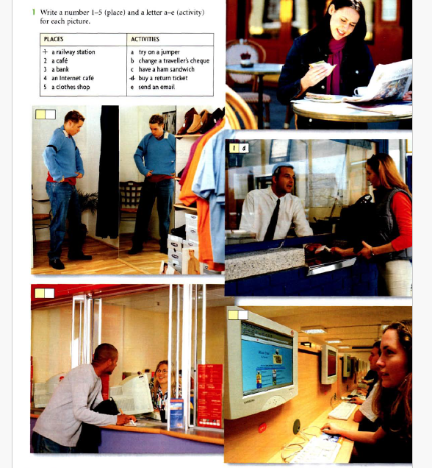

**7.6. Simple past tense**

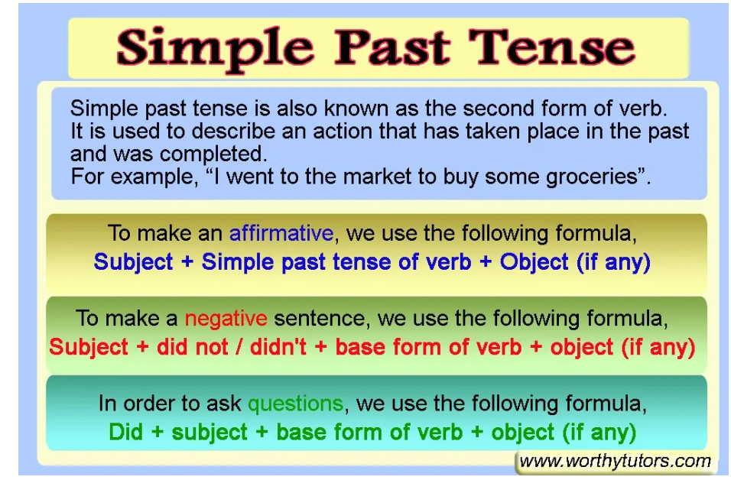

**7.6.1 Past simple regular verbs**

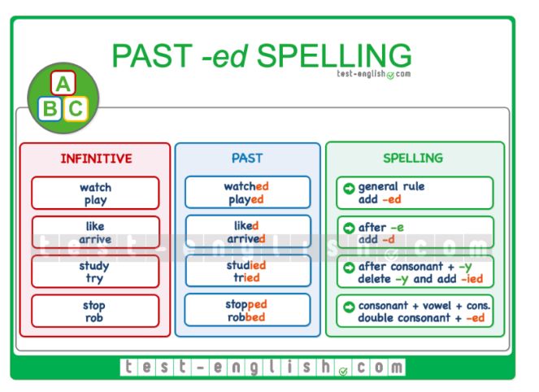

**7.6.2. Irregular past simple verbs**

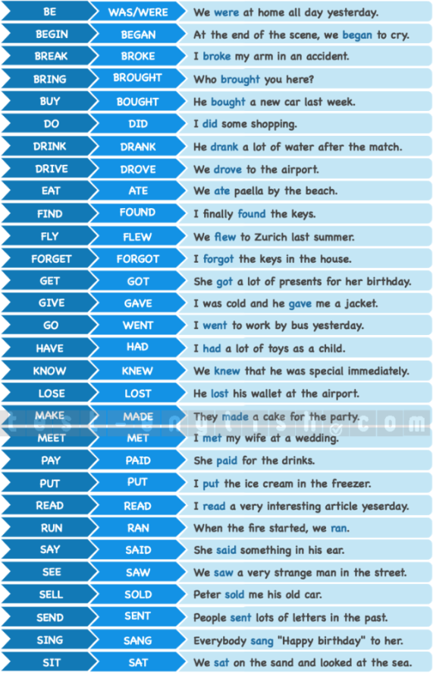

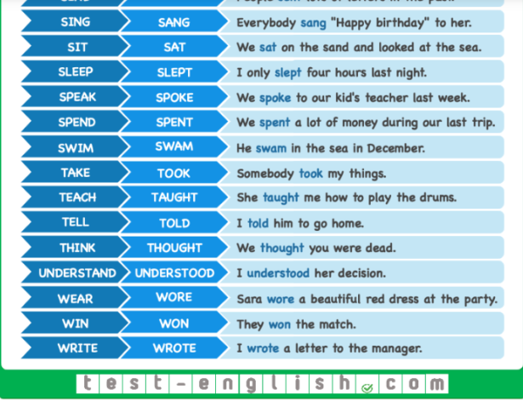

**7.7. Modal verbs**

The modal verbs are:

|  |  |
| --- | --- |
| *can may must shall will* | *could might  should would* |

- We use modals to show if we believe something is [certain, possible or impossible](https://learnenglish.britishcouncil.org/node/1378):

*My keys****must****be in the car.  
It****might****rain tomorrow.  
That****can't****be Peter's coat. It's too small.*

- We also use them to do things like talk about [ability](https://learnenglish.britishcouncil.org/node/1379), [ask permission](https://learnenglish.britishcouncil.org/node/10376), and [make requests and offers](https://learnenglish.britishcouncil.org/node/10377):

*I****can't****swim.****May****I ask a question?****Could****I have some tea, please?****Would****you like some help?*

[**Modal verbs**](https://learnenglish.britishcouncil.org/grammar/english-grammar-reference/modal-verbs)

Modal verbs are used along with a main verb to indicate ability, necessity, possibility, and permission. In sentences containing modal verbs, the main verb typically takes the infinitive form. Modal verbs come before main verbs and never change form.Top of Form

* 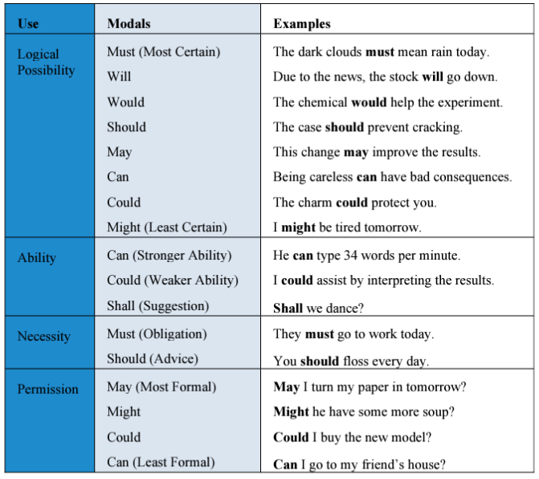 Bottom of Form

[Probability](https://learnenglish.britishcouncil.org/grammar/english-grammar-reference/probability)

* [Ability](https://learnenglish.britishcouncil.org/grammar/english-grammar-reference/ability)
* [Permission](https://learnenglish.britishcouncil.org/grammar/english-grammar-reference/permission)
* [Requests, offers and invitations](https://learnenglish.britishcouncil.org/grammar/english-grammar-reference/requests-offers-invitations)
* [Suggestions and obligations](https://learnenglish.britishcouncil.org/grammar/english-grammar-reference/suggestions-obligations)
* ['can' and 'could'](https://learnenglish.britishcouncil.org/grammar/english-grammar-reference/can-could)
* ['may' and 'might'](https://learnenglish.britishcouncil.org/grammar/english-grammar-reference/may-might)
* ['will' and 'would'](https://learnenglish.britishcouncil.org/grammar/english-grammar-reference/will-would)
* ['will have' and 'would have'](https://learnenglish.britishcouncil.org/grammar/english-grammar-reference/will-have-would-have)
* [Modals with 'have'](https://learnenglish.britishcouncil.org/grammar/english-grammar-reference/modals-have)

**7.8 . Auxiliary verbs**

A list of verbs that (can) function as auxiliaries in English is as follows: be, can, could, dare, do, have, may, might, must, need, ought, shall, should, will, would. The status of dare (not), need (not), and ought (to) is debatable and the use of these verbs as auxiliaries can vary across dialects of English.

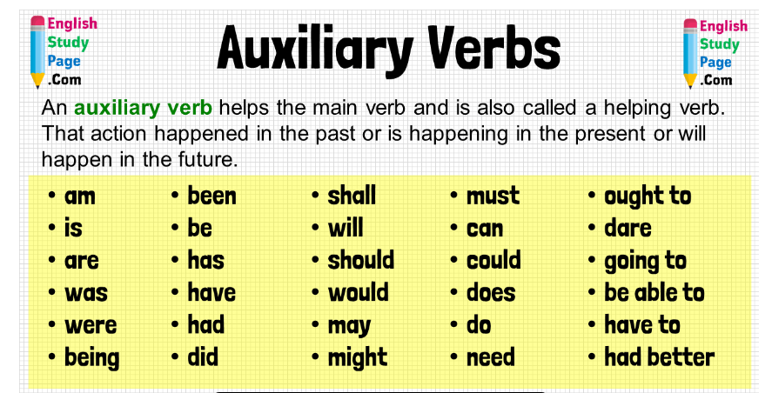

**7.9. Homework**

**7.9.1. Write only one word for each sentence.**



**7.9.2. Complete the e-mail with the verbs in brackets.**

Dear Jane,

How are you doing? I feel miserable, I must admit. And I'm going to tell you why. Yesterday I ..................... (do) my homework, ..................... (tidy) my bedroom and ..................... (decide) to go out. The weather ..................... (be) perfect and so I ..................... (go) to the park. And do you know who I ..................... (see) there? Jason, my boyfriend. I ..................... (want) to say hello to him, but then I ..................... (stop), because I ..................... (can) see a girl coming to him. Guess what ..................... (happen). They ..................... (meet) in the middle of the road and he ..................... (kiss) her. My Jason! Jason and I ..................... (be) in the park three times and he never ..................... (try) to kiss me! I didn't know what to do. I just ..................... (run) away. When I ..................... (come) back home, I ..................... (cry). Just a little bit, you know. Then I ..................... (say) to myself: Forget about Jason. There are plenty more fish in the sea! What do you think of him? Is he worth it?

Please, write back soon.

Love, Bea

**7.10. References**

**1.** [**https://test-english.com/explanation/a1/past-simple-regular-irregular/**](https://test-english.com/explanation/a1/past-simple-regular-irregular/)

**2. chrome extension: //efaidnbmnnnibpcajpcglclefindmkaj/** [**https://www.sjsu.edu/writingcenter/docs/handouts/Modal%20Verbs.pdf**](https://www.sjsu.edu/writingcenter/docs/handouts/Modal%20Verbs.pdf)

**3.** [**https://englishstudypage.com/verbs/30-auxiliary-verbs-definition-and-examples/**](https://englishstudypage.com/verbs/30-auxiliary-verbs-definition-and-examples/)

**4. New head way – student book**

**5. New head way – Work book**