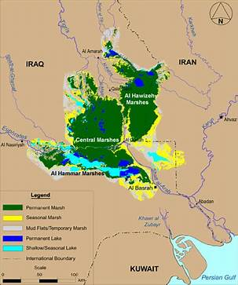

The Iraqi Marshes
The Mesopotamian Marshes, also known as the Iraqi Marshes, are a wetland area located in Southern Iraq and southwestern Iran as well as partially in northern Kuwait. The marshes are primarily located on the floodplains of the Euphrates and Tigris rivers bound by the cities of Basra, Nasiriyah, Amarah and a portion of southwestern Iran and northern Kuwait (particularly Bubiyan Island). Historically the marshlands, mainly composed of the separate but adjacent Central, Hawizeh and Hammar Marshes, used to be the largest wetland ecosystem of Western Eurasia. The unique wetland landscape is home to the Marsh people, who have developed a unique culture tightly coupled to the landscape – harvesting reeds and rice, fishing and herding water buffalo.
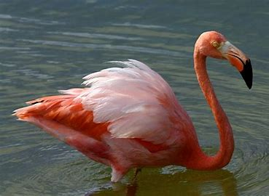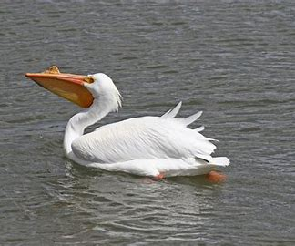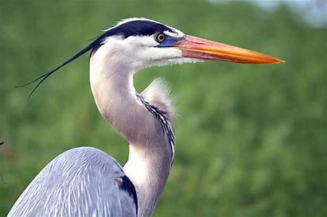

The marshes are home to 40 species of bird and several species of fish. Birds like Flamingos, pelicans and herons inhabit the marshes. The marshes were once home to a large number of birds and the stopover for many other migratory birds as they traveled from Siberia to Africa. At risk are 40% to 60% of the world's marbled teal population that live in the marshes, along with 90% of the world's population of Basra reed-warbler. A subspecies of the hooded crow known as the Mesopotamian crow is found in this part of southern Iraq. Seven species are now extinct. The draining of the marshes caused a significant decline in bioproductivity; following the 2003- US invasion to Iraq, water flow to the marshes was restored and the ecosystem has begun to recover.

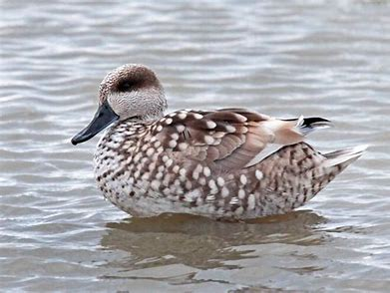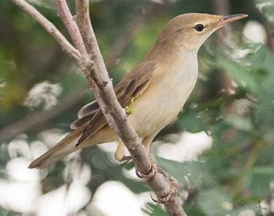
People live in isolated villages of reed houses throughout the marshes, often only reached by boat. Fish, rice cultivation, water buffalo and other resources are also used in their daily lives. In the 1950s, there were an estimated 500,000 Marsh Arabs. This population shrank to about 20,000 following the draining between1980-2003. Following the 2003 Iraq invasion, Marsh Arabs have begun to return to the marshes.

Source: Wikipedia
Mesopotamian Marshes - Wikipedia

