Prokaryotes and Eukaryotes

Taxonomy
Is the science of defining groups of biological organisms on the basis of shared characteristics and giving names to those groups. Organisms are grouped together into taxa and given a taxonomic rank.
Species are arranged in a hierarchical system in which genera are grouped into families, families into orders, orders into classes, classes into phylum (alternatively called division in plants, fungi and bacteria), phyla into kingdoms, kingdom into domain. The following figure shows the hierarchical system used in classifying organisms
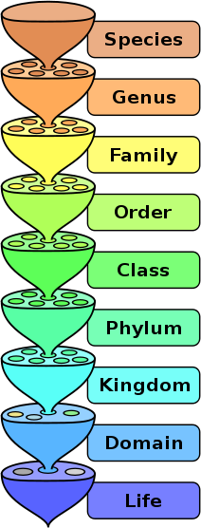
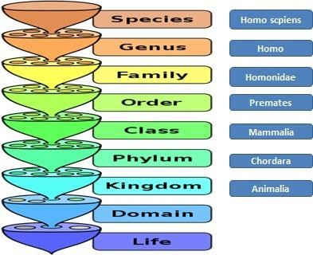

The hierarchical system of humans
The earliest classification system recognized only two kingdoms (plants and animals).As biologists discovered microorganisms and learned more about other organisms, the number of kingdoms increased. Biologists now use their, six-kingdom system, which included two of prokaryotes and four kingdoms of eukaryotes.

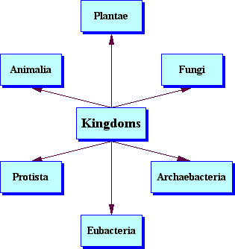

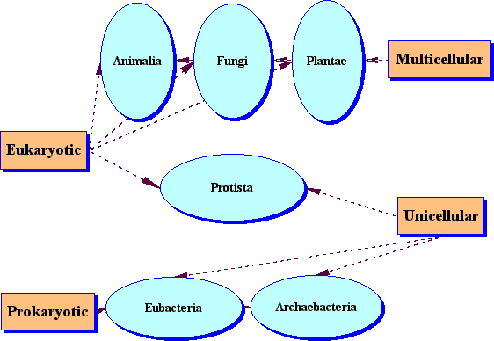

Prokaryotes: are organisms without a cell nucleus or any other membrane-bound organelles. Most are unicellular, but some prokaryotes are multicellular.
Eukaryotes: are organisms whose cells are organized into complex structures by internal membranes and a cytoskeleton. The most characteristic membrane bound structure is the nucleus.

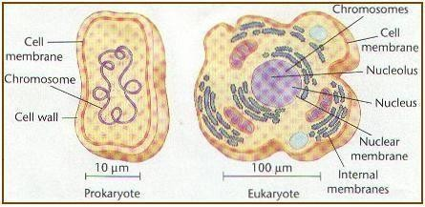
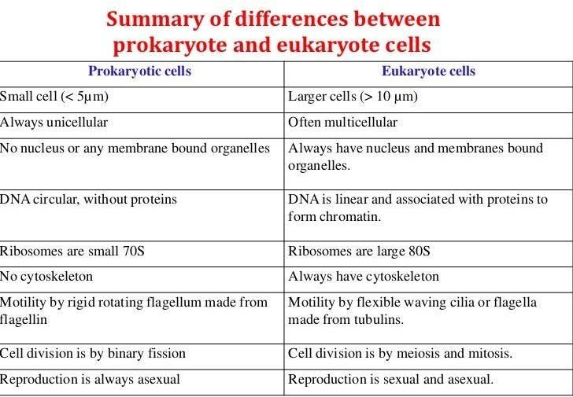

Al-Mustaqbal College University Department Of Dentistry
Biology Lec-2 M.Sc Fatima Hakim

