Bacteria and oral disease

Bacteria (bacterium): prokaryotic unicellular microorganisms that were the first forms of life to appear on Earth, about 4 billion years ago.

Morphology
Bacteria display a wide diversity of shapes and sizes. Bacterial cells are about one-tenth the size of eukaryotic cells and are typically 0.5–5.0 micrometers (µm) in length. However, a few species are visible to the naked eye, for example, Thiomargarita is up to half a millimeter long. Among the smallest bacteria are members of the genus Mycoplasma, which measure only 0.3 micrometers, as small as the largest viruses. Some bacteria may be even smaller, but these ultra microbacteria are not well studied
1-Most bacterial species are either spherical, called cocci (sing. coccus).
2-Others are rod-shaped, called bacilli (sing. bacillus).
3-Some bacteria, called vibrio, are shaped like slightly curved rods or comma-shaped.
4-others can be spiral-shaped, called spirilla, or tightly coiled, called spirochaetes.
5-A small number of species even have tetrahedral or cuboidal shapes. More recently, some bacteria were discovered deep under Earth's crust that grow as branching filamentous types

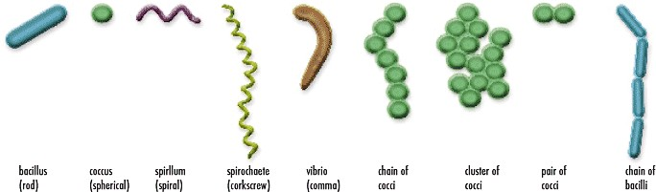
Cell structure
The protoplast of the bacterial cell is the whole body of living material(protoplasm) which bounded peripherally cytoplasmic membrane.

Bacterial structure
Bacteria, despite their simplicity, contain a well-developed cell structure, which is responsible for many of their unique biological functions. Bacterial cells typically contain the following structures: a cell wall, cell membrane, cytoplasm, ribosomes, plasmids, flagella, and a nucleiod region.
Cell Wall - Outer covering of the cell that protects the bacterial cell and gives it shape.
Cytoplasm - A gel-like substance composed mainly of water that also contains enzymes, salts, cell components, and various organic molecules.
Cell Membrane or Plasma Membrane - Surrounds the cell's cytoplasm and regulates the flow of substances in and out of the cell.
Nucleoid Region - Area of the cytoplasm that contains the single bacterial DNA molecule.
Inclusions-Inclusion are considered to be nonliving components of the cell that do not possess metabolic activity and are not bounded by membranes. The most common inclusions are glycogen, lipid droplets, crystals, and pigments.
Plasmid -most bacteria also contain small independent pieces of DNA called plasmid that often encode for traits that are advantageous but not essential to their bacterial host. Plasmids can be easily gained or lost by a bacterium and can be transferred between bacteria. So plasmids can be described as an extra chromosomal DNA in a bacterial cell.
Flagella - Long, whip-like protrusion that aids in cellular locomotion.

Ribosomes - Cell structures responsible for protein production.
Endospores- are bacterial survival structures that are highly resistant to many different types of chemical and environmental stresses and therefore enable the survival of bacteria in environments that would be lethal for these cells
Fimbriae - are protein tubes that extend out from the outer membrane They are generally short in length and present in high numbers about the entire bacterial cell surface. Fimbriae usually function to facilitate the attachment of a bacterium to a surface.
Pili- are similar in structure to fimbriae but are much longer and present on the bacterial cell in low numbers. Pili are involved in the process of bacterial conjugation where they are called conjugation pili or sex pili. Pili are absent in gram-positive bacteria and present in gram-negative bacteria.
Cell wall
The envelope is composed of the plasma membrane and cell wall. The bacterial cell wall differs from that of all other organisms by the presence of peptidoglycan which is located immediately outside of the cytoplasmic membrane. Peptidoglycan is made up of a polysaccharide backbone consisting of alternating N-Acetylmuramic acid (NAM) and N- acetylglucosamine (NAG) residues in equal amounts. The major function of the cell wall is to provide rigidity, tensile strength, structural support, protection against mechanical stress and infection. It also aids in diffusion of gases in and out of the cell
Gram-positive cell walls are thick and the peptidoglycan ( also known as murein) layer form almost 95% of the cell , The gram positive bacteria have a thick cell wall and is made up of many layers of peptidoglycan and teichoic acids.
Gram-negative cell walls are thin and unlike the gram-positive cell walls, they contain a thin peptidoglycan layer(5-10%) adjacent to the cytoplasmic membrane. The gram negative bacteria have thinner cell walls, and is made up of few layers of peptidoglycans and is surrounded by a lipid membrane containing lipopolysacccharides and lipoproteins(outer membrane)

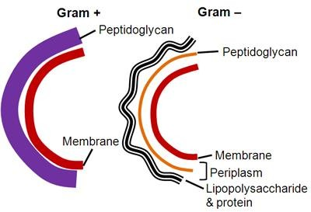

Flagella
Flagella are extracellular bacterial cell structures .Flagella are whip-like structures protruding from the bacterial cell wall and are responsible for bacterial motility (i.e. movement). The arrangement of flagella about the bacterial cell is unique to the species observed. Common forms include:
A-Monotrichous - Single flagellum
B-Lophotrichous - A tuft of flagella found at one of the cell pole
C-Amphitrichous - Single flagellum found at each of two opposite poles D-Peritrichous – Multiple flagella found at several locations about the cell
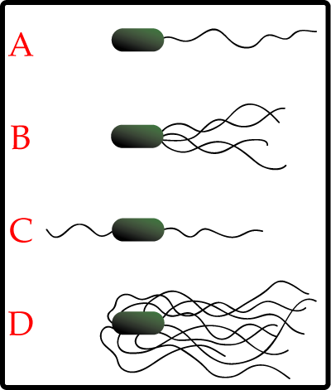

Bacterial reproduction
1-asexual reproduction
-Bacterial reproduction most commonly occurs by a kind of cell division called simple binary fission. Binary fission results in the formation of two bacterial cells that are genetically identical.
-Budding: external buds from the parent cell

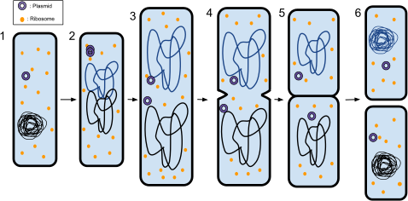 Binary fission in a prokaryote
1-The bacterium before binary fission is when the DNA is tightly coiled.
2-The DNA of the bacterium has uncoiled and replicated.
3-The DNA is pulled to the separate poles of the bacterium as it increases size to prepare for splitting.
4-The growth of a new cell wall begins to separate the bacterium.
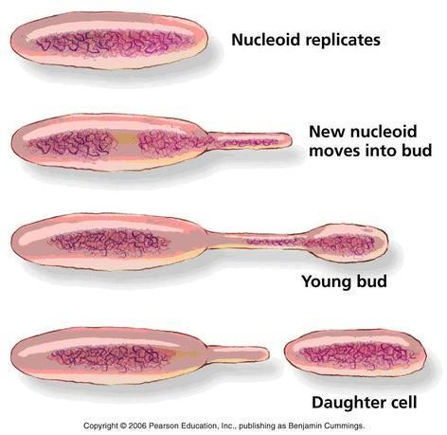
5-The new cell wall fully develops, resulting in the complete split of the bacterium.

2-Sexual reproduction
In sexual reproduction there is no meiosis(formation of gametes and zygote).Instead, it involves transfer of a portion of genetic material (DNA) from a donor cell to a recipient cell. This process called as genetic
recombination, it is occur in the following three ways:Transformation( the liberated DNA from a destroyed cell penetrates another one)
Transduction (when a bacteriophage carries DNA fragments from one cell to another)
Conjugation (sexual contact between two bacterial cells)
bacterial conjugation occur through which a donor cell transfers plasmid DNA(small circular molecule of extra bacterial DNA that carries a few genes and is replicated independently of the chromosome) to recipient cell through a conjugation tube formed between both cells.in the recipient cell, replication starts on the transferred DNA, then the cell move apart and the plasmid in each cell forms a circle .

Bacterial growth
Bacterial growth follows four phases. When a population of bacteria first enter a high-nutrient environment that allows growth, the cells need to adapt to their new environment. The first phase of growth is the lag phase, a period of slow growth when the cells are adapting to the high- nutrient environment and preparing for fast growth. The lag phase has high biosynthesis rates, as proteins necessary for rapid growth are produced. The second phase of growth is the log phase, also known as the exponential phase. The log phase is marked by rapid exponential growth. The rate at which cells grow during this phase is known as the growth rate (k), and the time it takes the cells to double is known as the generation time (g). During log phase, nutrients are metabolised at maximum speed until one of the nutrients is depleted and starts limiting growth. The third phase of growth is the stationary phase and is caused by depleted nutrients. The cells reduce their metabolic activity and consume non-essential cellular proteins. The stationary phase is a transition from rapid growth to a stress response state The final phase is the decling death phase where the bacteria run out of nutrients and die.

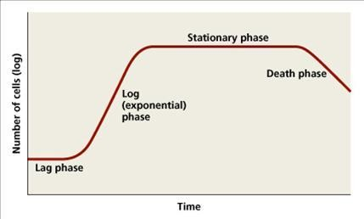
Metabolism - How do bacteria feed themselves?
Bacteria feed themselves in a variety of ways.

***Heterotrophic bacteria (or just heterotrophs)
is an organism that cannot fix carbon, and uses organic carbon for growth. Heterotrophs can be further divided based on how they obtain energy; if the heterotroph uses light for energy, then it is considered a photoheterotroph , while if the heterotroph uses chemical energy, it is considered a chemoheterotroph .

***Autotrophic bacteria (or just autotrophs)
microorganisms that are able to make their own food, from simple substances present in its surroundings (They synthesize their own organic food from inorganic substances) . There are two major classes of autotrophs: Chemoautotrophs and photoautotrophs. Phototrophs use light as an energy source, while chemotrophs utilize electron donors as a source of energy, whether from organic or inorganic sources;
Chemoautotrophs are bacteria that use chemical energy. They are able to take in carbon dioxide and water and convert those substances into carbohydrates and sugars. Carbohydrates and sugar are the main energy sources for bacteria.
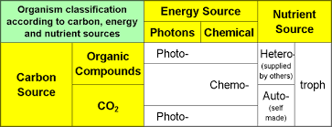
Photoautotrophs are autotrophs that obtain their energy from sunlight. Much like plants, these organisms can turn light energy into chemical energy that will fuel the bacteria’s processes. These organisms contain a green pigment called cyanobacteria. Much like the chlorophyll in plants, this substance helps to convert carbon dioxide and sunlight into oxygen and sugar

What kinds of environments do bacteria inhabit?
***Aerobes (aerobic bacteria) - these can grow only in the presence of oxygen. Some types may cause serious problems to people's infrastructure as they can cause corrosion, fouling, problems with water clarity, and bad smells.
***Anaerobes (anaerobic bacteria) - these can only grow if there is no oxygen present. In humans, they are most commonly found in the gastrointestinal tract. They also cause gas gangrene, tetanus, and botulism. Most dental infections are caused by this type of bacterium.
***Facultative anaerobes (facultative anaerobic bacteria) - these thrive in environments with or without oxygen. However, when given both options, they prefer to use oxygen for respiration. Most commonly found in soil, water, vegetation and some normal flora of humans and animals. An example of a facultative anaerobic bacterium is salmonella.

Bacteria and disease
Although the great majority of bacteria play a positive role in human life in recycling essential substances to all other life forms, some bacteria are pathogenic(disease causing) to plants and animals. In humans, bacteria cause diseases through consumed contaminated food and water, inhalation and sexually transmission, such as dental caries , tuberculosis, pneumonia, syphilis and gonorrhea.
Bacteria vary in their:
1-pathogenicity (ability to cause disease)
2-virulence(degreeof pathogenicity)
3-invasiveness (ability to invade the host tissues or fluids)
4-toxicity(ability to create clinical response due to exotoxin or endotoxin).

