- The interaction of the laser with the material
Introduction;

Introduction: Electromagnetic waves are used to transmit signals or information from one place to another for the purpose of communication (Communication) and that is a material by loading or embedding the signal to be transmitted on the electromagnetic wave that acts as a medium for carrying or transmitting the information signal. Modulation and high frequencies However, the problem was to find the medium that can transmit or deliver this beam to long distances, as the air medium limits the use of this optical wave to a short distance only, so its use was limited at first within this field, for example, within one building or between buildings Contiguous between them places hundreds of meters in addition to the possibility of employing them in outer space and between satellites, for example.
The transmission of the beam for long distances in the air will be difficult due to the weather conditions of rain, snow, fog and dust, as these factors work to scatter (scattering) such a beam and attenuate it (Artenuation).

Therefore, the need for a transparent kiel that isolates the driving of the optical wave has become, as it acts as a waveguide called fiber optics to avoid the forbidden optical attenuation due to weather conditions.
You know that light waves (laser beams) transmit energy and that the amount of energy that passes through a unit area perpendicular to the direction of the path per second is called intensity 1 (Intensity).
In spherical waves, the intensity is inversely proportional to the square

of the distance from the source, and this is due to the fact that the same amount of energy must pass through any sphere whose center is the same source, provided that there is no transformation of energy into any form whatsoever. If absorption occurs, then both the amplitude and intensity in flat waves will decrease as the waves penetrate more and more into the medium, and this also happens with regard to spherical waves, the decrease in intensity here will be faster according to the inverse square law.
The absorbance (A) is defined as the logarithm (to base 10) of the ratio between the input intensity Io and the window intensity 1 and it increases directly with the density (concentration of the absorbent material) and the length of the path traveled by the beam.
In flat waves, the ratio of the intensity lost during the passage of waves through a very small thickness of dx is directly proportional to that thickness, i.e.: di
dI/I=-α dx ........(1)

Where α:- the absorption coefficient is a measure of the percentage of loss in light.
The goal of the experiment:-
Calculation of the glass absorption coefficient of the laser beam
The devices used:
1-laser He-Ne
2-intensity and energy meter 3-pregnant
4-glass slides

Experience theory:-
To get the magnitude of the decrease as the laser beam passes through an absorbing medium of thickness x, we integrate equation (1) along the thickness as follows:-
Ƒx0dI/I=-αƒx0 dx Ix=IOe-αx .........*
This is the basic law of absorption, and the following figure shows the relationship between the ratio of the penetrating intensity to the total intensity with the thickness of a medium in it α=0.4cm

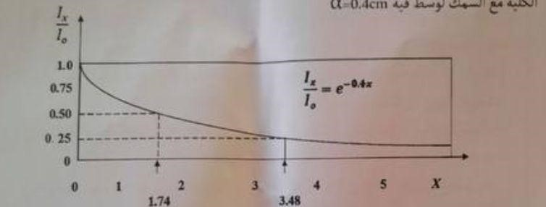

If a beam of light (laser beam) passes through a

transparent material, its passage is affected by two things
1-The intensity decreases as the light penetrates more through the medium.
2-The velocity is lower in this medium than in a vacuum or (air). The method of work:-
1-We install the laser at an appropriate distance from the intensity or energy scale and at one level.
2-Read the intensity value I0(zero fish).
3-We install the glass slide on the holder and intercept the laser beam and measure the intensity IX.
4-Increase the number of absorbent strips, measure the intensity each time, and record the readings in a table.
5-Draw the relationship between(ln/I0) Find the absorption coefficient of glass.
6-Calculate the half thickness of the glass that cuts the intensity in half from the graph of the relationship between(IX/I0) and the(x) As in the previous diagram, calculate the absorption coefficient from it.

