Lecture 2 Dental Equipment Technologies Dr.Muna Merza

Agar-agar melting machine, Flask cooling and Burn-out furnace

Agar-agar melting machine (Gelovet):
It is a device used to soft gelatin duplication materials (Agar - Agar materials) and then poured in the opening of the duplication flask. it's used in chromium-cobalt lab, it consists of:
A. Upper lid
B. Control panel
C. Legs
D. Main switch
E. Spout
F. Tap
G. Mixing fan

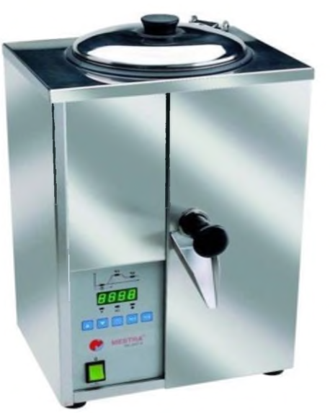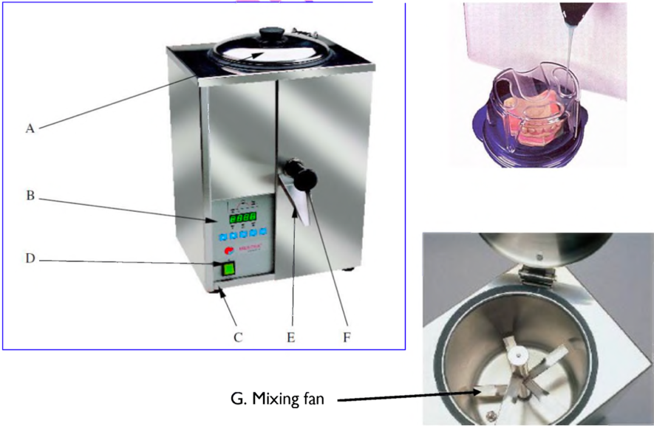

Casting ring:
It's a piece of stainless steel or plastic, cylindrical in shape used to hold the investment available in a variety of diameters and highest to accept patterns of various sizes and shapes.
The casting ring use to:
1- Hold the investment during the setting.
2- Restricted the expansion of the mold.

Sprue base (crucible former):
It's the base on which the sprue pattern is a position to hold it in place during the investing procedure it is also term crucible, since, its form a depression in the investment which is used to hold the metal during melting procedure, if it’s made of rubber or plastic, its different size to fit various size & types of casting ring. Universal cone
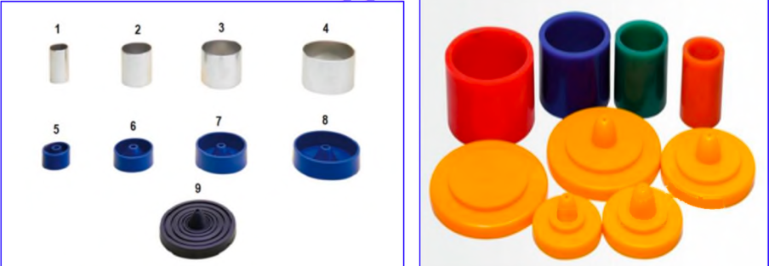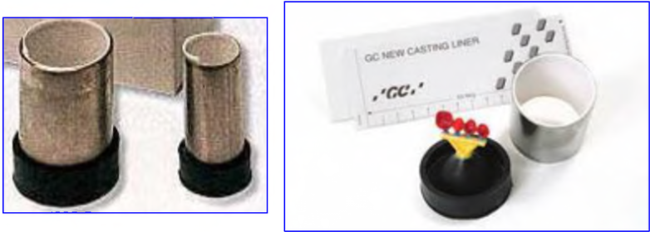
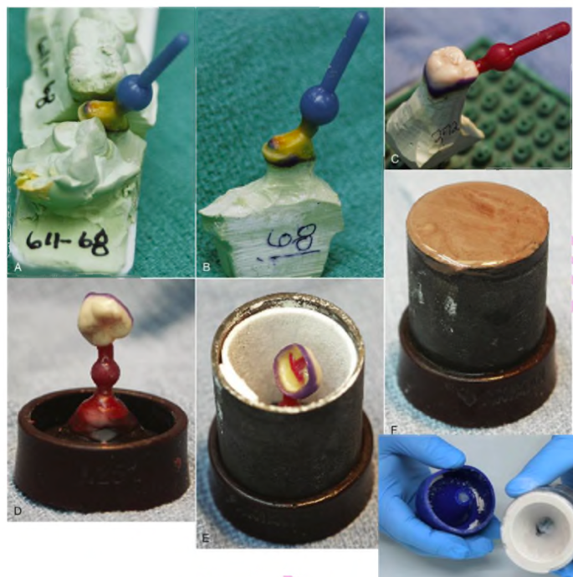

Burn-out Furnace:
Is an electric furnace is used in the dental laboratory in (crown & bridge and chromium-cobalt construction) chiefly for:
1 wax elimination.
2) Heating investment models.
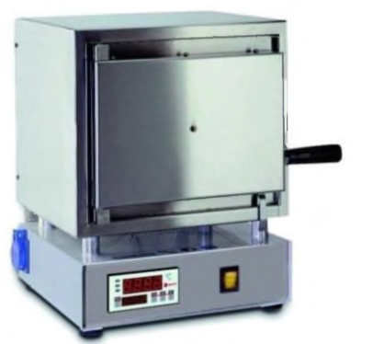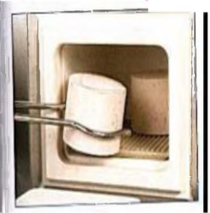

There are several types of this furnace called firing furnace, this furnace consists of:
A. On-Off switch
B. Control panel
C. Temperature display
D. Time display
E. Door
F. Hearth
G. Muffle
H. Ventilation Tube
I. Current pickup

