Lecture 12 Dental Equipment Technologies Dr.Muna Merza
Electronic spatula for wax modeling

Is an electronic spatula for wax modeling with one or two heating heads, specially designed
to be used by professionals in the field of dental prosthesis.
Its ergonomics, ease of use, and small size make it an optimal tool for this type of work.
The accuracy of the electronic controls is also remarkable since it maintains the temperature in
the spatula head within a narrow error range.
The working temperature is shown on the digital display in the controls box.

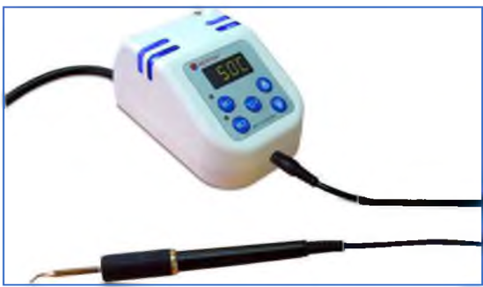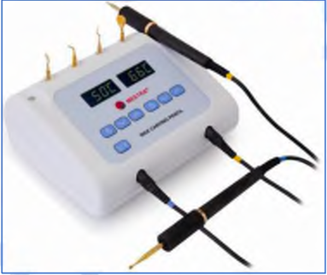

Parts:

A. Point
B. Handle
C. Main switch
D. Magnetic holder
E. Connection hole
F. Case for points

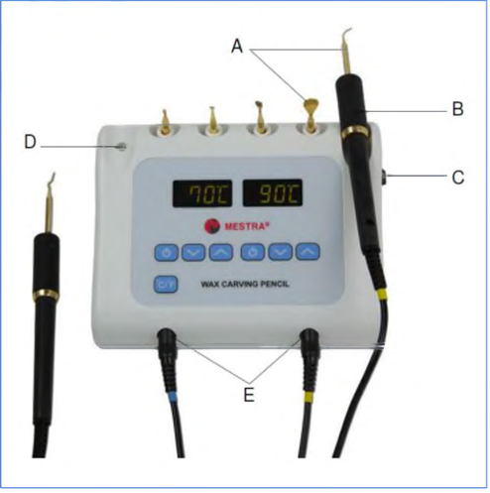
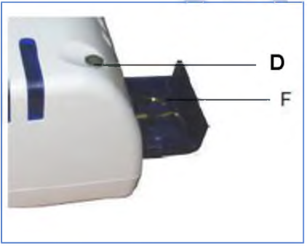

Lecture 13 Induction Wax Modelling and Dipping Wax Unit

Induction Tool Heater:
The Induction Tool Heater is a simple desktop device to heat metallic spatulas and similar tools used for wax modelling in the Dental Lab. Just insert the head of the tool you want to heat into the hole at the front of the device, and in a few seconds, it will reach the optimal working
temperature. This way you don’t need to use the traditional Bunsen burner and you will prevent its drawbacks: gas tanks, fumes, fire hazard, etc.
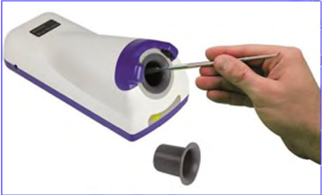
Parts:
A. Sensors
B. Induction cavity
C. Display
D. Sensitivity adjustment -
E. Disposable shield
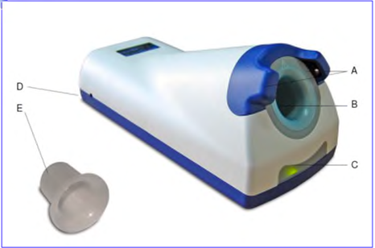
Dipping wax heater (Wax heater bowls):
Is a practical wax immerse heater which has been specially designed for use in the dental prosthesis sector.
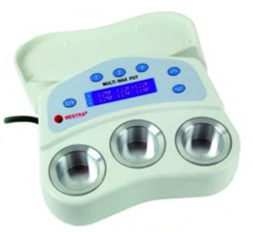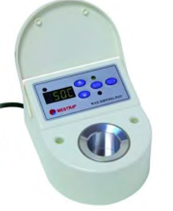
Parts:
1. Lid
2. Heating pilot light
3. Display
4. Tank
5. Set Point temperature pilot light.
6. Set Point actual temperature key.
7. oC - oF Key
8. Actual temperature pilot light
9. Up-down keys

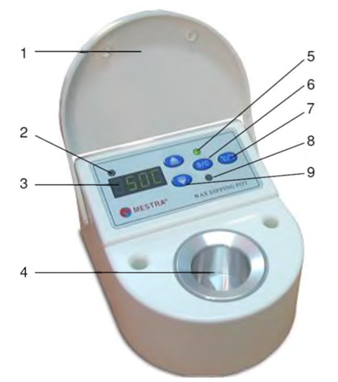

Lecture 14 General Measurement Instrument and Hopper Duplicator
General Measurement Instrument:
This instrument with different shape use in prosthesis laboratories & have two types:
A- Distance & thickness measurement tools.
B- Volume measurement tools.

Tools & instrumentst that are used for measuring thickness and distance:
- Ruler: used for distance

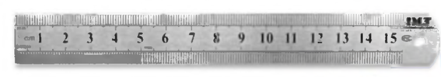
2- Vernier: used for measuring thickness, distance and depth Made from stainless steel
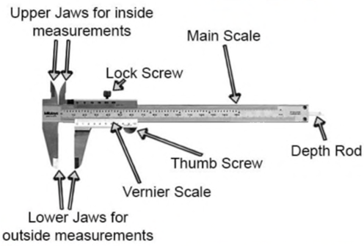
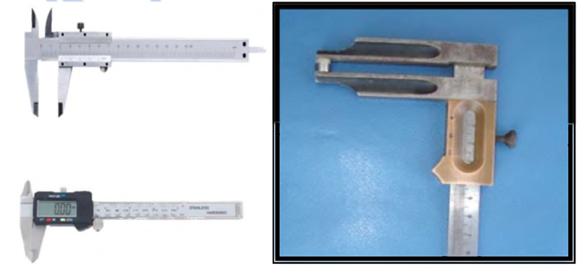
3- Iwanson caliper device:
This device have head & ruler start from (0 - 10 mm), made of stainless steel, they are 2 types:
Type (I) Wax caliper device.
Type (II) Metal caliper device.
The difference between type I & Il the head of wax caliper device is round end to measure the wax in crown & bridge, while the head of metal caliper device is pointed end to measure the metal in crown & bridge.
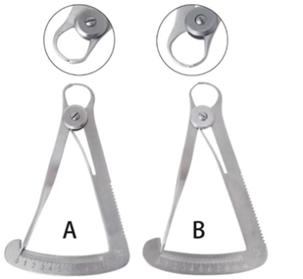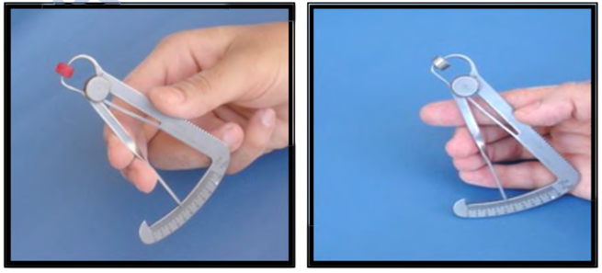
4- Volume measurement tools include:
1. Glass measuring cylinder
2. Glassflask
3. Beaker 4. Measuring spoon with different size.
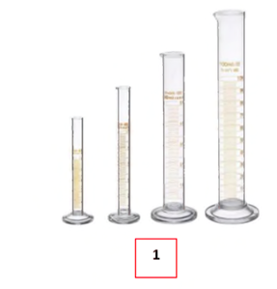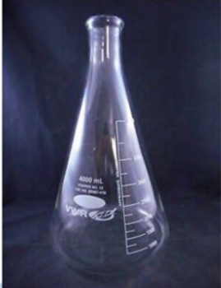 2 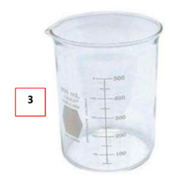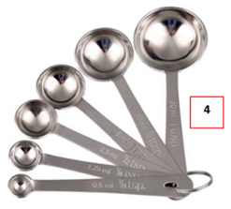
Hopper Duplicator:
This instrument maintains the relationship of the teeth to the cast during the rebasing procedure ((rebasing removed the old denture base & replaced by a new denture base material with preservation of the relation of denture teeth)). The parts of hopper duplicator (upper and lower members separated which contact with secrow). Note the occlusal index on the lower member of duplicator.
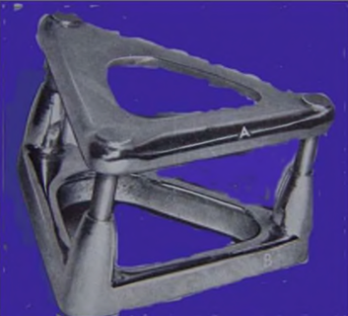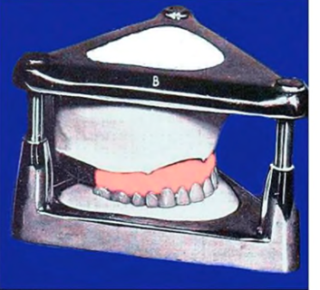
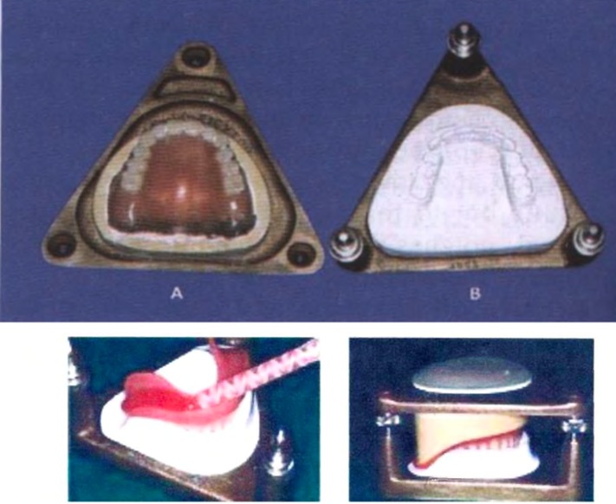
Lecture 15 CAD CAM Production Methods
CAD CAM
(Computer - aided design and computer -aided manufacture)
Is a term that refers to computer system that are used to both design and manufacture products.
CAD / is the use of computer technology for process ofdesign and design- documentation.
CAM / is the use of computer system both for designing product and for controlling manufacturing processes.
The use of CAD/CAM system to create an appropriate design and fitness of different dental restorations like zirconium crown, fixed bridges, dental (Veneers, Inlays, Onlays), dental implant restorations, orthodontic appliances, and removable dentures (complete and/or partial).

CAD/CAM components
CAD/CAM systems are composed of three major parts:
1- A scanner or digitizing instrument that transforms physical geometry into digital data.
2- Software for designing virtual restorations on avirtual working cast and then computing the milling parameters.
3- A computerized milling device for manufacturing the restoration from a solid block of restorative material or additive manufacturing.

