Computer
Introduction to Computer components

A computer is an electronic device, operating under the control of instructions stored
in its own memory that can accept data (input), process the data according to specified rules, produce information (output), and store the information for future use1.

Generations of Computers
The history of computer development is often referred to the different generations of computing devices. Each generation of computer is characterized by a major technological development that fundamentally changed the way computers operate, resulting in increasingly smaller, cheaper, more powerful, more efficient and reliable devices.

First Generation (1940-1956) Vacuum Tubes
The first computers used vacuum tubes for circuitry and magnetic drums for memory, and were often enormous, taking up entire rooms. They were very expensive to operate and in addition to using a great deal of electricity, generated a lot of heat, which was often the cause of malfunctions.
First generation computers relied on machine language, the lowest-level programming language understood by computers, to perform operations, and they couldonly solve one problem at a time. Input was based on punched cards and paper tape, and output was displayed on printouts.
The UNIVAC and ENIAC computers are examples of first-generation computing devices.

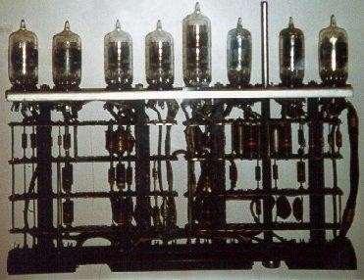

vacuum tubes

Second Generation(1956-1963) Transistors Transistors replacedvacuumtubes in the second generationof computers.. The transistor was far superior to the vacuumtube, allowing computers to become smaller, faster, cheaper, more energy-efficient and more reliable than their first-generation predecessors. Though the transistor still generated a great deal of heat that subjected the computer to damage, it was a vast improvement over the vacuum tube. Second-generation computers still relied on punched cards for input and printouts for output.

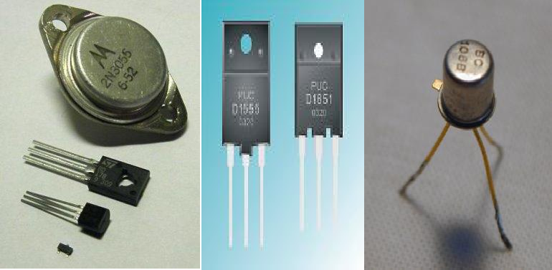

Transistors

Third Generation (1964-1971) Integrated Circuits The development of the integrated circuit was the hallmark of the third generation of computers. Transistors were placed on silicon chips, called semiconductors, which drastically increased the speed and efficiency of computers.
users interacted with third generation computers through keyboards and monitors and interfaced with an operating system, which allowed the device to run many different applications at one time with a central program that monitored the memory.

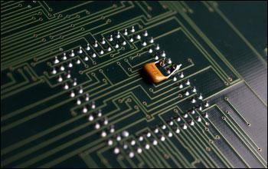

Integrated ciurcits

Fourth Generation (1971-Present) Microprocessors The microprocessor brought the fourth generation of computers, as thousands of integrated circuits were built onto a single silicon chip. What in the first generation filled an entire room could now fit in the palm of the hand.
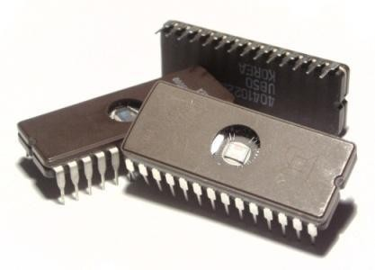
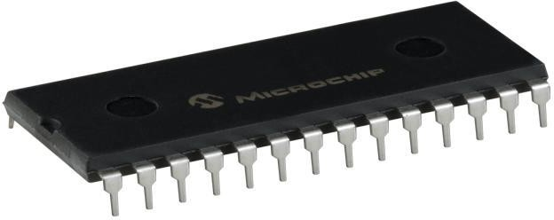

Microcircuits

Fifth Generation (Present and Beyond) Artificial Intelligence Fifth generation computing devices, based on artificial intelligence, are still in development, though there are some applications, such as voice recognition, that are being used today. The use of parallel processing and superconductors is helping to make artificial intelligence a reality.

Functionalities of a computer²
Any digital computer carries out five functions in gross terms:

Computer Components

Any kind of computers consists of HARDWARE AND SOFTWARE.

Hardware
Computer hardware is the collection of physical elements that constitutes a computer system. Computer hardwarerefersto the physical partsor components of a computer such as the monitor, mouse, keyboard, computer data storage, hard drive disk (HDD),
system unit (graphic cards, sound cards, memory, motherboard and chips), etc. all of which are physical objects that can be touched.³

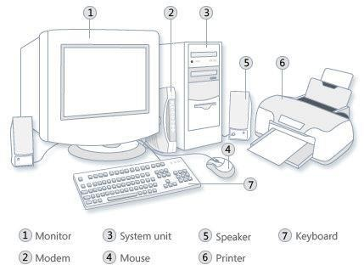

Input Devices

Input device is any peripheral (piece of computer hardware equipment to provide data and control signals to an information processing system such as a computer or other information appliance.
Input device Translate data from formthat humans understandto onethatthe computer can work with. Most common are keyboard and mouse

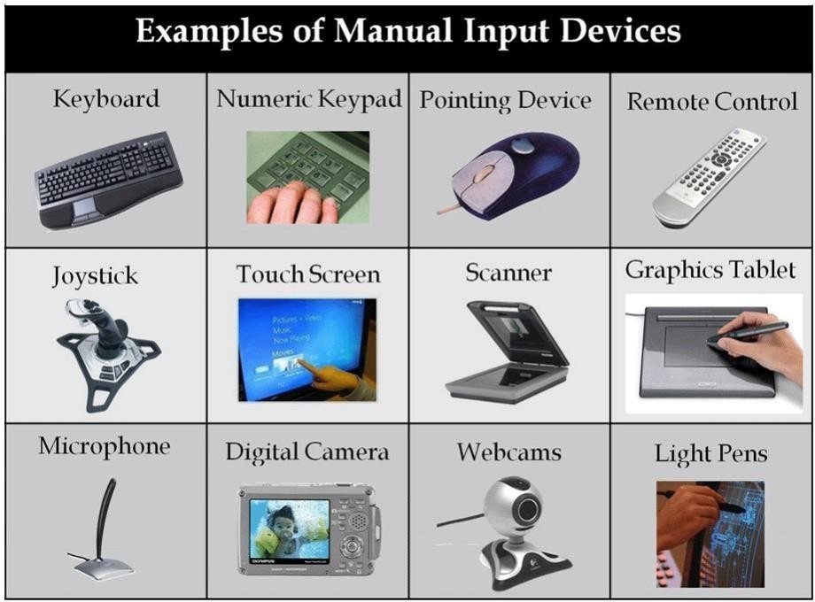

Example of Input Devices:-

1. Keyboard | 2. Mouse (pointing device) | 3. Microphone
4. Touch screen | 5. Scanner | 6. Webcam
7. Touchpads | 8. MIDI keyboard | 9.
10.Graphics Tablets | 11.Cameras | 12.Pen Input
13.Video Capture Hardware | 14.Microphone | 15.Trackballs
16.Barcode reader | 17.Digital camera | 18.Joystick
19.Gamepad | 20.Electronic Whiteboard | 21.

Note: The most common use keyboard is the QWERTY keyboard. Generally standard Keyboard has 104 keys.

Central Processing Unit (CPU)

A CPU is brain of a computer. It is responsible for all functions and processes. Regarding computing power, the CPU is the most important element of a computer system.
The CPU is comprised of three main parts :
- Arithmetic Logic Unit (ALU): Executes all arithmetic and logical operations.
Arithmetic calculations like as addition, subtraction, multiplication and division. Logical operation like compare numbers, letters, or special characters
- Control Unit (CU): controls and co-ordinates computer components.
  - Read the code for the next instruction to be executed.

  - Increment the program counter so it points to the next instruction.
  - Read whatever data the instruction requires from cells in memory.
  - Provide the necessary data to an ALU or register.

  - If the instruction requires an ALU or specialized hardware to complete, instruct the hardware to perform the requested operation.
* Registers :Stores the data that is to be executed next, "very fast storage area".

Primary Memory:-
- RAM: Random Access Memory (RAM) is a memory scheme within the computer
system responsible for storing data on a temporary basis, so that it can be promptly accessedby the processor asandwhenneeded. It isvolatile in nature, which means that data will be erased once supply to the storage device is turned off. RAM stores data randomly and the processor accessesthese data randomly from the RAM storage. RAM is considered "random access" because you can access any memory cell directly if you know the row and column that intersect at that cell.
- ROM (Read Only Memory): ROM is a permanent form of storage. ROM stays active regardless of whether power supply to it is turned on or off. ROM devices do not allow data stored on them to be modified.

Secondary Memory:-
Stores data and programs permanently: its retained after the power is turned off

- Hard drive (HD): A hard disk is part of a unit, often called a "disk drive," "hard drive," or "hard disk drive," that store and provides relatively quick access to large amounts of data on an electromagnetically charged surface or set of surfaces.

- Optical Disk: an optical disc drive (ODD) is a disk drive that uses laser light as part of the process of reading or writing data to or from optical discs. Some drives can only read from discs, but recent drives are commonly both readers and recorders, also called burners or writers. Compact discs, DVDs, and Blu- ray discs are common types of optical media which can be read and recorded by such drives. Optical drive is the generic name; drives are usually described as "CD" "DVD", or "Bluray", followed by "drive", "writer", etc.
There are three main types of optical media: CD, DVD, and Blu-ray disc. CDs can store up to 700 megabytes (MB) of data and DVDs can store up to 8.4 GB of data. Blu-ray discs, which are the newest type of optical media, can store up to 50 GB of data. This storage capacity is a clear advantage over the floppy disk storage media (a magnetic media), which only has a capacity of 1.44 MB.

Flash Disk
A storage module made of flash memory chips. A Flash disks have no mechanical platters or access
arms, but the term "disk" is used because the data are accessed as if they were on a hard drive. The disk storage structure is emulated.

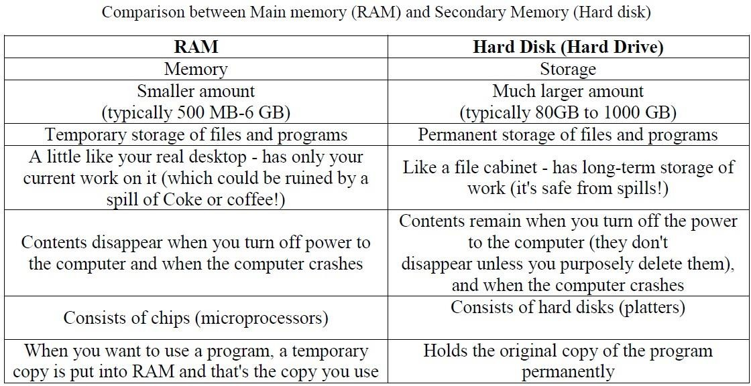

Output devices
An output device is any piece of computer hardware equipment used to communicate
the results of data processing carried out by an information processing system (such as a computer) which converts the electronically generated information into human- readable form.

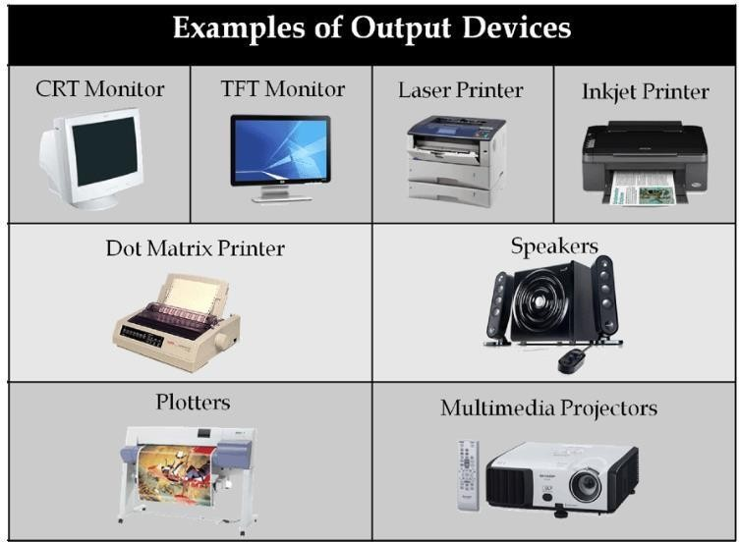

Examples on Output Devices:

1. Monitor | 2. LCD Projection Panels
3. Printers (all types) | 4. Computer Output Microfilm (COM)
5. Plotters | 6. Speaker(s)
7. Projector

Note Basic types of monitors are a.Cathode Ray Tube (CRT). B. Liquid Crystal Displays (LCD). c.light-emitting diode (LED).

Printer types: 1-Laser Printer. 2-Ink Jet Printer. 3-Dot Matrix Printer.

Software
Software is a generic term for organized collections of computer data and instructions, often broken into two major categories: system software that provides the basic non- task-specific functions of the computer, and application software which is used by users to accomplish specific tasks.

Software Types

  - System software is responsible for controlling, integrating, and managing the individual hardware components of a computer system so that other software and the users of the system seeit asa functionalunit without having to be concerned with the low-level details such as transferring data from memory to disk, or rendering text onto a display. Generally, system software consists of an operating system and some fundamental utilities such as disk formatters, file managers, display managers, text editors, user authentication (login) and management tools, and networking and device control software.

  - Application software is used to accomplish specific tasks other than just running the computer system. Application software may consist of a single program, such as an image viewer; a small collection of programs (often called a software package) that work closely together to accomplish a task, such as a spreadsheet or text processing system; a larger collection (often called a software suite) of related but independent programs and packages that have a common user interface or shared data format, such as Microsoft Office, which consists of closely integrated word processor, spreadsheet, database, etc.; or a software system, such as a database management system,which is a collection of fundamental programs that may provide some service to a variety of other independent applications.

Comparison Application Software and System Software

 | System Software | Application Software
 | Computer software, or just software is  a  general term primarily used for digitally  stored data such as computer programs and other kinds of information read and | Application software, also known as an application or an "app", is computer software designed to help the user to
Example: | - Microsoft Windows  - Linux | - Opera (Web Browser)  - Microsoft Word (Word Processing)  - Microsoft Excel (Spreadsheet software)
Interaction: | Generally, users do not interact with system software as it works in the background. | Users always interact with application software  while doing different activities.
Dependency: | System software can run independently of  the | Application software cannot run without  the

Units of Measurement

Storage measurements: The basic unit used in computer data storage is called a bit (binary digit). Computers use these little bits, which are composedof ones andzeros,to do things and talk to othercomputers. All your files, for instance, are kept in the computer as binary files and translated into words and pictures by the software (which is also ones and zeros). This two number system, is called a “binary number system” since it has only two numbers in it. The decimal number system in contrast hasten unique digits, zero through nine.

Computer Storage units

Bit | BIT | 0 or 1
Kilobyte | KB | 1024 bytes
Megabyte | MB | 1024 kilobytes
Gigabyte | GB | 1024 megabytes
Terabyte | TB | 1024 gigabytes

Speed measurement: The speed of Central Processing Unit (CPU) is measured by Hertz (Hz), Which represent a CPU cycle. The speed of CPU is known as Computer Speed.

CPU SPEED MEASURES
1 hertz or Hz | 1 cycle per second
1 MHz | 1 million cycles per second or 1000 Hz
1 GHz | 1 billion cycles per second or 1000 MHz

References
1 Vermaat, Misty E. Microsoft Office 2013 Introductory. Cengage Learning, p.IT3. 2014
2
http://www.tutorialspoint.com/computer_fundamentals/computer_quick_guide. htm

3 http://en.wikipedia.org/wiki/Computer_hardware

***http://www.acobas.net/teaching/survival/handouts/pcwebopedia.pdf.

