Ministry of Higher Education and Scientific Research
Al-Mustaqbal University College

Chemical engineering and petroleum industries
(Materials Science lab)

Experiment No.1
(Tensile test)

Prepared by
Eng.Fatima Oday
Eng.Zainab Imad
Eng.Zainab Jwad

Aim of experiment:
• To obtain a general understanding of how material behave under tensile loading.
• Demonstrate the relationship between stress and strain.
Theory
One of the most fundamental mechanical tests that can be performed on a material is the tensile test. A test sample is loaded in tension when it experiences opposing forces acting upon opposite faces both located on the same axis that attempt to pull the specimen apart. These tests are simple to setup and complete and reveal many characteristics of the material that is tested.
The basic idea of a tensile test is to place a sample of a material between two fixtures called "grips" which clamp the material. The material has known dimensions, like length and cross-sectional area. We then begin to apply weight to the material gripped at one end while the other end is fixed. We keep increasing the weight (often called the load or force) while at the same time measuring the change in length of the sample.
Stress It is defined as the ratio of applied load to the cross section area of the body.
$$σ=\frac{F}{A}$$
F : the applied force in KN
A: the cross sectional area in mm²

Strain is the measure of the deformation of the material. It is simply a ratio of the change in length to the original length.
$$ε=\frac{∆L}{L_{0}}=\frac{(L_{f}-L_{0})}{L_{0}}$$
L_{f} : final length in mm
L₀: initial length in mm

Stress-strain curve
When we study solids and their mechanical properties, information regarding their elastic properties is most important. We can learn about the elastic properties of materials by studying the stress-strain relationships, under different loads, in these materials.
The material’s stress-strain curve gives its stress-strain relationship. In a stress-strain curve, the stress and its corresponding strain values are plotted. An example of a stress-strain curve is given below.
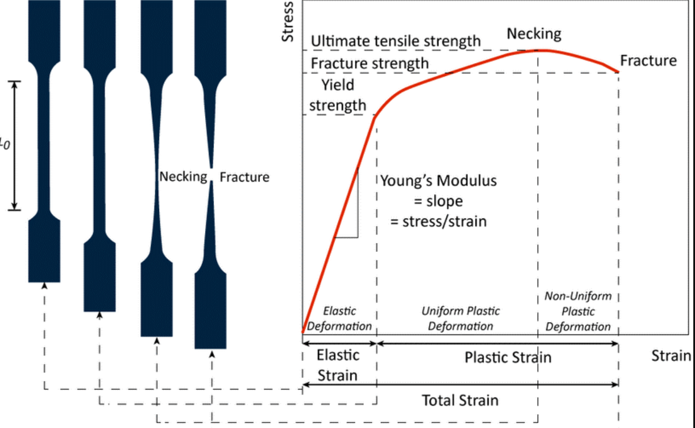

Young's modulus (E) is a measure of a solid's stiffness or resistance to elastic deformation under load.
It relates stress (force per unit area) to strain (proportional deformation) along an axis or line. The basic principle is that a material undergoes elastic deformation when it is compressed or extended, returning to its original shape when the load is removed. More deformation occurs in a flexible material compared to that of a stiff material. In other words:
- A low Young's modulus value means a solid is elastic.
- A high Young's modulus value means a solid is inelastic or stiff.
$$E =\frac{σ}{ε}$$
E: Young's modulus
σ: Stress
ε: Strain
Elastic region It is the region where the material can be deformed and when released will return back to its original configuration.
Plastic region it is the region where some permanent deformation will occur, even if the load is removed.
Necking is a type of plastic deformation observed in ductile materials subjected to tensile stress. This deformation is characterized by a localized reduction in the cross-sectional area of the material
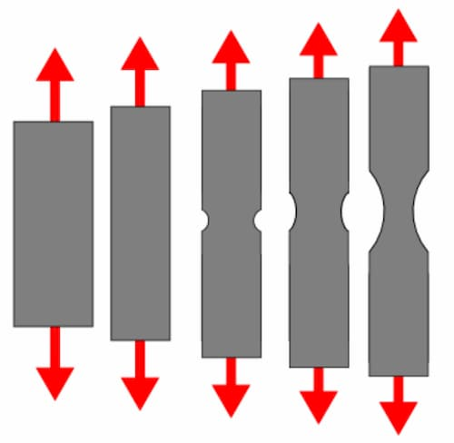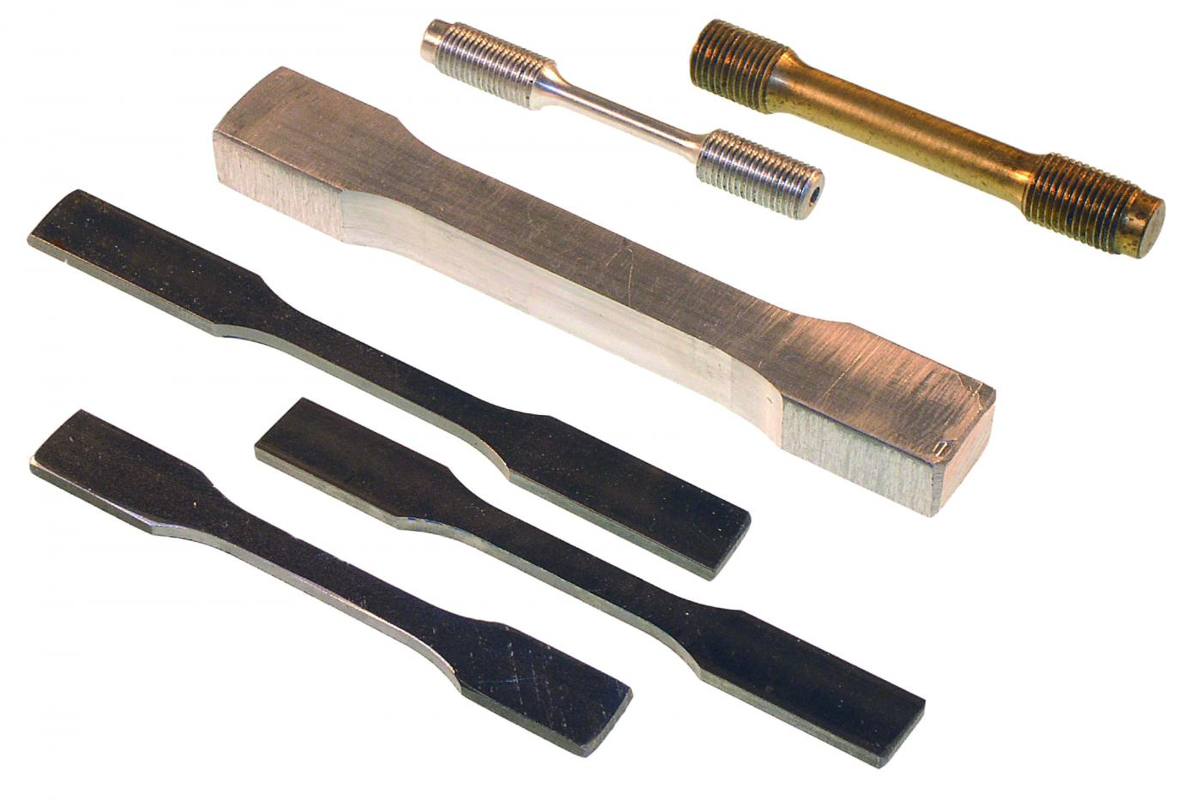

Procedure
1- Measure the initial length and the cross sectional area of the specimen
2- Put the specimen in the tensile test machine
3- Turn on the machine .it will apply a force on the specimen. Then record the force for every elongation that occurs
4- Continue until the specimen breaks and the failure occur

Calculations
Draw the stress-strain curve from the data.

Discussion:
1- Why do we do a tensile test for materials?
2- What is stress-strain curve?
3- What is necking?
4- What is elastic region?
5- What is stress?
6- What is Young’s modulus?

Load  (KN) | Elongation  (mm)$(∆L)$
0 | 0
2.5 | 0.000225
6.5 | 0.000625
8.5 | 0.001
9.2 | 0.001625
9.8 | 0.00245
12 | 0.01
14 | 0.03
14.5 | 0.0625
14 | 0.0875
13.2 | 0.1175
12.5 | 0.1325
12 | 0.15
11.8 | 0.17

The specimen is rounded so the cross sectional area will be of a circle
$$A=\frac{π}{{4d}^{2}}$$
D: 8 mm
L₀: 50mm

