Basics of material science
Dental Material
M.Sc Sadiq Almayali
Lec.1

Basics of material science

A material is defined as a substance that is intended to be used for certain applications. There are various materials around us; they can be found in anything from buildings and cars to spacecraft. The main classes of materials are metals, ceramics, polymers and composites.

The basis of materials science is studying the interplay between the structure of materials, the processing methods to make that material, and the resulting material properties. The complex combination of these produces the performance of a material in a specific application.

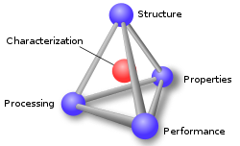

The science of dental materials involves a study of the composition and properties of materials and the way in which they interact with the environment.
Dental material science is defined as the science that deals with dental materials (their physical and mechanical properties, and their manipulation).

Importance of knowledge dental material science:
- make optimal selection of various materials.
- understand material behavior, use, handling and manipulation.

The dentist and dental technician have access to a larger range of materials. Rigid polymers, elastomers, metals, alloys, ceramics, inorganic salts and composite materials.

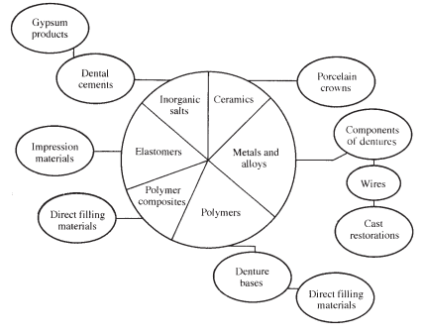
Diagram indicating the wide variety of materials used in dentistry and
some of their applications.

Selection of dental materials
- Analysis of the problem.
- Consideration of requirements.
- Consideration of available materials and their properties.
- Choice of material.

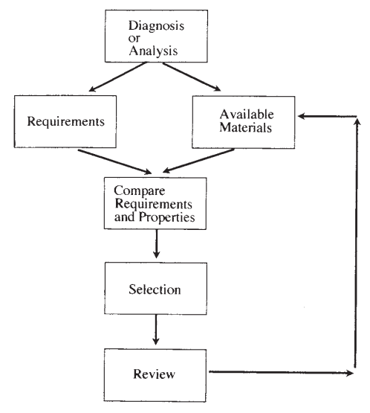
Flow chart indicating a logical method of material selection.

Classification of dental materials
1. Preventive materials: include materials used to prevent dental diseases like
pit and fissure sealants.

2. Restorative materials: include materials used to repair or replace tooth structure like amalgam, composites, ceramics, cast metal structures and denture materials.
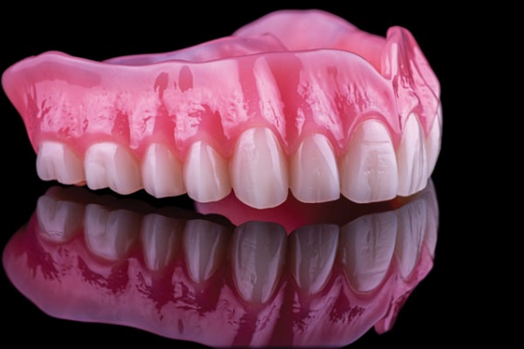

3. Auxiliary materials are substances that aid in the fabrication process but not part of the restoration like gypsum products, impression materials, casting investments, waxes, etc.

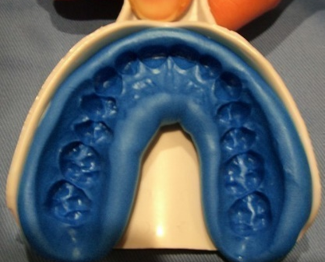

Requirements of Dental Materials
1. Biocompatibility: A dental material should be:
1. Nontoxic to the body.
2. Nonirritant to the oral or other tissues.
3. Not produce allergic reactions.
4. Not be mutagenic or carcinogenic.
2. High corrosion resistance.
3. High wear resistance.
4. It can be machined and formed easily into different shapes.
5. Available.
6. Low cost

Evaluation of the materials:
As the number of available materials increases, it becomes more and more important for the dentist and dental technician to be protected from unsuitable materials which have not been thoroughly evaluated. It depends on three aspects:
1. Standard specifications.
2. Laboratory evaluations.
3. Clinical trials

