Biological properties of dental material
Dental Material
M.Sc Sadiq Almayali
Lec. 10 and 11

Biocompatibility

Introduction
The science of dental materials must include a knowledge of the biological considerations that are associated with selection and use of materials designed for the oral cavity. Strength and resistance to corrosion are unimportant if the material irritates soft tissue.
In the early days of dentistry, the patient’s mouth was the testing ground of dental materials. Modern dentistry, however, involves extensive testing before the material is certified for human use.

Biomaterials
A biomaterial is defined as any substance that can be used to treat or replace any tissue, organ or function of the body.

- Many materials used in the mouth are classed as ‘biomaterials’.

Biocompatibility is defined as the ability of a material to have an appropriate biological response in a given application in the body.

- a single material may not be biologically acceptable in all applications. Materials that are biocompatible in contact with the oral mucosal surface may cause adverse reactions if they are implanted beneath it.

Biological Requirements of Dental Materials
A dental material should be:
1. Nontoxic to the body.
2. Nonirritant to the oral or other tissues.
3. Not produce allergic reactions.
4. Not be mutagenic or carcinogenic.

Measuring biocompatibility
- In Vitro Tests
Done outside a living organism and require placement of a material in contact with a cell or enzyme.

- Advantages
- Quick to perform
- Least expensive
- Large-scale screening
- Good experimental control

- Disadvantages
Less accuracy (compared to the other tests)

- Animal Tests (in vivo tests)
Involving mammals such as mice, rats, hamsters, or guinea pigs.

- Advantages
1. Allows complex systemic interactions.
2. More relevant than in vitro tests.

- Disadvantages
1. Expensive
2. Time consuming
3. Legal/ethical concerns
4. Difficult to control

- Usage Tests
Done in animals or in human study participants. Usage tests in animals employ larger animals that have similar oral environments to humans, such as dogs, mini-swine, or monkeys. The material be placed in a situation identical to its intended clinical use.

- Advantages
The most accurate test.

- Disadvantages
1. Very expensive
2. Very time consuming
3. Major legal/ethical issues
4. Can be difficult to control

Note: the most accurate and effective way to assess biocompatibility of a new material is a combination of in vitro, animal, and usage tests.

Biofilm formation and bioadhesion

Introduction
All surfaces in the oral cavity are covered by a pellicle of glycoproteins from saliva within seconds after cleaning. Microorganisms such as bacteria, virus and fungi are able to adhere to this layer and form biofilms. Most of the microorganisms in the oral biofilm can cause damage to the mineralized tissues or infections in the soft tissues.
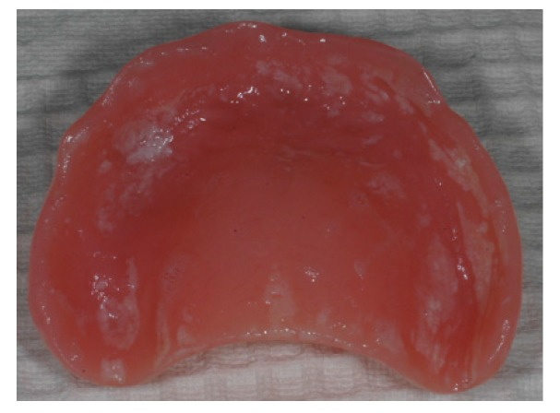

Biofilm formation depend on:
- Surface Energy
Surfaces with a low surface energy have lower adherence to biofilms than higher surface energy.

- Surface Roughness
Increased surface roughness shows higher attraction to microbes than smoother surfaces.

- Chemical Composition
The chemical composition of the dental material will affect the bacterial adhesion .

- Dental Restorations
A restoration of smooth margin and polished surface can be easily cleaned and have very little retention for biofilms.

Bioadhesion refers to the phenomenon where natural and synthetic materials adhere to biological surfaces (the incorporation of the biomaterial in the body).

Note: in case of dental implant, the bioadhesion between the biomaterial and bone lead to the formation of a biofilm (protein layer), which, in turn, facilitates the integration of the implant to the bone.

