Lecture 10 Dental Equipment Technologies Dr.Muna Merza
Wax Extraction Machine

It is an electric device used in the acrylic lab to extract and clean the wax found in the metal flask before acrylic filling.
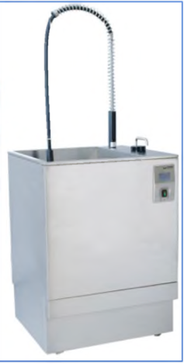
Parts of Wax Extraction:

1) Sink: Fully automatic wax removal of up to 12 half flasks, it's used to store the amount of the water, and in the lower part of the sink connected with a filter to separate molten wax from
water.
2) Heater: it used for heating the water according to uses.
3) Hand shower: Separate hand shower for manual spray, it is used for washing and cleaning of flasks from any excess of wax.
4) Control: Multi-function touchscreen controls with easy programming this control connected within the device for setting temperature and time required.
5) Cover: This device is made from high-quality stainless-steel construction.

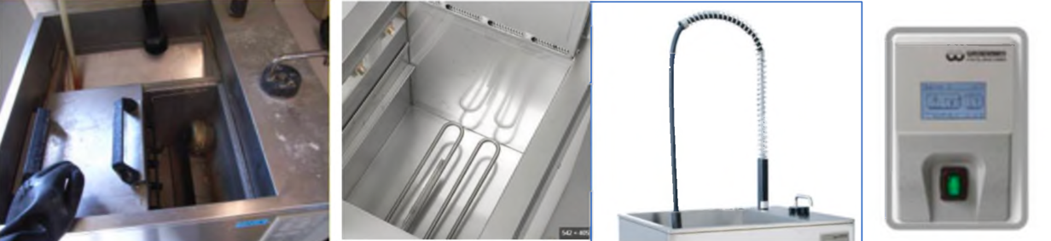

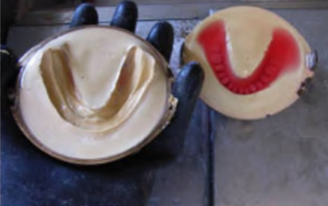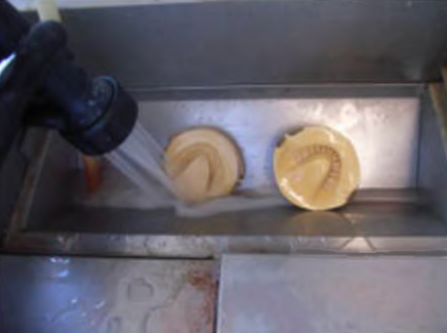
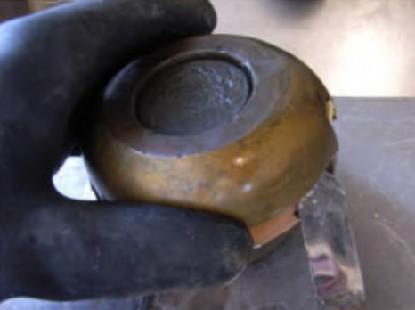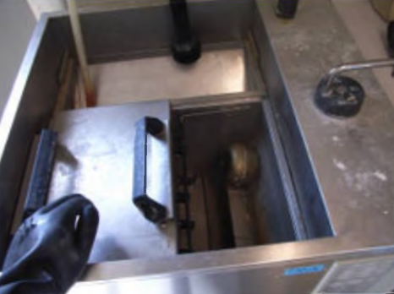

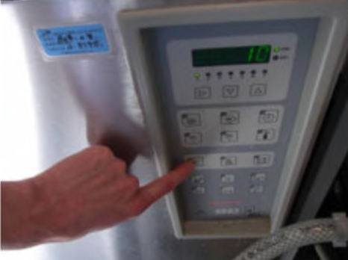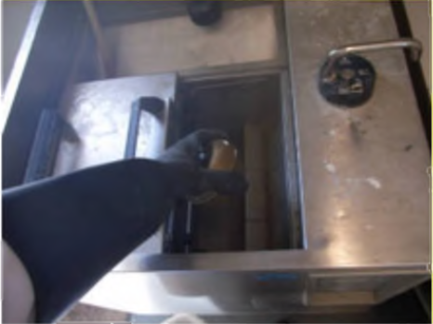

Dental Flask cooling Machine:
It is an electric device used for cooling the metal flask after extracting of the wax and curing the acrylic and cooling the duplication flask of chromium -cobalt laboratory (Agar -Agar material), this instrument made from stainless steel, the above surface is a perforated plate, connected with motor & fun to push the air (Not cold) toward the perforated (holes) for cooling the flask faster than table cooling.
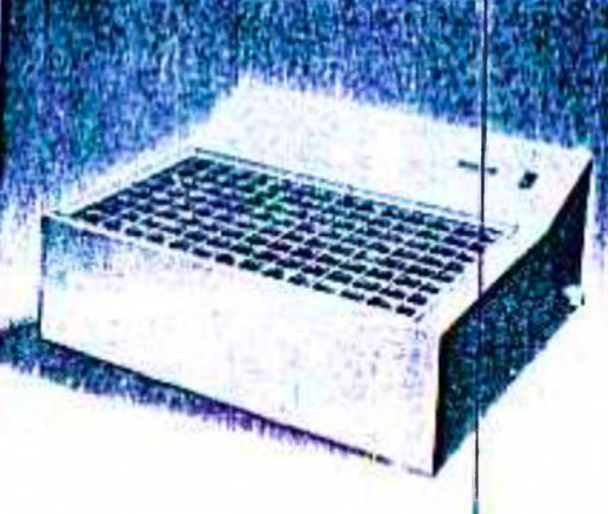
Dental Lathe Machine:
The dental ahlte is a very important electrical device that uses in the last step of
acrylic dentures working and for polishing and finishing step of metalworking of different types for polishing them and cannot work in any laboratory without these devices.

They divided into two trpes of the dental lathe:
1. First is the bench.
2. The second is hanging.

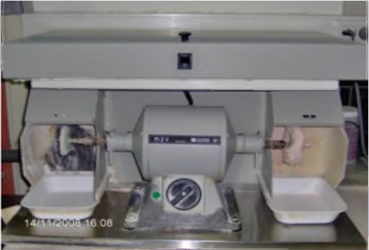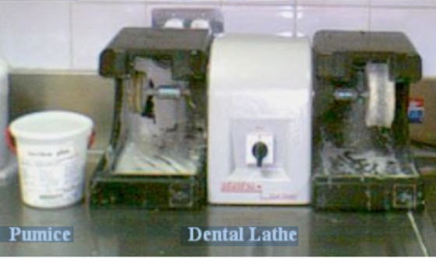

Parts of the dental lathe:

1) Themotor acts to direct and move brush-holder from two sides.
2) handbrush-holderare spiral cylindrical of different sizes.
3) Cover: product themotor from dirty and soils.
4) O nswitcht o open and close the machine
5) Speed selector is chosen either low speed or high speed.
6) Protector glass aspect for protecting the eye from polishing materials.
7) Rubber protector for keep polishing material wet and not fly at the same time keep the piece of prosthetic that requires polishing from a fracture in case of shoot strangely during works.

