Connective tissue
Connective tissue provides a matrix that supports and physically connects other tissues and cells together to form the organs of the body. The interstitial fluid of connective tissue gives metabolic support to cells as the medium for diffusion of nutrients and waste products. Unlike the other tissue types (epithelium, muscle, and nerve), which consist mainly of cells, the major constituent of connective tissue is the extracellular matrix (ECM). Extracellular matrix consist of different combinations of protein fibers (collagen and elastic fibers) and ground substance. Ground substance is a complex of anionic, hydrophilic proteoglycans, glycosaminoglycans (GAGs), and multiadhesive glycoproteins (laminin, fibronectin, and others). Water within this ground substance allows the exchange of nutrients and metabolic wastes between cells and the blood supply.
All connective tissues originate from embryonic mesenchyme, a tissue developing mainly from the middle layer of the embryo, the mesoderm. Mesenchyme consists largely of viscous ground substance with few collagen fibers. Mesenchymal cells are undifferentiated and have large nuclei, with prominent nucleoli and fine chromatin.
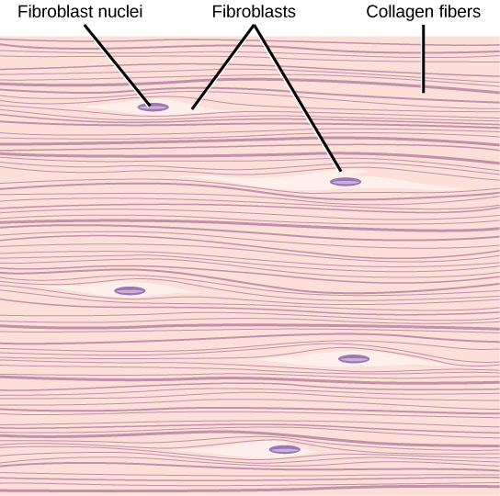

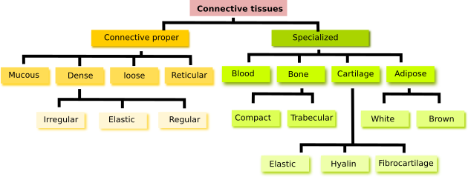

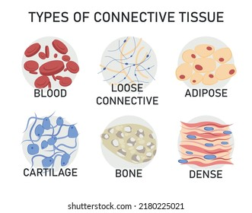

Types of Connective Tissue
Different combinations and densities of the cells, fibers, and other ECM components produce graded variations in histological structure within connective tissue. The main types of connective tissue.
1-Connective Tissue Proper.
2-Specialized Connective Tissues.
1-Connective Tissue Proper
Connective tissue proper is broadly classified as “loose” or “dense,”
A--Loose connective tissue is common, forming a layer beneath the epithelial lining of many organs and filling the spaces between fibers of muscle and nerve also called areolar tissue, the loose connective tissue typically contains cells, fibers, and ground substance in roughly equal parts. The most numerous cells are fibroblasts, but the other types of connective tissue cells are also normally found, along with nerves and small blood vessels. Collagen fibers predominate, but elastic and reticular fibers are also present.
B--Dense connective tissue has similar components as loose connective tissue, but with fewer cells, mostly fibroblasts, and a clear predominance of bundled type I collagen fibers over ground substance. The abundance of collagen here protects organs and strengthens them structurally.
B (1) -Dense irregular connective tissue bundles of collagen fibers appear randomly interwoven, with no definite orientation.
B (2) - Dense regular connective tissue consists mostly of type I collagen bundles and fibroblasts aligned in parallel for great resistance to prolonged or repeated stresses from the same direction. The best examples of dense regular connective tissue are the very strong and flexible tendons, cords connecting muscles to bones, aponeuroses, which are sheet-like tendons; and ligaments, bands or sheets that hold together components of the skeletal system.

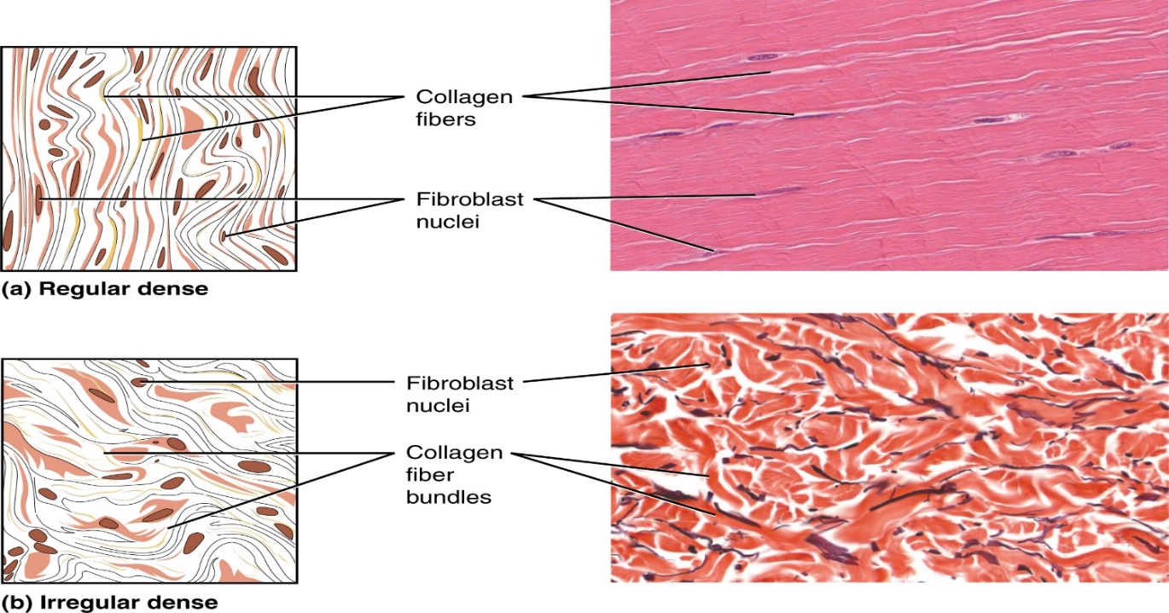
2-Specialized Connective Tissues
A-Reticular connective tissue.
B-Adipose Tissue.
C-Cartilage.
D-Bone.
E- Blood.

****Embryonic Connective Tissues
A--- Mesenchyme Sparse, undifferentiated cells, uniformly distributed in matrix with sparse collagen fibers, Major Functions Contains stem/progenitor cells for all adult connective tissue cells.. Examples Mesodermal layer of early embryo.
B---Mucoid (mucous) connective tissue Random fibroblasts and collagen fibers in viscous matrix. Major Functions Supports and cushions large blood vessels Examples Matrix of the fetal umbilical cord.
***Cells of Connective Tissue
1- Fibroblasts:-
Fibroblasts are the key cells in connective tissue proper. Fibroblasts originate locally from mesenchymal cells and are permanent residents of connective tissue. Other cells found here, such as macrophages, plasma cells, and mast cells, originate from hematopoietic stem cells in bone marrow, circulate in the blood, and then move into connective tissue where they function. These and other white blood cells (leukocytes) are transient cells of most connective tissues, where they perform various functions for a short period as needed and then die by apoptosis.
Fibroblasts are targets of many families of proteins called growth factors that influence cell growth and differentiation. In adults, connective tissue fibroblasts rarely undergo division. However, stimulated by locally released growth factors, cell cycling and mitotic activity resume when the tissue requires additional fibroblasts, for example, to repair a damaged organ. Fibroblasts involved in wound healing, sometimes called myofibroblasts, have a well-developed contractile function and are enriched with a form of actin also found in smooth muscle cells. Fibroblasts synthesize and secrete collagen (the most abundant protein of the body) and elastin, which both form large fibers, as well as the GAGs, proteoglycans, and multiadhesive glycoproteins that comprise the ground substance. As described later, most of the secreted ECM components undergo further modification outside the cell before assembling as a matrix

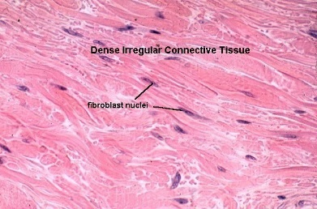

2-Adipocytes:-
Adipocytes, or fat cells, are found in the connective tissue of many organs. These large, mesenchymally derived cells are specialized for cytoplasmic storage of lipid as neutral fats, or less commonly for the production of heat. Tissue with a large population of adipocytes, called adipose connective tissue, serves to cushion and insulate the skin and other organs. Adipocytes have major metabolic significance with considerable medical importance and are described and discussed separately.
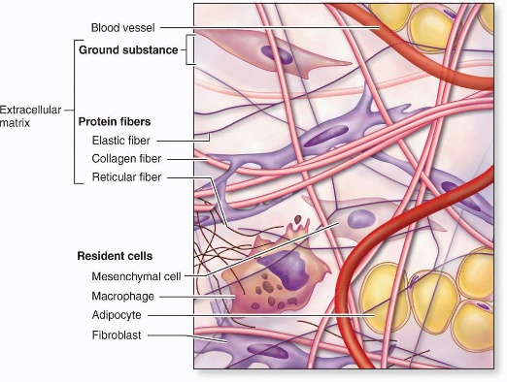

Functions of cells in connective tissue proper:-
Product or Activity | Cell Type Major
Extracellular fibers and ground substance | 1-Fibroblasts (fibrocytes)
Antibodies | 2-Plasma cells
Various immune/defense functions | 3-Lymphocytes(several types)
Modulate allergic/vasoactive reactions and defense against parasites | 4-Eosinophilic leukocytes
Phagocytosis of ECM components and debris; antigen processing and presentation to immune cells; secretion of growth factors, cytokines, and other agents | 5-Macrophages
Pharmacologically active molecules (eg, histamine) | 6-Mast cells and basophilic leukocytes
Storage of neutral fats | 7-Adipocytes

3-Macrophages & the Mononuclear Phagocyte System:-
Macrophages have highly developed phagocytic ability and specialize in turnover of protein fibers and removal of dead cells, tissue debris, or other particulate material, being especially abundant at sites of inflammation. Size and shape vary considerably, corresponding to their state of functional activity. A typical macrophage measures between 10 and 30 μm in diameter and has an eccentrically located, oval or kidney-shaped nucleus. Macrophages are present in the connective tissue of most organs and are sometimes referred to by pathologists as “histiocytic.”
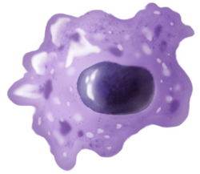

4-Mast Cells:-
Mast cells are oval or irregularly shaped cells of connective tissue, between 7 and 20 μm in diameter, filled with basophilic secretory granules, which often obscure the central nucleus. These granules are electron-dense and of variable size, ranging from 0.3 to 2.0 μm in diameter. Because of the high content of acidic radicals in their sulfated GAGs, mast cell granules display metachromasia, which means that they can change the color of some basic dyes (eg, toluidine blue) from blue to purple or red. The granules are poorly preserved by common fixatives, so that mast cells may be difficult to identify in routinely prepared slides.
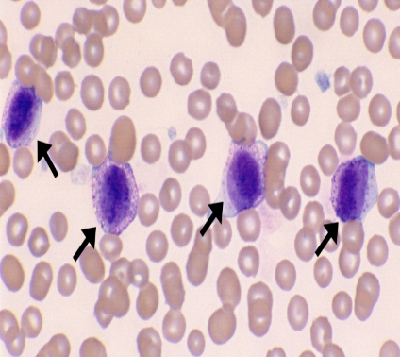
Mast cells function in the localized release of many bioactive substances important in the local inflammatory response, innate immunity, and tissue repair. A partial list of molecules released from these cells’ secretory granules includes the following:
- Heparin, a sulfated GAG that acts locally as an anticoagulant.
- Histamine, which promotes increased vascular permeability and smooth muscle contraction.
- Serine proteases, which activate various mediators of inflammation.
- Eosinophil and neutrophil chemotactic factors, which attract those leukocytes
- Cytokines, polypeptides directing activities of leukocytes and other cells of the immune system
- Phospholipid precursors, which are converted to prostaglandins, leukotrienes, and other important lipid mediators of the inflammatory response
5-Plasma Cells
Plasma cells are lymphocyte–derived, antibody-producing cells. These relatively large, ovoid cells have basophilic cytoplasm rich in RER and a large Golgi apparatus near the nucleus that may appear pale in routine histologic preparations
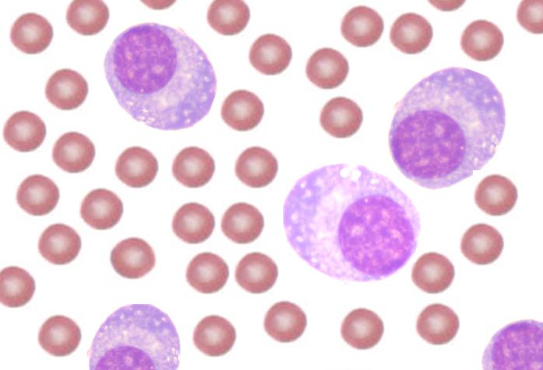
6-Leukocytes:-
Other white blood cells, or leukocytes, besides macrophages and plasma cells normally comprise a population of wandering cells in connective tissue. Derived from circulating blood cells, they leave blood by migrating between the endothelial cells of venules to enter connective tissue. This process increases greatly during inflammation, which is a vascular and cellular defensive response to injury or foreign substances, including pathogenic bacteria or irritating chemical substances
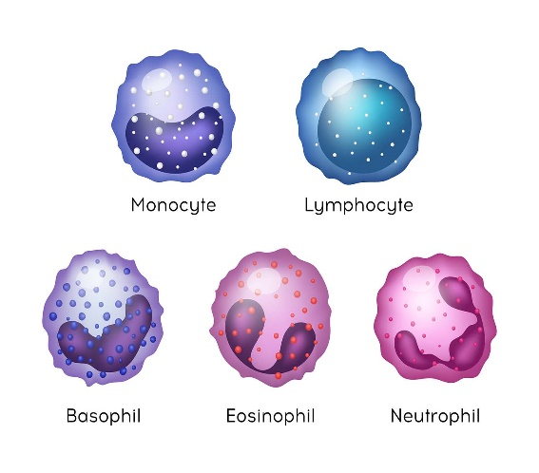

Fibers****
The fibrous components of connective tissue are elongated structures formed from proteins that polymerize after secretion from fibroblasts The three main types of fibers include
1-Collagen, Fibrillar collagens, notably collagen types I, II, and III.
2-Reticular, reticular fibers consist mainly of collagen type III.
3-Elastic fibers. Elastic fibers (and lamellae) are a composite of fibrillin (350 kDa), which forms a network of microfibrils, embedded in a larger mass of cross-linked elastin (60 kDa).
Collagen and reticular fibers are both formed by proteins of the collagen family, and elastic fibers are composed mainly of the protein elastin. These fibers are distributed unequally among the different types of connective tissue, with the predominant fiber type conferring most specific tissue properties.
,
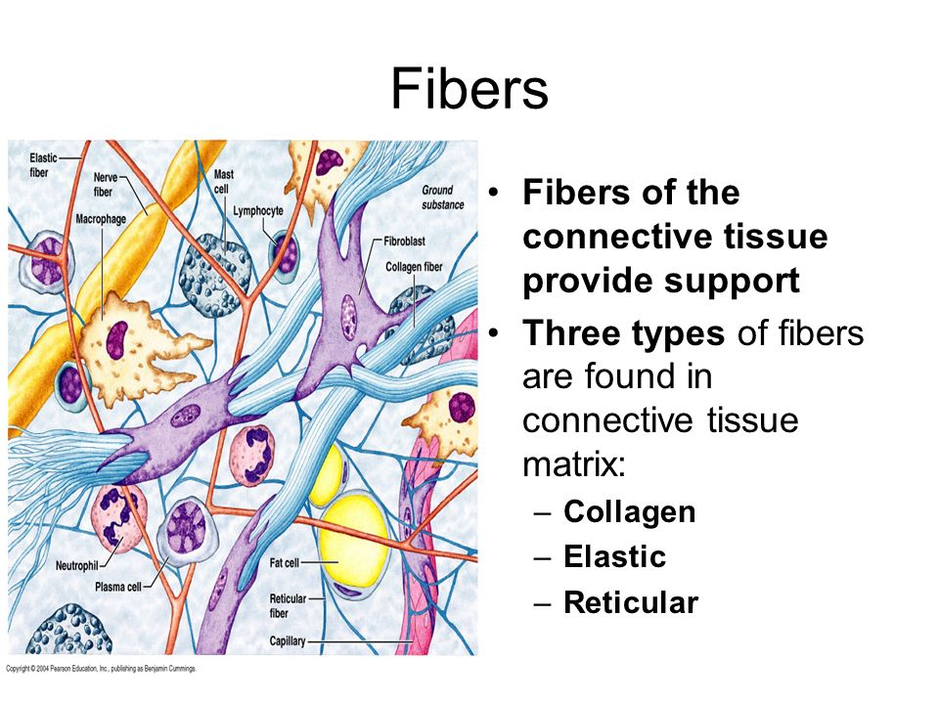

***Ground Substance
The ground substance of the ECM is a highly hydrated (with much bound water), transparent, complex mixture of three major kinds of macromolecules:
***glycosaminoglycan's (GAGs).
***proteoglycans.
***multiadhesive glycoproteins.

