Bacteria
Bacteria are single-celled prokaryotic microorganisms, and their DNA is not contained within a separate nucleus as in eukaryotic cells. They are approximately 0.1–10.0 µm in size and exist in various shapes, including spheres (cocci), curves, spirals and rods (bacilli).
Bacterial Classification Bacterial classification depends on the following characteristics. 1. Morphology and arrangement 2. Staining 3. Cultural characteristics 4. Biochemical reactions 5. Antigenic structure 6. Base composition of bacterial DNA. Morphology and staining of bacteria are the commonly used characteristics to classify bacteria. Morphology of bacteria When bacteria are visualized under light microscope, the following morphology are seen. 1. Cocci (singular coccus): Round or oval bacteria measuring about 0.5- 1.0μmb in diameter.They are found insingle, pairs, chains or clusters. 2. Bacilli (singular bacillus): Stick-like bacteria with rounded, tapered الطرف مستدق, square or swollen ends; with a size measuring 1-10μm in length by 0.3-1.0μm in width. 3. Coccobacilli (singular coccobacillus): Short rods
Types of microbiological stains
• Basic stains
• Acidic stains
• Neutral stains. Bacterial staining methods include:
• Simple stain.. (ex. Methylene blue stain)
• Differential stain. (ex. Gram stain, Acid fast stain)
According to the Gram-stain technique the bacterial cells classified into: Gram-positive bacteria (purpule color), and Gram-negative bacteria (Pink- color). Some bacterial cell cannot be stained with Gram- sain according to the difference of structure in the bacterial cell wall, thus it must be stained with other techniques such as Acid- Fast stain

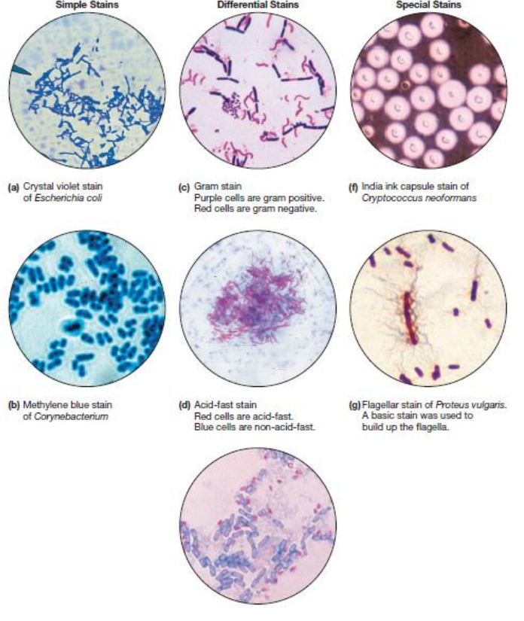
Bacterial staining Method

Bacterial Cell Structure
.... (part one) The prokaryotic cell is simpler than the eukaryotic cell at every level, with one exception: The cell envelope is more complex. The general property of the bacterial cell includes.... • Typical prokaryotic cell • Contain both DNA and RNA • Most grow in artificial media • Replicate by binary fission • Almost all contain rigid cell wall • Sensitive to antimicrobial agent Bacterial structure is considered at three levels. 1. Cell envelope proper: Cell wall and cell membrane. 2. Cellular element enclosed with in the cell envelope: Mesosomes, ribosomes, nuclear apparatus, polyamines and cytoplasmic granules. 3. Cellular element external to the cell envelope: Flagellum, Pilus and Glycocalyx.
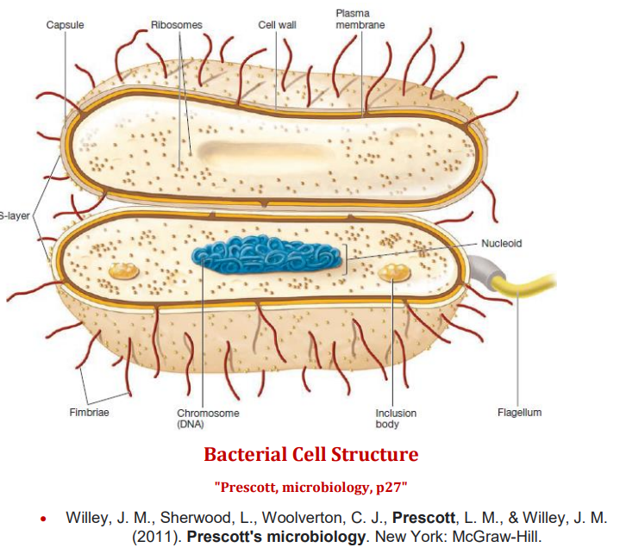

Cell wall structure
The bacterial cell wall composed of a substance variously referred to as murein, mucopeptide, or peptidoglycan (all, including “cell wall,” are synonyms). Most bacteria are classified as Gram-positive or Gram-negative according to their response to the Gram-staining procedure. Peptidoglycan is a complex polymer consisting, for the purposes of description, of three parts: a backbone, composed of alternating Nacetylglucosamine and N-acetylmuramic acidconnected by β1→4 linkages; a set of identical tetrapeptide side chains attached to N-acetylmuramic acid; and a set of identical peptide cross-bridges.
Diaminopimelic acid is a unique element of bacterial cell walls. It is never found in the cell walls of Archaea or eukaryotes. Special Components of Gram-Positive Cell Walls
• Teichoic and teichuronic acids.
• Polysaccharides
