Ministry of Higher Education and Scientific Research Al-Mustaqbal University College

Department of Chemical Engineering and petroleum Industrials
Properties of petroleum products

3rd Stage

Lecturer: Dr. Duaa Alwarid

2022-2023
LUBE BASE STOCKS
• Lubricants are required in machines to reduce friction and wear between moving parts.
• Lubricant base stocks make up a large portion of finished lubricants, from about 75 to 80 percent in automotive engine oils to 90 percent or more in some industrial oils.
• Thus, base stocks contribute significantly to the finished product properties.
• Base stock has a major impact on the viscosity, volatility, low temperature fluidity, solvency for additives and contaminants.
• Petroleum lubricating base stocks are made of a higher boiling portion of crude oil that remains after the removal of lighter hydrocarbons.
• Starting material for their manufacture is usually atmospheric residue boiling above 650°F.
• Careful selection of a base stock is key to formulating a quality finished lubricant.
• Base stock properties are related to base stock composition.
• Base stocks contain three types of hydrocarbon: paraffins, naphthenes. and aromatics.
• In the paraffin group,
• isoparaffins are the preferred type because they exhibit excellent oxidation stability. low volatility, and good viscosity characteristics.
• Normal paraffins, however, are not a desirable component because of their poor cold flow properties such as pour point, cold filter plug point (CFPP).
• Aromatics are good for the solvency of additives and contaminants but generally have poor oxidation stability and high volatility.
• Naphthenes also have good low temperature fluidity and oxidation stability.
• Sulfur and nitrogen are often present in combination with hydrocarbons in a base stock, particularly the aromatics.
The manufacture of lube base stocks from crude oil involves a series of steps aimed at the removal of certain undesirable components resulting in a base oil that meets the performance requirements of lubricating oils.
• There are two basic routes for making lube base stocks:
• the conventional process, consisting of
• solvent extraction,
• solvent dewaxing, and
• hydrofinishing, and
• the hydroprocessing route, consisting of
• lube hydrocracking,
• hydrodewaxing, and
• deephydrotreating.
• The hydrotreating route produces higher viscosity index (VI) lubes with superior quality but cannot produce high-viscosity lube base stocks.
CONVENTIONAL PROCESS
The conventional lube base stock manufacturing process consists of the following steps:
• Vacuum distillation of atmospheric resid to yield several distillate cuts and vacuum resid
• Propane deasphalting of vacuum residuum to yield bright stock and asphaltic pitch
• Solvent extraction of vacuum distillates and bright stock to remove aromatics and improve the viscosity index of lubricating oil base stock
• Solvent dewaxing of distillate cuts to yield slack wax and various lube cuts, which improves the cold flow properties such as pour point and cloud point of the lube base stock
• Hydrofinishing or clay treatment to improve color, oxidation stability, and thermal stability of lubricating oils
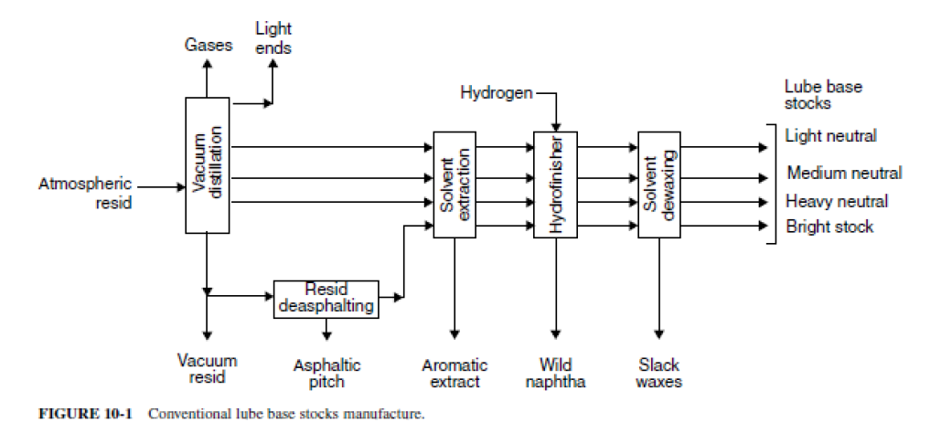
CLASSIFICATION OF LUBRICATING OILS
Lubricating oils and greases can be classified in many ways;
– by viscosity grades,
– by their additives package, or
– by their producers’ brand names.
• The most popular classification of lubes is according to their usage:
• Engine oils (petrol and diesel engines, aircraft, marine engines)
• Turbine oils
• Gear oils
• Compressor (refrigeration, air) oils
• Quench oils used in metalworking
• Cutting oils (in metal cutting)
• Insulating oils used in transformer and circuit breakers
• Hydraulic oils
• CLASSIFICATION BY VISCOSITY
Classification according to viscosity has been done by these professional societies and organizations:
• SAE (Society of Automotive Engineers. USA)
• API (American Petroleum Institute)
• AGMA (American Gear Manufacturers Association)
• NLGI (National Lubricating Grease Institute) .

