Lecture 4 Dental Equipment Technologies Dr.Muna Merza

Dental Burner uses in Prosthodontic Dentistry

There are different types of burners used in prosthodontic dentistry and they are divided into:

- Alcohol burner (spirit lamp): -

- It has a small container with a small cover that has a hole and there is cord "made from cotton” pass through the hole and entering inside the container, the other end projects outside the cover, also contain cover that covers flame side to avoid evaporation of alcohol when it not used.
- Fill the container with alcohol (that is used in this field) this leads to saturating the cotton cord with alcohol & be flamed when burning it.

The requirement of flame of this type of burner:

- It must be blue color flame to get the required heating degree
- If the flam is blue with redness this is because the alcohol that is used is not pure & should not be used.

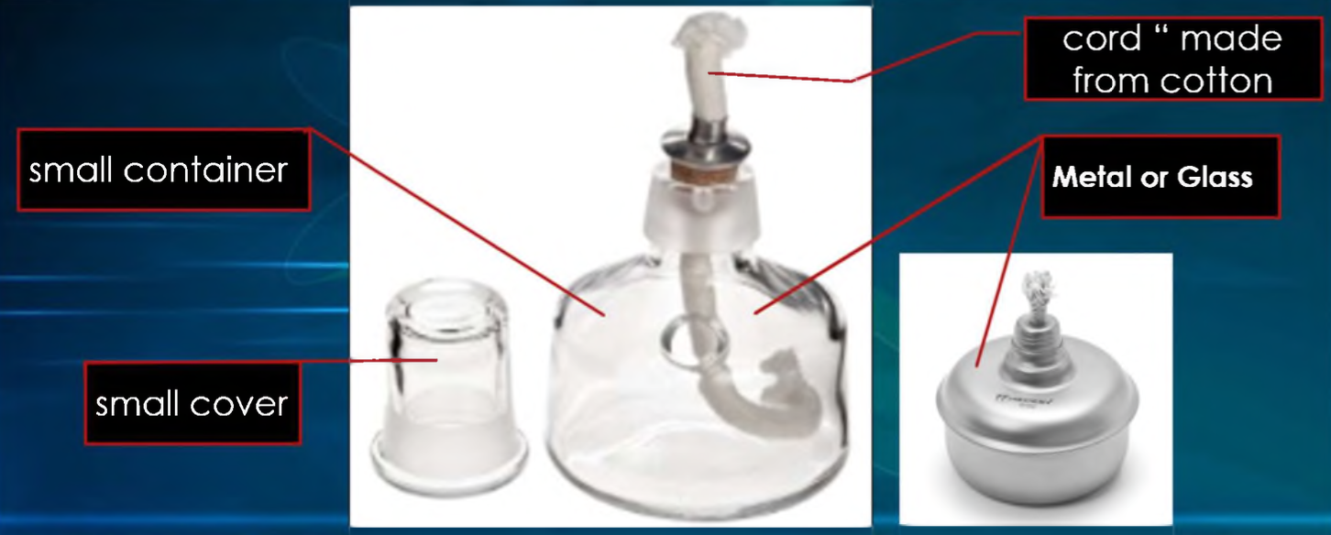

- Air-Alcohol burner (Air alcohol torch):

- It's like the alcohol burner but with another part added that gives air application to the flame of burner which leads to changing its way and converting it to long stable flame
- In this way we can control the flame direction and apply it to the wanted area with an increase in heating degree.

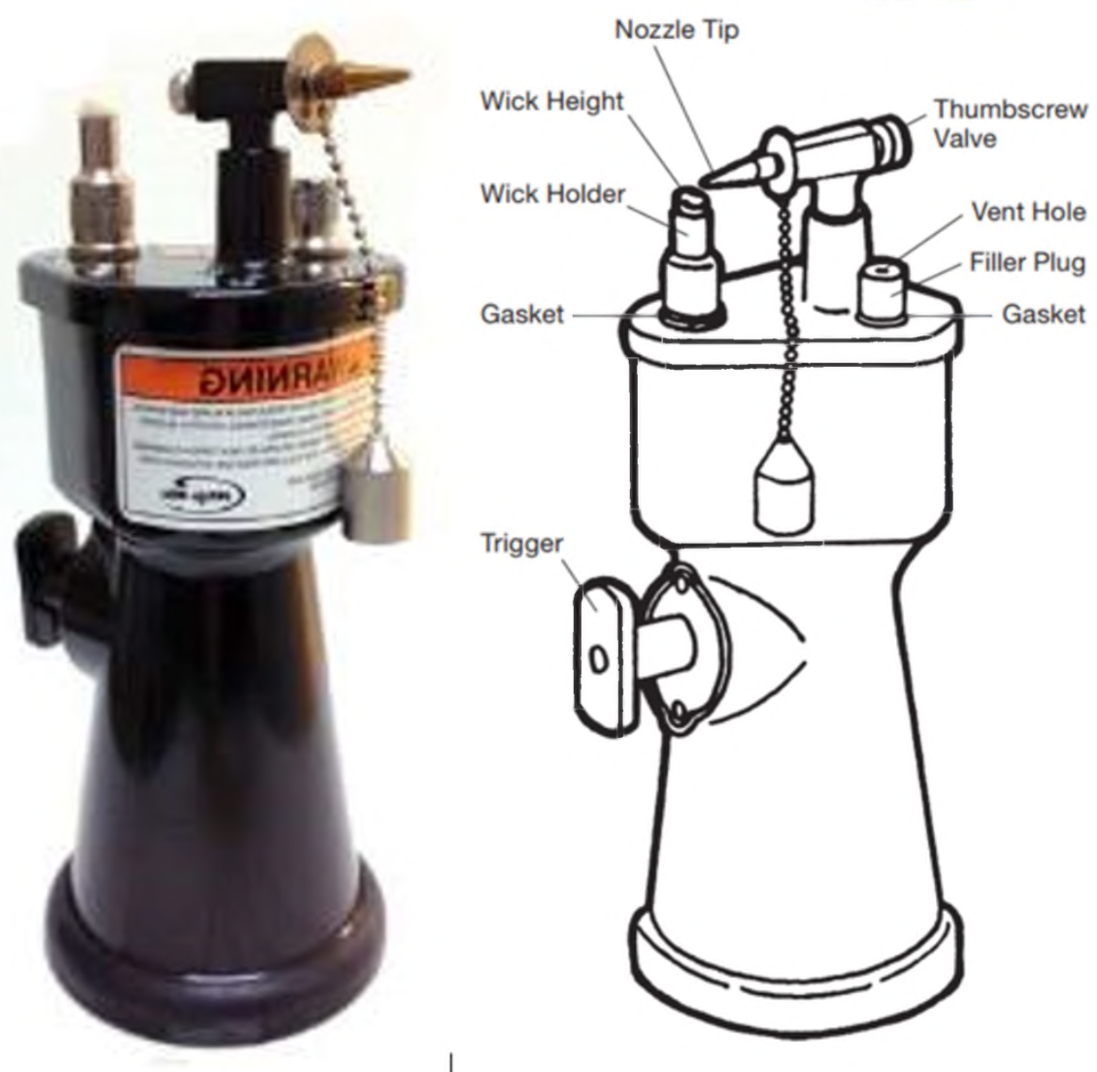

- Table gas burner

- It consists of a cylinder tube stable on the base that connects to the gas source
- There is a hole in the lower of the connection that controls air entering which helps in gas burning.
- We can use Bunsen burner with all types of gases in case of changing the diameter of the gas hole that is used because each type of gas demands a certain diameter of the hole that controls the amount of gas that is going outside

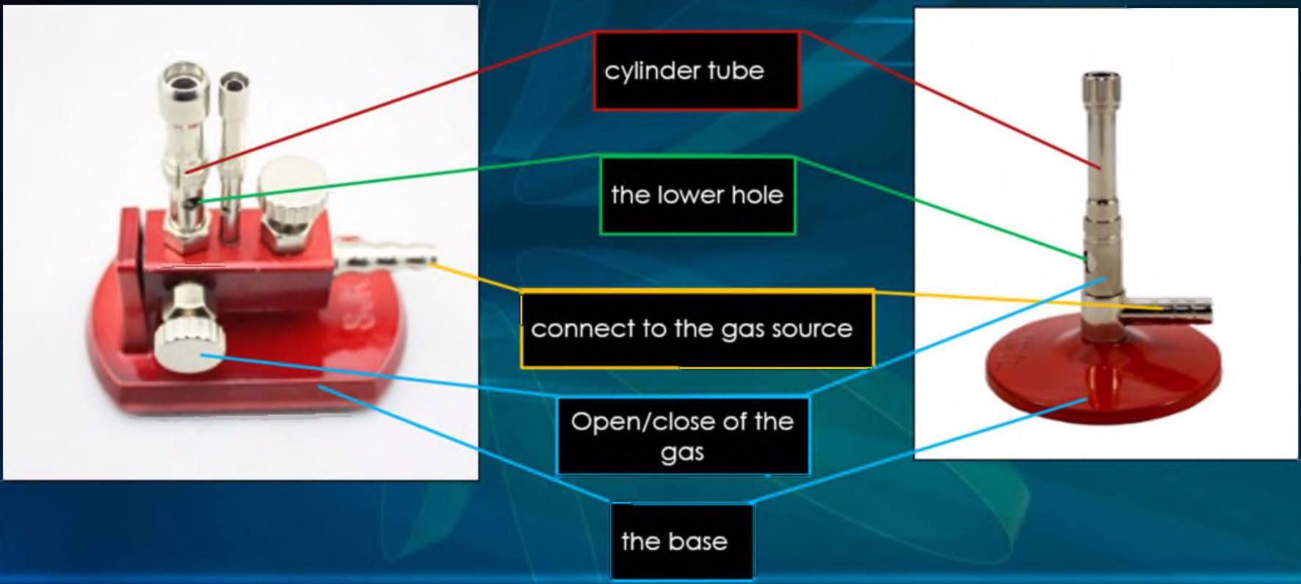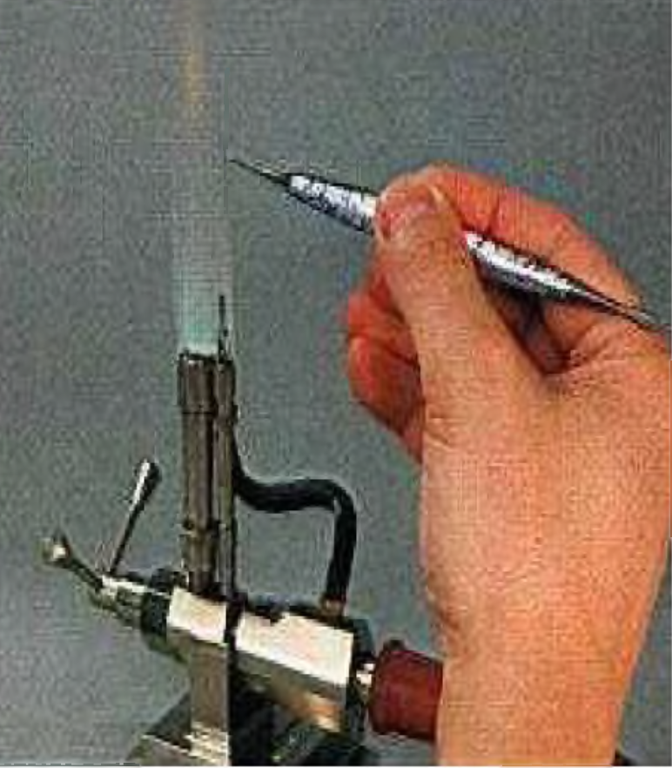

- Metal melting torch:
- Is the instrument used to melt alloy when the flame is used for this purpose.

- There are two types of metal melting torches:
1 -Single orifice torch
2- Multi orifice torch

In general, this torch consists of:

- Handle: each one connects to a respective tube.
- The keyway: the red one is the acetylene & blue one is contacting the oxygen or compressor
- Flame: the flame is about 20 cm in length & have 4 zones:

- Mixing (zone black).
- Combustion (zone green)
- Reducing (zone blue).
- Oxidation zone

