Ministry of Higher Education and Scientific Research Al-Mustaqbal University College

Department of Chemical Engineering and petroleum Industrials
Properties of petroleum products

3rd Stage

Lecturer: Dr. Duaa Alwarid

2022-2023
LUBE BASE STOCKS
CLASSIFICATION OF LUBRICATING OILS
Lubricating oils and greases can be classified in many ways;
– by viscosity grades,
– by their additives package, or
– by their producers’ brand names.
–
• The most popular classification of lubes is according to their usage:
• Engine oils (petrol and diesel engines, aircraft, marine engines)
• Turbine oils
• Gear oils
• Compressor (refrigeration, air) oils
• Quench oils used in metalworking
• Cutting oils (in metal cutting)
• Insulating oils used in transformer and circuit breakers
• Hydraulic oils
• CLASSIFICATION BY VISCOSITY
Classification according to viscosity has been done by these professional societies and organizations:
• SAE (Society of Automotive Engineers. USA)
• API (American Petroleum Institute)
• AGMA (American Gear Manufacturers Association)
• NLGI (National Lubricating Grease Institute)
CLASSIFICATION BY ADDITIVE TYPES
Lube oils may be classified by additive type as follows:
• Inhibited or RO (rust and oxidation inhibitor containing additives)
• Anti-wear (AW) containing lube oils
• Lubes with extreme pressure (EP) additives
• Compounded oils: containing 3 to 10 percent fatty or synthetic fatty oils
• Residual compounds
AUTOMOTIVE ENGINE OILS
• Viscosity is considered the most important single property of lubricating oils.
• Automotive crankcase and gear oils used in gasoline and diesel engine lubrication.
• The viscosity classification takes into account the temperature at which the oils are to be used.
• The SAE viscosity rating was based on average time
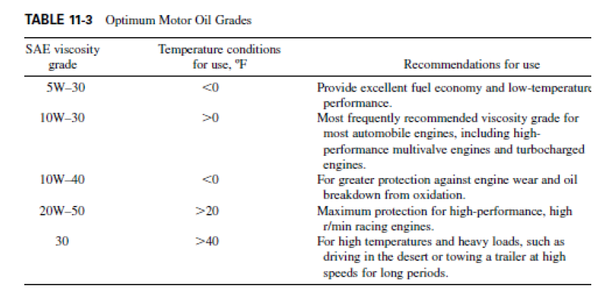
AUTOMOTIVE OIL ADDITIVES
– Viscosity index improvers
– Detergents
– Dispersants
– Anti-wear/Extreme pressure additives
– Friction modifiers
– Antioxidants/Corrosion inhibitors
– Rust and corrosion control additives
– Anti-foam agents

ENGINE OIL FORMULATION
• In an engine oil. o the base oil components may be 75 to 85 percent of the total formulated lube,
o and the remaining 15 to 25 percent may be different types of additives.
• Viscosity modifiers and detergent inhibitors are the most prominent additives.
• Other additives used in lube formulation are dispersants. AW/EP agents, oxidation inhibitors, antifoamants. rust inhibitors, and demulsifiers.
• Base oils of a required viscosity are obtained by blending different base stocks such as neutrals and bright stocks.
• The additives are added to the base oil to enhance its performance when used in various types of engines.
• The most important properties of a lubricating oil are its viscosity and alkali reserve (base number, or BN).
• In addition, many other properties of the oil affect the performance of the engine.
• Fuel quality significantly affects the kind of lubricating oil to be used.
• For example, for a low-sulfur fuel such as natural gas. o little sulfur dioxide is formed during combustion.
o In this case a lubricating oil with a low BN. 4 to 7. may be OK.
• In case the fuel contains high sulfur. 0.5 to 5 percent, o a higher alkali reserve is required to prevent corrosion damage.
• For fuels containing 2 percent or more sulfur,
• The high water content can be reduced by efficient centrifuging, which can extend the life of lubricating oil.

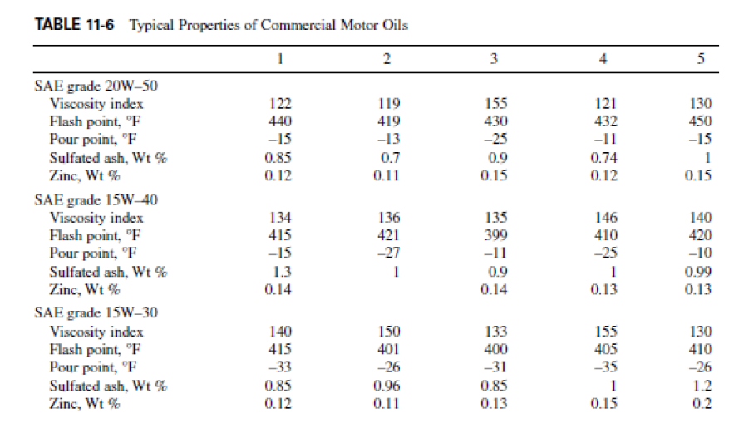
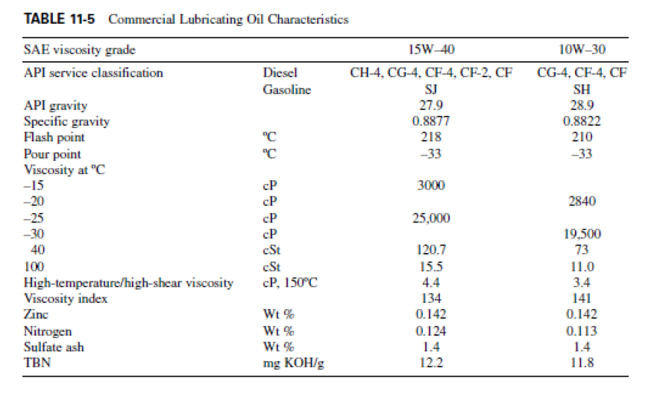
SYNTHETIC LUBRICANTS
• Synthetic lubricants were developed more than 50 years ago and became widely used in jet engines.
• Lower than -120°F operating temperatures, 60.000 r/min shaft speed, and 500°F+ exhaust temperatures proved too much for conventional lubes.
• Synthetic lubes were created specifically for these harsh operating conditions, and at present every jet engine in the world uses synthetic lubricants.
• A synthetic lubricant base stock is a product made from a chemical reaction of two or more simple chemical compounds.
• These base stocks are manufactured to meet specific physical and chemical characteristics not found in petroleum lubricant base stocks.
• This base stock is then used to formulate lubricants by the addition of performance additives.
• Some of the most common synthetic lubricants are as follows:
• Polymerized alpha olefins, olefin polymers, olefin oligomers
• Dibasic acid esters
• Polyols esters
• Polyalkaylene glycol ethers
• Phosphate esters
• Alkylated benzenes, a synthetic hydrocarbon
• Silicons
• Their viscosity indexes and flash points are higher, however, and their pour points are considerably lower.
The following performance features are claimed for synthetic lubricants over mineral oil lubes:
• Engine cleanliness
• Improved fuel economy
• Lower oil consumption
• Good low temperature (cold starting) fluidity
• Outstanding performance in extended oil drain intervals
• Superior high-temperature oxidation resistance
• Excellent wear protection
The main disadvantage of synthetics is that they are
– inherently more expensive than mineral oil and
– available in limited supply.
• This limits their use only to specialty oils and greases that command a premium price.
• Esters suffer the further disadvantage

