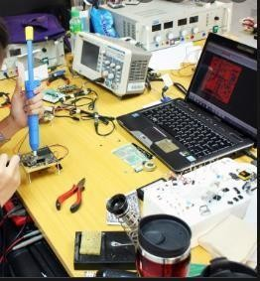

Workshops

(Use different measuring devices in the workshop)

For

Students of first class
Department of Electrical Engineering techniques

By

Assistant lecturer ALI IMAD
1/ Overview

1 –Target population :-
For students of first class
Department of Electrical power techniques

2 –Rationale :-
This unit introduces principles of how to use different measuring devices in the workshop

3 –Central Idea :-
The major topics discussed in this unit are included in the following outline.

Digital multimeter
- Oscilloscopes (or scopes)

Function generator
- Power supply

2/ Performance Objectives :-

After studying the first modular unit, the student will be able to-
- Know the types measurement devices.
- Utilities of measurement devices.

3/ Pre test :-

Circle the correct answer:-

A device used for viewing signals
  - Power supply (P.S.).
  - Scope.
  - Function generator (F.G.).
  - Avo meter.

A device used for testing components:
a- P.S. b- Avo meter
c- F.G. d- Scope

A device used to generate signals:-
- F.G.
- Scope.
- Avo meter
- P.s.

4/ the text :-

Measurement device 1- Digital multimeter
It is a test tool used to measure two or more electrical values principally voltage (volts), current (amps) and resistance (ohms). It is a standard diagnostic tool for technicians in the electrical/electronic industries. Digital multimeters long ago replaced needle-based analog meters due to their ability to measure with greater accuracy, reliability and increased impedance. Fluke introduced its first digital multimeter in 1977. Digital multimeters combine the testing capabilities of single- task meters—the voltmeter (for measuring volts), ammeter (amps) and ohmmeter (ohms). Often, they include several additional specialized features or advanced options. Technicians with specific needs, therefore, can seek out a model targeted to meet their needs.

The face of a multimeter typically includes four components:
- -Display: Where measurement readouts can be viewed.
- -Buttons: For selecting various functions; the options vary by model. 3 -Dial (or rotary switch): For selecting primary measurement values (volts, amps, ohms).
4 -Input jacks: Where test leads are inserted.
Test leads are flexible, insulated wires (red for positive, black for negative) that plug into the DMM. They serve as the conductor from the item being tested to the multimeter. The probe tips on each lead are used for testing circuits.

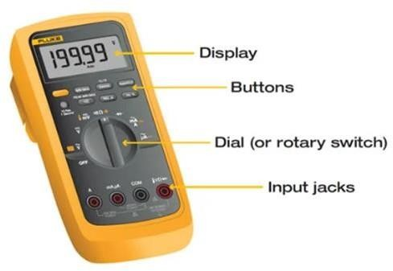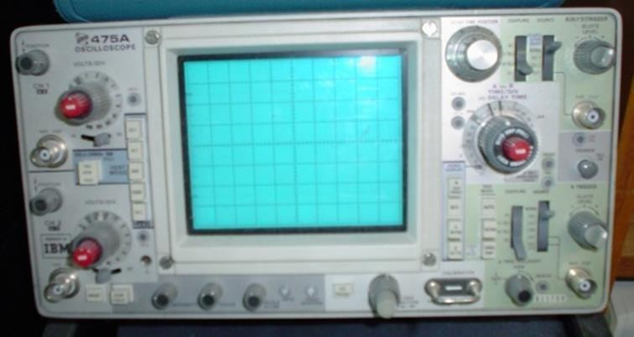

2- Oscilloscopes (or scopes)
It is an electronic test equipment that used to display voltage signals as waveforms, visual representations of the variation of voltage over time. The signals are plotted on a graph, which shows how the signal changes. The vertical (Y) access represents the voltage magnitude and the horizontal (X) axis represents time.

The graph on an oscilloscope can reveal important information:
- Voltage signal shape when operating as intended.
- Current signal shape when using a current clamp suitable for using on an oscilloscope Signal anomalies.
- Amplitude modulation of an oscillating signal and any variations in frequency.
- Whether a signal includes noise and changes to the noise.

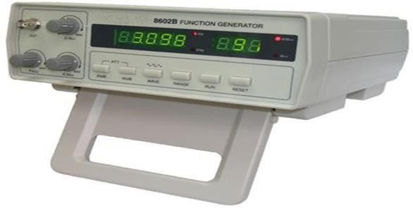3- Function generator
It is usually a piece of electronic test equipment or software used to generate different types of electrical waveforms over a wide range of frequencies. Some of the most common waveforms produced by the function generator are the sine wave, square wave, triangular wave and saw tooth shapes. These waveforms can be either repetitive or single- shot.

3- Power supply
A power supply is an electrical device that supplies electric power to an electrical load. The main purpose of a power supply is to convert electric current from a source to the correct voltage, current, and frequency to power the load. As a result, power supplies are sometimes referred to as electric power converters.

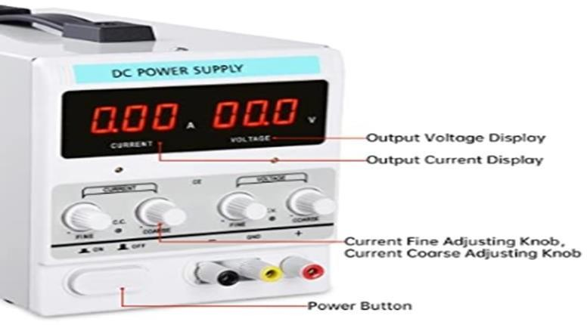

5/ Post test :-

Circle the correct answer:-

- A device used to feed the circuit
  - P.s.
  - Scope.
  - F.G.
  - Avo meter.

There are three signals in F.G.:
- True.
- False.

Current, voltage, and resistance can be tested by using
- F.G.
- Avo meter.
- P.S.
  - b

7/References :-

1. Encyclopedia of Electronic Components Volume 1 (Charles Platt).

