وزارة التعليم العالي والبحث العلمي  كلية المستقبل الجامعة  قسم/-هندسة تقنيات الحاسوب  مختبر/- اتصالات الرقمية |  | رمز السجل :  تاريخ الإصدار:  رقم الإصدار:
 |  | المرحلة :الثالثة
 | سجل التجارب للعام الدراسي 2023-2024

Experiment :2

Pulse Position Modulation & Demodulation (PPM)

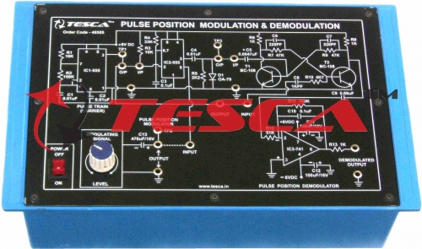
Object:
First of all pulse position modulate (PPM) signal is obtained by sampling the modulating signal with a pulse train (carrier signal) the PWM thus obtained is then differentiated . the resulting signal has positive and negative going pulses corresponding to leading and trailing edges of the PPM signal.

Features & procedure :
The board consists of the following built in parts :
1. ± 6V D.C. at 100mA, IC regulated Power Supply internally connected
2. Pulse Train (Carrier) Generator based on timer IC
3. 50 Hz A.C. sinusoidal modulating signal obtained from stepped down transformer
4. Pulse Position Modulating circuit based on IC
5. Demodulating circuitry based on an IC and transistors
6. Adequate no. of other electronic components
7. Mains ON/OFF switch, Fuse and Jewel light
* The unit is operative on 230V ±10% at 50Hz A.C. Mains
* Adequate no. of patch cords stackable from rear both ends 2mm spring loaded plug length ½ meter
* Good Quality, reliable terminal/sockets are provided at appropriate places on panel for connections/ observation of waveforms
* Strongly supported by detailed Operating Instructions, giving details of Object, Theory, Design procedures, Report Suggestions and Book Reference.

Theory:
From the above differentiated waveform the positive going pulses are removed the resulting waveform is (PPM) Pulse position modulated signal is converted back to (PWM) pulse width modulated signal the PWM signal is then integrated to recover the modulating signal . this experiment has two distinct circuits (i)Bistable -in order to convert PPM back to PWM and (ii)integrator –which recovers the modulating signal from the PWM signal , both these circuits are simple to understand and need not be explained the bistable circuit has two inputs one is the PPM signal and the other is the pulse train (carrier ) .the pulse train (carrier)
Is used here as a synchronizing signal .
in actual PPM transmission these synchronization pulses are transmitted along with the PPM signal . but here in this training board due to simple techniques used the synchronizing pulses are separately provided on the panel.
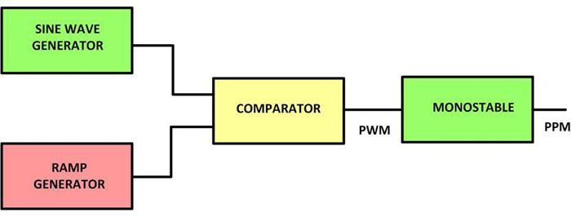

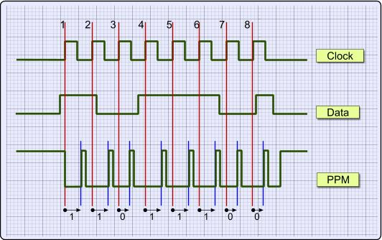

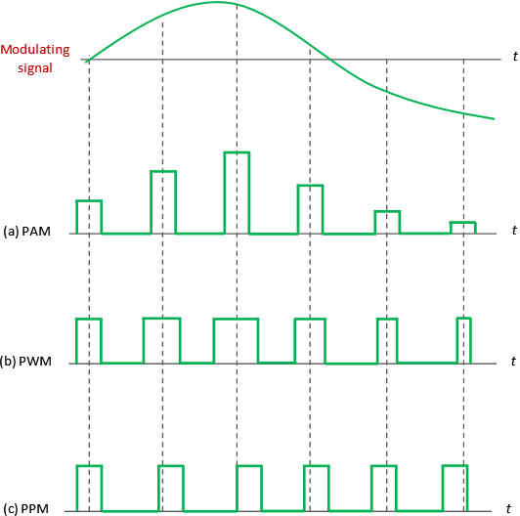

Demodulation:
- PPM signal can be generated with the help of PWM as shown in Fig7 below.
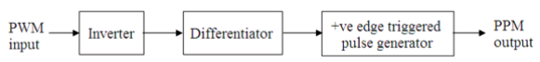
Fig7. PPM generation from PWM

