Ministry of Higher Education and Scientific Research Al-Mustaqbal University College

Department of Chemical Engineering and petroleum Industrials
Properties of petroleum products

3rd Stage

Lecturer: Dr. Duaa Alwarid

2022-2023
CARBON BLACK
• Carbon black products are direct descendants of earlier “lamp blacks,” a black pigment produced and used by various civilizations to create rock paintings more than 3000 years ago.
• For a long time, black pigment was obtained by charring organic materials such as wood or bone or collecting soot from burning oils in wick lamps.
• These early blacks were not very pure and differed greatly in their chemical composition from present-day carbon blacks, which are almost pure carbon.
The main use of carbon black in
• the rubber industry is as a reinforcement and filler.
• The addition of carbon black to rubber improves the wear resistance of tires and other properties.
• The stability against UV radiation is also enhanced because black pigment hinders light.
• The content of carbon black is the reason why so many rubber products are black.
• Carbon black in rubbers and plastics not only makes the substance black, but it also make them UV stable and heat conducting: taking heat away from the tread and thus producing less static.
• Practically all rubber products where tensile and abrasion wear properties are important use carbon black as a reinforcing material. Rubber such as styrene butadiene rubber (SBR) may be blended with up to 50 percent by weight (wt %) of carbon black to improve its tensile strength and wear resistance.
MANUFACTURING PROCESSES
Today ,Variety of processes are used to produce carbon black .
– Most processes involve partial combustion in a restricted supply of air or thermal decomposition of hydrocarbons such as oil or natural gas.
– The characteristics of carbon blacks produced vary, depending more on manufacturing process employed and less on feedstock.
– Therefore carbon blacks are classified by their manufacturing methods.
Major processes used to manufacture carbon blacks are as follows:
• Channel process
• Gas black process
• Thermal black process)
• Acetylene black process
• Lamp black process
• Furnace black process
Furnace black process
– is the most important one for the production of carbon black and allows production of nearly all types of carbon blacks required for rubber, plastics, paint, and pigment manufacture.
– Lamp and gas blacks are important alternatives to furnace blacks.
– These processes yield carbon blacks having properties that partially overlap with those obtainable from furnace black process
– The acetylene black process produces high-conductivity carbon blacks specifically for the dry cell industry.
CHANNEL BLACK PROCESS
– The channel process for carbon black manufacture uses natural gas as raw material.
– A large numbers of small flames fed by natural gas from ceramic burners impinge on the underside of a water-cooled steel channel, depositing a layer of carbon black that is periodically removed by scrapping devices.
– These iron channels, which moved slowly back and forth over the flames, have since lent their name to this manufacturing process.
– The deposited carbon black is scrapped off into a funnel-shaped trough and transferred by screw conveyers to storage silos.
– The yield of carbon black was only 5 percent.
– The channel process produced carbon black with a particle size of 10 to 30 nm.
– It was possible to vary carbon black particle size by altering the distance of the burner tip from the channel and changing the natural gas and air flow rates.
– The channel process produced several grades of fine carbon blacks that had maximum color and were fully reinforcing in rubber.
GAS BLACK PROCESS
• the gas black process uses vaporized oil instead of natural gas as a feedstock.
• Coal tar distillates arc the preferred feedstock.
• These oils arc heated in a vaporizer, and the resultant vapors arc carried by a hydrogen-rich gas to the burner.
• The hydrogen-rich gas is called producer gas (CO + H,).
• The flame is allowed to impinge on water-cooled rollers.
• Most of the carbon black formed is deposited on rollers, and the remainder is collected in filters.
• Both the streams arc combined and processed further into pellets for export.
• The process of charging carrier gas with vaporized oil provides a means of controlling particle size or specific surface area.
• Carbon black particle size is in the range of 10 to 30 nm.
In this process, natural gas is thermally decomposed into carbon and hydrogen at elevated temperatures of 2500 to 3000°F in a cyclic operation.
• The reaction is conducted in a checker brick furnace.
ACETYLENE BLACK PROCESS
• Acetylene black is also used as an additive to antistatic and electrically conductive rubbers and plastic materials.
• Acetylene black is produced by the continuous thermal decomposition of acetylene gas in the absence of oxygen.
• The reactor is heated initially by burning acetylene to a temperature of 1112°F.
• The air flow is stopped when the required reactor temperature is reached while acetylene flow continues.
• Acetylene rapidly decomposes into carbon and hydrogen.
LAMP BLACK PROCESS
• Currently, lamp black is used as black pigment in printing inks, crayons, shoe polishes, carbon paper, ceramics, and cements.
• Lamp black is a deep black pigment consisting of amorphous carbon in a fine state of division.
• It is obtained by the imperfect combustion of highly carbonaceous substances such as resins, resinous wood, fatty oils and fats, paraffin oils, and coal tar oils are burned with an insufficient supply of air.
• A considerable part of carbon may be deposited in the form of soot.
• This soot, however, is not pure carbon but retains variable proportions of tarry products of imperfect combustion.
• Today, lamp blacks are prepared by the imperfect combustion of coal lar distillates.
• They are generally of large particle size (110 to 120 nm) and display a high degree of structure.
• Lamp black possesses little reinforcing ability in rubber.
FURNACE BLACK PROCESS
• Most carbon black production throughout the world is now from furnace black.
• The furnace black process allows for the production of nearly all the types of carbon blacks required for rubber, plastics, paints, inks, and so on.
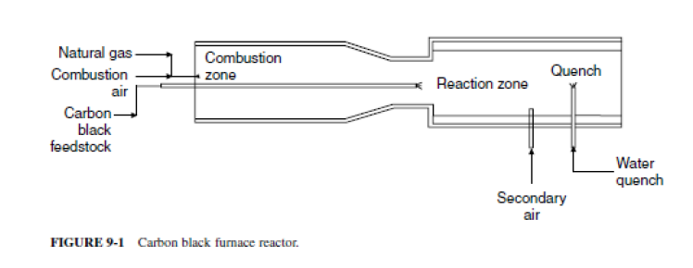
CARBON BLACK PROPERTIES
The most important properties of carbon blacks are as follows:
• Particle size
• Structure
• Surface activity
These properties have a large effect on some important physical properties of carbon blacks for use in rubber, pigments, and plastics.
Particle Size
• The typical carbon black particle size ranges from 8 nm for furnace blacks to 300 nm for thermal blacks.
• In rubber processing, finer particles increase reinforcement and abrasion resistance and improve tensile strength.
• Surface area is used by the industry to define carbon black fineness.
Structures
• During the manufacture of carbon black, primary carbon particles fuse to form aggregates .
• The shape and degree of aggregate branching is referred to as structure.
• Increasing the structure typically increases the modulus, hardness, electrical conductivity, and compound viscosity.
• Generally, an increase in structure size improves dispersibility but lowers blackness.
• Carbon black with large structure shows excellent electric conductivity. DBPA absorption is a measure of structure, with a high number representing a higher structure.
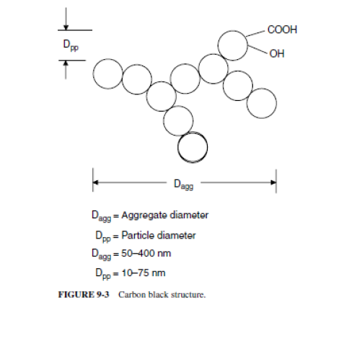
Surface Activity
• All carbon blacks have chemisorbed oxygen complexes (carboxylic, quinonic. lactonic. or phenolic groups) on their surfaces to varying degrees depending on the condition of manufacture.
• These surface groups are called volatile content and expressed as weight loss in percent after heating a dried sample of carbon black.
Porosity
• Porosity is the fundamental property of carbon black that can be controlled during the manufacturing process.
• Increasing the porosity reduces the density of the aggregate.
• This allows increased carbon black loading, which in turn leads to increased modulus and electrical conductivity for a fixed loading.
CARBON BLACK APPLICATION AND USES
• Carbon black is the predominant reinforcing filler used in rubber compounds.
• A typical passenger car or truck tire may contain approximately 30 percent by weight carbon black.
• The improvement in rubber properties is a function of the physical and chemical properties of carbon black.
• The most important physical and chemical properties of carbon black that affect rubber properties are – aggregate size,
– shape (structure),
– particle size,
– surface activity,
– and porosity.
• The physical form of carbon black (beads or powder) can affect its handling and mixing characteristics and thus rubber properties.
• The ultimate degree of dispersion is also a function of the mixing procedure and equipment used.

