Experiment No.5

MOSFET Characteristics and Switch

Experiment No.5 MOSFET Characteristics and switch

Objective :
To display and study the V-I characteristics of a MOSFET on the oscilloscope, and examine its operation as a switch.

Apparatus used:
1. ST2712 board. 2. Oscilloscope. 3. Function generator. 4. DC Voltmeter. 5. Diode.
6. LED. 7. Potentiometer 5KΩ(1/4w). 8. Resistances 1KΩ(1/4w), and 10 Ω(1/2 W).

Theory :
MOSFET(Metal Oxide Silicon Field Effect Transistor) come in four different types. They may be enhancement or depletion mode, and they may be n-channel or p-channel. The symbol of each is shown in figure (1). It has three terminals : D (drain), S (source), and G (gate). The gate of a MOSFET is isolated electrically from the source by a layer of silicon oxide. The gate draws only a minute leakage current on the order of nanoamperes. Hence, the gate drive circuit is simple and power loss in the gate control circuit is practically negligible.
The MOSFET is known as voltage control devices but its conduction losses are high while its switching losses are low, but it is normally operates at less frequency than BJT. Since the voltage control devices are better than current control devices and requires very low control current so it is very convenient to use it in digital control systems.

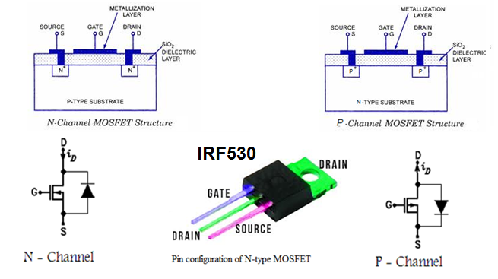
Figure (1) Symbols and configuration of a MOSFET.

I-V characteristics (Output characteristics)
It is the relationship between i_{D} and V_{DS} in many VGS conditions. (Refer to Figure (2). It is divided into the ohmic region, the saturation (=active) region, and the cut-off region.
Ohmic region:
A constant resistance region. If the drain-to-source voltage is zero, the drain current also becomes zero regardless of gate–to-source voltage. This region is at the left side of the VGS – VGS(th) = VDS boundary line [V_{GS} – V_{GS}(th ( >V_{DS} > 0].

Saturation region:
A constant current region. It is at the right side of the V_{GS} – V_{GS}(th( = V_{DS} boundary line. Here, the drain current differs by the gate–to source voltage, and not by the drain-to-source voltage. Hence, the drain current is called saturated.

Cut-off region:
It is called the cut-off region, because the gate-to-source voltage is lower than the VGS(th) (threshold voltage). A power MOSFET is a unipolar, majority carrier, "zero junction". Voltage-controlled device. If the gate voltage is positive and beyond a threshold value (V_{GTH}), an N-type conducting channel will be inducted that will permit current flow by majority carrier (electrons) between the drain and the source. Although the gate impedance is extremely high at steady state, the effective gate-source capacitance will demand a pulse current during turn-on and turn-off. The device has asymmetric voltage-blocking capability, and had an integral body diode as shown which can carry full current in the reserve direction. The diode is characterized by slow recovery and is often by applying a external fast-recovery diode in high frequency application.
The V-I characteristics of the device have two distinct regions. A constant resistance (R_{DS(on)} ) region and constant current region. The R_{DS(ON)} of MOSFET is an important parameter which determines the conduction drop of the device. For a high voltage MOSFET, the longer conduction channel makes this drop large (R_{DS(ON)} α V_{DS} ^{2.5}) at the ohmic region. it is interesting to note that modern trench gate technology tends to lower the conduction resistance. The positive temperature coefficient of this resistance makes parallel operation of MOSFET easy. In fact, large MOSFETS are fabricated by parallel connection of many devices.

Figure (2) MOSFET Output characteristics.

MOSFET as a Switch
MOSFETs are commonly used as electronic switches, both for moderate-power applications such as switched-mode power supplies and for low-power applications such as logic gates.
The circuit of the MOSFET as switch is just like that of the BJT as switch.
In any switching circuit, values of input voltage would be chosen such that the output is either completely off, or completely on. The transistor is acting as a switch, and this type of operation is common in digital circuits where only "on" and "off" values are relevant.

PART I. MOSFET characteristics.

Procedure:

- Connect the circuit as shown in figure (3).
- Set the oscilloscope as follows:
- X-Y mode.
- Channel 1 at 5 V/Div. on the drain .
- Channel 2 at 0.1V/Div. on the source .
3.Switch ON the power supply of the board.
4.Vary VGS by using the 5K pot. for the values as shown in table (1) and record ID and VDS for each value. Also display the characteristics on the oscilloscope for each value and plot all the characteristics in the same graph paper.

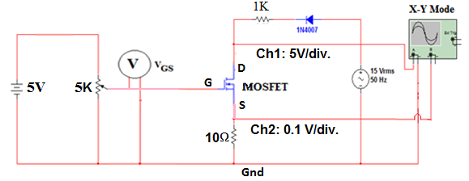

Figure (3) the practical circuit to plot the MOSFET characteristics on the oscilloscope.

Table (1) results obtained for a MOSFET characteristics.

Region | Cut Off | Active |  |  | Saturation
VGS(V) | 0 | 3.7 | 3.9 | 4.0 | 4.3
VDS(V)
ID(mA)
PART II. MOSFET as Switch.
Procedure:
- Connect the circuit diagram as shown in figure (4).
- Adjust the oscilloscope as follows:
CH1. at 5 V/div. on the emitter.
CH2 at 5 V/div. on the function generator.
Put the selector on the dual mode .
Press chopper .
Put time on the 5 msec/div. with 30 Hz ,
and 0.2 msec/div. with 1KHz .
- Adjust the duty cycle and the frequency of the square wave for the function generator built in on ST2712 board as shown in the figure for duty cycle of 50%. and frequency of 30 Hz. Note the blanking operation of the LED also sketch the wave forms displayed on the oscilloscope.
- Vary the frequency of the function generator at 1KHz and display both the input signal (ch.1) and the output signal (ch2). Sketch the signal displayed on the oscilloscope. You can notice the ON-OFF operation clearly.
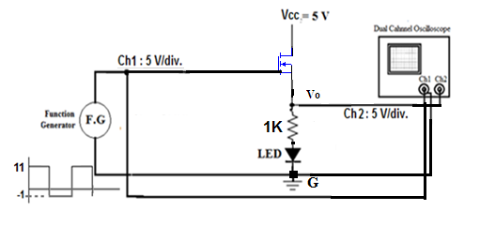
Figure (4) Experiment setup for MOSFET as switch.

Discussion.
- Comment on the obtained results?
- Explain briefly about each region of the MOSFET c/c ?
- Large MOSFETS are fabricated by parallel connection of many devices, why?
- Compare between MOSFET & BJT.
- Where is the (RDS) being (fixed, variable & zero) according to the c/c?
- From the practical results in the Table (1) find (RDS & Ploss(total)) for each step ?
- The Ploss in the gate control cct. is practically neglected ,why ?
- What is the best Q-point you choose for good amplification?
- What is the effectness of adding ( R ) or (diode) on the gate, and why ?
- Is the MOSFET consider (current or voltage) control device ,and why ?
- How can you distinguish the type of the ( MOSFET) and its terminals by the AVO meter?
- What is the benefit of the connection a diode across the MOSFET?

