Al-Mustaqbal University
College of Science
Dep. Medical Physics

Lec 10

Microsoft Excel

MS.c Mortada Sabri
MS.c Noor Mohammed

What is Excel?
Excel is a spreadsheet program, which helps organize, summarize, and calculate data. Spreadsheets are an everyday part of many professions, including accounting, statistical analysis, and project management, you can use Excel for all sorts of tasks involving numbers such as budgeting, sales analysis, forecasting, charting and graphing, Excel is a tool used to perform calculations with numbers, so That can perform any calculation operation can be done in the Excel.
To start Microsoft Excel:
  - Click the Windows Start button
  - Click All Programs
  - Click Microsoft Office
  - Click Microsoft Excel 2010

Workbooks:
When Excel is opened, a workbook appears with three worksheets. Each worksheet contains columns and rows. There are 1,048,575 rows and 16,384 columns. The combination of a column coordinate and a row coordinate make up a cell address. For example, the cell located in the upper left corner of the worksheet is cell A1, meaning column A and row 1. The cell address is visible in the Name Box.
Place your cursor in the first cell, A1. The formula bar will display the cell address in the Name Box on the left side of the Formula Bar. Notice that the address changes as you move around the sheet. You can easily move from cell to cell by pressing tab or using the arrow
A cell can contain any of the following:
    - A number
    - Text (including any combination of letters, numbers, and symbols that aren't number-related).
    - A formula, which is a math equation.
    - A function, which is a named equation that shortcuts an otherwise complex operation.

A column is the vertical line of cells from the top to the bottom of the page. Columns are alphabetized.

Microsoft Excel 2010 Layout:

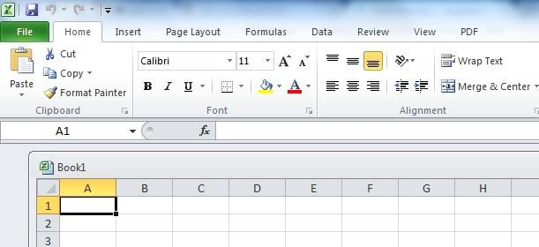Excel is a spreadsheet program that manipulates, graphs, and analyzes numeric data. Common uses for Excel are: budgets, grade books, address lists, or simple inventories.
The Name Box tells you the name/coordinates of the cell selected. Note how cell A1 is where column A and row 1 intersect.
The formula bar allows you to enter or edit data in the selected cell.
Formulas and functions can also be entered.
A row is the line of cells from the left to the right of the page. Rows are numbered.
The Quick Access Toolbar is a customizable shortcut menu to commonly used commands. It’s visible no matter which tab is selected.

The Ribbon contains the commands. It has multiple tabs that have their own groups of commands. Some groups have an arrow at the bottom-right corner that will reveal more options once clicked.

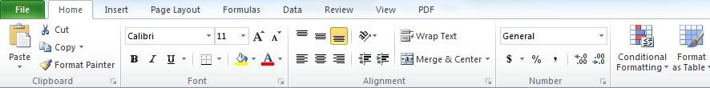
Each tab will have groups
The arrow in the bottom-corner of groups will allow you to see more options for that group
Click on a Tab to see the ribbon change with different commands

Columns, Rows, Cells, and Ranges:
Columns, rows, and cells are the most fundamental components of a work sheet.
    - A column: is a vertical series of adjacent cells from top to bottom.
    - A row: is a horizontal series of cells from left to right.
    - A cells: is an individual rectangle anywhere in the grid area of a worksheet.

The Active Cell
Every cell in your spreadsheet has a name or reference that can be formed by a letter-number combination, e.g. A5, D6.

When you select a cell in an Excel worksheet, it becomes enhanced with a thicker border. The cell you have chosen is now the active cell, and its name or reference is the cell column letter followed by the cell row number. In this image, cell G4 is the active cell.
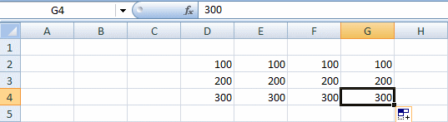

The active cell is G4
The column letter and row number of the active cell are displayed in the Name Box near the upper left corner of the Excel grid

If you enter text or numbers into the Formula Bar (shown below), the text or number that you type will also be entered into the active cell.

Entering Text
Any items that are not to be used in calculations are considered, in Excel’s terminology, labels. This includes numerical information, such as phone numbers and zip codes. Labels usually include the title, column and row headings.
To Enter Text/Labels:
- Click in a cell.
- Type text.
- Press Enter.

Modifying Columns, Rows, & Cells:
When you first open an excel workbook, the cells, rows, and columns appear to have a set size. You can easily modify the default sizes, as well as add and delete.

Changing Column Width:

      - Position your mouse over the column border in the top column heading. Your mouse pointer should change from a white cross , to a double arrow.
      - Click and drag the column line to the right to increase the width.
      - Release the mouse button. The column width will remain where you release.

Tip! If you see hashtags (#######) in a cell, it means the column is not wide enough to display the cell’s content. Continue to increase the width to show the cell’s data.

Changing Row Height:

      - Position your mouse on a row border in the first column where the rows are numbered. The white cross will change to a double arrow.
      - Click and drag the arrow downward/upward to increase the row’s height.
      - Release the mouse and the row height will remain where the mouse was released.

Insert Rows:

1.
Select the row below where you want the new row to appear. Select the entire row by clicking on the numbered row heading.
Click on the row number to select the entire row

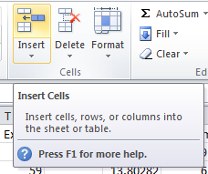2. Click the Insert command on the Home tab.
Click the Insert command on the Home tab to insert rows, cells, or columns

Insert Columns:

- Select the column to the right of where you want the new column to appear. For example, if you want a new column between C and D, select column D.
- Click the Insert command on the Home tab (same button used to insert rows).

Tip: When inserting rows and columns, make sure you select the entire row or column by clicking on its heading (numbers for rows & letters for columns). If you only select a cell, then only a new cell will be created

Formatting Text, Numbers, and Cells Selecting/Moving Rows or Columns:
-To select an entire row, click on the number of the row in the gray column on the left.
- To select an entire column, click on the letter of the column in the gray row at the top.
-To move the entire row or column select entire row, hold down the shift key, click on row/column line and drag it to the d

Wrapping Text and Merging Cells:
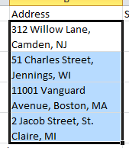
When a cell contains more text than can be displayed, you can choose to wrap the text within the cell or merge empty cells together.

Wrapping text makes the information display on multiple lines down, and merging cells will combine cells creating one big space for text.
1.5.1. To Wrap Text:
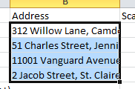
1.Select the cells you would like to wrap text. 2.Select the Wrap Text command on the Home tab. 3.The text in the selected cells will be wrapped.
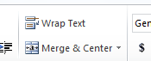

Tip! If you change your mind, click Wrap Text again to undo

Copying Formula:
- click on the cell that has the formula you want to copy. go to the bottom right hand corner and get the black cross symbol.
- click the left mouse button and drag down through the rest of the rows and let go of the mouse. This will copy the formula down for the rest of the names.

To Clear a Cell Format:
- Click in the cell that contains formatting

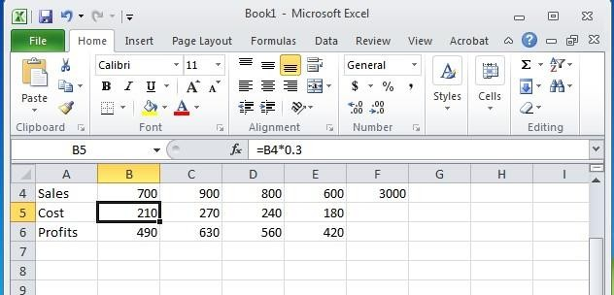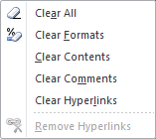

- Click the drop-down arrow next to the Clear button on the Home tab in the Editing group
- Click Clear Formats

Sorting & Filtering:
If you are working with a large amount of data in your worksheet, sort and filter can make finding information faster. You can customize the order of your data alphabetically, numerically, by groups, and with multiple layers too.
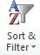

1.8.1. Sort:
Sort allows you to change or customize the order of your data. Do you want your attendance list to be alphabetized? Or order a column of numbers from smallest to largest? The sort command allows you to do this and not mess up the rest of your spreadsheet too. Below are some common sort commands.

Sort Alphabetically

Sort by Date or Time

Sort in an order of your choosing

Sort with multiple levels

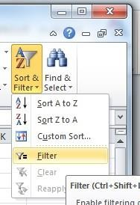
1.8.2 Filter
Filter is useful when you want to narrow down your data and hide other parts. You can filter text, dates, and numbers.
You can also use more than on filter to further narrow your data.
To use the filter command, you must have a spreadsheet that has a header row.
- Click the Sort & Filter command in the Home tab.
- There is also a Filter command located under the Data tab.
- Click on Filter.
- Drop-down arrows will appear in every column in the header row.
- Click the drop-down arrow in the column that you want to filter.
- The filter menu appears.
- Uncheck any boxes next to data that you do not want to view. Anything that remains checked will remain visible.
- Click OK and your spreadsheet will be filtered. The data not visible is hidden temporarily. It has not been deleted.

Entering Values
Numerical pieces of information that will be used for calculations are called values. They are entered the same way as labels. It is important NOT to type values with characters such as “,” or “$”.
To Enter Values:
- Navigate to a cell
- Type a value
- Press Enter

Creating Formulas

Operator (Key) | Function
= | Begins all Excel functions and formulas
+ | Addition
- | Subtraction
* | Multiplication
/ | Division

  - To Create a Formula:
- Click in a cell
- Press the = key
- Type the formula
- Press Enter

Excel Functions:
As we have previously seen, the power of Excel lies in its ability to perform calculations. The real strength of this is shown in Functions. Functions are more complex formulas that are executed by using the name of a function and stating whatever parameters the function requires.
Function | Defined
=SUM(range of cells) | returns the sum of the selected cells
=AVERAGE (range of cells) | returns the average of the selected cells
=MAX(range of cells) | returns the highest value of the selected cells
=MIN(range of cells) | returns the lowest value of the selected cells
=COUNT(range of cells) | returns the number of values of the selected cells

Closing Excel
To close Excel and all open Excel files, click the top X in the upper right corner of the Excel screen.
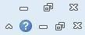

Thank you

