GENERAL SURGERY
LECTURE 1
HEAD INJURY
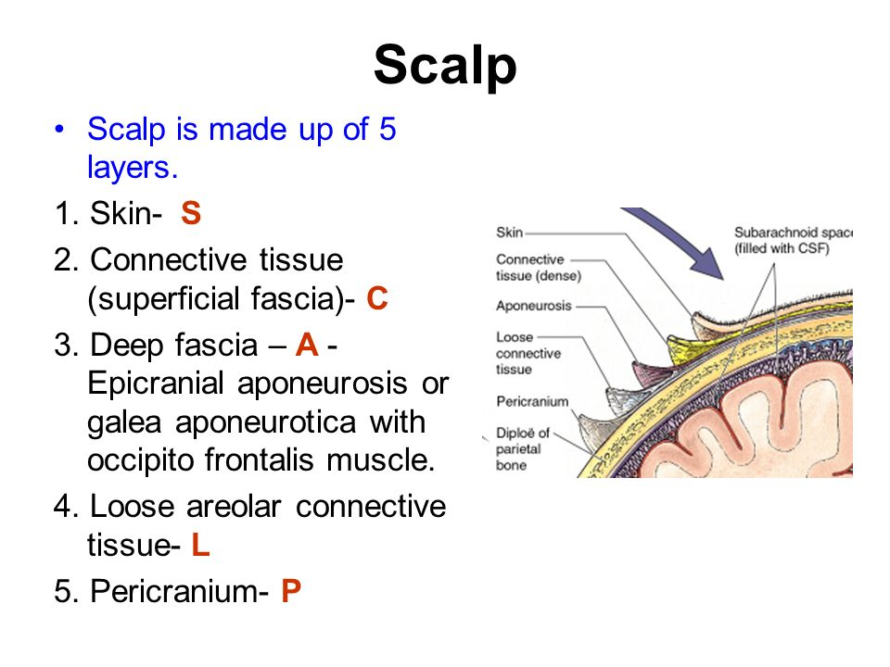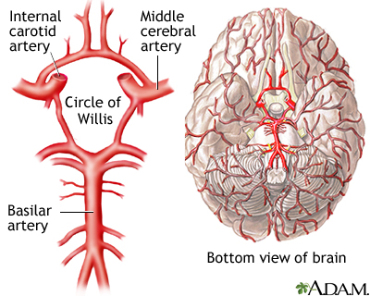

Circle of the Willis:
The Circle of Willis is the joining area of several arteries at the bottom (inferior) side of the brain. At the Circle of Willis, the internal carotid arteries branch into smaller arteries that supply oxygenated blood to the cerebrum
Meninges of the brain:
The meninges refer to the membranous coverings of the brain and spinal cord. There are three layers of meninges, known as the dura mater, arachnoid& pia mater.
types of head injury:
1-closed head injury.
2-open head injury.
Risk factors of head injury include:
male sex, recreational drugs (including alcohol and substance abuse) and youth, with a peak at 15–30 years of age. Road traffic accidents are the leading cause of head injury, being responsible for up to 50 % of cases. Other common mechanisms of injury include falls and assault. There is significant geographical variation, for example firearms are the third leading cause in the US.
Cerebral blood flow: The brain is dependent on continuous cerebral blood-flow for oxygen and glucose delivery, and hence survival. Normal cerebral blood flow (CBF) is about 55mL/minute for every 100 g of brain tissue. Ischemia results when this rate drops below 20 mL/min, and even lower levels will result in infarction unless promptly corrected.
The flow rate is related to cerebral perfusion pressure (CPP), the difference between mean arterial pressure (MAP) and intracranial pressure (ICP): CPP (75–105 mmHg) = MAP (90– 110 mmHg) − ICP (5–15 mmHg).
ICP Alexander Monro observed in 1783 that the cranium is a ‘rigid box’ containing a ‘nearly incompressible brain’. Therefore, any expansion in the contents, especially hematoma and brain swelling, may be initially accommodated by exclusion of fluid components, venous blood and cerebrospinal fluid (CSF). Further expansion is associated with an exponential rise in intracranial pressure. The result is hypoperfusion and herniation.
Initial evaluation and management The modern management of trauma is based on a firm understanding of the pathophysiology of trauma and an understanding of how patients actually die. This understanding has led to the development of several trauma systems, of which the Advanced Trauma Life Support (ATLS) is now generally recognized as the ‘gold standard’. ATLS was originally introduced by the American College of Surgeons Committee of Trauma and is now taught in over 50 countries worldwide.
It provides a systematic approach that should ensure that life threatening and subsequent injuries are identified and managed in an appropriate and timely manner. Management is based on a number of well-established principles History Vital information may need to be obtained from paramedics and observers when the patient is unable to give a full history (as is usually the case).
Mechanism: Head injuries arising from high energy mechanisms of injury, such as a fall from a height or a high-speed road accident. This makes multisystem injury (especially to the spine) likely so. The possibility that a fall or crash may have resulted from a prior medical problem, such as myocardial infarction, hypoglycemia or subarachnoid hemorrhage, should be borne in mind when trying to get a full history Neurological progression A specific check should be made for any loss of consciousness at the time of injury, and its duration.
The Glasgow Coma Score (GCS) and pupil responses at the scene and on arrival in Accident and Emergency should be obtained and documented. GCS is an important index of developing, and potentially reversible, secondary injury. It is also useful to assess the extent of amnesia, retrograde (events prior to the injury) and anterograde (events afterwards). Examination: primary survey Patient assessment commences with a rapid primary survey during which lifesaving interventions are undertaken. Urgent investigations and other interventions are then performed. The patient is then re-evaluated (secondary survey), stabilized and when required, transferred to a facility for specialized care. It is during the rapid primary survey that consideration of life-threatening complications of facial injuries should be made.
Rapid primary survey in order of priority Airway with cervical spine control Breathing and ventilation (oxygenation) Circulation and control of hemorrhage Disability – assessment of neurological deficit Exposure and environmental control Glasgow Coma Score The GCS is the sum of scores on three components as detailed below.
Remember a patient flexing in response to a painful stimulus scores ‘M5’. A sternal or sternal area.
, or trapezius squeeze will usually be an appropriate stimulus. Remember that 3/15 is the lowest possible GCS score Table Head injury severity:
EYE response =4
Eyes open Spontaneously--- 4
To verbal command---------- 3
To painful stimulus----------- 2
Do not open -------------------1
Verbal response:
Normal oriented conversation=5
Confused ---------------------------------------4
Inappropriate/words only ------------------- 3
Sounds only -----------------------------------2
No sounds -------------------------------------1
Motor response:
Obeys commands =6
Localizes to pain-------------------5
Withdrawal/flexion--------------- 4
Abnormal flexion------------------3
Extension---------------------------2
No motor response----------------1
secondary survey: Examination of the head should include inspection and palpation of the scalp for evidence of sub-galeal hematoma and scalp lacerations, which may bleed profusely, and potentially overlie fractures.
Examine the face for evidence of fractures and CSF rhinorrhea or otorrhea (clear cerebro-spinal fluid usually mixed with blood coming from the nose or the ear) are also highly suggestive of a fracture of the base of the skull. A complete examination of the cranial nerves will reveal, for example, facial or vestibulo-cochlear nerve damage associated with skull base fracture. Midbrain or brainstem dysfunction may produce gaze paresis (inability of eye to look across beyond the midline), dysconjugate gaze (inability of the eyes to work together. Inspect the conjunctiva and cornea of the eyes, and the retina using an ophthalmoscope, looking for hyphaema (blood in the anterior chamber of the eye), papilloedema or retinal detachment. Blood in the mouth may be due to tongue-biting at seizure or at the time of trauma. The GCS and pupil status, assessed as part of the primary survey, require reevaluation at the secondary survey and regularly thereafter Neck and spine In moderate or severe traumatic brain injury (TBI), there is an associated cervical spine fracture in around 10 per cent of cases. Therefore, cervical spine injury must be presumed in the context of head injury until actively excluded. In a high energy mechanism, such as road traffic accident or fall from a height, thoracic and lumbar spine injuries must also be excluded.
Plain x-rays are of limited value in excluding significant cervical spine injury. Even computed tomography (CT) imaging does not exclude the possibility of significant ligamentous injury. Therefore, where possible, these patients should be managed in a hard collar until their spine can be cleared clinically.
CLASSIFICATION OF SEVERITY AND TYPE OF HEAD INJURY :as it is the GCS – and in particular the motor score – that is the best predictor of neurological outcome.
Discharge criteria in minor and mild head injury by (NICE)
1-GCS 15/15 with no focal deficits
2-Normal CT brain if indicated
3-Patient not under the influence of alcohol or drugs
4-Patient accompanied by a responsible adult
5-Verbal and written head injury advice: seek medical attention if:
A-Persistent/worsening headache despite analgesia
B-Persistent vomiting
C-Drowsiness
D-Visual disturbance
E-Limb weakness or numbness
Intracranial hematoma: Hemorrhage within the cranium occurs in four main sites: extradural, subdural, subarachnoid and intraparenchymal. Each has a characteristic cause, presentation and treatment. However, a common characteristic is that all cause a rise in intracranial pressure, which may compromise perfusion of the brain. Minimizing the secondary injury by making sure that the patient is well oxygenated and that their blood pressure is within normal limits is important in the early management of these cases Types of Injury Extradural hematoma Typically, it is damage to the middle meningeal artery under the thin temporal bone. A low energy injury mechanism, perhaps with brief loss of consciousness, is sufficient to start the extradural bleeding. The patient may then present in the subsequent lucid interval with headache, once the limits of compensation have been reached after as long as some hours, rapid deterioration follows.
Overall mortality is around 10–20 per cent Acute subdural hematoma arises from rupture of cortical vessels. associated with a high energy injury mechanism and significant primary brain injury. Conscious level is usually therefore impaired at presentation, but may deteriorate further as the hematoma expands.
mortality in this group is about 50 per cent Chronic subdural hematoma The patient is generally elderly, may be taking antiplatelet or anticoagulant medications, and there is usually a history of a recent fall. Cerebral atrophy commonly found in the elderly is believed to stretch bridging veins. These can then rupture after only minor trauma, bleed, and then tamponade (stop bleeding due to the pressure which has been produced by the bleed). Subsequent degradation of the blood clot over days or weeks Drainage is performed using burr holes, often under local anesthetic (especially in elderly patients who present asubstantial anesthetic risk). Anticoagulation should be reversed by administration of vitamin K.
Management of head injuries :
• Scalp wounds need closure.
• Significant depressed fractures need elevating, antibiotics and antiepileptics .
• Skull base fractures may be associated with CSF leak. Pneumococcus vaccination is valuable, but prophylactic antibiotics are not usually indicated.
Head Injury Classification:
A- Severe Head Injury----GCS score of 8 or less
B- Moderate Head Injury----GCS score of 9 to 12
C-Mild Head Injury----GCS score of 13 to 15
BASAL SKULL FRACTURES
Basal skull fractures are often not detectable with skull x-rays or even CT scan. Basal skull fractures are most frequently diagnosed by clinical findings, making clinical assessment skills critical. CT may reveal suspicious fluid collections near a fracture if bleeding has occurred, or if damage to the dura resulted in a leak of CSF. The base of the skull contains a number of bony channels or foramen that permit the passage of blood vessels and nerves through the bottom of the skull. Clinical findings consistent with basal skull fracture are generally the result of bleeding or CSF leaks into one or more of these foramen or into the sinuses, or due to damage of the nerve that traverses the bony canals.
signs of basal skull fracture:
Anterior Fossa Fracture - anosmia, epistaxis, rhinorrhea, subconjunctival hemorrhage, periorbital hemorrage (raccoon eyes, visual disturbances, altered eye movement, ptosis, loss of sensation to forehead, cornea and nare
Middle Fossa Fracture - loss of sensation to lower face, ottorrhea, deafness, tinnitus, facial palsy, hemotympanium
Posterior Fossa Fracture - echymosis behind the ear (battle sign), impaired gag reflex
Catastrophic injuries can occur if there is a major disruption of the carotid artery (blood supply to middle and anterior cerebral cortex) or vertebral artery (blood supply to brainstem and posterior cerebral cortex), or if the brain stem is disrupted.
symptoms correlate to the area of injury.
The base or bottom of the skull is continuous, with one large opening for the brainstem (called the foramen magnum) and several small foramens or canals that permit nerves and vessels to travel through the skull bones. The approximate location of some of the major foramen are identified in Diagram 3 (note that in this diagram, the maxilla covers the frontal bone - the frontal bone is the true base of the anterior fossa).
When the base of the skull is fractured, disruption of the dura can allow CSF to leak into the sinuses or foramen that are close to the injury. Bleeding from surrounding blood vessels can also enter these channels. Symptoms of basal skull fracture include CSF leaks or bleeding into sinuses and canals and/or injuries to adjacent nerves.
Diagram 3
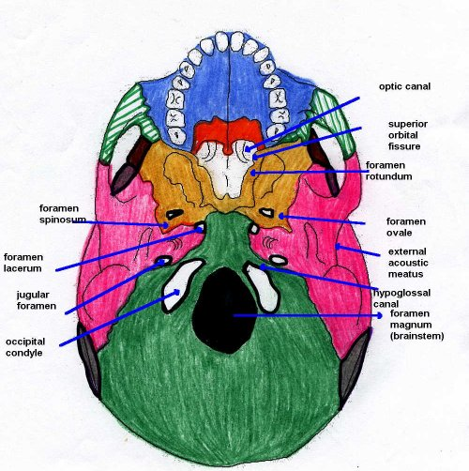
When the base of the skull is fractured, disruption of the dura can allow CSF to leak into the sinuses or foramen that are close to the injury. Bleeding from surrounding blood vessels can also enter these channels. Symptoms of basal skull fracture include CSF leaks or bleeding into sinuses and canals and/or injuries to adjacent nerves.

