**Problem 4**

A force F of magnitude 40 N is applied to the gear. Determine the moment of F about point O.



Solution



**Problem 5**

Calculate the moment of the 250·N force on the handle of the monkey wrench about the center of the bolt.



Solution

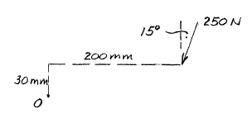



**Problem 6**

A portion of a mechanical coin sorter works as follows: Pennies and dimes roll down the 200 incline, the last triangular portion of which pivots freely about a horizontal axis through O. Dimes are light enough (2.28 grams each ) so that the triangular portion remains stationary, and the dimes roll into the right collection column. Pennies, on the other hand, are heavy enough (3.06 grams each) so that the triangular portion pivots clockwise , and the pennies roll into the left collection column. Determine the moment about O of the weight of the penny in terms of the slant distance *s* in millimeter s .



Solution





**Problem 7**

The 30·N force P is applied perpendicular to the portion BC of the bent bar. Determine the moment of P about point B and about point A.



Solution

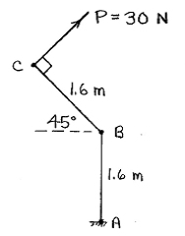

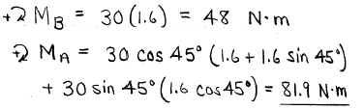

**Problem 8**

A force of 200 N is applied to the end of the wrench to tighten a flange bolt which holds the wheel to the axle. Determine the moment AI produced by this force about the center O of the wheel for the position of the wrench shown.



Solution

