Oral Histology

Amelogenesis and Enamel structure

Lecture 7

Prof. Dr. Muna Merza

Life Cycle of the Ameloblasts
Enamel is the hardest calcified matrix of the body. The cells that are responsible for formation of enamel, the ameloblasts, are lost as the tooth erupts into the oral cavity, and hence enamel cannot renew itself.
According to their function, the life span of the cells of the inner enamel epithelium can be divided into six stages:
- Morphogenic stage.
- Organizing or histodifferentiation stage.
- Formative or secretory stage
- Maturative stage.
- Protective stage.
- Desmolytic stage.
1.Morphogenic stage
Before the ameloblasts are fully differentiated and produce enamel,they interact with the adjacent mesenchymal cells,determining the shape of the dentinoenamel junction and the crown .

2.Organizing or histodifferentiation stage
In the organizing stage of development ,the inner enamel epithelium interacts with the adjacent connective tissue cells, which differentiate into odontoblasts.
3.Formative or secretory stage
The ameloblasts enter their formative stage after the first layer of dentin has been formed.
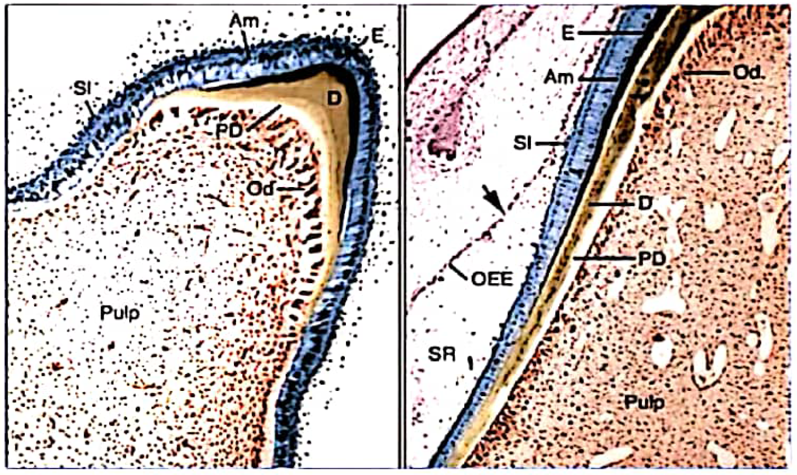
4.Maturative stage
Enamel maturation (full mineralization) occurs after most of the thickness of the enamel matrix has been formed in the occlusal or incisal area. In the cervical parts of the crown, enamel matrix formation is still progressing at this time
5.Protective stage
When the enamel has completely developed and has fully calcified,the ameloblasts cease to be arranged in a well-defined layer and can no longer be differentiated from the cells of the stratum intermedium and outer enamel epithelium.

These cell layers then form a stratified epithelial covering of the enamel,the so-called reduced enamel epithelium.

The function of the reduced enamel epithelium is that of protecting the mature enamel by separating it from the connective tissue until the tooth erupts.
6.Desmolytic stage

The reduced enamel epithelium proliferates and seems to induce atrophy of the connective tissue separating it from the oral epithelium, so that fusion of the two epithelia can occur.It is probable that the epithelial cells elaborate enzymes that are able to destroy connective tissue fibers by desmolysis. Premature degeneration of the epithelium may prevent the eruption of a reduced enamel tooth.
Amelogenesis
Amelogenesis,or enamel formation, is a two-step process. When enamel first forms,it mineralizes only partially to approximately 30%. Subsequently, as the organic matrix breaks down and is removed, crystals grow wider and thicker. This process whereby organic matrix and water are lost and mineral is added accentuates after the full thickness of the enamel layer has been formed to attain greater than 96% mineral content
Formation of the enamel matrix
The ameloblasts begin their secretory activity when a small amount of dentin has been laid down.The ameloblasts lose the projections that had penetrated the basal lamina separating them from the predentin and islands of enamel matrix are deposited along the predentin proceeds, a thin, continuous layer of enamel is formed along the dentin The second stage, or maturation, is characterized by the gradual completion of mineralization.

Development of Tomes' processes
The projections of the ameloblasts into the enamel matrix have been named Tomes' processes
Mineralization and maturation of the enamel matrix
Mineralization of the enamel matrix takes place in two stages.In the first stage a partial mineralization occurs in the matrix segments and the interprismatic substance are laid down.
The second stage, or maturation, is characterized by the gradual completion of mineralization. The process of maturation starts from the height of the crown and progresses cervically. Thus there is an integration of two processes: each rod matures from the depth to the surface, and the sequence of maturing rods is from cusps or incisal edge toward the cervical line. The rate of formation of enamel is 4 um/day, therefore to form a layer of enamel of 1mm thickness it would take about 240 days.The rate of enamel formation is more in permanent teeth than in deciduous teeth.

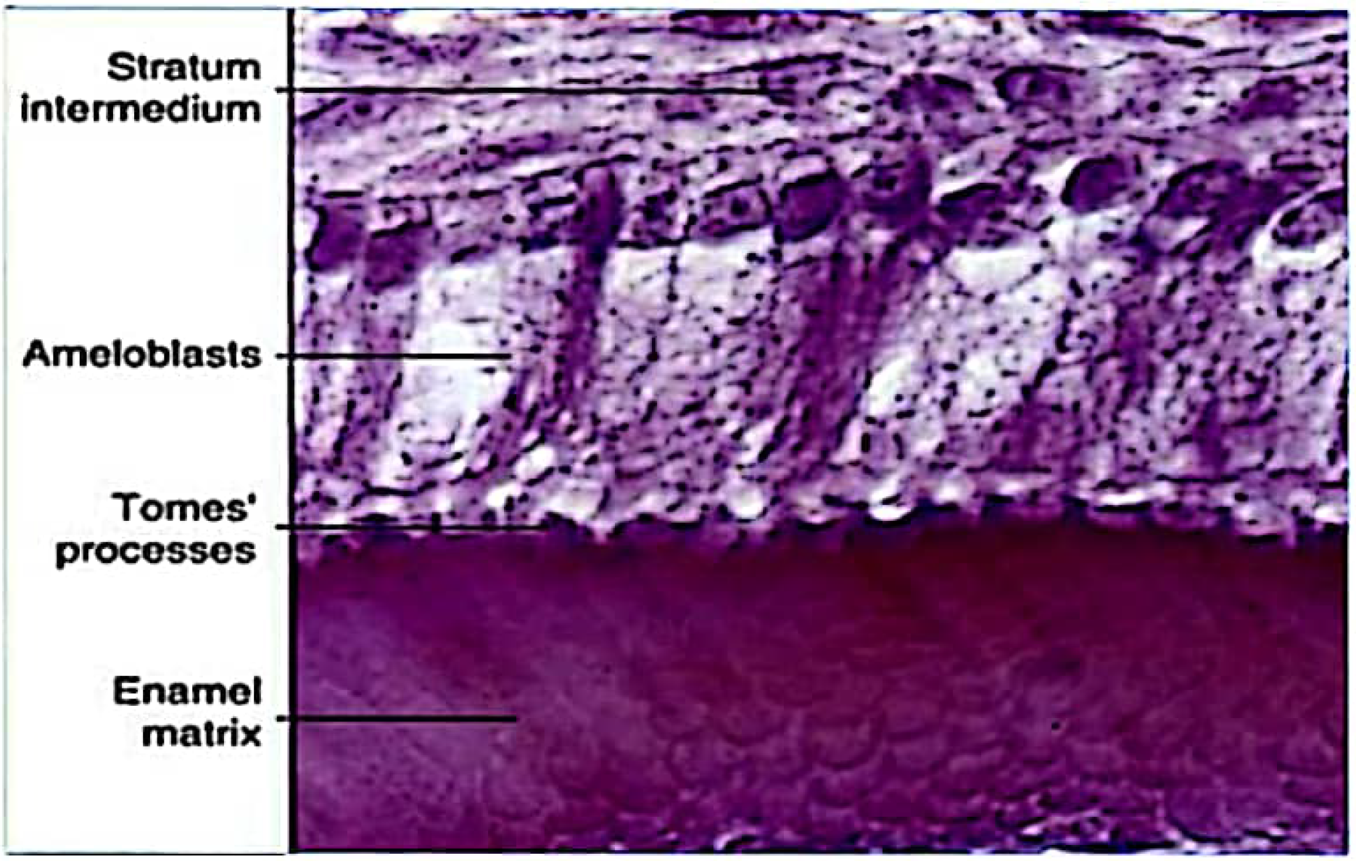

Enamel structure
1.Physical Characteristics:
Enamel forms a protective covering of variable thickness over the entire surface of the crown.On the cusps of human molars and premolars the enamel attains a maximum thickness of about 2 to 2.5 mm,thinning down to almost a knife edge at the neck of the tooth
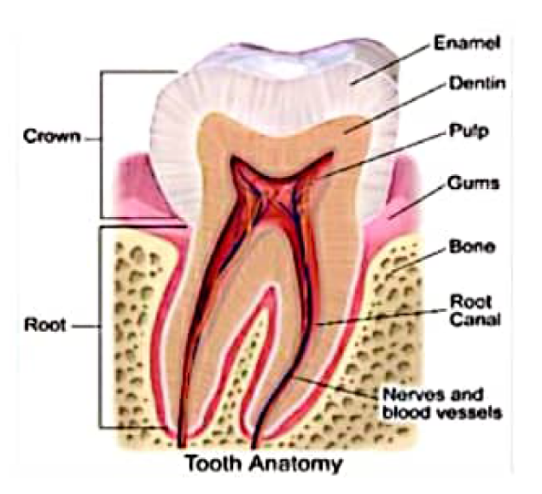
The enamel was found to be thicker in the lingual surfaces of maxillary molars and in the buccal surfaces of mandibular molars.
Because of its high content of mineral salts and their crystalline arrangement, enamel is the hardest calcified tissue in the human body. The function of the enamel is to form a resistant covering of the teeth,rendering them suitable for mastication.
Chemical Properties
The enamel consists mainly of inorganic material (96%) and only a small amount of organic substance and water (1%).
The organic material consists of some unique proteins, found exclusively in the enamel and lipids. The proteins found in the enamel are of two main groups the amelogenins and the nonamelogenins.

Amelogenins are a heterogeneous group of low molecular weight proteins,accounting for about 90% of the enamel proteins.

The inorganic material of the enamel is hydroxyapatite.
Structure Rod:
The enamel is composed of enamel rods or prisms, rod sheaths, and in some regions a cementing interprismatic substance. The enamel rods normally have a clear crystalline appearance,permitting light to pass through them.

