Dentinogenesis
&
Dentin structure

Prof. Dr.Muna Merza

Lecture 8

Dentin

The dentin provides the bulk and general form of the tooth and is characterized as a hard tissue with tubules throughout its thickness.
Since it begins to form slightly before the enamel, it determines the shape of the crown, including the cusps and ridges, and the number and size of the roots. As a living tissue it contains within its tubules the processes of the specialized cells, the odontoblasts.
PHYSICAL AND CHEMICAL PROPERTIES

In the teeth of young individuals the dentin usually is light yellowish in color, becoming darker with age. Unlike enamel, which is very hard and brittle, dentin is viscoelastic and subject to slight deformation. It is somewhat harder than bone but considerably softer than enamel. Dentin hardness varies slightly between tooth types and between crown and root dentin. Dentin consists of 35% organic matter and water and 65% inorganic material.
The organic substance consists of collagenous fibrils embedded in the ground substance of mucopolysaccharides.

The inorganic component is consist of hydroxyapatite, as in bone, cementum, and enamel. Dentin also contains small amounts of phosphates, carbonates, and sulfates. The crystals are poor in calcium but rich in carbon when compared to enamel. Organic and inorganic substances can be separated by decalcification .
Dentinogenesis
Dentinogenesis begins at the cusp tips after the odontoblasts have differentiated and begin collagen production. Dentinogenesis is a two-phase sequence in which a collagen matrix is first formed and then calcified.
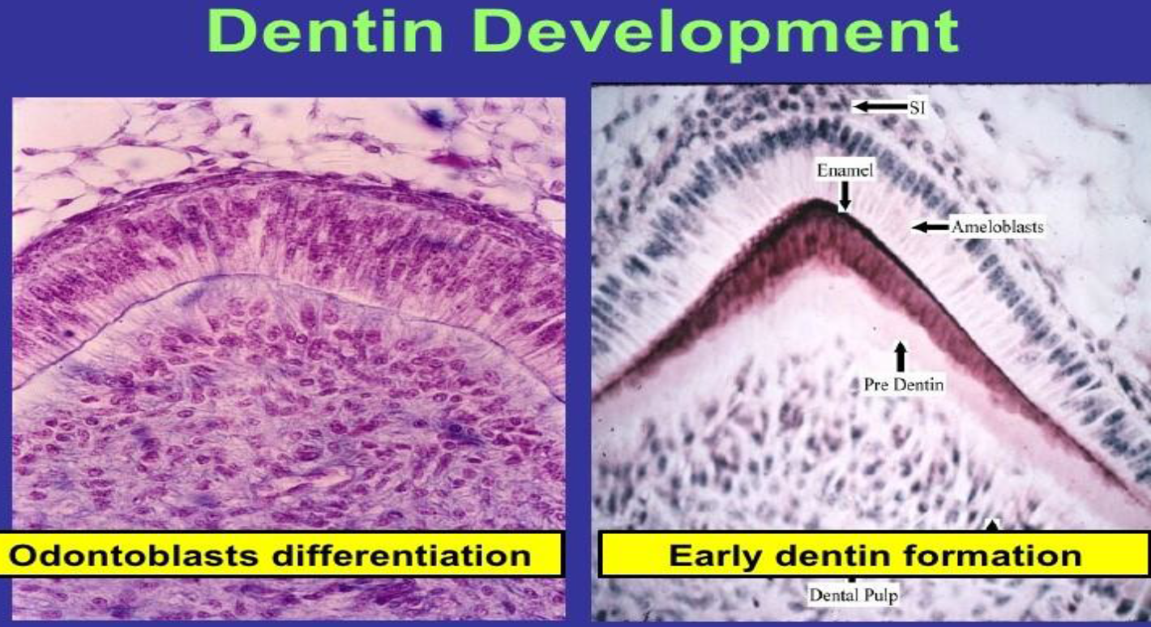

After differentiation, the odontoblast begins secreting an organic matrix around the area directly adjacent to the IEE, closest to the area of the future cusp of a tooth.

The odontoblasts begin to move toward the center of the tooth, forming an extension called the odontoblast process.

The odontoblast processes are the cytoplasmic extensions of the odontoblasts. The odontoblast cells reside in the peripheral pulp at the pulp-predentin border and their processes extend into the dentinal tubules . The processes are largest in diameter near the pulp (3 to 4 μm) and taper to approximately 1 μm further into the dentin.

The bodies of the odontoblasts are arranged in a layer on the pulpal surface of the dentin, and only their cytoplasmic processes are included in the tubules in the mineralized matrix. Each cell gives rise to one process, which traverses the predentin and calcified dentin within one tubule and terminates in a branching network at the junction with enamel or cementum. Tubules are found throughout normal dentin and are therefore characteristic of it.

Thus, dentin formation proceeds toward the inside of the tooth. The odontoblast process causes the secretion of hydroxyapatite crystals and mineralization of the matrix. This area of mineralization is known as mantle dentin .

Maturation of dentin or mineralization of predentin occurs soon after its apposition, which takes place in two phases: primary and secondary. Initially, the calcium hydroxyapatite crystals form as globules in the collagen fibers of the predentin Later, new areas of mineralization occur as globules form in the partially mineralized predentin during the secondary mineralization.
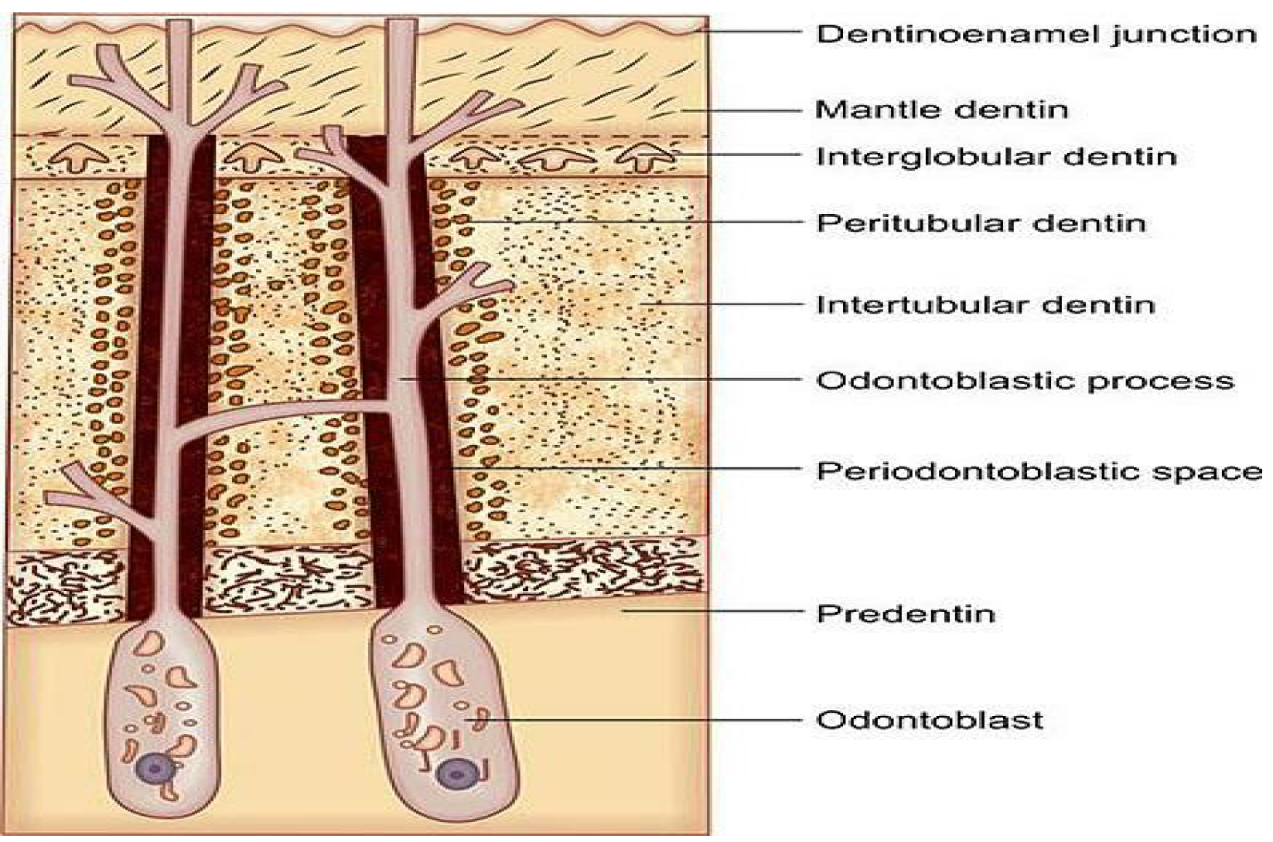
Dentinal tubules

Are small hollow microscopic channels that travel from the inside of the tooth where the pulp is out through the dentin ending right beneath the enamel.

