Radiology
Lec 1. Physics of Radiation

Introduction
- Radiology is the science that deals with diagnostic, therapeutic and researches application of high energy radiation.
- Radiography is a process of image production for an object through the use of x – radiation.

- Radiologic examination is an integral component of the diagnostic procedure. Dentists often make radiographic images of patients to obtain additional information beyond that available from a clinical examination or their patient's history. These images is combined with the clinical examination and history to make a diagnosis and formulate an appropriate treatment plan.

Nature of Radiation
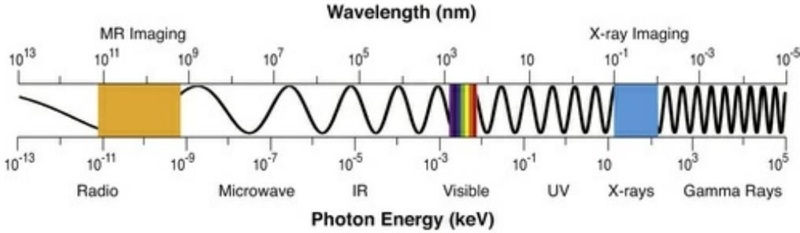
Radiation is the transmission of energy through space and matter. It may occur in two forms: electromagnetic and particulate.

Electromagnetic spectrum
- X – Ray was discovered by (Roentgen) in 1895 and the X ray beam is composed of X-photons or (quantum) which travel with a wave motion called (sine - wave), the distance between the crest of these waves is called (wave length) and the amount of energy contained in each photon called (photon energy) which depend on wave length and frequency.
The x ray photon with high frequency and short wave length has more energy than a low frequency long wave length X – ray photons.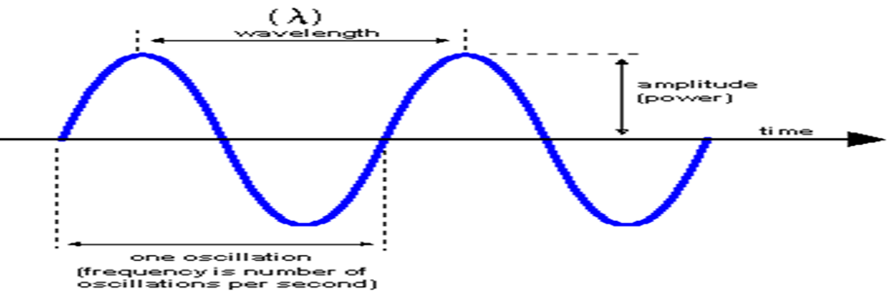

The wave length of the x ray is so short that they are measured in Angstrom unit A.

A = 1/100 000 000 cm.

X ray wave length used in diagnostic radiation range from (0.1 – 0.5 ) A

Comparison between x – ray and light

- Both belong to the same electro – magnetic radiation family.
- Both travel in straight lines at the same speed which is 186,000 miles per seconds.
- Both affected the photographic films and made them black.
- Both not affected by magnetic fields
- X-ray and light cast the shadows of the objects in the same manner
- X-ray has the ability to penetrate objects that the light cannot pass through
- X-ray has the ability to ionize atoms
- X-ray has the ability to produce light (blue light) when it hits some objects and this phenomena called (fluorescence).
- X-ray is invisible

Components of X-ray machine and generation of X-ray

Dental X ray machine is used to generate X ray. It composed of:
1. X ray tube head
2. Extension arms
3.Control panel

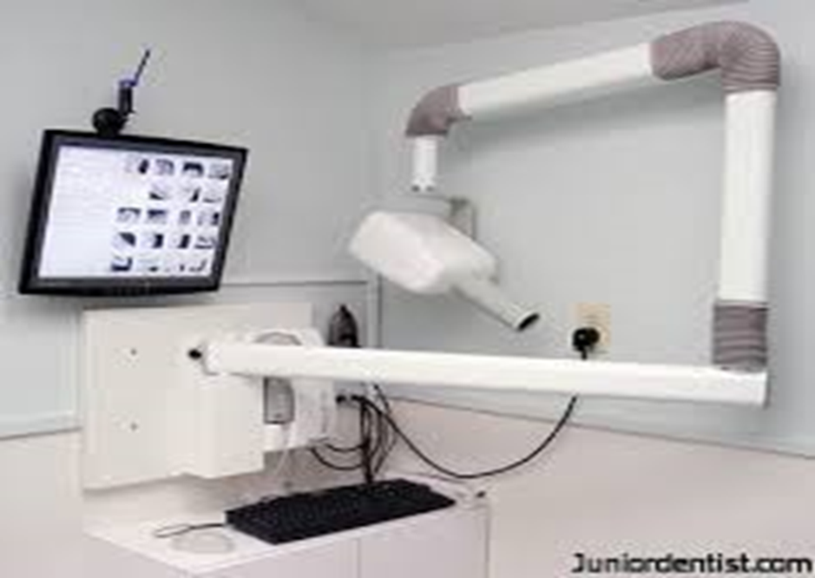

dental x ray machine

1. X ray tube head: it is a tightly sealed, heavy metal housing that contain x ray tube with its power supply (transformers) and other component.

**X ray tube:- it’s the heart of the x ray generating system. It composed of a cathode and an anode within an evacuated glass tube.
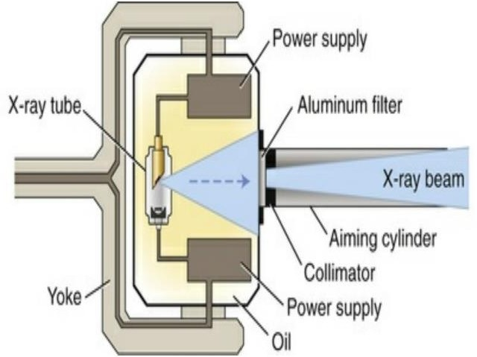
The glass tube is leaded to prevent the generated X ray from escaping in all directions, while the window is of unleaded glass so that x ray exit out through this window..
most important components of x-ray machine

**The cathode consists of a filament and a focusing cup. The filament is the source of electrons within the x-ray tube. It is a coil of tungsten wire approximately 2 mm in diameter and 1 cm or less in length, and typically contains approximately 1% thorium, which greatly increases the release of electrons from the heated wire. The filament is heated by a low-voltage source and emits electrons at a rate proportional to the temperature of the filament. Often, the tube is recessed within the tube head to increase the source-to-object distance and minimize distortion.
The filament lies in a focusing cup, a negatively charged concave molybdenum bowl. The electrons emitted by the filament and directed to a small rectangular area on the anode target called the focal spot. The x-ray tube is evacuated to prevent collision of the fast-moving electrons with gas molecules, which would significantly reduce their speed. The vacuum also prevents oxidation, or “burnout,” of the filament.
**The anode in an x-ray tube consists of a tungsten target embedded in a copper stem .The purpose of the target in an x-ray tube is to convert the kinetic energy of the colliding electrons into x-ray photons. The conversion of the kinetic energy of the electrons into x-ray photons is an inefficient process, with more than 99% of the electron kinetic energy converted to heat, that is why the tube is surrounded by an insulating oil bath which used to absorb heat that is created during generation of x ray.
Focal spot: it’s a small area on the tungsten target surface on which electrons comes from cathode are impacted and x ray photons are produced. The rectangular focal spot called ( actual focal spot).
The sharpness of the radiographic image is increased as the size of the focal spot is decreased.

The target is made of tungsten, an element that has several characteristics of an ideal target material, including the following:
  - High atomic number (74), allows for efficient x-ray production.
  - High melting point (3422°C), to withstand heat produced during x-ray production.
  - High thermal conductivity (173 W m−1 K−1), to dissipate the heat produced away from the target.
  - Low vapor pressure at the working temperatures of an x-ray tube, to help maintain vacuum in the tube at high operating temperatures.
The tungsten target is typically embedded in a large block of copper which functions as a
thermal conductor to remove heat from the tungsten, reducing the risk of the target melting.

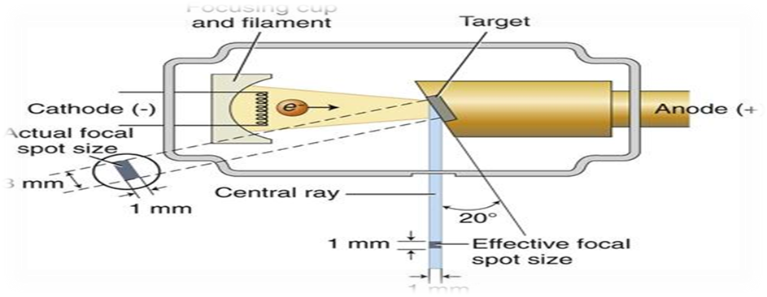
x-ray tube head and production of useful x-ray beam; notice the focal spot

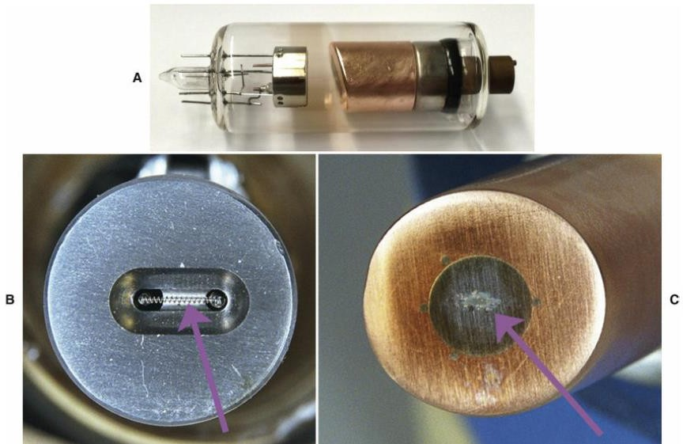

(A) Dental x-ray tube with cathode on left and copper anode on right. (B) Focusing cup containing a filament (arrow) in the cathode. (C) Copper anode with tungsten inset.

2.Extension arms:- It carries the x ray tubehead and houses the electrical wires that extends from the control panel to the tubehead. It allows the movement and positioning of the tube head.

3.Control panel:- it contains on-off switch control, exposure bottom, control devices (time, kilovoltage and milliamperage) to regulate the x ray beam

للاطلاع) )How are the x ray produced:

There are two electrical circuits operating during an x ray exposure. The first of these is the low voltage circuit ( step down transformer) which connects to the cathode and controls the heating of the filament. when the exposure button is depressed, this low voltage circuit operates for ½ second or less to heat up the filament. There are no x ray produced during this time. As we continue to depress the exposure button, the high voltage circuit ( step up transformer ) is activated .

This circuit controls the flow of electrons across the x ray tube; the negative electrons are pulled across the x ray tube to the positive target. X rays are produced until the exposure time ends

X ray results from conversion of kinetic energy of cathode electrons into x ray photons energy, and this is basically accomplished by 2 ways:

First:- (breaking radiation) (Bremsstraahlung radiation)

These photons are produced by the sudden stopping or slowing of high speed electrons by target nucleus.

Second:- (Characteristic radiation)

When the cathode electrons able to dislodge one or more orbital electrons from tungsten atom.

For example cathode electron causes dislodgement of K orbital electron of tungsten atom, then after this dislodgment; an electron from L shell falls into the empty space of the k shell and release photon with energy equivalent to the difference in the binding energies of the two orbital. This photon has a definite wavelength of a particular element, this phenomena is used to identify elements and the radiation is called Characteristic.

Types of radiation:

1. central ray: is the x ray photons that travelling in the center of the radiation beam and its commonly used to fix and locate the position of the x ray beam.

2. characteristic radiation. 3. Breaking radiation.

4. primary radiation: radiation emerge from machine in form of collimated useful x ray beam.

5. secondary radiation : radiation results from interaction of primary beam with matter.

6. leakage radiation: x ray escape through the protective housing and results in an unnecessary exposure to the patient and radiologist and have no value in diagnostic radiology.

Definition of terms used in X – ray interaction:-

- Scattering: - change in direction of photon with or without a loss of energy.
- Absorption: - deposition of energy i.e. removal of energy from the photon.
- Attenuation: - reduction in the intensity of X – ray beam caused by absorption and scattering attenuation = absorption + scattering.
- Ionization: - removal of an electron from neutral atom.

X-ray interaction with matter (Absorption of X – ray)
x – Ray absorbed by any form of matter (solid, liquid, and gas) when photons reach an atom, different types of interaction may occur depends on photon energy:
- X – Ray photons can pass through the atom without any change occurred to both of them.

- Coherent scattering sometimes called classical scattering or Thompson scattering occur by interaction of low energy x-ray photon and atom. there is no loss of photon energy only changes in direction (photon of scattered radiation) .
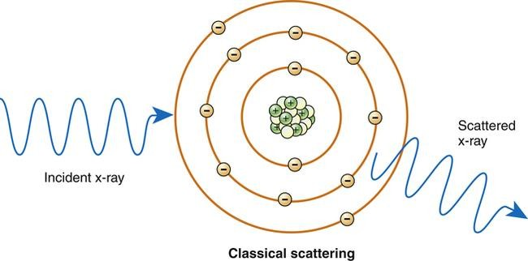
- Compton Effect: occur between moderate energy x-ray photon and free or loosely bound outer shell electron of atom. It result in ionization of atom (ejection of Compton recoil electron) , reduction of photon energy (there is some absorption of photon energy by ejected electron which undergoes further ionization interaction within the tissue) , and change in x-ray direction (scattered radiation ).
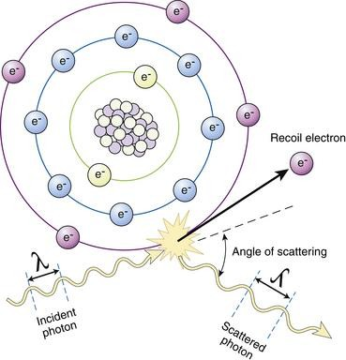
- Photoelectric effect: occur by X – Ray photon interaction with inner – shell electron of the tissue atom (ex. From k shell) , the X – ray photon disappears and deposits all its energy ;this process is pure absorption. Now the inner – shell electron is ejected with considerable energy (now called a photo – electron) in to the tissue for further interaction with other electrons of other tissue atoms. So this high – energy ejected photo electron behaves like the original high energy X
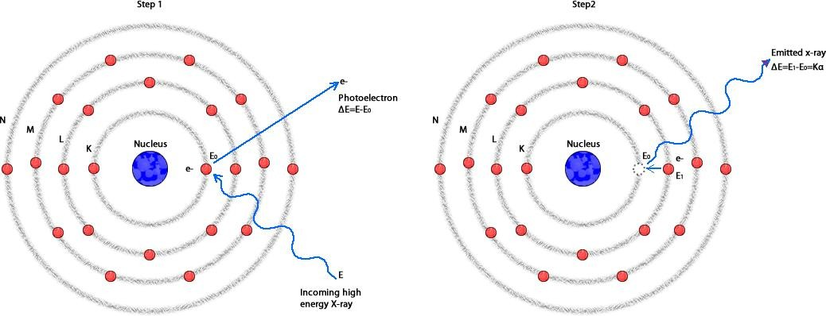
– ray photons interact and eject other electrons as it passes through the tissues, these ejected electrons are responsible for the majority of ionization interactions within the tissue and the possible resulting damage attributable to the X – rays.

Photoelectric effect is accompanied by characteristic radiation when the outer shell electron falls in the void left in the inner shell .

Filtration
X – ray used in dentistry must be able to penetrate dental hard tissues (teeth and bone). The longer wave length X – ray (soft X – ray) are not useful in diagnostic radiology so we should remove these long wave length photons from the beam by passing the beam through a filter made from Aluminum which absorb most of long wave length photons (soft X – ray), the resulting X – ray beam will consist mainly of X – ray photons with short wave length, high energy photons and high penetrating power that’s why they named (hard X – ray beam).

Types of filtration:

1. Inherent filtration: done by filter built-in to the X – ray machine by manufacturer (as
glass wall, the insulating oil and the metal housing of the tube head). The inherent filtration tends to increase with age because some of tungsten metal of both target and filament is vaporized and deposited on the inside of the tube window
The inherent filtration is equivalent of 0.5 to 2 mm of Aluminum.
2. Added filtration : done by using aluminum sheet as extra filter.

*[total filtration = inherent filtration + added filtration]
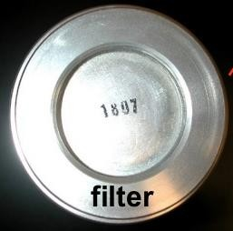 aluminum filter attached to the tube head

Collimation
Is a process used to control the size and shape of X – ray beam.
Collimator is a metallic barrier usually lead with an aperture in the middle used to reduce the size of the x ray beam and thereby the volume of the irradiated tissue. Round and rectangular collimator are frequently used in intraoral radiography. Round collimator is thick plate of lead with circular opening. It collimated the beam to a circle 2.75 inches in diameter at the patients face. Typically round collimator is built into the x ray tube head.
Rectangular collimator further limits the size of the beam to just larger than intraoral receptor ( so it is better) , it is usually added to the machine as external collimator or as a part from receptor holding instrument. It collimate the beam to approximately 1.5 x 2 inches on the face.

Collimation can be achieved by one of the following methods:

- diaphragms (round or rectangular shape).
- metal cylinders, cones and rectangular tubes.

Diaphragm Consists of a metal plate or disk made from lead with a hole in the center of the disk which allow the beam to pass through it only.

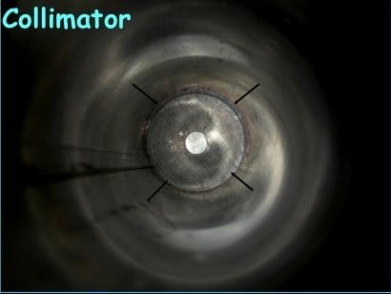 collimator attached to the end of tube head

a b

X- ray Film

exposed tissues

X- ray Film

comparison between exposed tissues with (a)rectangular and (b)round collimator

Half – value layer:
It’s a method of monitoring the penetration quality of the X – ray beam. Determination of half – value layer is done by placing thin filtering material such as aluminum filter in front of the beam so we continue increase the thickness of filtering material until we have a thickness that reduce the number of X – ray photons in the beam passing through it to (one half) this will representing a half – value layer for such beam of radiation.
High half value layer the high penetrating ability of the beam. In oral diagnosis the acceptable value is approximately 2 mm of aluminum

للاطلاع) )X-ray measuring units:
- Traditional Units
- Roentgen ( R) is the basic unit of radiation exposure for the amount of X-radiation or gamma radiation which will produced in one cc of air ions carrying one electrostatic unit of either sign.
- rad ( roentgens absorbed dose ) is a measure of the amount of energy absorbed by an organ or tissue.
- rem ( roentgens equivalent man ) is a measure of the degree of damage caused to different organs or tissues.
- Curie (Ci) : is the unit of quantity of radioactive material and not the radiation emitted by that material.
- RBE: is a relative biological effectiveness dose.

- International system of units SI Units
- Coulomb per kilogram (C\kg) : 1 C\kg = 3876 R
- Gray (Gy) : 1 Gy = 100 rad
- Sievert (Sv) : 1 Sv = 100 rem
- Becquerel (Bq) : 1 Bq=2.7 x 10*11 Ci

