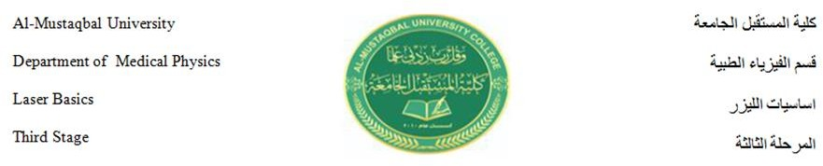

مبادئ الليزر /محاضرة 3

ا.م.د.محمد حمزة المعموري

Absorption and emission of light

Absorbance is defined as "the logarithm of the ratio of incident to transmitted radiant power through a sample (excluding the effects on cell walls)". Alternatively, for samples which scatter light, absorbance may be defined as "the negative logarithm of one minus absorptance, as measured on a uniform sample".The term is used in many technical areas to quantify the results of an experimental measurement. While the term has its origin in quantifying the absorption of light, it is often entangled with quantification of light which is “lost” to a detector system through other mechanisms. What these uses of the term tend to have in common is that they refer to a logarithm of the ratio of a quantity of light incident on a sample or material to that which is detected after the light has interacted with the sample.
The term absorption refers to the physical process of absorbing light, while absorbance does not always measure only absorption; it may measure attenuation (of transmitted radiant power) caused by absorption, as well as reflection, scattering, and other physical processes.

Bouguer-Lambert law

The roots of the term absorbance are in the law of Bouguer (Bouguer-Lambert law). As light moves through a media, it will become dimmer as it is being "extinguished". Bouguer recognized that this extinction (now often called attenuation) was not linear with distance traveled through the medium, but related by what we now refer to as an exponential function. If I₀ is the intensity of the

light at the beginning of the travel and I_{S} is the intensity of the light detected after travel of a distance d , the fraction transmitted,T , is given by:
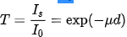

Where µ is called an attenuation constant (a term used in various fields where a signal is transmitted though a medium) or coefficient. The amount of light transmitted is falling off exponentially with distance. Taking the Napierian (natural) logarithm in the above equation, we get:
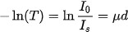

Light absorption is the process in which light is absorbed by matter and converted into energy. In an atom, electrons vibrate at a specific frequency – this is called the natural frequency. If a wave of light hits a material in which the electrons are vibrating at the same frequency as the wave of light, the electrons will absorb the energy and convert it into vibrational motion. This is why objects have different colours – different materials‟ electrons will vibrate at different rates, and therefore absorb different frequencies of light.

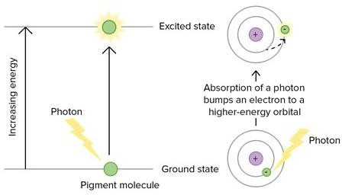

Light absorption and matter
Electrons can only exist in discrete energy levels (these can also be called electron shells) – they can‟t exist halfway between. The lowest energy level that an electron can be in is called the ground state. For an electron to move from a lower energy level to a higher energy level, it must absorb a set amount of energy because energy levels are quantised. This means that the energy absorbed by the electron must be exactly the same as the energy difference between the two levels.
When an electron absorbs energy, is it promoted to a higher energy level further away from the nucleus of the atom and is described as being „excited‟.

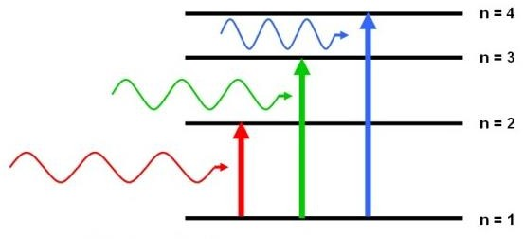

Electrons don‟t like being in an excited state. This means that after becoming excited and moving to a higher energy level, they soon fall back to their original energy level. However, to do this, they have to release a packet of energy – this is called a photon. The size of the photon released is exactly equal to the size of the jump the electron had to make in the first place.
Absorption Spectroscopy
Absorption spectroscopy is a technique used to measure the absorption of energy. The absorption spectrum of a certain material is shown by a continuous band of colour with black lines between them. The coloured parts represent the total light that is focused on the material. The black lines show an absence of this light – these are the parts of the spectrum where the electrons have absorbed the light photons.

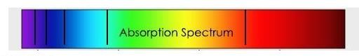

There are two types of absorption spectroscopy: atomic and molecular. Atomic absorption spectroscopy is the method of producing a spectrum when free atoms absorb different wavelengths of light – this is usually used for gases. Molecular absorption spectroscopy is the method of producing a spectrum when whole molecules absorb different wavelengths of light (usually ultraviolet or visible).
Absorption spectrums are the exact opposite of emission spectrums.

Emission
In physics, emission is the process by which a higher energy quantum mechanical state of a particle becomes converted to a lower one through the emission of a photon, resulting in the production of light. The frequency of light emitted is a function of the energy of the transition.
Since energy must be conserved, the energy difference between the two states equals the energy carried off by the photon. The energy states of the transitions can lead to emissions over a very large range of frequencies. For example, visible light is emitted by the coupling of electronic states in atoms and molecules (then the phenomenon is called fluorescence or phosphorescence). On the other hand, nuclear shell transitions can emit high energy gamma rays, while nuclear spin transitions emit low energy radio waves.

The emittance of an object quantifies how much light is emitted by it. This may be related to other properties of the object through the Stefan–Boltzmann law. For most substances, the amount of emission varies with the temperature and the spectroscopic composition of the object, leading to the appearance of color temperature and emission lines. Precise measurements at many wavelengths allow the identification of a substance via emission spectroscopy.
Emission of radiation is typically described using semi-classical quantum mechanics: the particle's energy levels and spacings are determined from quantum mechanics, and light is treated as an oscillating electric field that can drive a transition if it is in resonance with the system's natural frequency. The quantum mechanics problem is treated using time-dependent perturbation theory and leads to the general result known as Fermi's golden rule. The description has been superseded by quantum electrodynamics, although the semi-classical version continues to be more useful in most practical computations.
Origins
When the electrons in the atom are excited, for example by being heated, the additional energy pushes the electrons to higher energy orbitals. When the electrons fall back down and leave the excited state, energy is re-emitted in the form of a photon. The wavelength (or equivalently, frequency) of the photon is determined by the difference in energy between the two states. These emitted photons form the element's spectrum.
The fact that only certain colors appear in an element's atomic emission spectrum means that only certain frequencies of light are emitted. Each of these frequencies are related to energy by the formula:

where is the energy of the photon, υ is its frequency, and h is Planck's constant. This concludes that only photons with specific energies are emitted by the atom. The principle of the atomic emission spectrum explains the varied colors in neon signs, as well as chemical flame test results (described below).
The frequencies of light that an atom can emit are dependent on states the electrons can be in. When excited, an electron moves to a higher energy level or orbital. When the electron falls back to its ground level the light is emitted.

The above picture shows the visible light emission spectrum for hydrogen. If only a single atom of hydrogen were present, then only a single wavelength would be observed at a given instant. Several of the possible emissions are observed because the sample contains many hydrogen atoms that are in different initial energy states and reach different final energy states. These different combinations lead to simultaneous emissions at different wavelengths.
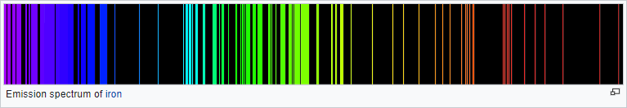

Emission spectroscopy is a spectroscopic technique which examines the wavelengths of photons emitted by atoms or molecules during their transition from an excited state to a lower energy state. Each element emits a characteristic set of discrete wavelengths according to its electronic structure, and by observing these wavelengths the elemental composition of the sample can be determined. Emission spectroscopy developed in the late 19th century and efforts in theoretical explanation of atomic emission spectra eventually led to quantum mechanics.
There are many ways in which atoms can be brought to an excited state. Interaction with electromagnetic radiation is used in fluorescence spectroscopy, protons or other heavier particles in Particle-Induced X-ray Emission and electrons or X-ray photons in Energy-dispersive X-ray spectroscopy or X-ray fluorescence. The simplest method is to heat the sample to a high temperature, after which the excitations are produced by collisions between the sample atoms. This method is used in flame emission spectroscopy, and it was also the method used by Anders Jonas Ångström when he discovered the phenomenon of discrete emission lines in the 1850s. Although the emission lines are caused by a transition between quantized energy states and may at first look very sharp, they do have a finite width, i.e. they are composed of more than one wavelength of light. This spectral line broadening has many different causes.
Emission spectroscopy is often referred to as optical emission spectroscopy because of the light nature of what is being emitted.

