Al-Mustaqbal University
Oral Medicine 5th stage/2023-2024
Lecture 2 Dr. Muayed Hashim
Laboratory Investigation
Biopsy: an examination of tissue removed from a living body to discover the presence, cause, or extent of a disease.

Types of biopsy:-
1-ExcisionaI
2-lncisionaI
3-Fine Needle Aspiration (FNA)
4-Thick (core) needle biopsy
5- Exfoliative cytology
6-Frozen section
7-Oral brush biopsy

Indications:
1-Lesions which have neoplastic or premalignant features
2-Lesions of uncertain etiology
3- Persistent lesions failing to respond treatment
4- Confirmation of clinical diagnosis.

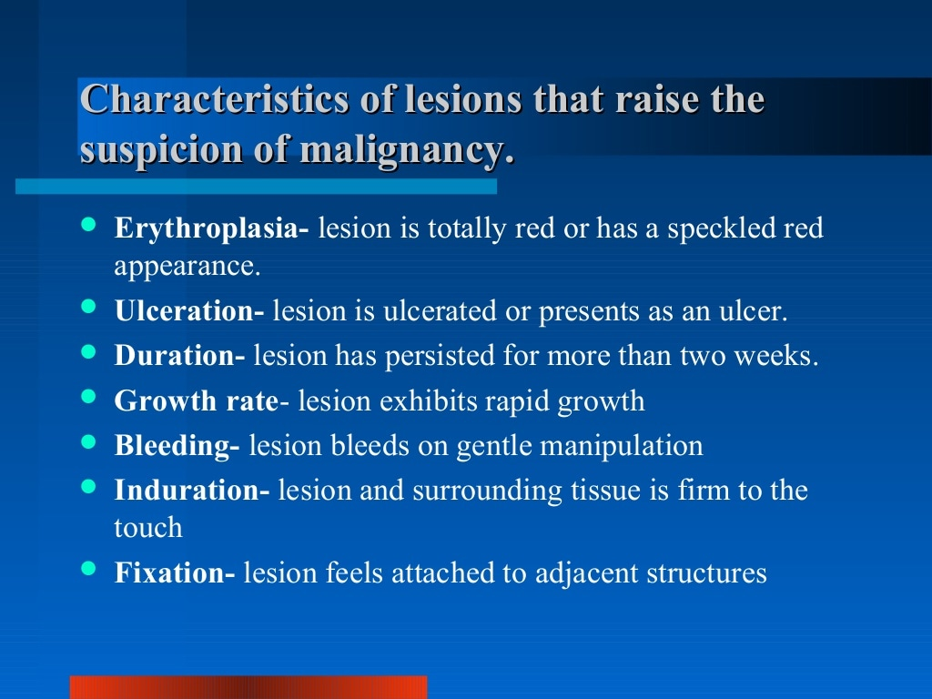

Incisional is the removal of part of the lesion used to determine the diagnosis before treatment
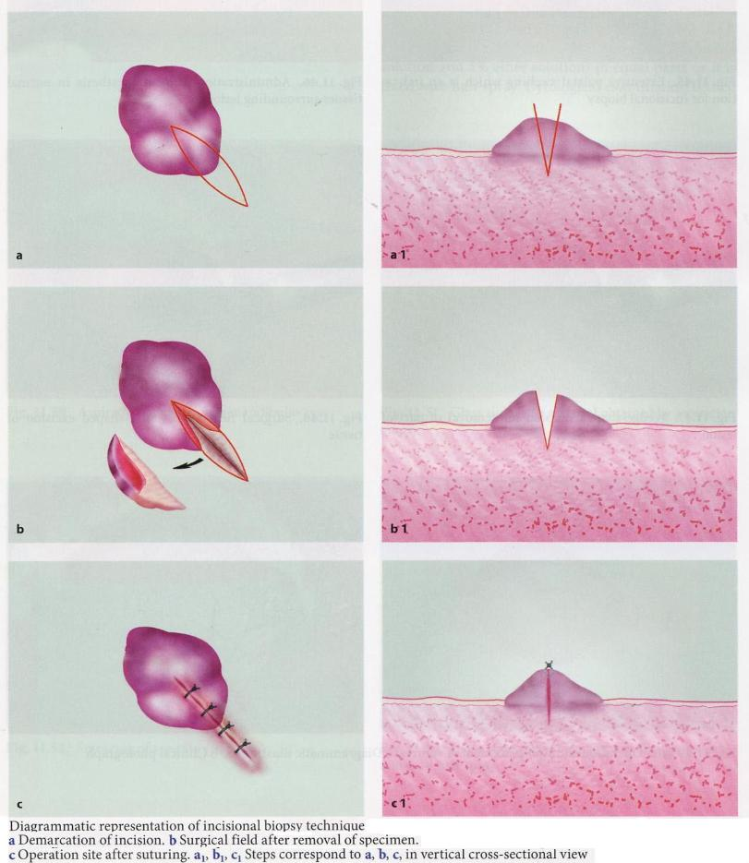
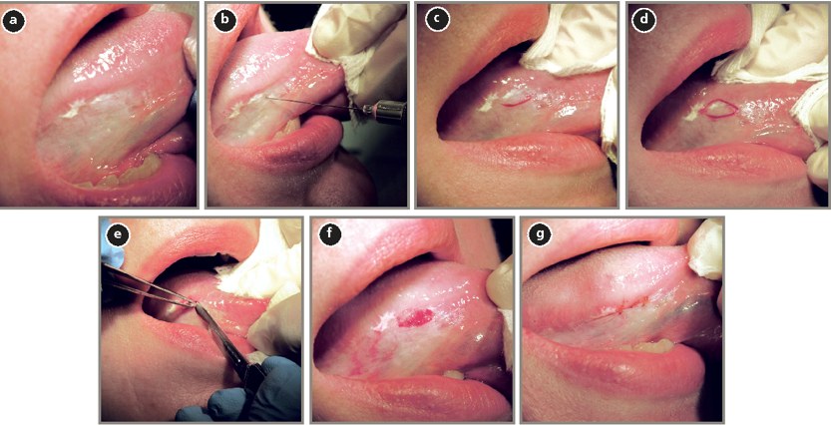
Homogenous leukoplakia affecting the right lateral and ventral areas of the tongue (a). Incisional biopsy is used to sample a thick, keratotic region at the anterior aspect of the tongue. Infiltration of local anesthetic (b) is followed by tracing of an ellipse (c and d)

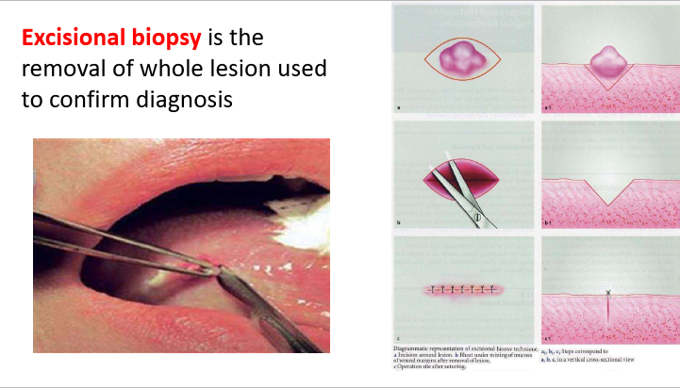

Fine needle aspiration biopsy
During fine-needle aspiration, a long, thin needle is inserted into the suspicious area.
A syringe is used usually effective to diagnose of malignant from benign neoplasm although it is not completely conclusive.
small size of the needle avoid damage to vital structure & it is valuable in case when incisional biopsy contra indicated as in pleomorphic adenoma or other types of malignant lesions in parotid gland
Disadvantage: it require experience, small specimen may be unrepresentative, definitive diagnosis is not always possible

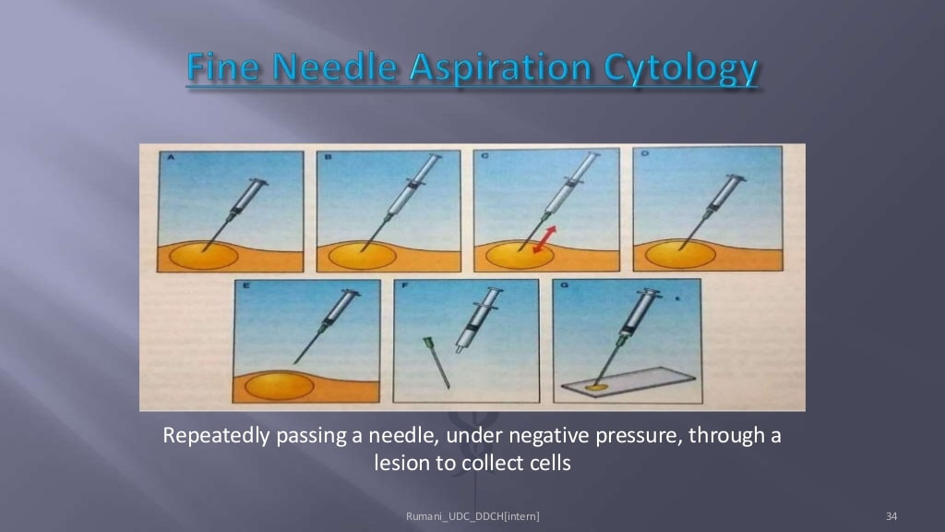

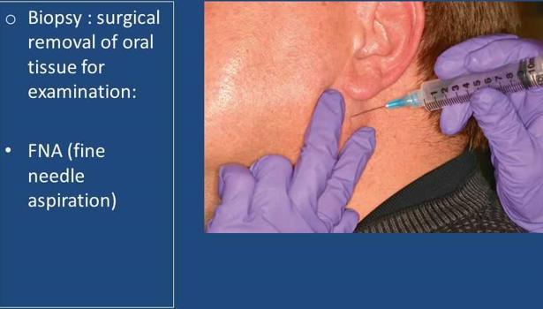

Core needle biopsy:
A larger needle with a cutting tip is used during core needle biopsy to draw a column of tissue out of a suspicious area. the sample are larger than FNA & preserve architecture of tissue ,give more definitive diagnosis than FNA , but there is increase of the risk of seeding of neoplasm into the tissue & risk of damaging vital structures. It is used when incisional biopsy is inaccessible
e.g. laryngeal tumor.

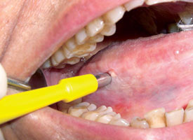

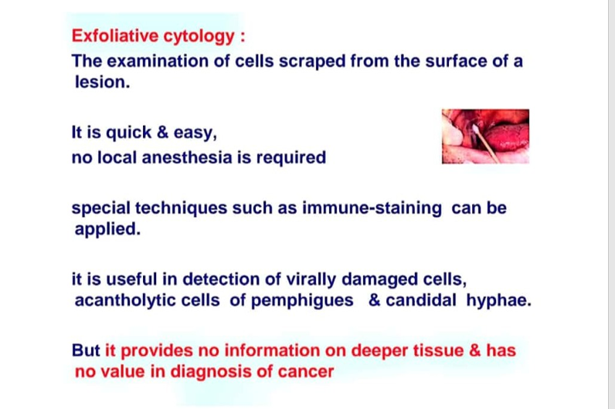

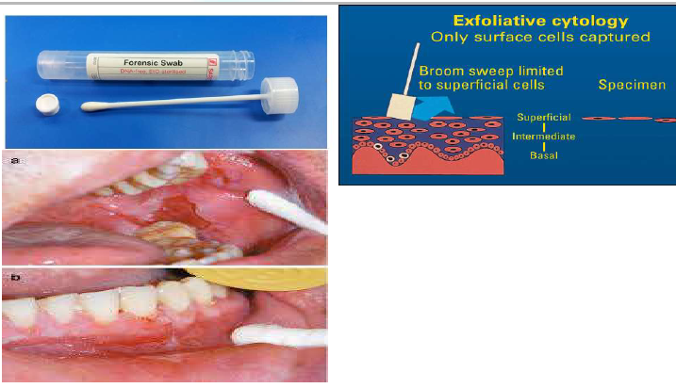

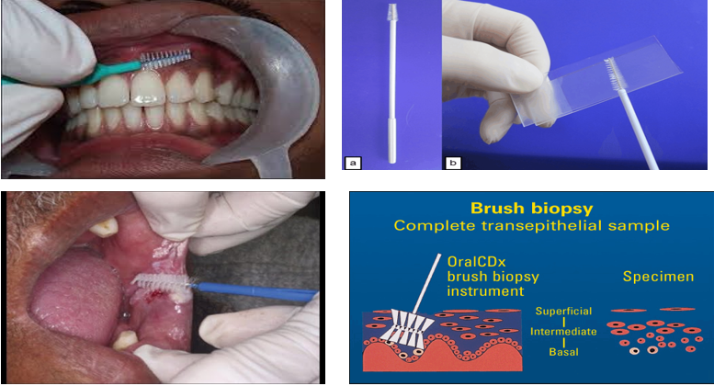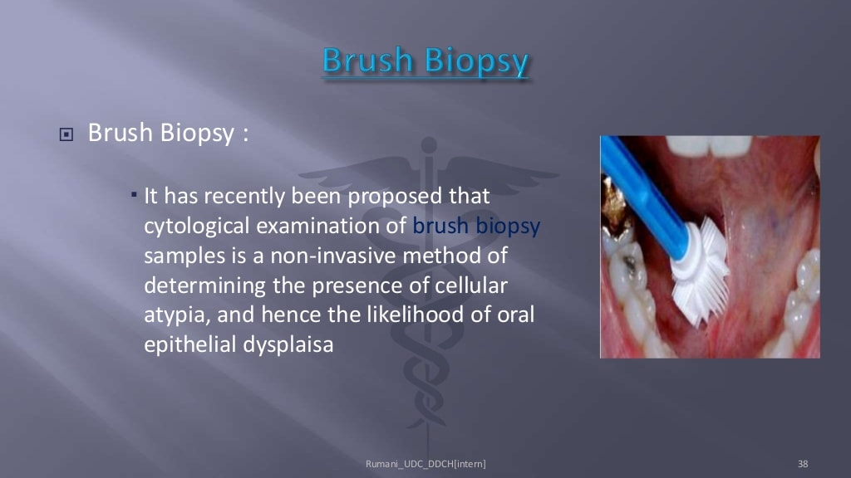

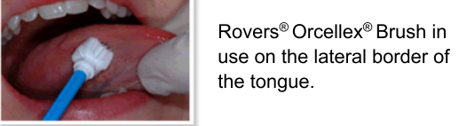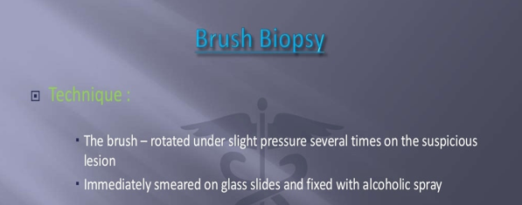

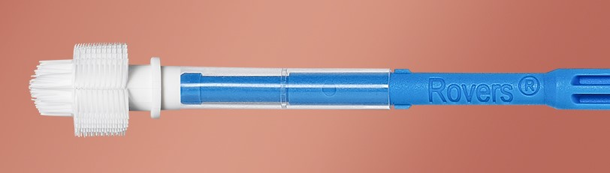

Fixation of tissue
Usually 10% formalin is used, procedure take about 24 hour, specimen should put in 10 time their volume because tissue make the fixative weaker as fixation proceeds
After fixation tissue is dehydrated by the use of solvent & then impregnated in paraffin wax, the wax block is mounted on microtome & sectioned to micro millimeter thick.
Staining procedure
The most common stain is the combination of haemotoxylin & eosin (H&E).
Haemotoxylin is dark blue basic dye; eosin is red acidic dye.
The second common dye is periodic acid – Schiff (PAS) it stain carbohydrates & mucinous substances ,pink, it is useful in identify salivary & other mucins, glycogen & candidal hyphae in sections.
Sliver stain is black stain useful for fungi in sections but gram stain is quicker and more useful for smear

Immunofluorecent
Immunofluorecent staining can used to identify pemphigues as autoantibody bound to epithelial prickle cells (to desmosomes) & in pemphigoid autoantibodies bond to the basement membrane

