Introduction to digital system:-

A digital system is a system that uses numbers as distinct independent values and is a translation of the Latin word digital

Digital system is an expression often used in devices that rely on electrical tension as their input, and often refers to the binary system in counting based on values 1 and 0 and is different from the analogue system (Analog).

The difference between the digital and analogue system lies in the quality and shape of the signal in terms of its amplitude or value, as well as in terms of the time it occupies. An analogue signal can take any value in continuous and uninterrupted time, while a numeric takes only one of the values recognized in the system within continuous or intermittent times.

The source of a digital signal is always analogue as life around us is analogue and therefore any analogue signal is converted to digital by a certain technology and actions and by an Analog Digital Converter (ADC)

The broader scope of use of a digital or binary system is computers and electronic devices in general. The digital system is electrically expressed by electrical impulses often where in a digital system based on the binary system the values can be represented as follows: 1 there is a positive pulse (a voltage of a specific value (e.g. 5 V) for a specific duration), 0 There is no voltage (0 V) for the same duration.

Numbering systems

  - Decimal Numbering System (Base 10)

In the decimal numbering system, each position contains 10 different possible digits. These digits are 0, 1, 2, 3, 4, 5, 6, 7, 8, and 9. Each position in a multidigit number will have a weighting factor based on a power of 10.

(Figure _1)
Weighting factors of four-digit decimal number.

The least significant position has a weighting factor of 10⁰
The most significant position (leftmost) has a weighting factor of 10³:

Example: To evaluate the decimal number 4623, the digit in each position is multiplied by the appropriate weighting factor:

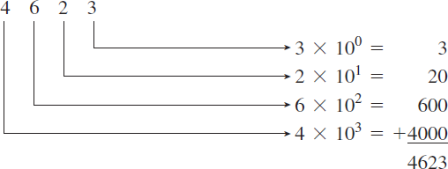
Answer:

  - Binary Numbering System (Base 2)

Digital electronics use the binary numbering system because it uses only the digits 0 and 1, which can be represented simply in a digital system by two distinct voltage levels, such as +5 V = 1 and 0 V = 0.

Binary to Decimal conversion

The weighting factors for binary positions are the powers of 2 shown in Table 1–1.
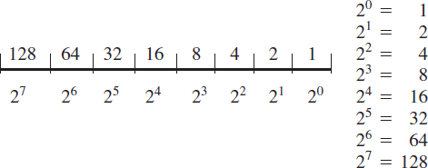
)Figure 2( Weighting factors of 8-digit binary number.

Example: Convert the binary number (01010110)₂ to decimal?

Answer:
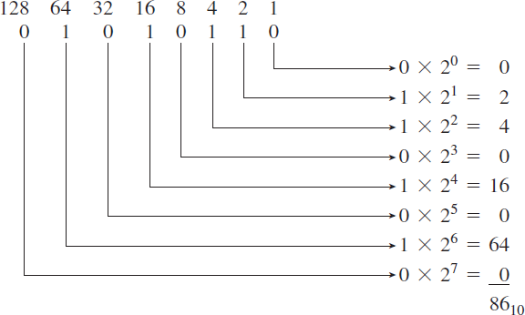
(01010110)₂= (86)₁₀

Example: Convert the fractional binary number (1011.1010)₂to decimal?

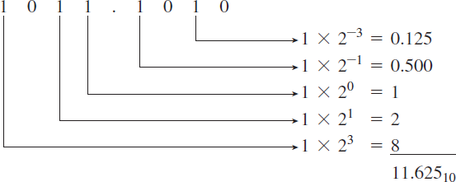
Answer:

(1011.1010)₂= (11.625)₁₀

Decimal to Binary conversion

The binary equivalent can be found by successively dividing the integer part of the number by 2and recording the remainders until the quotient becomes ‘0’. The remainders written in reverse order constitute the binary equivalent.
Example: Convert(152)₁₀to binary number?

Answer:
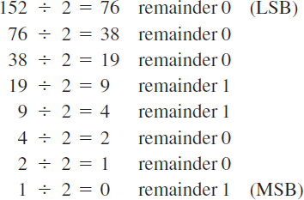

(152)₁₀= (10011000)₂
Example: Convert(87)₁₀to binary number?

Answer:

 | 2 | 87 | 1
 | 2 | 43 | 1
 | 2 | 21 | 1
 | 2 | 10 | 0
 | 2 | 5 | 1
 | 2 | 2 | 0
 | 2 | 1 | 1
(87)₁₀= (1010111)₂

Example: Convert(20.625)₁₀to binary number?

Answer:

2 | 20 | 0 | 0.625 × 2 = 1.25 | 1
2 | 10 | 0 | 0.25 × 2 = 0.5 | 0
2 | 5 | 1 | 0.5 × 2 = 1 | 1
2 | 2 | 0
2 | 1 | 1

(20.625)₁₀= (10100.101)₂

Octal Numbering System (Base 8)

The octal numbering system is a method of grouping binary numbers in groups of
three. The eight allowable digits are 0, 1, 2, 3, 4, 5, 6, and 7. The octal numbering system is used by manufacturers of computers that utilize 3-bit codes to indicate instructions or operations to be performed. By using the octal representation instead of binary, the user can simplify the task of entering or reading computer instructions and thus save time.
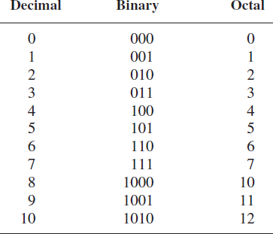

Example: Convert(137.21)₈to decimal number?

Answer:

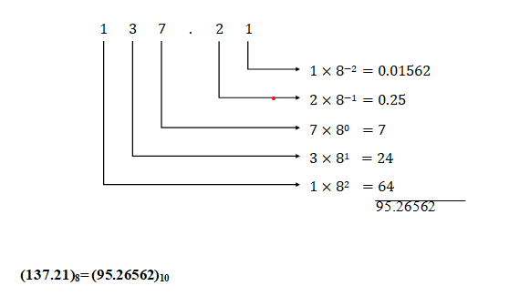

Example: Convert(73.75)₁₀to octal number?

Answer:

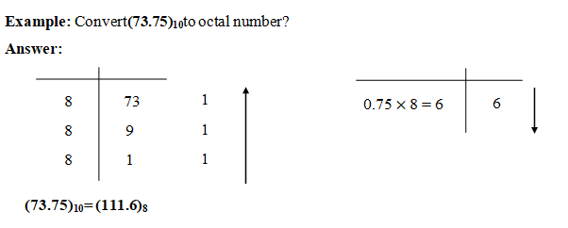

    - Binary–Octal and Octal–Binary Conversions

An octal number can be converted into its binary equivalent by replacing each octal digit with its three-bit binary equivalent. We take the three-bit equivalent because the base of the octal number system is 8 and it is the third power of the base of the binary number system, i.e. 2. All we have then to remember is the three-bit binary equivalents of the basic digits of the octal number system. A binary number can be converted into an equivalent octal number by splitting the integer and fractional parts into groups of three bits, starting from the binary point on both sides. The 0s can be added to complete the outside groups if needed.

Example: Convert(624)₈to binary number?

Answer:
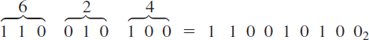

(624)₈= (110010100)₂
Example: Convert(10111001)₂to octal number?

Answer:
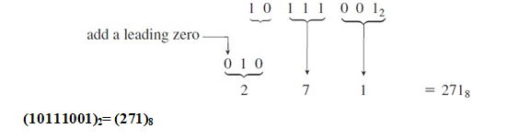

Hexadecimal Numbering System (Base 16)

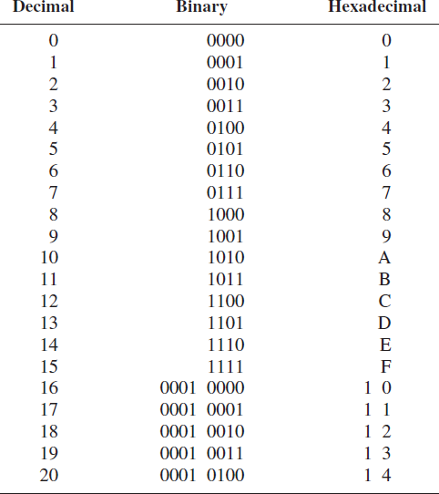
The hexadecimal numbering system, like the octal system, is a method of grouping bits to simplify entering and reading the instructions or data present in digital computer systems. Hexadecimal (hex) uses 16 different digits and is a method of grouping binary numbers in groups of four.

Example: Convert(2A6)₁₆to decimal number?

Answer:
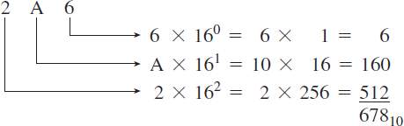

(2A6)₁₆= (678)₁₀
Example: Convert(82.25)₁₀to hexadecimal number?

Answer:
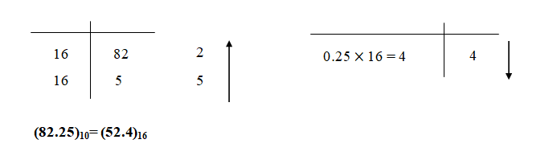
To convert from binary to hexadecimal, group the binary number in groups of four(starting in the least significant position) and write down the equivalent hex digit.

Example: Convert(01101101)₂to hexadecimal number?

Answer:
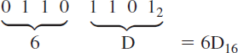
(01101101)₂= (6D)₁₆

Example: Convert(A9)₁₆to binary number?
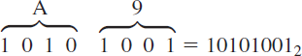
Answer:

(A9)₁₆= (10101001)₂

Binary-Coded-Decimal System (BCD)
- The binary-coded-decimal (BCD) system is used to represent each of the 10 decimal digits as a 4-bit binary code. This code is useful for outputting to displays that are always numeric (0 to 9), such as those found in digital clocks or digital voltmeters.
- To form a BCD number, simply convert each decimal digit to its 4-bit binary code.

Example: Convert(496)₁₀to BCD?

Answer:
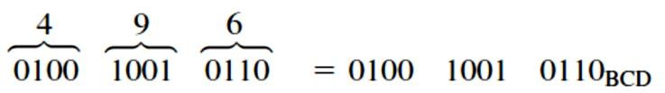

(496)₁₀= (0100 1001 0110)_{BCD}
Example: Convert(0111 0101 1000)_{BCD} to decimal?

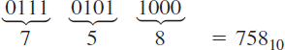
Answer:

(0111 0101 1000)_{BCD}= (758)₁₀

Example: Convert(0110 0100 1011)_{BCD} to decimal?

Answer:
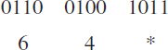
This conversion is impossible because 1011 is not a valid binary-coded decimal. It is not in the range 0 to 9.

Arithmetic Operations

  - Addition

The following tables illustrate the rules of addition in Binary.
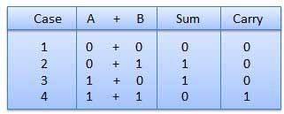
5 1+1+1 1 1

Figure Binary addition rules.

Example: Add (0011010)₂to (0001100)₂?

Answer:

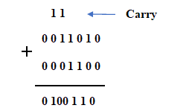

Example: Find the result of (11010.1101)₂+(111101.111)₂?
Answer:
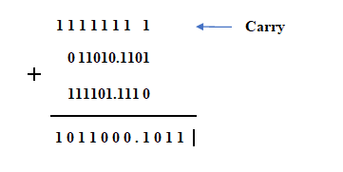

Subtraction

    - Binary Subtraction

Subtraction and Borrow, these two words will be used very frequently for the binary subtraction. There are four rules of binary subtraction.

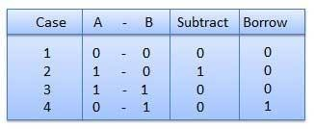
Figure Binary subtraction rules

Example: Find the results of (0011010)₂-(001100)₂?
Answer:
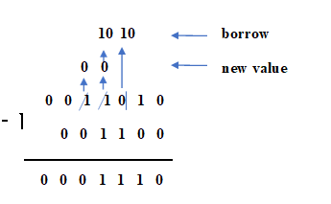

Example: Find the results of (110.1101)₂-(11.1011)₂?
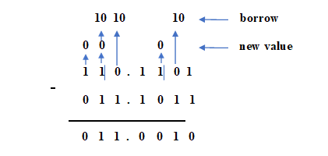
Answer:

Multiplication

In this section we will discuss the multiplication rules only in binary numbers.
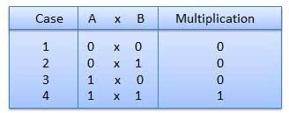
Binary multiplication is similar to decimal multiplication. It is simpler than decimal multiplication because only 0s and 1s are involved. There are four rules of binary multiplication.
Figure Binary multiplication rules

Example: Find the results of(10011)₂×(0101)₂?
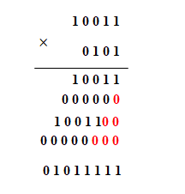
Answer:

Example: Find the results of (100.111)₂×(010.11)₂?
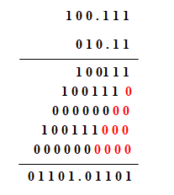
Answer:

3.1.Division
Binary division is similar to decimal division. It is called as the long division procedure.
Example: Find the results of (11011)₂÷(11)₂?
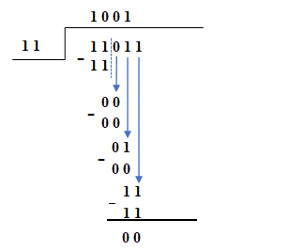
Answer:

